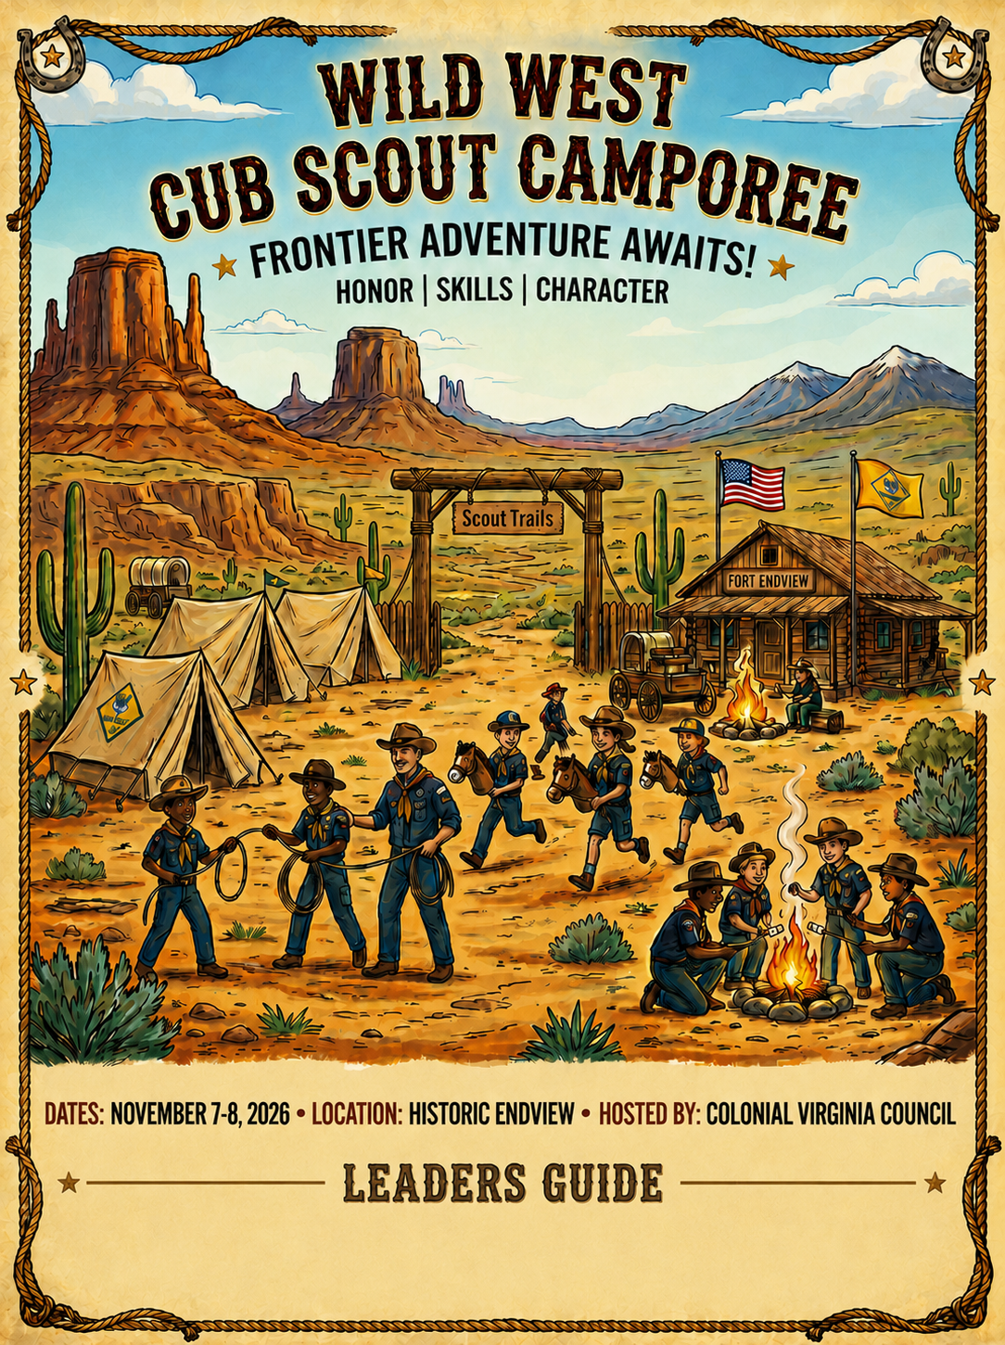

To All Cub Scouts and Families:

Welcome to the Colonial Virginia Council’s Wild West Cub Scout Camporee! The camporee staff has worked hard to provide you, the Cub Scout Family, with an enjoyable and safe family camping experience. Set against the backdrop of the beautiful spring season and Historic Endview, the Wild West Cub Scout Camporee is an event you won’t want to miss!

The Wild West Cub Scout Camporee is a time for families to spend time together camping, enjoying the great outdoors, participating in fun Cub Scout activities, and enjoying the evening show.

This event is open to all Cub Scouts and their families. On Saturday, there will be a variety of games, crafts and activities specifically geared towards Cub Scouts.

Leaders, please use this guide to prepare your unit for the Wild West Cub Scout Camporee. This guide provides general and specific information for a safe, fun event for your unit. Please share this information with members of your pack.

The registration fee is $20.00 per youth and $15 for adults for all units registering by Wednesday, November 4, 2026. Children under Age 5 are free. Each unit must have health forms for all its campers in camp at all times. If there are special health requirements for any youth or adult leader, please notify the event chairman. Families and Packs are to supply their own meals and gear.

There will be a briefing for Unit leaders at HQ tent on Saturday at 11:30 a.m.

Please forward questions or comments to the event chairman, Bob Efird, befird28@aol.com.

We look forward to seeing all of you at Historic Endview for the Wild West Cub Scout Camporee!!

General Information

What is the Wild West Cub Scout Camporee?
The camporee is a time for Cub Scouts and their families to spend time together camping, enjoying the great outdoors, participating in fun activities geared towards Cub Scouts, and enjoying the evening show.

When is the Wild West Cub Scout Camporee?
Cub Family Campout 2026 will be held November 7-8, 2026. In case of foul weather everyone will have to make do in the rain and mud. So, check the weather and be prepared!

Who can attend the Wild West Cub Scout Camporee?
All Colonial Virginia Council Cub Scout packs and out of Council packs are welcome to attend!

Where is the Wild West Cub Scout Camporee?
The Cub Family Campout is being held at Historic Endview, 362 Yorktown Rd, Newport News, VA 23603.

What are the Wild West Cub Scout Camporee activities?
Below is a sampling of the various types of activities available
Archery
Slingshots
Arts & Crafts (Flag making, leather work, foam noodles)
Gaga ball
Cornhole
Relay Races
Branding
Lasso
Campfire and skits
Western games

Rules and Regulations

The following rules were made to ensure a fun and safe camping experience. It is the responsibility of the adults in charge to educate their Scouts and Scouters on these rules. Anyone caught violating them may be asked to leave the camp.

CHECK-IN/REGISTRATION
Units should arrive between 8:00 AM - 12:00 pm on Saturday, November 7, to set up campsites. If you plan to arrive on Friday night you MUST contact Bob Efird to make arrangements (or you may end up waiting until our staff is ready to receive you). Upon entering camp, proceed to the registration area to sign in (located at HQ Tent on road leading into Historic Endview). You will receive your campsite assignment number at that time.
THE ONLY VEHICLE ALLOWED INTO THE CAMPSITE IS THE VEHICLE USED TO HAUL Pack GEAR—IF A UNIT HAS MORE THAN ONE VEHICLE ONLY ONE WILL BE ALLOWED IN AT A TIME!!!! PLEASE FOLLOW THESE INTRUCTIONS!! No vehicles are allowed to stay in the campsite areas or activity field.
All Vehicles must be in the parking area by 12:00 Saturday afternoon!!!!
HANDICAPPED PARKING
Requests for special parking passes for medical conditions will be made on a case-by-case basis. Special passes must be requested in advance and will be issued on the day of the event. We prefer to discuss the request prior to event to allow for the greatest degree of accommodation. Every reasonable effort will be made to accommodate those with physical disabilities or special needs.

REGISTRATION & FEES
There is a registration fee of $20 for Cub Scouts and $15.00 Adults per person to cover awards, patches, ribbons, toilets, insurance, and park fees. Children under age 5 are free. All participants must be listed on the registration form and turned into the Scout Shop by November 4 or register online with Black Pug on the council website.

The Unit Leader will submit an updated roster of all Cub Scouts and Leaders attending Cub Campout at the Saturday 12:00 briefing. The total fee paid at the Scout Office must equal participants; additional personnel may be paid for upon arrival however they will not be guaranteed an event patch. We will issue extra patches on a first come basis.

Camping at Historic Endview
The city of Newport News has graciously allowed us to use Historic Endview for this event and we want to make sure that we take good care of the property. Remember to follow Leave No Trace principles. Here are some specific Historic Endview regulations:

1. We will be using port-a-johns so please plan accordingly. There will not be running water or flush toilets.
2. Bring your own water for the weekend. There will be spigot water available if necessary.
3. We will be camping in the battle fields behind the plantation. There are historic earthworks that we must stay off. Please keep the Scouts to the designated camping areas only.
4. Vehicles will be able to park close to the campsite area, and one vehicle per site will be allowed back at setup. If your troop brings a trailer, you will be able to leave it in your site.
5. The sites are marked out squares in the middle of a large field. Please make sure you and your Scouts stay within your campsite’s boundaries.

MORE CAMPING STUFF
Campers are responsible for the following:
- All meals
- Personal or Troop Tents
- Trash removal from campsite. Bring plenty of trash bags. The onsite dumpster cannot handle all our trash so please plan on packing trash out.
- Campsite cleanup to include firewood removal from fire stands and campsites.
- We will be utilizing a Gray Water dump container that will be located near Port-a-Johns ALL GRAY WATER MUST BE DISPOSED IN THE CONTAINER AND NOT ON THE GROUNDS OR IN THE WOODED AREAS
- Observe the Outdoor Code & follow the rules of Leave No Trace
- Please adhere to BSA policies found in “Guide to Safe Scouting.”

CAMPFIRES
- ALL CAMPFIRES WILL USE RAISED FIRE STANDS.
- Bonfires are not permitted, but campfires contained within raised fire stands or in the fire drums located at camp are permitted.
- Depending on local fire conditions, additional restrictions may be imposed.
- Firewood brought in from an outside source is recommended; however, on site deadfall may be used.
- Campfire should be managed by Scouts who have their Firem’n Chit
- A campfire should be monitored at all times by adults.
- Campfires are allowed in burn barrels lifted off the ground or a leave no trace fire must be used. This means that when your site is inspected on Sunday morning there is ZERO evidence of a ground fire!!!!!

FIRST AID
Each pack is expected to have a first aid kit for minor injuries. Emergency medical care will be available for severe injuries at the HQ Tent.

GENERAL CONCERNS

- Vehicle Speed – Drivers must exercise EXTREME caution when operating motor vehicles on camp property. Speed limit is 10 MPH.
- Passengers are not allowed to ride in back of pickup trucks or on trailers.
- Pets are not permitted on any camp property during the duration of this camp event. Service animals will be permitted but must be reported in advance.
- Tent trenching is not allowed.
- Open flames in tents are prohibited.
- Gasoline and “white gas” are not permitted in camp, nor is propane allowed in tents. However, liquid fuels, such as charcoal starter and Coleman individual propane type cook stove fuel is allowed---use with caution.
- Firearms and fireworks are not allowed in camp.
- Radios and electronic devices are strongly discouraged. The staff uses the same type of radios that you have and if we can’t communicate when there is an issue, safety may be jeopardized. Remember the life you save might be your own.
- Alcoholic beverages and illegal substances are never permitted on camp property. Offenders will be asked to leave the property.
- Secure and store foods to prevent attracting our little furry friends.
- All campers are to stay within the boundaries of the camp. We do not want scouts wandering away from camp.
- Please enforce the Buddy System with your scouts
- Each unit must have two-deep adult leadership.
- Please respect others during Lights Out. Scouts are not allowed out of their site after lights out with the exception of to and from the latrine.
- Due to the nature of certain skills all Scouts must have earned their Totin’ Chip to participate in stations that utilize cutting tools.

Wild West Cub Scout Camporee Spirit Award

The Wild West Cub Scout Camporee Spirit Award will be presented at the Saturday Night Campfire and will go to the unit who shows the BEST team spirit during the activities on Saturday.

Wild West Cub Scout Camporee Schedule

Saturday, November 7

8:00 a.m. - 12:00 p.m. Registration and Camp set up
11:45 – 12:00 pm Leaders Meeting at HQ
12:00 – 12:45 pm. Lunch in Campsite
12:45 p.m.- 1:00 p.m. Opening Ceremony
1:00 p.m. – 5:00 p.m. Activities open
5:00 p.m. - 7:00 p.m. Dinner with pack
7:15 p.m. – 8:30 p.m. Campfire
8:45 p.m. - 10:00 p.m. Unit cracker barrel at campsite
10:00 p.m. Taps – Lights Out

Sunday, November 8

7:00 a.m. - 8:30 a.m. Breakfast and Clean-up with pack
9:00 a.m. - 9:30 a.m. Chapel Service
9:30 a.m. - 10:00 p.m. Check-out at staff area and pick up packet

Be sure to check Lost and Found prior to departure.

Have a safe journey back home!

Wild West Cub Scout Camporee Registration

Registration can be made at the Colonial Virginia Council office.
Or register online with Black Pug on the council website at:
https://scoutingevent.com/595-88139

Cub Family Campout Roster and Registration
(Due by November 4, 2026)

Pack Number_________District___________________
Unit POC _________________________________________________
Phone#________________________________________________
Email ______________________________________________________
Adult Leaders __________

List additional names on separate page or back
Date Submitted _____________ Total Attendance ___________

______ Scouts x $20.00* = $ ________
______ Adults x $15.00* = $ ________

Total Fee Paid $________

Check No. ___ Receipt No. _______

Questions? E-mail or call Bob Efird, 757-784-1440 (befird28@aol.com)
Unit Leader _______________________ Ph. ________________
Email_________________________________________________
Scoutmaster/Leader Signature ______________________________Date_______
Verification: All Scouts and Scouters Listed above are registered in Scouting America.
EVENT CODE: 903

