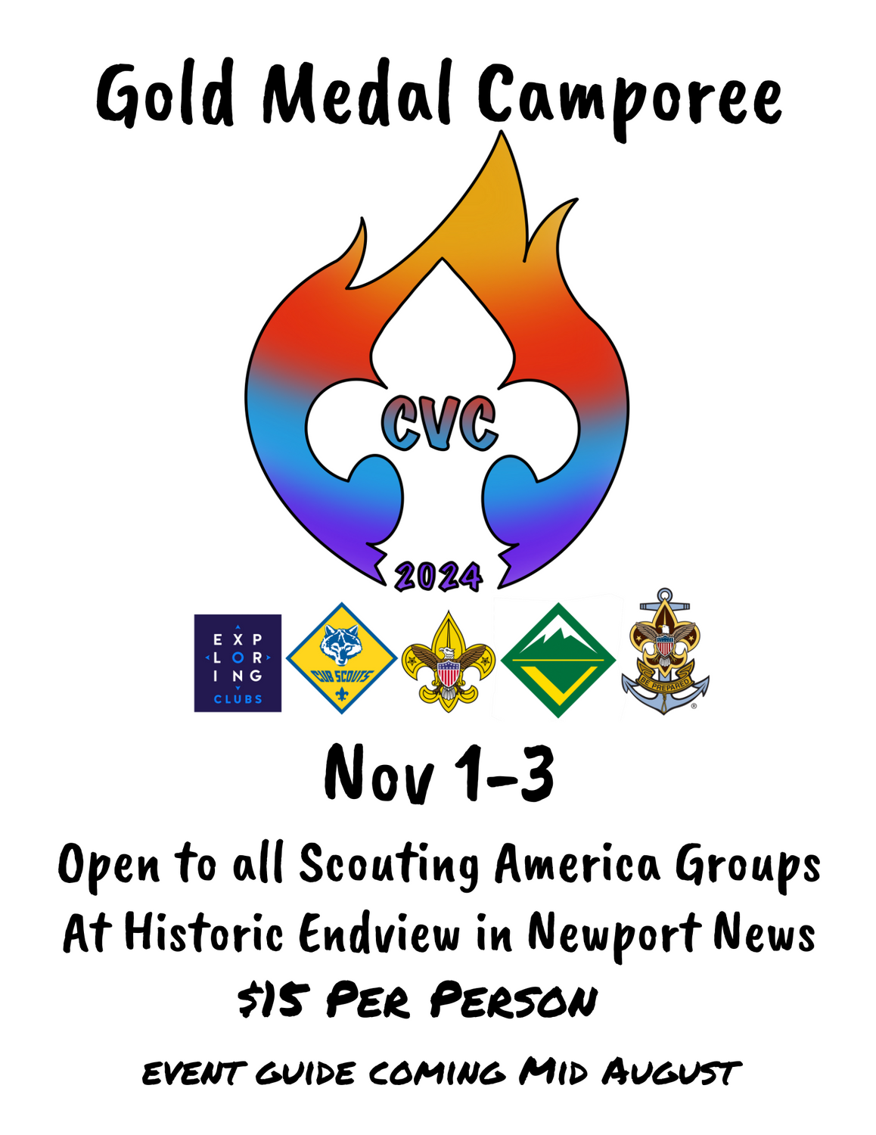

Colonial Virginia Council

Historic Endview
362 Yorktown Rd, Newport News, VA 23603

Gold Medal Camporee 2024

Everyone is invited to enjoy competition and camaraderie at the Gold Medal Camporee! This event is open to all Scouts and their families. Events will have male and female categories. There will be athletic competitions both individual and team along with games. For Scouts BSA and older units, there will be the opportunity to earn medals in the various competitions and for the Cub Scouts there will be a variety of games, crafts, and competitions.

Leaders, please use this guide to prepare your unit for the Gold Medal Camporee 2024. This guide provides general and specific information for a safe, fun event for your unit.

The registration fee is $15.00 per youth and adult for all units registering by Monday, October 28, 2024. Each unit must have health forms for all its campers in camp at all times. If there are special health requirements for any youth or adult leader, please notify the event chairman. Families, Packs, Troops, Crews & Ships are to supply their own meals and gear.

There will be a briefing for Unit leaders and Senior Patrol Leaders at HQ tent on Friday night at 8:00 p.m.

On Saturday there will be all types of fun activities geared around the Gold Medal Camporee theme. Saturday night, there will be a campfire with an Awards Ceremony and Order of the Arrow Call Out (for newly elected Scouts & Scouters).

Please forward questions or comments to the event chairman, Tom Auth. auth5@cox.net

We look forward to seeing all of you at Historic Endview for the Gold Medal Camporee 2024!!

General Information

What is the Gold Medal Camporee 2024?
Gold Medal Camporee 2024 is an athletic based event with both individual and team events. Cubs Scouts and their families will get the chance to participate in a variety of events, games and crafts. Scouts BSA and older units will get a chance to earn medals in the various competitions.

When is the Gold Medal Camporee 2024?
Gold Medal Camporee 2024 will be held November 1-3, 2024. In case of foul weather everyone will have to make do in the rain and mud. So, check the weather and be prepared!

Who can attend the Gold Medal Camporee 2024?
All Colonial Virginia Council Cub Scout Packs and families, Scout BSA Troops, Crews and Ships. Out of Council units well are welcome too!!

Where is the Gold Medal Camporee 2024?
Gold Medal Camporee 2024 is being held at Historic Endview, 362 Yorktown Rd, Newport News, VA 23603.

What are the Gold Medal Camporee 2024 Activities?
Below is a sampling of the various types of activities available.

Cub Scouts
Archery
Crafts (Flag making, leather work, foam noodles)
Gaga ball
Cornhole
Track style events

Scouts BSA, Venturers and Mates (Male and Female Divisions)
Archery
Sprints and medium distance runs
Volleyball
Scout skills challenge

Rules and Regulations

The following rules were made to ensure a fun and safe camping experience. It is the responsibility of the adults in charge to educate their Scouts and Scouters on these rules. Anyone caught violating them may be asked to leave the camp.

CHECK-IN/REGISTRATION
Troops and Crews may arrive at 5pm on Friday, November 1, to set up campsites. If you plan to arrive before 5pm you MUST contact Bob Efird to make arrangements (or you may end up waiting until our staff is ready to receive you). Upon entering camp, proceed to the registration area to sign in (located at HQ Tent on road leading into Historic Endview). You will receive your campsite assignment number at that time.
THE ONLY VEHICLE ALLOWED INTO THE CAMPSITE IS THE VEHICLE USED TO HAUL TROOP GEAR—IF A UNIT HAS MORE THAN ONE VEHICLE ONLY ONE WILL BE ALLOWED IN AT A TIME!!!! PLEASE FOLLOW THESE INTRUCTIONS!! No vehicles are allowed to stay in the campsite areas or activity field.
All Vehicles must be in the parking area by 9:00 Friday night!!!!!
HANDICAPPED PARKING
Requests for special parking passes for medical conditions will be made on a case-by-case basis. Special passes must be requested in advance and will be issued on the day of the event. We prefer to discuss the request prior to event to allow for the greatest degree of accommodation. Every reasonable effort will be made to accommodate those with physical disabilities or special needs.

REGISTRATION & FEES
There is a registration fee for Scouts and Scouters of $15.00 per person to cover awards, patches, ribbons, toilets, insurance, and park fees. All participants must be listed on the registration form and turned into the Scout Shop by October 28 or register online with Black Pug on the council website at:
FILL IN LINK HERE

The Senior Patrol Leader will submit an updated roster of all Scouts and Leaders attending Gold Medal Camporee at the 8:00 PM Friday night briefing. The total fee paid at the Scout Office must equal participants; additional personnel may be paid for upon arrival however they will not be guaranteed an event patch. We will issue extra patches on a first come basis.

OA Call Out
Please provide the names of all Scouts and Scouters who will be called out at the Saturday evening campfire when you check in on Friday. Be sure to bring OA sashes to identify Scouts during Call Out.

Camping at Historic Endview
The city of Newport News has graciously allowed us to use Historic Endview for this event and we want to make sure that we take good care of the property. Remember to follow Leave No Trace principles. Here are some specific Historic Endview regulations:

1. We will be using port-a-johns so please plan accordingly. There will not be running water or flush toilets.
2. There will be spigot water on site (marked with Traffic Cones) or bring your own water.
3. We will be camping in the battle fields behind the plantation. There are historic earthworks that we must stay off. Please keep the Scouts to the designated camping areas only.
4. Vehicles will be able to park close to the campsite area, and one vehicle per site will be allowed back at setup. If your troop brings a trailer, you will be able to leave it in your site.
5. The sites are marked out squares in the middle of a large field. Please make sure you and your Scouts stay within your campsite’s boundaries.

MORE CAMPING STUFF
Campers are responsible for the following:
- All meals
- Personal or Troop Tents
- Trash removal from campsite. Bring plenty of trash bags. The onsite dumpster cannot handle all our trash so please plan on packing trash out.
- Campsite cleanup to include firewood removal from fire stands and campsites.
- We will be utilizing a Gray Water dump container that will be located near Port-a-Johns ALL GRAY WATER MUST BE DISPOSED IN THE CONTAINER AND NOT ON THE GROUNDS OR IN THE WOODED AREAS
- Observe the Outdoor Code & follow the rules of Leave No Trace
- Please adhere to BSA policies found in “Guide to Safe Scouting.”

CAMPFIRES
- ALL CAMPFIRES WILL USE RAISED FIRE STANDS.
- Bonfires are not permitted, but campfires contained within raised fire stands or in the fire drums located at camp are permitted.
- Depending on local fire conditions, additional restrictions may be imposed.
- Firewood brought in from an outside source is recommended; however, on site deadfall may be used.
- Campfire should be managed by Scouts who have their Firem’n Chit
- A campfire should be monitored at all times by adults.
- Campfires are allowed in burn barrels lifted off the ground or a leave no trace fire must be used. This means that when your site is inspected on Sunday morning there is ZERO evidence of a ground fire!!!!!

FIRST AID
Each troop is expected to have a first aid kit for minor injuries. Emergency medical care will be available for severe injuries at the HQ Tent.

GENERAL CONCERNS

- Vehicle Speed – Drivers must exercise EXTREME caution when operating motor vehicles on camp property. Speed limit is 10 MPH.
- Passengers are not allowed to ride in back of pickup trucks or on trailers.
- Pets are not permitted on any camp property during the duration of this camp event. Service animals will be permitted but must be reported in advance.
- Tent trenching is not allowed.
- Open flames in tents are prohibited.
- Gasoline and “white gas” are not permitted in camp, nor is propane allowed in tents. However, liquid fuels, such as charcoal starter and Coleman individual propane type cook stove fuel is allowed---use with caution.
- Firearms and fireworks are not allowed in camp.
- Radios and electronic devices are strongly discouraged. The staff uses the same type of radios that you have and if we can’t communicate when there is an issue, safety may be jeopardized. Remember the life you save might be your own.
- Alcoholic beverages and illegal substances are never permitted on camp property. Offenders will be asked to leave the property.
- Secure and store foods to prevent attracting our little furry friends.
- All campers are to stay within the boundaries of the camp. We do not want scouts wandering away from camp.
- Please enforce the Buddy System with your scouts
- Each unit must have two-deep adult leadership.
- Please respect others during Lights Out. Scouts are not allowed out of their site after lights out with the exception of to and from the latrine.
- Due to the nature of certain skills all Scouts must have earned their Totin’ Chip to participate in stations that utilize cutting tools.

Gold Medal Camporee Spirit Award

The Gold Medal Camporee Spirit Award will be presented at the Awards Ceremony Saturday Night and will go to the Patrol who shows the BEST team spirit during competition on Saturday. The Gold Medal Camporee Spirit Award will be judged on the following:

- Patrol identification (banner, flag, etc.)
- Patrol Yell, Chant or Cheer
- Themed Attire/Costumes
- Interaction with each other as well as other Patrols.
- Sportsmanship
- Enthusiasm
- Creativity
- Overall Scout Spirit!!

Gold Medal Camporee 2024 Schedule

Friday, November 1

5:00 p.m. – 8:00 p.m. Check-in at Registration Area and set up campsites
8:00 p.m. – 8:30 p.m. Leader and SPL Meeting
10:00 p.m. Taps – Lights Out

Saturday, November 2

7:00 a.m. Reveille
7:01 a.m. - 8:15 a.m. Breakfast with troop
8:45 a.m. - 9:00 a.m. Opening Ceremony
9:00 a.m. - 12:00 p.m. Activities
12:00 p.m.- 1:20 p.m. Lunch/Rest time
1:30 p.m. - 4:30 p.m. Activities resume
4:45 p.m. Retire Colors (Optional-Staff will conduct)
4:30 p.m. - 7:00 p.m. Dinner with troop
7:15 p.m. – 8:30 p.m. Campfire, Awards and OA Call Out
8:45 p.m. - 10:00 p.m. Troop cracker barrel at troop campsite
10:00 p.m. Taps – Lights Out

Sunday November 3

7:00 a.m. - 8:30 a.m. Breakfast and Clean-up with troop
9:00 a.m. - 9:30 a.m. Chapel Service
9:30 a.m. - 10:00 p.m. Check-out at staff area and pick up packet

Be sure to check Lost and Found prior to departure.

Have a safe journey back home!

GOLD MEDAL CAMPOREE 2024 Registration

Registration can be made at the Colonial Virginia Council office.
Or register online with Black Pug on the council website at:
INSERT LINK. https://scoutingevent.com/595-88139

Gold Medal Camporee Roster and Registration
(Due by October 28, 2024)

Pack/Troop/Crew/Ship Number_________District___________________
Unit POC _________________________________________________
Phone#__________________________________________________
Email ______________________________________________________________

Adult Leaders __________

List additional names on separate page or back
Date Submitted _____________ Total Attendance _____________________

______ Scouts x $15.00* = $ ________Total Fee Paid $ ________________
______ Adults x $15.00* = $ ________ Check No. ___ Receipt No. _______

Questions? E-mail or call Bob Efird, 757-784-1440 (befird28@aol.com)
SM/Leader _______________________ Ph. _____________________________
Email_____________________________________________________________
Scoutmaster/Leader Signature ______________________________Date_______
Verification: All Scouts and Scouters Listed above are registered in The Boy Scouts of America.
EVENT CODE: 903

