TRAINER’S EDGE
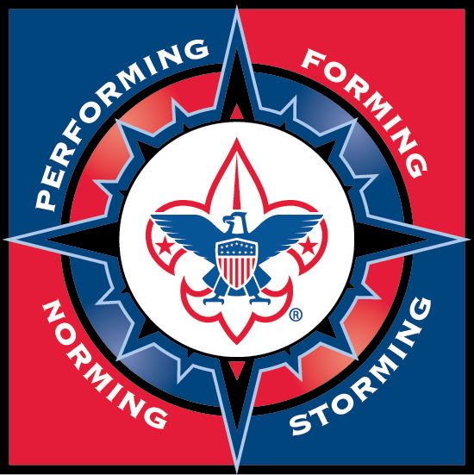

Saturday, September 7, 2024 | 9:00 am - 4:00 pm
King of Glory Lutheran Church

4897 Longhill Rd, Williamsburg, VA 23188

Trainer's EDGE is a train-the-trainer course required for Wood Badge staff and is highly recommended for everyone who does formal Scouting training. This course provides great information to improve your training, presentation, and public speaking skills.
This course supplements Wood Badge and NYLT staff development by focusing on you and raising the level of your skills as a trainer. Because only practice can polish these skills, this course is intended to “train the trainer” by offering hands-on experience in methods and media.
These skills can make you a better instructor and speaker both at University of Scouting and in in many civilian working environments.
EVERY PARTICIPANT MUST prepare a 10 – 12 minute presentation on a Scouting topic of your choice, which will allow you to demonstrate the skills of a trainer. You will receive constructive feedback on your presentation from the other participants. You must bring all materials and equipment that you need for your presentation to the course with you. Your prepared presentation is required for course completion.
For additional information, please contact Bill Raftery at Braftery@yahoo.com
Non-Refundable Course Fee: $15 (Lunch and snacks provided)

Registration via Black Pug at https://scoutingevent.com/595-87842
Registration Deadline: Tuesday, September 3, 2024

