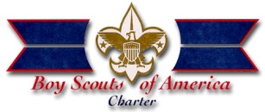 | Chartered Organization of the Year Award  This local award of the Monitor Merrimac District has been established  to recognize the noteworthy service provided by the  Chartered Organization above and beyond normal expectations.  It is presented at the Monitor Merrimac District Recognition  Banquet. | 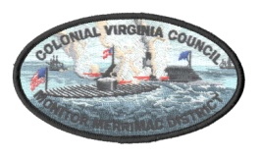
Nomination
To qualify for nomination, an organization should meet the following criteria:
- The organization must charter at least one Scouting unit.
- Nominee must have noteworthy service above the call of duty in their support of Scouting and their own mission as an organization.
- Not have received this award in the last year
Unit making Nomination: |  |  |  |  |  |  |  | Date:
Nominator: |  |  |  |  |  |  | Scouting Position:
Nominator Contact Phone Number & Email:
Chartered Organization:
Name of Executive Officer:
Organization Address:

Attach an additional page describing the noteworthy service above the call of duty upon which the nomination is based as well as clearly substantiating the award criteria.
Please furnish as much information as possible. This will be read at the District Recognition Banquet.

Nominations must be turned in by January 22, 2024 to:
Josh Jones-St. Clair (joshua.jonesstclair@scouting.org)

