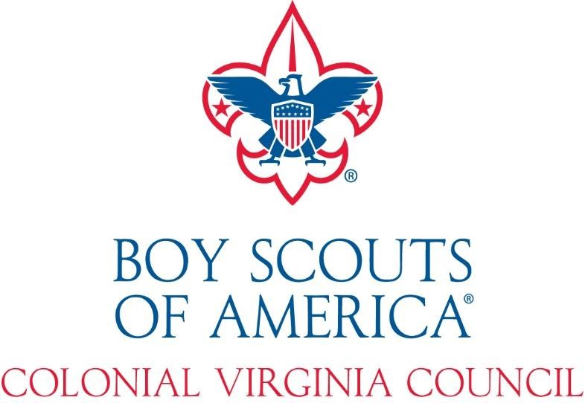

Bows and Barrels
Shooting Sports Day
May 19-21, 2023
Leaders Guide

Contents
Bows and Barrels Information 3
Introduction 4
Tentative Schedule of Events 5
General Event Information: 6
Activities and BSA Response to Coronavirus (COVID-19) Pandemic 6
Check-In 6
Check Out 6
Meals 6
Visitors & Guests 6
Adult Leaders 7
General Rules 7
Staff 7
Campsites/Camping 7
Water and Bath Facilities 7
Parking 7
Medical Matters 8
Emergency Procedures 8
Youth Protection Policies 9
General Policies 9
Appendix A: Evaluation Form 12
Appendix B: How to Get to Camp 13
Appendix C: COVID-19 Advisory - Disclaimer 15

ii

Bows and Barrels Information

When | May 19– 21, 2022 (Friday – Sunday)
 | Be Prepared. There is no rain/snow day for the event. All units should prepare for foul weather.
What | There will be three ranges set up for Archery, BB’s, Rifle, Shotgun, 3-D Archery, and long range.
Where | Pipsico Scout Reservation  Camp Kiwanis  57 Pipsico Road  Spring Grove, VA 23881
Contact: | Dave Singletary  david.singletary@gmail.com
Register | Register/Pay Online @ https://scoutingevent.com/595-57211 OR  Complete registration forms in this guide and turn in at Scout Office with the fees
Cost | $25 per Youth Participant  $10 per Adult
 | NO REGISTRATIONS WILL BE ACCEPTED AFTER MAY 13, 2022 THERE WILL BE NO ON-SITE REGISTRATION

Introduction
The Bows and Barrels (Shooting Sports Day) is designed to provide Scouts BSA Troops, Venture Crews, and Sea Scout Ships with an exciting weekend filled with the best outdoor programs the Boy Scouts of America has to offer.
This weekend is designed to provide these unique programs, normally only available to units at summer camp or at outside facilities, to units on a weekend camping experience. Units are encouraged to develop their own organizational structure using the patrol method and practice outdoor camping skills outside of the scheduled program times.
A lunch of will be available for purchase on Saturday only. The meal will consist of Hot Dogs, Chips, and a drink. All other meals should be planned and prepared for by the individual units. Water will be available in the camp.
These programs are age appropriate and safe with the goal of giving a positive experience of shooting for each youth. Shooting stations will include archery, BB’s, 22cal rifle, shotgun, and 3-D Archery is available for Scouts.
All activities are on Saturday only. Units are invited to arrive on Friday and depart on Sunday. Space is limited to 250 campers.
Participants are invited to camp from Friday through Sunday, or any portion in between. The program will be on Saturday. Units are welcome to arrive on Friday to escape the city and setup camp and relax (this makes Saturday easier). Likewise, after a day of craziness on Saturday you are welcome to take it easy Saturday night and make your way home on Sunday.
Please make arrangements for meals. Regardless, be prepared to prepare and clean-up what you bring. Water is available in the camp and dumpsters are located at the entrance to the camp for any waste. Please check the program schedule when planning your meals to ensure you have enough time to prepare, eat, and tidy up.
Important: Individual personal use of outside guns and ammunition is prohibited for safety reasons. Let’s keep it safe, but extremely fun!

Tentative Schedule of Events
Friday
5:00 - 9:30 PM Check-in (for Friday night campers)
Saturday
6:30 – 8:45 AM Breakfast in Campsites
7:45 – 8:45 AM Optional Check-in (for Saturday arrivals)
8:45 AM Opening & Rotation Assignments
9:00 – 10:30 AM Safety & Skills Instruction
10:30 AM – 12:00 PM Safety & Skills Instruction
12:00 – 1:00 PM Lunch
1:00 – 3:00 PM Fun Shooting & Open Rotation
5:00 PM Awards Ceremony
5:30 – 7:15 PM Dinner in Campsites
7:15 – 11:00 PM Evening Activities (Units on their own)
11:00 PM Lights Out
Sunday
7:00 – 8:00 AM Breakfast in Campsites
8:00 – 10:30 AM All Units Leave Camp SAFE DRIVE HOME!

General Event Information:

Activities and BSA Response to Coronavirus (COVID-19) Pandemic
The health and safety of our guests and staff has always and will continue to be the highest priority of our Camp. Colonial Virginia Council continually monitors COVID-19 related guidance and incorporates measures to provide a safe, clean, and healthy outdoor experience for its participants. As detailed in Appendix C, this event will only be conducted in compliance with CDC, ACA, and Commonwealth of Virginia recommendations and guidelines.

Check-In
Check-in will be conducted from 5:00 PM till 9:30 PM on Friday evening or between 7:45 & 8:15 AM Saturday. Check-in will be at the K-Bldg (Camp Kiwanis). You should plan to arrive Friday evening in order to take maximum advantage of the full program. Do not arrive early, there will be no one to check you in, you may NOT enter the campsites prior to check-in.
For the safety of scouts walking through camp, only vehicles pulling trailers will be allowed in camp. The trailer must be unhooked and parked in the designated area adjacent to your campsite. Tow vehicles are to be immediately moved to the front parking lot. All other vehicles are to stay in the parking lots and any additional gear or scouts will have to hike in. Your cooperation is greatly appreciated.

Check Out
Contingents may check-out after the conclusion of program on Saturday evening or stay until Sunday morning. For camper safety, during program sessions absolutely no vehicles will be allowed into camp for packing up campsites. Please come to the K-Bldg to check out and have your camping area checked for cleanliness. Please ensure that your camping area is left better than what you found it (Leave No Trace). If your group plans to leave on Sunday, you MUST be checked out by 10:30 AM. There will not be patches for this event.

Meals
Plan to prepare their own food in their campsite. Please be prepared to prepare and clean-up what you bring. Please check the program schedule when planning your meals to ensure you have enough time to prepare, eat, and tidy up before program sessions begin. On Saturday lunch will be available for purchase consisting of Hot Dogs, Chips, and Drink.

Visitors & Guests
Visitors are welcomed to view the daytime activities; however, they must leave the property at the completion of the evening activities and may not participate in activities without registering with the unit. The individual Unit Leaders in Charge at the event are responsible for the behavior of all guests visiting his/ her unit or its members. The Unit Leader is also responsible for ensuring that his unit’s visitors and guests are aware of the camp’s health and safety policies, and that they are followed. Visitors and guests are not permitted to spend the night.

Adult Leaders
All units must ensure that they always meet the BSA two-deep leadership requirement in camp. BSA policy always requires at least two adult leaders be at camp; one must be 21 years or older. See Guide to Safe Scouting for clarification. Troops should be organized under the patrol method, led by their Senior Patrol Leader, and for Crews under the President.

General Rules
- All camping will utilize Leave No Trace techniques.
- No open fires are permitted except in designated campfire rings.
- Scouts are not to roam through the campsites.
- Unit leaders are responsible for their units at all times.
- All vehicles are to be parked in the designated parking areas.
- Members will remain in their unit area between taps and reveille unless on authorized errands.
- No one will enter the camping area of another unit without permission.
- Campers are expected to conduct themselves in a manner that will bring credit to their unit and the BSA.

Staff
Weekend events are staffed by volunteers. The Boy Scouts of America is a volunteer run program. Every unit that participates in the event is expected to provide some form of contribution to the success of that event. Staff positions are available for direct program support as well as logistical support. Please inform the event chairman of the names and contact information for those volunteers in your unit who may help contribute to the event’s success.

Campsites/Camping
Campers need to provide their own tents and beddings. Sites will be assigned based on registration date, unit size, and if the unit has a trailer. Units are encouraged to set up their campsite with their unit identification number, an American flag, unit flag and patrol flags.

Water and Bath Facilities
Drinking water is available within the camp. No shower facilities will be available.

Parking
Absolutely no vehicles are permitted on the grass fields or inside campsites. Gear is to be unloaded at campsite entrances and all vehicles shall be returned to the parking lot immediately upon completion of unloading. Please make every effort to unload completely prior to setting up. Trailer parking is available at certain campsites. All parking will be either at the K-Bldg or at the barn if required.

Medical Matters
For Specific COVID-19 Health Polices See Appendix C.

Medicals
According to BSA policy, all Scouts and leaders should complete an Annual Heath and Medical Record form
(parts A&B only) for all scouting activities. This is just the health history form (excluding the physician’s portion). IT IS THE RESPONSIBILITY OF THE UNIT to obtain and maintain copies of these forms for members of their unit for all activities they conduct. Medical forms will NOT be turned in at check-in. The official BSA form is located here: http://www.scouting.org/filestore/HealthSafety/pdf/680-001_AB.pdf.

Medical Treatment
All units should bring a unit first aid kit and treat injuries within their capabilities. Units must report all injuries and other medical situations to the camp staff at the K-Bldg, even those they treat themselves. Qualified medical personnel will be on duty at the K-Bldg. If necessary, the camp staff will contact emergency medical services and ambulance services using 911. Unit leaders are expected to control all medications within their units.

Prescription Medications
All prescription drugs are kept and administered by the unit. It is to be kept in a secured location out of the reach of the children. If medication requires refrigeration, it can be checked in with the Health Officer at checkin. Provide a list of medication, dosage (Medical part B) and to whom you are administering medication to when you check in with the Health Officer. By law, medications must be in a container with a typed label from the pharmacy. Medications shall be given only in accordance with the label. Handwritten changes will not be accepted.

Emergency Procedures
Pipsico Scout Reservation maintains emergency procedures to meet, and in some cases, exceed the standards set by the Boy Scouts of America. It is essential for everyone’s safety that every member of your unit fully understands that these procedures exist - their life, your life, or someone else’s life could depend on it. Please be sure to follow only instructions delivered by the staff chain of command. Likewise, if an emergency arises, or is brought to your attention, please notify the nearest staff member immediately so that we may launch the appropriate procedures. Do not attempt to resolve an emergency situation alone. Notify the nearest staff member. In the event that an emergency arises, an alarm will sound K-Bld or an air horn will be used to alert everyone, When this alarm is heard, all units and participants are required to assemble in front of the OA Shelter, and await further instruction.

Youth Protection Policies
Leaders are asked to review the Guide to Safe Scouting before attending camp and ensure compliance by their unit with policies as detailed in the Guide, particularly in respect of youth protection policies. Failure to comply with Guide to Safe Scouting and youth protection policies will result in disciplinary action. Key portions of the youth protection policies found in the Guide to Safe Scouting are reproduced below. Other Guide to Safe Scouting policies are also contained elsewhere in this guide.
Adult leaders must respect the privacy of youth members and protect their own privacy at all times. Except in emergencies, adults and youth may not enter each other’s designated sleeping and shower areas. No Scout may share a tent with an adult who is not his own parent or guardian.

General Policies

Alcoholic Beverages & Drugs
Alcohol and illegal drugs are prohibited. All prescription drugs are kept and administered by an adult within the unit. (See the Prescription Medications section above.)

Cell Phone Policy
We would request that Scouts not take cell phones to program sessions or, at the very least, to turn them off during sessions. Use of cell phones during program sessions is inconsiderate to other participants and, in some cases can be extremely dangerous (Scouts participating in shooting sport activities should not be distracted by a ringing phone).

Electronic Devices
Radios, cell phones, CD players, video games, and other personal electronic devices detract from the camping experience and provide an inviting target for theft. We recommend that you do not bring them into camp. If you permit them during travel to and from camp, please leave them in the car during your stay at camp. Youth campers are not permitted to have two-way radios or pagers in camp, as these have proven to be highly disruptive of the camp routine.

Fires, Stoves, Tents & Open Flames
Fires will be authorized depending on the status of State and County fire prohibitions in effect for the weekend of the event. All ground fires are permitted ONLY in the designated fire rings at each camp site. The staff will update units on the current fire policy at check-in. Units must post water buckets or a fire extinguisher in the fire area. Cutting of live trees, shrubs, or vegetation is prohibited. Wood is available in the Ax Yard. We prohibit bringing wood from off property.

For safety reasons, there are to be no open flames in tents. This ban on open flames in tents includes a ban on the use of matches, candles, kerosene, propane or liquid lanterns in tents. Lighting in tents is to be provided by battery-powered lanterns or flashlights only. It is, however, acceptable to use a lantern under a dining fly. All cooking fires, campfires and stoves are to be attended while they are burning. Fires are only to be built in designated areas and must be extinguished so that they are cold to the touch when unattended.

Initiations, Hazing & Military Training
Corporal punishment, hazing, initiation of any sort, and military training and drill are not permitted in the Boy Scouts of America.

Liquid Fuels
Adult leaders only may use stoves and lanterns requiring liquid fuel. Extra fuel must be turned over to the Quartermaster for safekeeping in locked storage.

Money & Valuables
Each family must decide how much spending money a Scout should bring to camp. Each Scout is, however, responsible for the safeguarding of their money and personal property. It is recommended that expensive cameras, watches, and personal entertainment devices be left at home. Regardless, all items should be clearly marked, with the scout’s name and unit number.

Pets
No pets are allowed in camp. Please ensure that anyone planning to visit your unit during the event is also aware of this rule.

Restricted Areas
The following areas are off limits to all campers: The ranger’s home and maintenance areas, camp staff living areas, the kitchen and food storage areas, (except for authorized adult volunteers) any program area where staff is not present, and the cliffs along the James River. Scouts may visit the waterfront for beach combing or fishing only when staff is present or when accompanied by an adult leader.

Smoking & Vaping
Anyone under 21 years old is prohibited from using tobacco in any form while at camp. Adults who smoke must do so out of sight of any youth members. Smoking is prohibited in any tent or building. Cigarette butts must be field stripped and placed in a trash receptacle.

Taps/Lights Out
A Scout is courteous. All scouts should be in their designated campsites at 10:30 p.m. to wind-down the day’s activities. Taps is at 11 p.m. Unit leaders must ensure that fires and lanterns are out and that all their youth have retreated to their tents and are quiet.

Telephones
During this time of year, there is no active land line telephone on the property. If adult leaders need to receive regular calls at camp, bring a cell phone or pager, or make arrangements to check with their office on a regular schedule. During an emergency, you can contact the Camp Director (contact information above.)

Trailers
If your unit plans on bringing a trailer, please provide this information on the registration form. Specific campsites have been designated for unit use when a unit has a trailer. The requesting unit is permitted to have one trailer in the designated area at the perimeter of their campsite until checkout. Trailers are NOT to be parked past the wooden posts located around the perimeter of each campsite.

Trash Disposal
Participants should practice Leave No Trace principles to the maximum extent practicable. If you packed it in - you pack it out! All units are expected to police their camping area and remove all trash to the dumpsters located at the front of camp near the barn. Trash that will not fit in the dumpsters becomes the responsibility of the unit to remove from the campground. Do not pile trash next to the dumpsters. If the dumpsters are full at time of checkout then units MUST pack out their trash and dispose of it properly.

Vehicles in Camp
Absolutely no vehicles are permitted on grass or in campsites. The Colonial Virginia Council will not accept responsibility for any vehicle damage within camp.
No other motorized vehicles (golf carts, etc.) will be allowed in camp at any time except for use by designated camp staff. If the need arises for a vehicle to be in camp, approval MUST first be obtained from the Camp Director. Special arrangements will be available for special needs visitors, Scouts and Scouters as requested.

Weapons, Knives, Full Axes, Fireworks, & Firearms
All necessary and appropriate equipment for our shooting programs will be provided. Personal firearms, ammunition, bows and arrows are not permitted in camp. Also, no water guns are permitted at camp.
Pocketknives may be carried by adult leaders and any Scout who has earned the Totin’ Chip or Whittling Chip. Fireworks & firearms of any kind are prohibited in camp. Law Enforcement Officers (LEO’s) please notify the council prior to camp of any special requirements by your department.

Appendix A: Evaluation Form
Location (site & facilities): 1 2 3 4 5
Leader’s Guide (overall) 1 2 3 4 5
Did it help prepare you for this weekend? 1 2 3 4 5
Was it available in time? 1 2 3 4 5
(1: Way to Late, 5: Right when I needed it.)
Was any information missing? Please elaborate:

Staff (overall) | 1 | 2 | 3 | 4 | 5
Ease of registration: | 1 | 2 | 3 | 4 | 5
Was the staff responsive? | 1 | 2 | 3 | 4 | 5
Demonstrations/Activities (overall)  I liked: | 1 | 2 | 3 | 4 | 5
I did not like:
I would like in the future: (suggestion to better this event)

Would like to help plan an event in the future?
Yes, count me in Don’t know, call me when it’s I might be able to help out in a limited time.

capacity.
Name: Phone:
E-mail: Unit:

Suggestions: (What did we do wrong? What did we get right? How can we improve for next year?) (Continue on reverse, if required.)

Appendix B: How to Get to Camp
Pipsico is located at 57 Pipsico Road; Spring Grove Virginia, 23881, midway between Norfolk and Richmond.
Pipsico is centrally located, just a short distance away via the nearby ferry.
Detailed Directions can be found online: http://pipsicobsa.com/resource-bank/
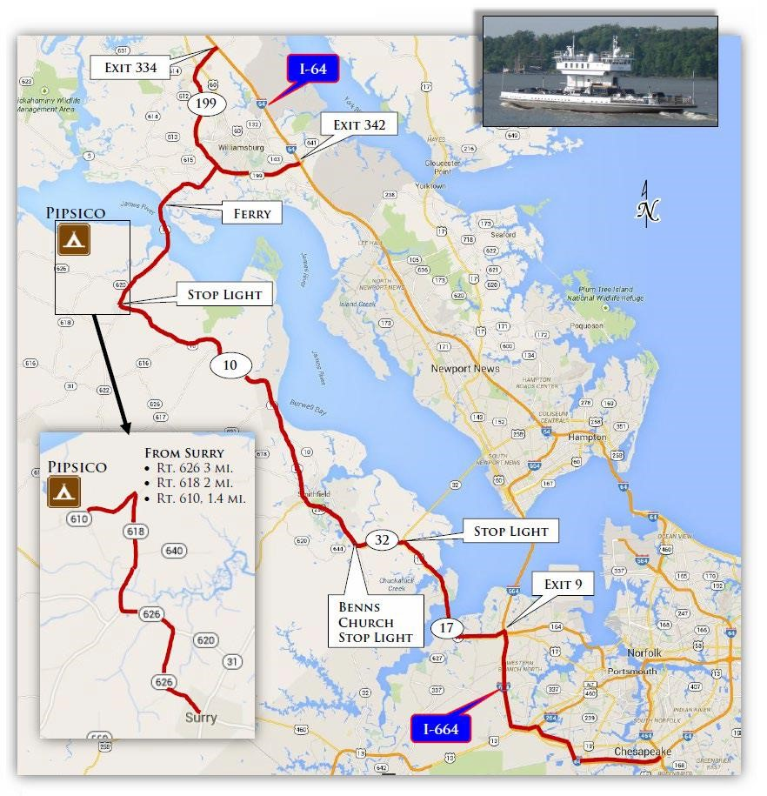

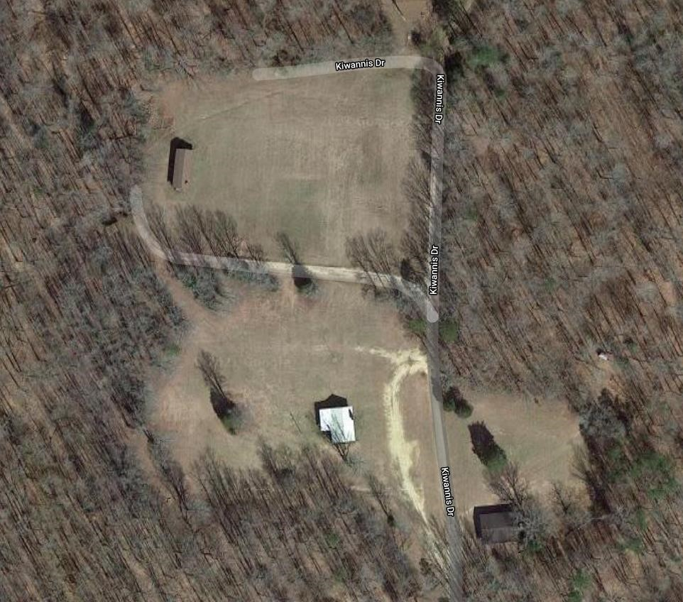

Access

K
-
Bldg

HQ/Staff

OA

Shelter

Appendix C: COVID-19 Advisory - Disclaimer
By attending Bows and barrels, you acknowledge and understand the following:
- COVID-19 is a highly communicable virus, and a risk exists that you could contract COVID-19 by participating in Bows and Barrels, just like participation in any other similar activity with others. You acknowledge that Bows and Barrels is implementing reasonable protocols to reduce the risk of transmission, but transmission is still possible. You agree that you are aware of these risks and the dangers associated with the COVID-19 virus.
- You knowingly and freely assume all such risks related to illness/death from COVID-19; and
- You hereby knowingly assume the risk of injury, harm and loss associated with participating in Bows and Barrels.
Bows and Barrels attendees waive all civil liability against Colonial Virginia Council, or National Service Territory 15 for any injuries caused by the inherent risk associated with contracting COVID-19 at public gatherings, except for gross negligence, willful and wanton misconduct, reckless infliction of harm, or intentional infliction of harm, by the individual or entity.
Face coverings (masks, gaiters, etc.) are recommended be worn when social distancing (6-feet) cannot be maintained indoors. The following guidance and precautions should be followed by all participants.
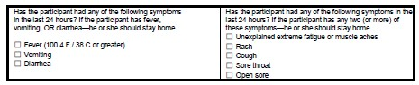

Unit Registration Form
May 19-21, 2023
Unit: Unit Leader:
Email:
Phone Number:

Scouts Attending: First & Last Name
1. | 13.
2. | 14.
3. | 15.
4. | 16.
5. | 17.
6. | 18.
7. | 19.
8. | 20.
9. | 21.
10. | 22.
11. | 23.
12. | 24.
(Add names to back of form if needed)
Adults Attending:
1. | 4.
2. | 5.
3. | 6.

FEES ON OR BEFORE May 13, 2022
Scouts @ $25 ea. Total Attending:
$

$

Adults @ $10 ea. Total Money:
$

ENCLOSED IS $ |  | FOR |  | ATTENDING

EVENT CODE: 708

