The Southern GMC Districts Present

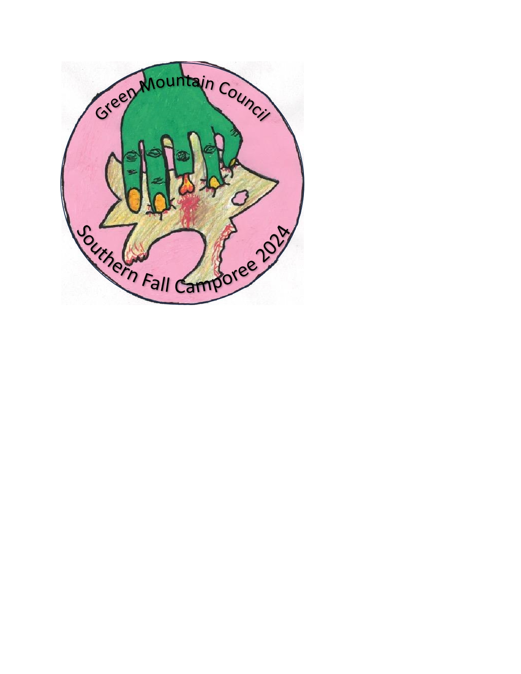

**Scout Survival in a**

**Zombie Apocalypse**

Southern Fall Camporee

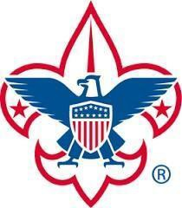We would like to welcome all Scouts, Scouters, and parents to the 2024 Fall Camporee for the Southern Vermont Districts. Troop 428 is hosting and has put together a camporee to challenge you both mentally and physically. This fall’s camporee will be set in the scene of a Zombie Apocalypse. Scouts must demonstrate their skills to survive.

We have confidence that we will have another fun, educational, and safe Camporee weekend that will embrace all that has drawn us to Scouting and all that it offers.

This packet will provide our Camporee participants with the details needed for the event. It will also provide our Troops with an overall description of the weekend so that they may **Be Prepared** for the day.

In closing, Troop 428 and Troop 405 are excited to be put on another great event for you and cannot wait to see you all there. If you have any questions or concerns, or would like to volunteer to help staff the event, please feel free to contact us at [jmatheson1971@gmail.com](mailto:jmatheson1971@gmail.com) or via phone at (802) 490-4711. We will do our best to help however possible.

Jennifer Matheson, Scoutmaster, Troop 428

# Registration and Check-in Procedures

**Registration Fee: $22 per Scout, $18 per Adult;**

**Character Co-op: $18 per Scout, $15 per Adult**

Register online at <https://scoutingevent.com/592-81901> and by **Friday September 17th**.

The Registration fee is for a full weekend of theme-based activities and, of course, a patch!

Female troops must be accompanied by a registered female adult (that has completed YPT) to all stations of the event.

Female lone scouts must connect with a female troop that is attending for tenting, meals and competitions.

**Check In at Rafters**

* Check-in time is Friday, September 27th from **5:30pm – 7:30pm**.  At check in, we will:
  + Check-in people on the rosters.
  + Let the unit know where their campsite is for the weekend.
* Only 1 vehicle with a trailer will be allowed at the unit campsite.  All other vehicles will need to park in the designated parking area (pointed out at registration)
* Every Scout will need to bring a completed Medical Form Part A & B.  We recommend the unit leader hold onto all these medical forms for the weekend.

## Directions / Location

Rafters at Derrybrook

165 Derrybrook Road

Rawsonville, VT

Location in Google Maps - <https://www.google.com/maps/place/The+Rafters/@43.1553261,-72.8538847,17z/data=!3m1!4b1!4m5!3m4!1s0x89e0572009867b09:0x69ae319afe146080!8m2!3d43.1553222!4d-72.851696>

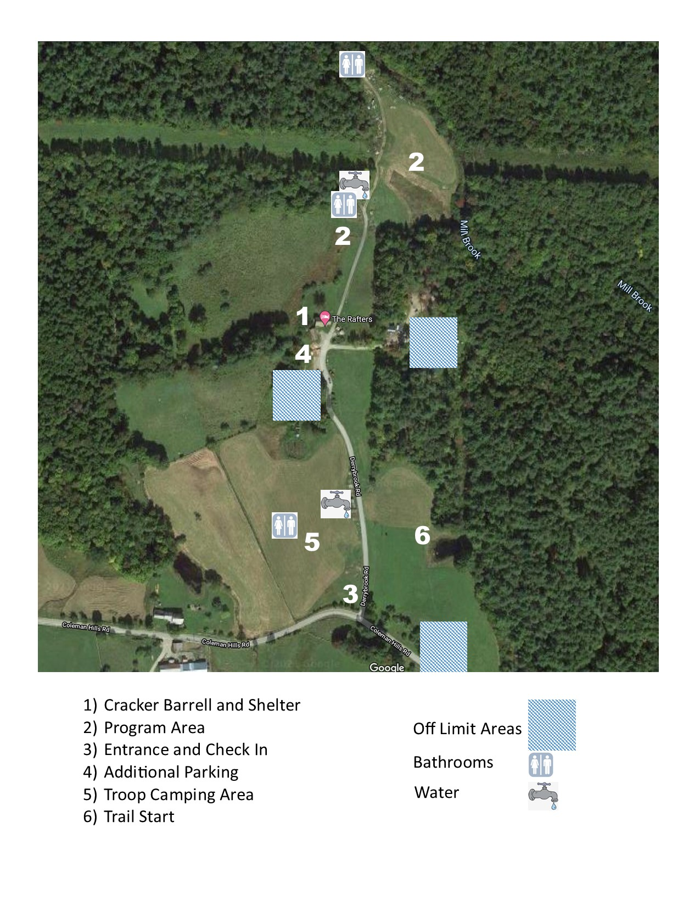

# BSA Requirements for 2024 Fall Camporee

**Medical Forms** - Each registered Scout and Scouter must have a completed BSA Annual Medical Form Part A and Part B. Part C requiring a doctor’s exam is NOT required for this weekend event.

These forms can be found online at -

http://www.scouting.org/scoutsource/HealthandSafety/ahmr.aspx

It is the responsibility of each Troop leader to maintain control of the medical forms for each of their Scouts participating, and to provide Camporee Staff with quick access in case of an emergency. If the Troop leader must leave the grounds for any reason, they need to transfer control of the medical forms to another Troop leader or parent. The Part B of the medical form includes the BSA Talent Release Agreement. If any participant elects not to sign the Talent Release Agreement, please bring this to the attention of the Camporee Staff when you check-in. If there are any medical conditions or considerations for any of your Scouts, please bring these to the Camporee Staff’s attention at check-in as well.

# Camporee General Information

**AOL’s -** Troops are encouraged to invite AOL Dens to the camporee as their guests. They will need to register with the troop for the event.

**Check-In - Friday September 27th, 2024 5:30pm to 7:30pm** - Campsites will be assigned at check-in and will be determined by the number of campers in each Troop. Your Troop trailer should be parked neatly within your designated campsite boundaries. Only 1 vehicle with a trailer will be allowed at the unit campsite.  All other vehicles will need to park in the designated parking area.

**Check-Out - Sunday September 29th, 2024 by 11am** - Sunday morning will consist of your Troop’s breakfast, help breaking down the events and individual campsite clean- up.

**Water** will be available in two locations. One by the camping area and other near the sugarhouse in the activity area. There is a single shower available if needed.

**Weather or other emergencies** will be signaled by three blasts of a car or air horn. All attendees should assemble at the flag area to be counted. If the emergency requires shelter, the Rafters main building will be used.

**Scout Spirit** - Scout Spirit is the core of everything we do as Scouts and Scouters. It is the embodiment of the Scout Oath and Scout Law, and it is the cheerful and positive attitude displayed in all we do. Scout Spirit is the beacon that sets Scouting apart from other youth programs. It is an expectation that all those participating in the Camporee be ambassadors of the Scouting Spirit in all we do.

**Uniform/Clothing** – The BSA Field (Class A) uniform is expected for all scouts and scouters at the flag ceremonies and closing campfire. The Activity (Class B) Uniform can be worn during campsite set up, competition, and meals. Please stay aware of the weather for Camporee weekend. It is the responsibility of the Troops to have weather appropriate clothing on hand, as well as a change of uniform and clothes if necessary.

**Troop Flags** - Each Unit should have their unit flag at the camporee to help identify their unit and show scout spirit. We strongly encourage each unit to bring their flags to the opening and closing ceremonies.

**Emergency Medical Service** - Camporee does provide an event medical staff for first- aid situations. Scout specific medication and other medical issues should be handled within the Troop. Each Troop should also be outfitted with a campsite first-aid kit that is centrally located. Each event station will have a first aid kit as well.

**Campfires** –Campsites can use a raised fire pit or charcoal table and/or propane stoves for meals and cooking. All these sources of flame should be clearly marked and away from tent areas. Please follow all fire safety rules.

**Cooking/Meals** - It is each Troop’s responsibility to provide all meals and snacks for themselves. Each Troop is responsible for the cleanliness of their campsite and for packing away their own trash after the event. NOTE: Scouts and Adults will be provided lunch if taking trainings during the day.

**Food Storage** - Each Troop is responsible for supplying their own secure food storage containers. There is known bear activity in the area. PLEASE store food and garbage appropriately.

**Camporee Service** - It is strongly encouraged that Scouters and older Scouts from each Troop help to contribute to the Camporee Program in some way, be it through Honor Guard detail, event sponsorship, or volunteering for staff. This is YOUR Camporee and your help is greatly appreciated.

**Scout Spirit** – This is listed a second time for a reason. Scout Spirit really is the core of what Scouting is and seeing it in action is why I continue to volunteer for Camporees. I love seeing our cheerful Scouts at their best in respectful competition. I love seeing their ingenuity and creativity as they embrace the theme for each year’s Camporees. The Campsite Entryways, their Troop/Patrol flags, and their Troop/Patrol cheers are all so awesome.

**Site Management** –We want to continue to show this appreciation by properly respecting the grounds during our event. This means staying within our area of operation and keeping it, and all its facilities, clean. BSA’s Outdoor Ethics should be embraced in full during the Camporee. We clean up after ourselves as well as police random litter as we come across it.

We would like to ask that we are vigilant regarding YPT, our Scouts utilizing the buddy system, our PLCs and adult Leaders having accountability of their Patrols/Troops, and all our attendees staying in our assigned areas for the event.

# Camporee Agenda

## Friday September 27th

5:30-7:30 pm Registration/Check-in & Campsite Setup

7:30 pm Registration Ends

8:30 pm Scoutmaster/SPL Cracker Barrel at Rafters Main Building

10:00 pm Quiet Hours/Taps

## Saturday September 28th

6:30 am Reveille

6:30 - 8am Breakfast and Cleanup

8:30 am Flags, Opening Ceremony

9:00 am -2:00pm ILST Training

12:00pm – 12:45pm Lunch (ILST participates will be provided lunch)

12:45 pm – 4:15 pm Various activities (Tomahawk, Archery, Lashings)

5pm – 5:15 pm Cook Off entry to Rafters building

4:30 - 5:45 pm Dinner and Cleanup

6:00 - 9:00 pm Program Activities

9:00 – 10:00pm Closing, awards, and Ice Cream

10:00 pm Quiet Hours/Taps

## Sunday September 29th

8:00 am Reveille

8:00-11am Breakfast, Cleanup (site and event sites), Pack up, Campsite Inspection, Departure. Please check out with staff and practice Leave No Trace.

11am Fall Camporee Closes

# The Outdoor Code

As an American I will do my best to; be clean in my outdoor manners, be careful with fire, be considerate in the outdoors, and be conservation minded.

## Principles of Outdoor Ethics

* Plan ahead and be prepared
* Travel and camp on durable surfaces
* Dispose of waste properly
* Leave what you find
* Minimize campfire impacts
* Respect wildlife
* Be considerate of other visitors

# Troop Items to Bring for the Competition

* Long Pants
* Closed Toe Shoes
* Gloves
* Pen or Pencil and Notepad
* 10 Essentials
* Scout Handbook
* Day pack and Water Bottle

**Plan Ahead Competitions**

**Apocalypse Cook Off** – Make a dish using 1-5 shelf stable ingredients.

**Scout Survival in a Zombie Apocalypse**

This camporee will be a combination of events and activities. During the day, besides available scout and adults training, scouts will be able to participate in tomahawk throws, archery, pioneering and more. There will be a cooking competition, at dinnertime. The main events will be in the evening. There will be eight different competitions that will challenge the scouts as well as Zombie’s asking trivia questions. If you can answer correctly you will survive.

Patrols should have 4-6 scouts ideally.

# Competition Scoring

Each event will be scored based on time, spirt and completion of the task given. There will also be extra points awarded for the number of trivia questions answered correctly. Every group should work as a team and involve each scout in all events to demonstrate their Scouting Spirit wherever they go. In all activities and challenges, every Scout should keep SAFETY FIRST as their first goal. Each event will be explained to a Team prior to the starting.

**Camporee 2021 Campfire Submission Form**

This form is to be used to submit each song or skit that will be performed at the Saturday night campfire program. Participation is encouraged, and Troops may perform multiple skits/songs. Use your imagination, have fun, and keep it Scout appropriate. Depending on the total number of submissions, not every skit/song may be able to be performed.

Unit:

|  |  |
| --- | --- |
| Patrol/Troop: |  |
| Skit |  |
| Song |  |
| Story |  |

Skit/Song/Story Name Description: