A Scoutmaster’s Guide to NYLT

2023 NATIONAL YOUTH LEADERSHIP TRAINING
Green Mountain Council

Index

2023 NYLT Course Details | 1
How to register | 2
Who should YOU send to NYLT? | 2
Why should you send a Scout to NYLT? | 3
Course Schedule | 4
NYLT Leadership Team | 5
Health Services and Medical Information | 5
Packing List | 6
NYLT Code of Conduct | 7

Course Details
WHY | “NYLT transforms the lives of the young people who attend, turning them into dynamic Leaders of Leaders. It creates the youth leaders of tomorrow that today so desperately demands.”
HOW | NYLT is more than just an intensive leadership course run at the gorgeous Camp Norris Scout Reservation in Eden, VT. It's a model of youth-led leadership in a Scout Troop, with young people leading the course, teaching the skills, and working with participants to improve skills.  The course models the ideal month in a Scout Troop, where each full course day (Monday - Thursday) model one week of the month. Youth see youth model the leadership tools they have been taught through hands-on experiments and practices.  We teach leadership by giving young people the chance to lead in a safe environment.
WHEN | Course begins on July 30th, 2023. Participants are to show up at noon on that Sunday in field uniform. Lunch is not provided on Sunday.  Course ends on August 4th, 2023. Parents and/or Scoutmasters are invited to attend the closing ceremony, which begins at 2:00pm Friday Afternoon. Participants depart immediately following the closing ceremony.

How to Register

Go to http://www.scoutingvermont.org/nylt.html to register today!

Who should YOU send to NYLT?
Prerequisites:
All Scouts attending NYLT should, at the bare minimum:
- Be:
  - Ready to be away from home for a week and engage with the course.
- Know:
  - Basic First-Class camping skills
  - The EDGE method, and have completed Introduction to Leadership Skills for Troops (ILST) within their troop.
- Do:
  - Be recommended by their Scoutmaster for attendance
Accommodations:
All participants must bring and sleep in their own tent. They should familiarize themselves with setting up their tent prior to arrival.
All participants must bring their own folding Chairs (weatherproof!).
Participants with dietary or medical restrictions will be accommodated to the best of our ability.
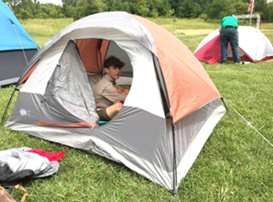

Why should you send someone to NYLT?

Sending Scouts to NYLT helps them develop their leadership potential. This results in a smoother running unit. If your Troop or Crew is committed to having a true youth-run unit, your youth leaders need the skills presented in this course.
NYLT builds on and enhances the skills and ideas introduced at the other levels of training. NYLT is not designed to replace the training done by the Scoutmaster/Crew Advisor, it is designed to provide additional leadership skills and enhance the Youth Leader's ability to lead within the troop or crew.
What will the Scout learn?
The Scout will learn the fundamentals of good leadership. These include the skills of motivating people and getting the job done. They are presented in a form that encourages the Scout to practice these skills as they are learned. The Scout will learn the importance of forming a group into a unit that is working together because they want to. The tools of communications, identifying and using resources, representing the group and dealing with problems will all be presented. Your Scout will have an opportunity to practice these skills while learning the kinds of results they can bring. The skills related to planning, effective teaching, and sharing leadership also will be presented. These tools are the ones that will get the job done. Scouts are challenged through various Patrol activities to provide practical, hands on, experience in the use of these skills. The Scout leaves with a "Leadership Toolkit" to aid them in applying his/her newly acquired skills back in the Troop/Crew.

Course Schedule Overview
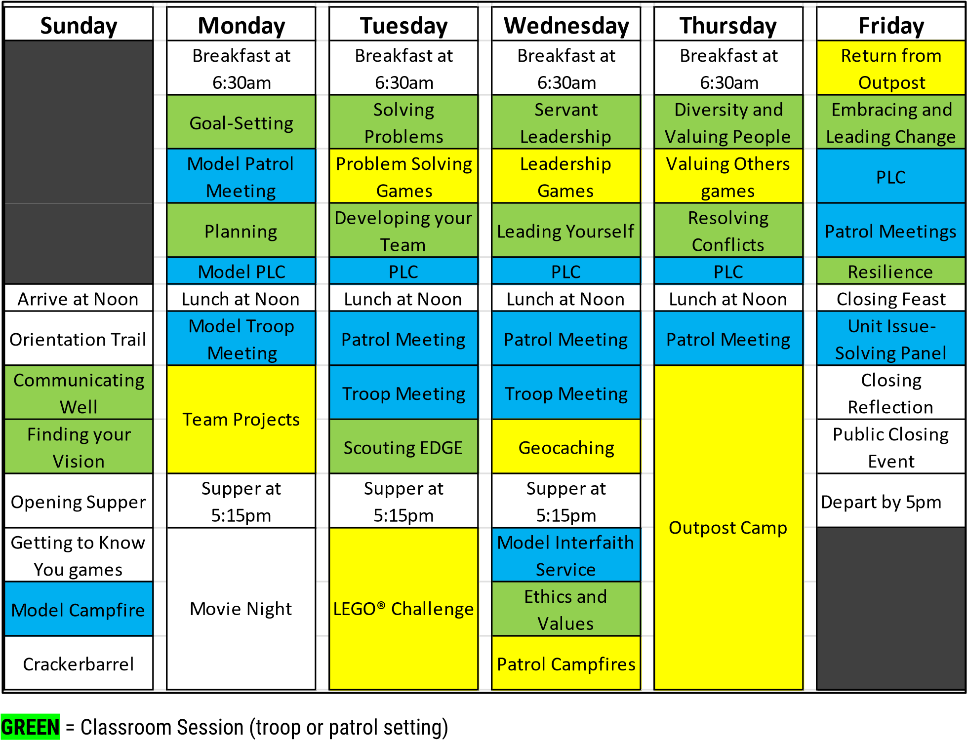
BLUE = Model Troop Experiences
YELLOW = Practical Experience
Note: This is a rough schedule for promotion purposes only.

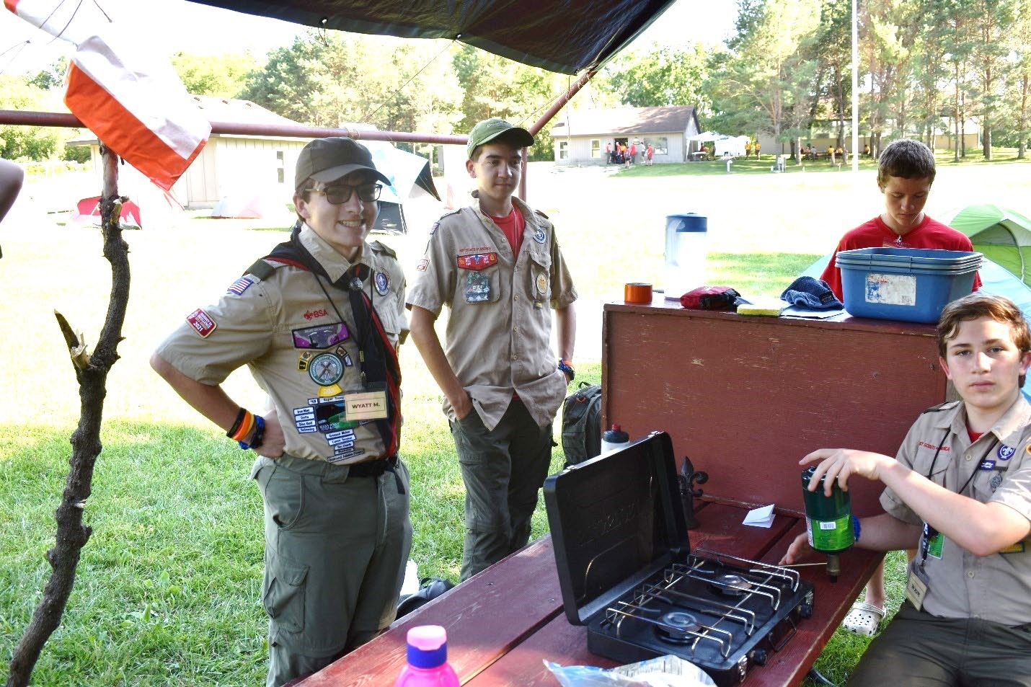

NYLT Leadership Team
The NYLT staff and participants model a well-organized and led troop, with all members filling necessary roles for the function of the troop. Youth are primary leaders, while adults help handle logistics and coaching as necessary.

Questions? Call Pia Sachs-Donerkiel, GMC 2023 Course Director at 802-318-5767

Health and Medical

Dietary Restrictions
We are able to accommodate necessary dietary restrictions given adequate warning (30 days minimum).

Annual Health and Medical Record (AHMR)
The BSA Annual Health and Medical Record MUST be completed in full (parts A, B, and C) before the course. Participants arriving without this form will be turned away and not allowed to participate. This is kept on file with the ASM – Health and Safety through the week and returned to the participants at the end of the week.
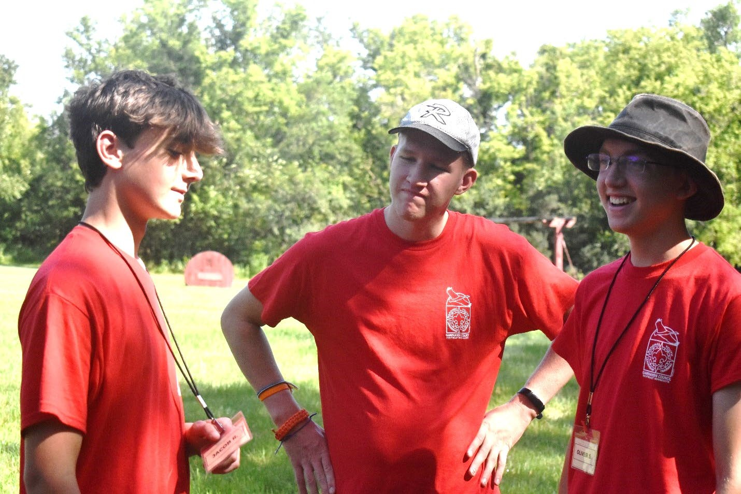

Packing List

Daily Uniform
NYLT is a uniformed event. Participants wear the full Field Uniform (“Class A”) or the provided activity uniform at alternating points throughout every day, as modelled by the youth staff.
FIELD UNIFORM (“Class A”)  - Tan Field Uniform Shirt with all appropriate patches  - Nametag (provided)  - Pencil / Pen  - Water Bottle  - Scout Pants / Shorts / Skirt / Skort  - Closed-toed shoes  Gear Packing List  - Sleeping Bag & Sleeping Pad  - Tent (each scout tents on their own)  - Backpack for Carrying Gear  - Flashlight or Lantern  - Small Pocket Knife  - Extra Pens / Pencils  - Portable / folding chair | ACTIVITY UNIFORM (“Class B”)  - NYLT T-Shirt (1 provided)  - Water Bottle  - Scout Pants / Shorts / Skirt / Skort  - Closed-toed shoes  Additional Clothing and Personal Items  - Rain suit or poncho  - Underwear (1/day)  - Light jacket or sweatshirt  - Sleeping clothes  - 2+ pairs of scout pants / shorts / skirts / skorts  - Socks  - Towel, Shower Shoes and Toiletries  - Insect Repellant and Sunscreen  - Watch

- All participants must hike their sleeping gear, tents, etc., to “Outpost Camp”.
- Aerosols are not allowed at camp
- Phones, while allowed for emergency reasons, are to be kept “off” while at NYLT and may be confiscated if being used for lighting or entertainment.

NYLT Code of Conduct
Failure to follow the NYLT Code of Conduct will result in disciplinary action up to and including removal from the course with no option for refund.

NYLT Is a Special Place
We expect all staff and attendees to help support, protect and keep it that way! We work to create a safe haven at NYLT, a place where everyone feels physically safe and emotionally secure. We do this in a number of ways, but it all starts with the Scout Oath and Scout Law, rules we all know. We set the example for ourselves and others by always behaving as Scouts should.
- We live the Scout Oath and Scout Law each moment of the day.
- We have a Zero Tolerance policy of any kind of inappropriate behavior, including put downs, name calling, or physical aggression.
- We communicate our acceptance of each other through expression of concern and by showing our appreciation whenever possible.
- We create an environment based on respect, learning and fun. We seek the best from others and ourselves, and we do our best to help everyone achieve their best.
- The buddy system is always required, except where privacy is expected, such as in bathrooms, showers, and tents.

Harassment and Discrimination
It is our responsibility to report instances of discrimination or harassment (directed at ourselves or another person) to the NYLT Course Director, or any adult on the NYLT course.
Everyone has the right to live and study in an environment free from discrimination or harassment based on race, color, ethnicity, religion, gender identity, sexual orientation, age, disability, national origin, or citizenship.
Prohibited / Offensive comments and conduct include the following:
- Using vulgar language.
- Threatening another participant or staff member or making derogatory comments.
- Mocking or telling jokes based on race, color, ethnicity, religion, gender, sexual
orientation, age, disability, national origin, or citizenship.
- Displaying degrading photographs, posters or objects.
- Reading out loud about degrading acts.
- Touching (e.g., brushing, patting, hugging, rubbing, pinching) other staff members or
participants.
- Staring or leering at participants or staff members.

On the first day, all participants will be asked to agree to this code of conduct.

