LEADERSHIP APPLICATION

In keeping with the policy of the BSA, the Caddo Area Council will recruit the best available leadership to accompany each Troop, Patrol, or Crew that participates in Council High Adventure activities. Co-ed Crews must have co-ed adult leadership. Adult leaders must be registered members of the BSA.

THE FOLLOWING GUIDELINES APPLY TO ALL GROUPS:
- Each crew or group must have at least two adult advisors, one advisor must be at least 21 years of age, the second advisor must be at least 18 years of age.
- A co-ed crew must have at least one male advisor and at least one female advisor, each of whom must be 21 years of age.
- Each group is required to have more youth participants than adult participants.
- Leasers should be able to serve as a role model of physical fitness.
- All leasers must comply with the height and weight guidelines as prescribed by the activity.
- Leasers must participate in training as prescribed by the Council. (Leaders Meetings, Shakedowns, First Aid & CPR certification, Wilderness First Aid, ect.)
- Leaders are expected to participate in the recruitment of youth for the High Adventure activity.
- Each Leader is Expected to reflect high moral standards established by custom, traditional values, religious teaching, and follow youth protection guidelines.

LEADERS NAME____________________________________ TROOP/VENTURE#___________________
ADDRESS_____________________________CITY___________________________STATE____________ ZIP________________ E-MAIL ADDRESS____________________________________________________
PRIMARY PHONE________________________ ALTERNATE PHONE_______________________________
BIRTH DATE______________________ AGE___________ WEIGHT___________ HEIGHT___________
SCOUTING POSITIONS HELD______________________________________________________________
ALLERGIES______________________________ DIETARY RESTRICTIONS__________________________
NUMBER OF TREKS_____________________ RELIGIOUS PREFERENCE__________________________

List experiences you have had in planning and caring out Scouting activities. _______________________
_____________________________________________________________________________________

If selected for one of the leadership positions I agree to participate in all training and leadership meetings as required by the Council.
Signed_____________________________________________ Date______________________________

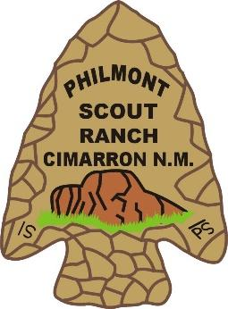
DATE OF 2023 PHILMONT TREK: Dates: July 8th to July 20th, 2023

RESERVATIONS: Reservations can be made by completing this application and returning it to the Caddo Area Council with a $150.00 Deposit. Deposits are non-refundable.

