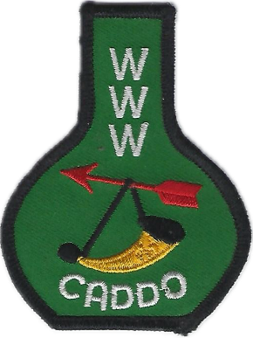
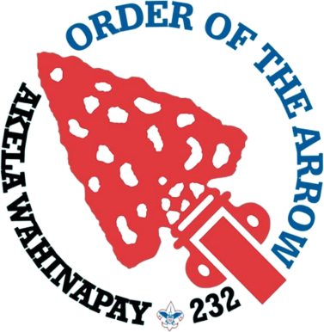
Akela Wahinapay Lodge 232
2026 Spring Arrowee Schedule

Friday, May 1, 2026
7:00 - 8:00pm | Check in | @ Dining Hall
8:15 - 9:00pm | Pre-Ordeal Ceremony | @ Adirondacks
9:15pm – 10:30 pm | Cracker Barrel & Cornhole | @ Dining Hall
11:00 pm | Lights Out

Saturday, May 2, 2026
8:00 am – 9:00 am | Breakfast | @ Dining Hall
9:00 am – 11:30 am | Work Crews
11:40 am – 12:30 am | Lunch | @ Dining Hall
12:30 pm – 1:00 pm | Brotherhood Testing Free Time | @ Dining Hall  @ Main Area
1:00 pm – 4:00 pm | Work Crews
4:15pm – 4:30pm | Brotherhood callout | @ CS Archery Range
4:45 pm – 5:30 pm | Brotherhood Ceremony | @ Brotherhood ring
5:45 pm – 6:30 pm | Ordeal Ceremony | @ Ordeal Ring
6:45 pm – 7:15 pm | Supper | @ Dining Hall
7:30 pm | Check Out | @Dining Hall

