Caddo Area Council
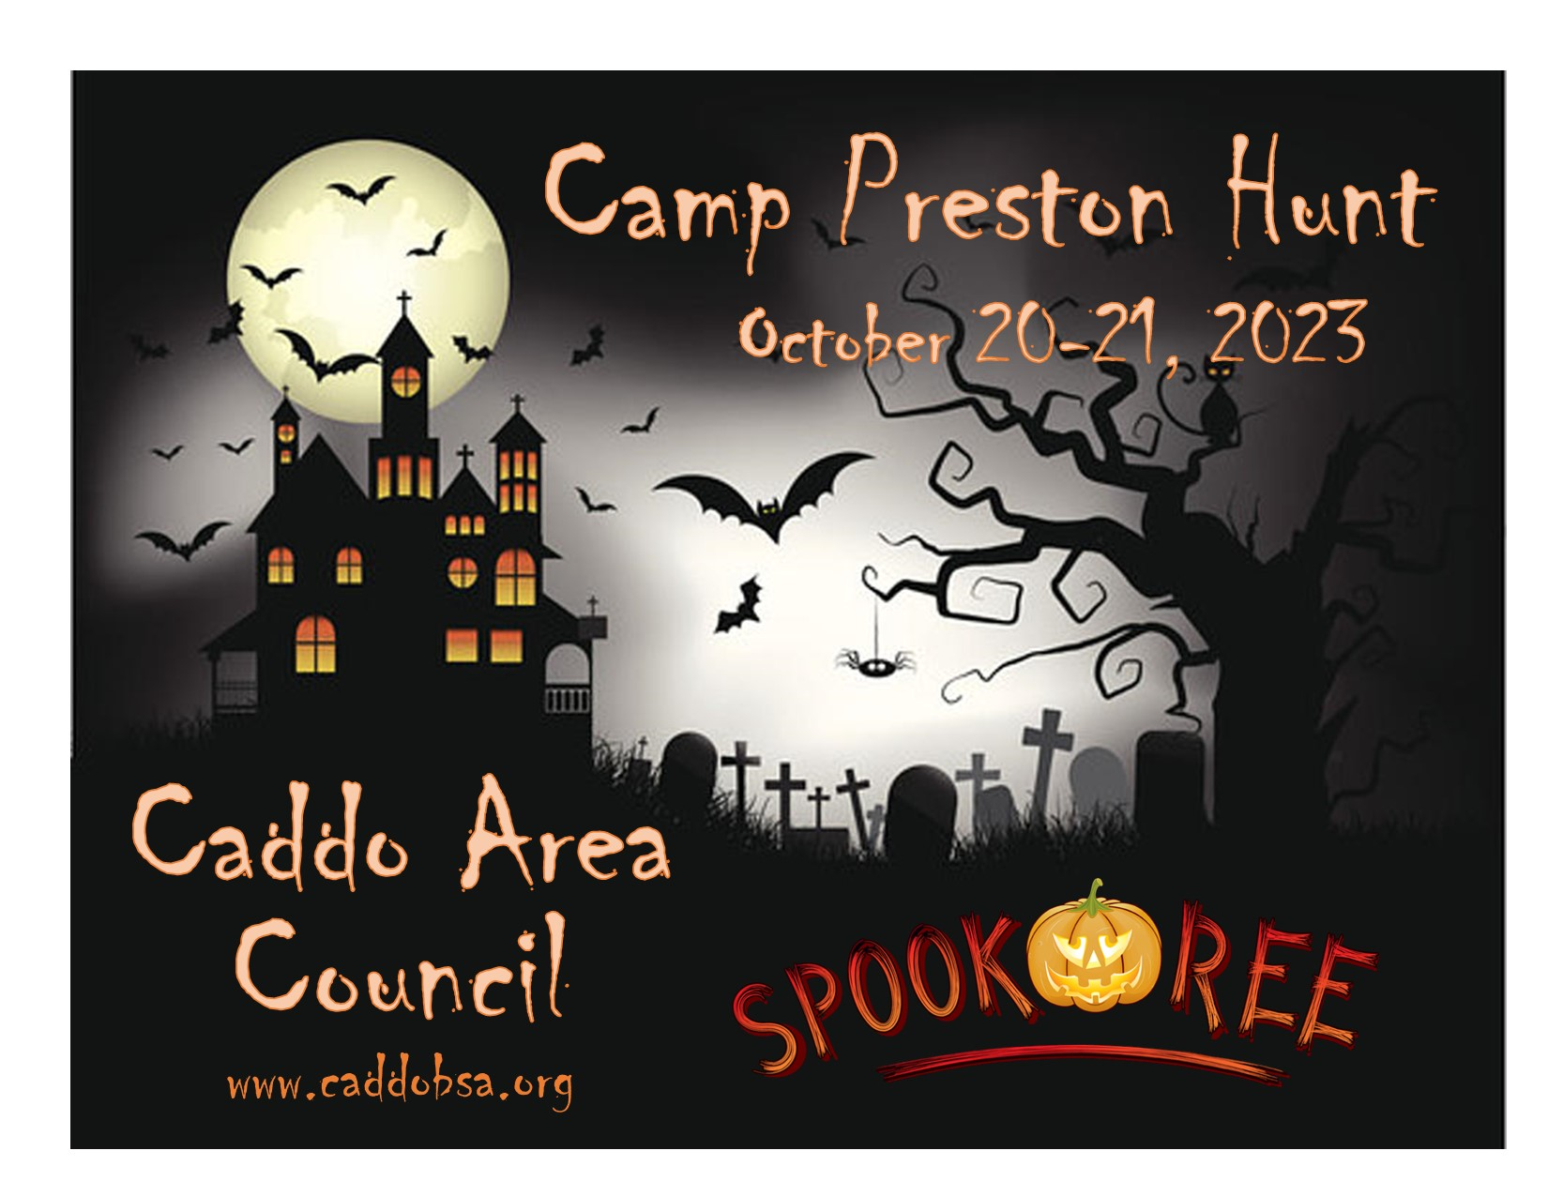

Leaders’ and Parents’ Guide

Spook-O-Ree Pack Camp Out
Contents

- Cost and Registration
2. Who can Attend
3. What to Expect
4. REMIND Notifications
5. Meals
6. Behavior
7. Camp Safety and Health Care
7.2. Health Forms
8. Vehicle Traffic
9. Inclement Weather
10. Service Animals
11. Suggested Camping Packing List
12. Things to leave at home
13. Have Fun!

1. Cost and Registration
- Pre-Registration required! Registration opens on 9/1 through https://www.facebook.com/CaddoBSA and will be done by individuals attending. Please note that space is limited.
- Cost:
  - $45/ person for Friday and Saturday (includes Saturday breakfast and Saturday lunch)
- Last day to register is 10/18/23 at 12 pm. Cubmasters will be emailed with a list of who has registered to attend from their Pack on 10/19. This will be sent to the email address that we have on file. If you think Caddo Area Council might have the incorrect email address, please email the correct one to lonna.johnson@scouting.org
- T-shirts orders must be turned in by 10/12 to ensure you receive a T-shirt. T-shirts might be available but are not promised of you register after 10/12.
- No refunds will be issued if you register but are unable to attend.
- Please make sure that the email address you submit at registration is correct and that it is one that you check on a frequent basis as we will send all relevant information there.

If you have any questions, please contact Lonna Johnson at the Caddo Area Council Office at (903-793-2179) or lonna.johnson@scouting.org

2. Who Can Attend
All registered Cub Scouts can attend. Siblings who are not registered with the BSA cannot attend.

All adults spending the night must have completed Youth Protection Training (available online through www.my.scouting.org). If you have never taken Youth Protection Training before, please complete the certificate and submit it to Lonna Johnson – lonna.johnson@scouting.org. This must be done by 10/19. In-person Youth Protection Training will NOT be offered at the camp. Anyone who has not completed this training will not be allowed to spend the night.

Wolves and up can attend with adult leaders provided from their Pack, one of whom must be over 21 years old – there must be a ratio of one adult for every 4 Cub Scouts and the Pack must have at least two adult leaders always present, even if there are less than 4 scouts attending from the Pack. This will allow them to always maintain two deep leadership. If the Pack does not plan to attend, Wolves and up can attend with a parent or guardian.

Tigers and Lions must attend with an adult partner over the age of 21. They cannot be unaccompanied.

Den Chiefs can attend with the Pack/Den they assist with.

Individual families may also choose to camp out, even if the rest of their Pack is not. Individual youth may not camp on their own. Please select the relevant section when registering.

3. What to Expect

Each group will be assigned a Halloween theme name to identify your group. Each group will go from station to station in multiple Halloween/Scouting themed activities.

Friday Check-In: 5:00 – 6:00 pm
- Check-In will be located at the Camp Office
- Please have your health forms ready to be turned in.

If individuals arrive late, please have them go to the Camp Office between to submit their documents. Upon arrival and no one is at the Camp Office, please text Lonna Johnson at (817)602-4313 to arrange for those individuals to check in.

Events:
- Opening Ceremony
- “Spooky Hayride”
- Visit the Haunted Pirate Ship
- Halloween Games
- Costume Contest
- Cabin Decorating Contest
- Shooting Sports Award: BB Guns, Archery, Slingshots
- Pedal Carts
- Fishing
- Pumpkin Painting

Event’s subject to change!

4. REMIND Notifications
Remind is a free messenger app. During the event will be using it to send out reminders and notifications, as well as posting a copy of the timetable to it, if you want to be able to access a digital copy.

If you do not have the app, it will send you the messages as regular text messages.

If you wish to sign up to receive these messages, text @spookor to 81010.

To leave the group text, text @leave to the message chain.
Your phone number will not be shared with anyone through this service.

5. Meals
Friday night dinner should be eaten prior to or purchased prior to Camp or provided by the unit. Saturday morning breakfast and Saturday lunch will be provided at the camp. All meals are served cafeteria style in the dining hall. The menu has been approved by a registered dietician and the staff works hard so that each meal is timely and tasty. If for any reason a camper, staff member, or adult leader has dietary issues, please let us know by 10/18 who they are, their contact details and their dietary requirements so that suitable meals can be prepared for them. In some cases, please be prepared to work with us, so that we can ensure the meals are suitable.

6. Behavior
We ask that all adults at camp help us in maintaining high standards of personal behavior. If at any time you see a camper, staff member, or adult leader acting in any way that is contrary to the Scout Law, please report them to Camp Director, Camp Ranger, or other member of council staff for action. One warning will be issued and documented and if the behavior does not cease, or further causes for concern arise with the same individual(s), then it will be documented again, and the Cub Scout and any accompanying adults will be asked to leave the camp. No refund will be issued for any individual asked to leave because of their behavior.

7. Camp Safety and Health Care
We have a well-equipped First Aid facility. Emergency procedures are established with the local hospital and ambulance service. All registered scouts are covered under Health and Accident insurance at camp. It is secondary insurance only. Every scout needs to provide a copy of their family insurance card with their physical. All injuries or illness must be reported to the First Aid office.

Closed toe and heeled shoes must always be worn within camp. Sandals may be worn in the showers only.

7.2. Health Forms
All attendees of the camp, whether youth, adults or staff are required to have their BSA Medical form (Part A & B) completed and turned into council at check in. This health form can be found at Any prescription medicine for a youth must be checked in and administered through our medical personnel.

8. Vehicle Traffic
Vehicle traffic in camp will be confined to the Camp Ranger’s Vehicle and those designated for emergency use within Camp Preston Hunt gates. All others must remain parked outside the gates of Camp Preston Hunt. There will be NO access to camp to unload personal vehicles at the camp locations. Instead, there will be a trailer at the main gate to Camp Preston Hunt, where you can place your belongings for them to be transported to your camp site or you can carry your belongings from the parking lot to your tent location.

9. Inclement Weather
Be assured that our greatest concern is the safety of our campers and staff. Should severe weather threaten camp, we will take the appropriate steps to ensure your Cub Scout’s safety. Refunds will not be given for weather unless the council cancels the camp.

10. Service Animals
Service Animals will be allowed with prior notification to the Camp Director and Proper Documentation.

11. Suggested Camping Packing List
- At least one change of clothes, preferably two, in case one gets wet, including underwear and socks, and warm clothing that can be layered for different temperatures.
- Closed toed and closed heeled shoes (not crocs) – sandals may not be worn at camp.
- Rain gear
- Sunscreen and Bug Spray
- Medical Form (required) and Medication
- Pen or Pencil
- Money for the Trading Post
- Tent
- Sleeping bag and other bedding
- Bag for dirty clothes (garbage bag works)
- Towel and Toiletry items,
- Camp chair
- Flashlight
- Costume

Any item that is lost is not the responsibility of the camp staff or camp. Lost and found will be placed in the trading post for the duration of the camp and then moved to the Scout Service Center. If not collected from there, after a month it will be disposed of.

Mark your name in everything!!!!

12. Things to leave at home
- Youths’ cell phones (adults are expected to respect the instructors and other adults and keep use to the minimum)
- electronic games/radio/televisions Knives/matches/candles/liquid fuel
- Pets (except for trained service animals)
- Axes, hatchets, saws, or big knives (no Cub Scout may carry a pocketknife until they have earned the whittling chip card, which they must have on them when carrying a pocketknife).
- Fireworks and liquid fuel are not allowed at Camp. This includes lantern fuel, Propane, and other flammable substances. Fuel powered lanterns are allowed, but the fuel needs to be stored with council staff.
- Illegal drugs, medical marijuana and alcohol are not permitted on the Camp Property or Parking Lot. If found and not removed from Camp Property, the authorities will be notified.
- Personal firearms are not allowed. Please do not bring personal air rifles, bb guns, or archery equipment to camp.

No smoking is allowed on Camp Property. If an adult over the age of 21 needs to smoke, please do so at the verge of Tennessee Road, when no youth can observe you. Please correctly dispose of your cigarette butts. Do not leave them on the ground.

13. Have Fun!

Remember this might be someone’s first time at camp. Teach them the ropes. Help when needed and don’t forget to have FUN!

