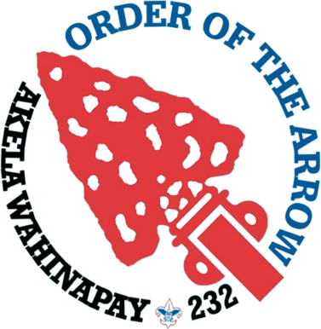
Akela Wahinapay Lodge 232
2023 POW-WOW Schedule

Friday, August 4th, 2023
7:00 - 8:00pm | Check in | @ Dining Hall
8:00 - 8:30pm | Callout Ceremony | @Arrows
9:00pm – 9:45 pm | Pre-Ordeal Ceremony | @ Pre-Ordeal Ring
10:00pm - 11:00pm  11:00 pm | Cracker Barrel  Lights Out | @Dining Hall  @ Designated sleeping areas

Saturday, August 5th, 2023
8:00 am – 9:00 am | Breakfast | @ Dining Hall
9:00 am – 11:30 am | Work Crews
11:40 am – 12:30 am | Lunch | @ Dining Hall
12:30 pm – 1:00 pm | Brotherhood Testing Free Time | @ Dining Hall  @ Main Area
1:00 pm – 3:15 pm | Fellowship | @ Parade Field
3:30 pm – 4:00 pm | Officer Elections | @ Dining Hall
4:20pm - 4:30 pm | Brotherhood Callout | @ CS Archery Range
4:45 pm – 5:30 pm | Brotherhood Ceremony | @ Brotherhood ring
5:45 pm – 6:30 pm | Ordeal Ceremony | @ Ordeal Ring
6:45 pm – 7:15 pm | Supper | @ Dining Hall
7:30 pm | Check Out | @Dining Hall

