2026 BSA KLONDIKE
CAMP DALE RESLER
LEADERS GUIDE
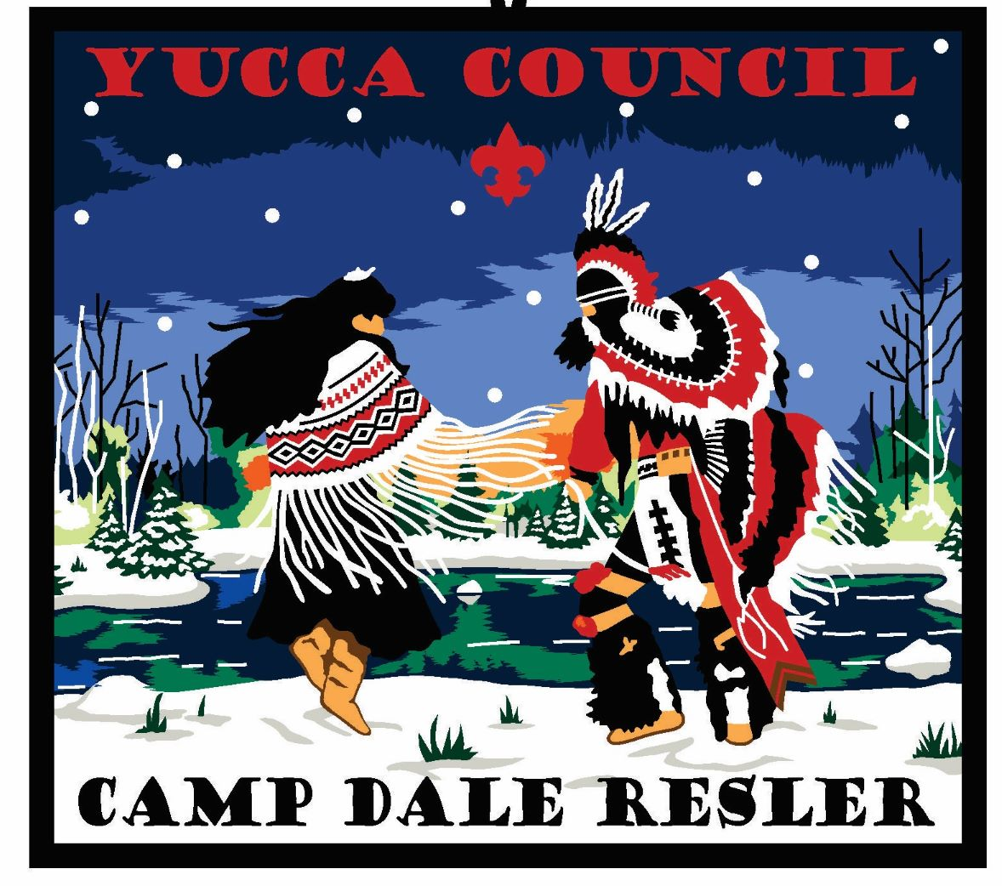

PLEASE READ AND REVIEW WITH ALL MEMBERS BEFORE ATTENDING KLONDIKE

Details

The 2026 BSA Klondike Derby will entail a series of challenges/quests that each Patrol of Scouts will need to complete. Each station will be awarded points based on how well each team performs the assigned task, which will also include aspects of leadership, teamwork, and Scout Spirit. Each patrol will be given a map with an assigned route to their stations that must be completed in the specified order. In order for each team of Scouts to pass the tests they must rely on their leadership, teamwork, Scout Spirit, Scout skills, their sled and equipment.

NO UNIT ADULT is to be with a patrol on the trail or to coach, help or otherwise assist any Scout or Patrol while that Scout or Patrol is involved with Derby competition (This rule will be waived by the Klondike Marshall for special needs Scouts on a case-by-case scenario). All leaders and spectators will remain in the areas designated for them by the Marshall of the camp.

WEATHER

Winter weather will be a challenge and concern for Scouts during the Klondike. As seen from past BSA Klondike Derby's, temperatures average from +18 to +42 degrees, with an average snowfall of 14 inches. The weather can include snow, rain, sleet, or sunshine, sometimes all in the same day. Scouts (and Scouters) must be appropriately dressed for the weather, or THEY WILL NOT BE AALLOWED TO PARTICIPATE. That means long underwear, hats and gloves, wool or synthetic socks, boots {NOT sneakers), and layers of outerwear. COTTON IS NOT YOUR FRIEND and should not be worn. Rain gear (raincoat, poncho, etc.) must be carried or be available for each Scout on the sled or in daypacks.
SCHEDULE

The Klondike registration will open Saturday at 8:00 am and close 8:45am. Please ensure you arrive with enough time to not interfere with opening ceremonies. Opening Ceremony will begin at 8:50am with actual BSA Klondike Derby to start at 9:00am. Each Patrol will start at the Lodge and then continue to their assigned station. Units camping should plan on departing no later than 9am on Sunday morning.

SLED CHECK-IN

Each Scout BSA Patrol Leader will be responsible for presenting instructions to his/her group on preventing hypothermia. It is also recommended that a leader assigns an "Observer'' within his/her group to keep track of everyone's health, and make sure each scout is prepared for the weather and is able to continue participating throughout the Klondike. Information on hypothermia has been included in this packet as a reference for your convenience.

In the event of severe weather, an e-mail will be used to notify Unit Leaders of the postponement (or cancellation) of the Klondike. All cancellations will also be posted on 2024 Yucca Council BSA Klondike Derby registration page or via e-mail from the BSA Klondike Derby Committee

STATIONS

ALL PATROLS WILL START AT FLAG POLE. THESE ARE THE STATIONS AND THE ORDER WILL BE RANDOM DEPENDING ON THE TRAIL PROVIDED. ALL PATROLS WILL COMPLETE 6 STATIONS. STATIONS WILL VARY!

Station # 1 “Get them off the Mountain!” Skills: Pioneering

Station # 2 ”Will it snow?” Skills: Survival

Station # 3 “Bring on the heat” Skills: Wood Cutting

Station # 4 “To the left. To the right…” Skills: Woodwork.

Station #5 “Home home on the range” Skills: Communication

2026 BSA Klondike Derby (Information)

The Unit is responsible for its’ meals. You must bring your own water!!!!!

The Unit is responsible for the well being of it’s youth and adults. Under no circumstances will non-registered adults, siblings of participants and animals be allowed. They will be asked to leave the camp.

Do not forget your ten essentials.

Warm beverages available also On the porch.

Please remember we are attending to have fun and that this event is run by youth for youth.

Remember that a p pro priate Scout S pirit is courteous, kind, friendl y and includes
s portsmanship and positive team su pport.

Schedule on the day is subject to change

Sled Equipment List

Other than your personal gear or any other items that you may want to carry on your Patrol's sled, the following items are mandatory and must be on your sled (or person) during the initial Sled Inspection at the start, throughout, and at the finish of the BSA Klondike Derby:

EACH PATROL SHOULD BRING THE FOLLOWING:
- Patrol Flag
- 50 or 100' length of paracord
- Each scout should bring a mug/ cup (for hot cocoa). Snacks.
- Rain Gear (raincoat, poncho, etc.)
- Fire starting materials (matches, lighters, lint, shavings, tinder, fatwood, etc.)
- Personal first aid kit.
- Scout Handbook
- One Totin' chit
- One Firem'n's chit
- Water- 1 quart for each scout in Patrol
- Sled w/tow-ropes
Proper footwear and clothing
- Gallon zip-lock bag
- Garbage bag for trash and discarded items during the competition

Special Instructions

1. All Units must pre-register at 2026 High Desert Council BSA Klondike Derby in order to receive a 2026 BSA Klondike Derby Patch.

2. AIl Patrols should arrive at least 1 hour before the start time on Saturday Morning. Only the Patrol Leader will check-in at Headquarters. At the check-in, each sled team and Crew will be given a set of instructions, a map of the course
and events. All events must be completed in the assigned order, shown in
the instructions. Registered Scouts & AOLS participate only.

3. No registrations will be accepted on the day of the event. No exceptions.

4. All trash must be packed out, including trash generated on the trail. Each Patrol must bring at least one heavy-duty garbage bag and use it.

5. 1st, 2nd, and 3rd place (as measured by total points) will be awarded. Bonus Points will be awarded to the fastest sled team competing in the sled race. Our plan is to present all ribbons at the conclusion of the day's events; approximately 5pm or so.

6. No drugs, vaping, smoking or alcohol permitted at a BSA event. No exceptions.

7. The First aid station will be at the Lodge. Please report all injuries to the station leader.

8. In the event of severe weather, requiring postponement or cancellation of the Klondike, Unit Leaders will be contacted by e-mail from the BSA Klondike Derby Committee.

9. Proper Footwear and Clothing: Scouts who are not appropriately dressed for the weather will not be permitted to participate. That means warm boots, long pants, heavy jacket, gloves, hat, and rain gear. Remember cotton is not your friend. Troop Leaders are responsible to police their patrols before they are sent out to participate with the Klondike. We suggest communicating to parents early to make sure the scouts are properly prepared. Most important, please make sure that all scouts have two pairs of gloves in the event of snow.

10. Leave-No-Trace: All trash must be carried out by each unit.

11. Two blasts of the air horn will be sounded for the beginning of lunch.

Winter Activity Safety
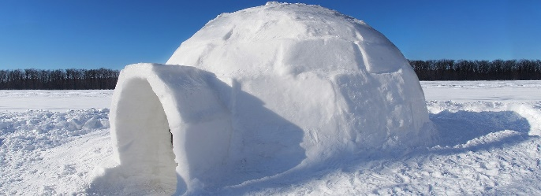
- SUMMARY
There is magic to camping in winter. It is one of the most challenging outdoor adventures. However, potentially extreme weather conditions, cold temperatures, and unique hazards associated with outdoor winter activities require careful planning to ensure safety.
- GENERAL INFORMATION
Eating the right type of food when camping or playing in the cold is important.
One of the best ways to remember what is appropriate to eat when you are spending extended periods of time outside in cold weather is to use good nutrition to build the fire within. Make sure your food consumption includes sugars, which act like a fire starter; carbohydrates and proteins, which act as kindling; and fats that produce the energy needed to keep the fire burning and your body running at peak performance. Stay away from caffeinated drinks such as soda, coffee, and tea; drink plenty of plain water to keep yourself properly hydrated.
Keeping warm is the most important part of cold-weather camping and outdoor activities. Use the “C-O-L-D” method to stay warm.
- C=Clean: Since insulation is only effective when heat is trapped by dead air spaces, keep your insulating layers clean and fluffy. Dirt, grime, and perspiration can mat down those air spaces and reduce the warmth of a garment.
- O=Overheating: Avoid overheating by adjusting the layers of your clothing to meet the outside temperature and the exertions of your activities. Stay hydrated by drinking plenty of water, and refrain from drinking caffeinated drinks that act as diuretics.
- L=Loose layers: A steady flow of warm blood is essential to keeping all parts of your body heated. Wear several loosely fitting layers of clothing and footgear that will allow maximum insulation without impeding your circulation. Having clothing that is brightly colored (orange or red) is also a good idea, so hunters and sportsmen can see you in snowy conditions. Always have a hat and wear it.
- D=Dry: Sweaty, damp clothing and skin can cause your body to cool quickly, possibly leading to frostnip and hypothermia. Keep dry by avoiding clothes that absorb moisture. Always brush away snow on your clothes before you enter a heated area. Keep clothing around your neck loosened so that body heat and moisture can escape instead of soaking through your layers.

- Hypothermia
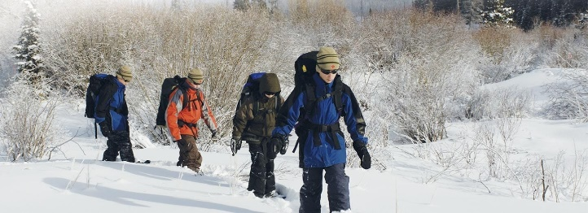
- SUMMARY
Hypothermia is an abnormally low body temperature that is dangerous and potentially fatal if not properly cared for. Hypothermia most often occurs when individuals are exposed to extremely cold temperatures for extended periods of time. However, it can also occur in warmer environments in situations such as wearing wet clothing in windy conditions, becoming chilled from being in the rain for an extended period, or being submersed in cold water. Planning is essential before a trek or outing to make sure you are prepared for possible changes in environmental conditions.
- GENERAL INFORMATION
Hypothermia occurs when the body loses heat faster than it can be generated. Once the body temperature begins to drop, the heart, brain, and other organs start losing their ability to function properly. Left untreated, these vital organs will begin to fail, eventually leading to death. A person experiencing hypothermia often isn’t aware of their condition because the onset is gradual and, as hypothermia progresses, they become confused and agitated.
To prevent hypothermia, be aware of your environment and dress accordingly. Cover as much exposed skin surface as possible to help prevent heat loss. Avoid activities and clothing that will cause you to sweat a lot. The combination of wet clothing and cold temperatures will cause additional heat loss. Wear multiple layers and stay dry.
Signs/Symptoms of Hypothermia
- Feeling cold, shivering uncontrollably
- Cool or cold skin on the abdomen, chest, or back
- Presence of the “umbles”
  - Stumbles: loss of control over movement
  - Mumbles: slurred or incoherent speech
  - Fumbles: poor coordination or reaction time
  - Grumbles: change in behavior or attitude
- Fatigue
As hypothermia progresses, the person will exhibit:
- Stiff muscles
- No shivering
- Skin that feels ice-cold and may appear bluish
- Confusion, agitation, memory loss
- Slow, weak pulse
- Slow, shallow breathing
- Loss of consciousness

The Risk Factors
- Exhaustion
- Victims who are very young or old; the body’s thermoregulation is not at its peak.
- Alcohol or drug use
- Certain medical conditions and medications can affect one’s ability to regulate body temperature.
- Cold, damp weather conditions

Care of Hypothermia
- Get the victim out of the cold.
- Remove wet clothing and wrap them up in warm, dry clothes. Add additional layers such as a sleeping bag, blankets, or some form of plastic to hold in body heat.
- If the victim is conscious and able to swallow, offer warm liquids to drink. Do not give alcoholic drinks.
- Handle them gently. Excessive movements or rough handling can lead to cardiac arrest.
- Apply warm, dry compresses to the neck, chest, and groin areas. Do not apply heat to the arms or legs, because this speeds cold blood back to the heart, lungs, and brain, causing the core temperature to drop even lower; this can be fatal.
- Do not apply direct heat as with hot water bottles, a heating pad, or a heating lamp. This extreme heat can cause skin damage, an irregular heart rhythm, or even cardiac arrest.
- If a person with severe hypothermia who is unconscious seems to not have a pulse or not be breathing, perform CPR. CPR should continue during rewarming. Sometimes, people experiencing hypothermia can be successfully resuscitated.
- Get emergency care/call 911.

- Frostbite
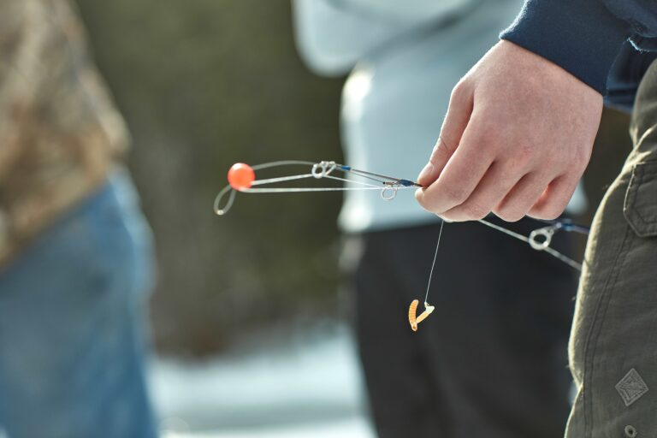
- SUMMARY
Serious injuries can occur when it’s cold and you spend time working, playing, or sleeping outside, particularly if you are wet or your clothes are wet or too tight. Scouts should be instructed to inform an adult as soon as possible if they are at an event, winter camp, or troop campout and start experiencing any of the symptoms in this Safety Moment.
- GENERAL INFORMATION
There are four degrees of severity from the cold, ranging from frost nip to frostbite. The extent of the injury will depend on the individual’s length of exposure, outside temperature, wind chill, and how the exposure is treated. Listed below from the University of Utah Health Burn Center* are frostbite severities and descriptions of the identification and severity of injury, characteristics, prevention, and treatment guidelines.
Identification
- First-degree frost nip (superficial)—Limited damage to skin, may be painful with no immediate blistering. Wounds will look like a central white area surrounded by pink skin, followed by mild swelling. Immediately remove yourself or someone with these symptoms from the cold and change clothing if needed. Soak the affected area in warm water or use body heat to provide warmth.
- Second-degree frostbite (superficial)—This degree affects both the top layer of your skin and slightly deeper into your tissue. Signs are pink and moist tissue present beneath clear blisters, usually surrounded by redness and swelling. Be sure not to rub the affected area because friction may cause more damage to your skin. Take care not to damage the blisters because they are protecting the tissue underneath. Rewarming must begin immediately followed by professional medical care.
- Third- or fourth-degree frostbite (deep)—These degrees of frostbite are dangerous and can lead to damage in muscles, tendons, and bones (fourth degree). Skin feels frozen and hard and appears red, purple, or even black. If left untreated, a development of thick, black, dead tissue over one to two weeks will follow. Rewarming in this condition will induce critical pain.

Prevention and Treatment
- Be prepared: Pack warm clothes and change them frequently, or as needed. At the first signs of redness or pain in any skin area, get out of the cold or protect any exposed skin—frostbite may be beginning.
- Act quickly: Frostbite treatment needs to be addressed immediately. The most dangerous situations may occur hours away from a medical professional’s help. The first line of treatment is wearing appropriate clothing. Finding shelter to get out of the elements is necessary as well. Eating can also aid in elevating body temperature.
- Prevention is key: Layering clothing, socks, gloves, scarves, and hats will help prevent frostbite, while removing layers can help to prevent excess sweating. Change clothing immediately if it becomes wet, including any base layers due to perspiration. Your base layer of clothing should fit loosely enough to allow full blood flow, which is necessary for warmth, and the air space between layers of clothing provides additional insulation against the elements such as cotton and wool material.
- If anyone experiences or displays any symptoms of second-, third-, or fourth-degree frostbite, go to the nearest health-care facility immediately. For optimum results, injuries should be examined by a doctor as soon as possible.

Weather-Related Safety

- SUMMARY
Robert Baden-Powell once said the definition of the Scout motto Be Prepared is this: “A Scout must prepare himself by previous thinking out and practicing how to act on any accident or emergency so that he is never taken by surprise.” Baden-Powell also advocated that young men spend a lot of time learning in and about the out-of-doors, as he said, “The open-air is the real objective of Scouting and the key to its success.” However, we still need to be aware of our surroundings and their changing conditions, including what is happening with the weather.
- GENERAL INFORMATION
Severe weather hazards, such as tornadoes, lightning, hail, flash flooding, and downbursts, can be dangerous. Each requires a basic understanding of what to do so that you can protect yourself and your Scouts. The scale of weather conditions can seem daunting—ranging from high heat with no humidity to torrential downpours with possible flooding. However, some key basic principles can help everyone prepare. Here are a few for you to consider:
- Know the weather forecast before you set out on your trip.
- Prepare for the types of weather hazards that are associated with your destination, such as tornadoes, lightning, snow, torrential rains, and high winds. The BSA’s online Weather Hazards training (available through My.Scouting.org) is a great resource in this area and should be renewed every two years.
- Double-check weather conditions immediately upon arrival to verify forecasts.
- The weather can be integral in becoming lost or injured. If visibility becomes limited, respond quickly to gather the Scouts in your care.
- Inquire about the location of any designated emergency shelters in the area.
You may never encounter a severe weather hazard. Your chances of being hit by lightning in your lifetime are 1 in 700,000, and the chances of your home being destroyed by a tornado (if you live in tornado alley) are 1 in 150,000. By learning and following these key principles, you can move forward with confidence and provide every opportunity to your Scouts to participate in Baden-Powell’s outdoor laboratory.

Insulating layers
When it comes to insulation, most hikers have at least one synthetic pile or fleece article of clothing. Fleece pullovers, vests, zip-up jackets, and pants are available in a variety of weights, measured usually between 100 and 300. The higher the number, the heavier-and warmer-the jacket.
The lightest is 100-weight, useful in pullovers and middle layers as vests, or as an outer layer in warm temperatures. A good all-around choice is 200-weight fleece, because it can be used as either a heavier pullover or a jacket. A 300-weight fleece jacket is so warm that you would use it more often in camp or during rest breaks than while working up a sweat on the trail.

Microfleece jackets have a tighter weave and block wind better, and pile has a rougher texture and tends to be warmer and bulkier.
Some manufacturers have added other features to their fabrics, like stretchy, form-fitting microfiber or water-repellent treatments. For example, a new 300-weight fleece that features a durable, water-repellent finish, making it useful as an outer layer in light rain conditions. Two- way pit zippers allow excess heat to escape. And don't forget about your legs: While most hikers don't hike in fleece during the day, fleece pants can be cozy on cold evenings. You'll also use fleece for hats, mittens-and even socks for camp wear.

Insulating fills
Another way to stay warm is with a jacket filled with down or some other insulating fill. Following the layering principle, you don't want one of those heavy-duty jackets that could practically double as a sleeping bag. Instead, have a lightweight jacket that can be part of a layering system.
While down is highly compressible and extremely warm, it does not insulate when wet. Down works better in snow, that can be brushed off. If you're unsure of whether to expect rain or snow, you might opt for synthetic fill instead.

