Yucca Council Boy Scouts of America

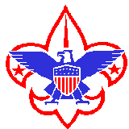

CUB SCOUT KLONDIKE DERBY

WHITE SANDS NATIONAL PARK

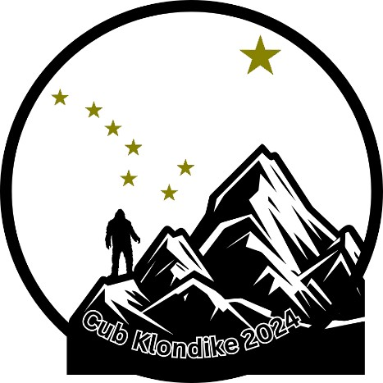

For more information contact the Yucca Council Service Center at 915-772-2292 or visit www.yuccabsa.org
Email: charlestspencer@gmail.com or sarah.davis@scouting.org

Yucca Council Boy Scouts of America

General Information

What is it? | Yucca Council invites all Arrow of Light, Webelos, Bears, Wolves, Tiger, and Lion Scouts to come out to the White Sands National Park and join us in a day of fun in the ‘snow’. Families are highly encouraged to attend. Pair you dens with scouts from your local troops to help out and guide the cubs through their adventures in the Klondike of New Mexico.
Where? | White Sands National Park (19955 U.S. 70 Alamogordo, NM 88310) at the large group site (See map)
Cost? | Registration fee is $10.00 per Scout (by 2/17) and $5.00 for additional patches.
$7.00-$8.00 for food provided by our OA Scouts.
Registration MUST be received

NATIONAL PARK SERVICE REGULATIONS PROHIBIT ACCEPTANCE OF ANY PAYMENTS OR REGISTRATION AT THE EVENT – THIS INCLUDES LUNCH PAYMENTS.

THE NATIONAL PARK ENTRY FEE IS AN ADDITIONAL FEE PAID AT PARK ENTRANCE.

Current fee for National Park Entry Fee is $25.00 per vehicle, payable at the main entrance.

Check-In? 8:00 A.M. Check-in at Roadrunner and Primrose picnic area.

Refunds? Refunds are not available but can be transferred to another Scout or leader for this event only.

Concessions? The Order of the Arrow Gila Lodge will be providing hamburgers or hot dogs, chips, and drinks at the Roadkill Café. Meals are $8 for hamburger meal and $7 for hot dog meal, money transactions will not be allowed, meals must be bought beforehand at registration via www.yuccabsa.org. Meal tickets will be distributed at check-in.
Grills? | Charcoal and gas grills can be used for lunch. Bring your own grill or use the park’s grills. Please do not leave used charcoal in the grills or throw charcoal into trash containers. Take used charcoal home with you.
Parking? | Ample parking is available, but carpooling is strongly recommended. See map on the next page.
Awards? | 1st, 2nd, and 3rd place awards will be presented for each event.
Access? | White Sands National Park assesses an entrance fee. Please check the following site for up-to-date fees. https://www.nps.gov/whsa/planyourvisit/fees.htm
**Please be advised that the entry fee is separate from the Yucca Council registration fee. **
Insurance? | Liability as well as sickness and Accident Insurance are provided for all registered youth and adult members of the Yucca Council.
Insurance? |  | Program Schedule
8:00 A.M. |  | Check In/Registration
9:00 A.M. |  | Opening Ceremony
9:15 A.M. |  | Water In/Water Out (Hydration and Bathroom Break)
9:30 A.M. |  | Klondike Trails Open-Derby Events BEGINS
12:00 P.M. |  | Klondike Trails Close-Derby Events STOPS
12:00 P.M. |  | Lunch (Fun Area and Sledding OPEN)
1:30 P.M. |  | Webelos Sled Race Begins
 |  | Awards/Presentations immediately after the sled races

*Open sledding and fun events area available in designated area for non-participants during the day (Own Supervision Required) *

All Drivers:
Traffic speed limits are posted throughout for the safety of everyone, especially our Scouts. Park Rangers and Staff will be observing our event and have the authority to stop the event due to unsafe conditions – speeding is an unsafe condition. The speed drops very suddenly when you leave the asphalt onto the packed sand road.

Please Be Careful!

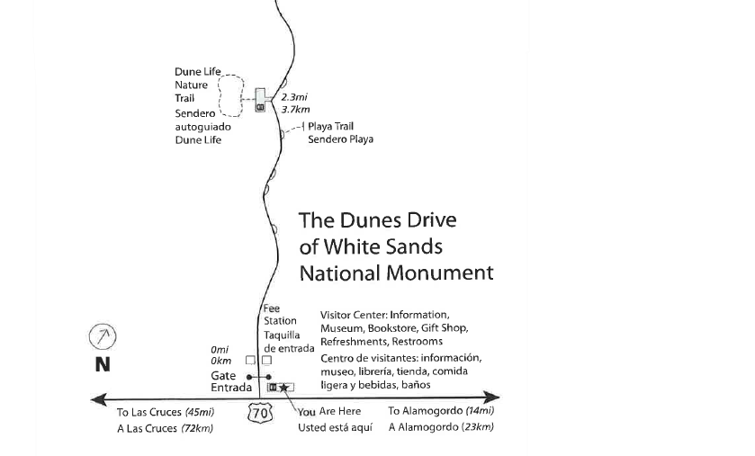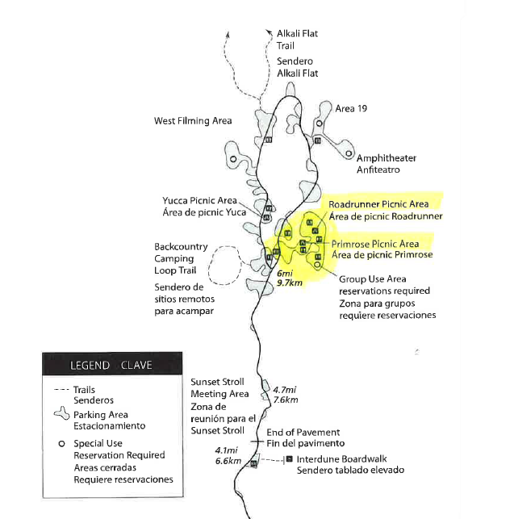

All Cub Scouts and Families
LUNCH - Bring your own lunch or dine at the Order of the Arrow food tent and enjoy delicious hamburgers or hot dogs, drinks and chips. Lunch from the Order of the Arrow MUST be pre-ordered. No payments can be accepted on site by National Park rules. Meal tickets will be distributed at check-in.
Suggested Clothing- Be prepared for wet or dry weather with temperatures ranging from 40 to 70 degrees. The following is a suggested clothing list for cooler weather. Pack Activity Shirt (Non-Scout Uniform) suggested, Field Uniform (Scout Uniform) not Required.
- Cap with ear flaps/toboggan
- Gloves (good for Webelos in sled race)
- Extra pair of pants
- Long underwear or PJs
- Sunglasses
- Sweater or sweatshirt
- Sunscreen & Chap-stick/lip balm
***Layering of clothing is better than a heavy coat. Tennis shoes can be worn. ***
ALL YOUTH, SIBLINGS, PARENTS, GAURDIANS MUST HAVE FILLED OUT HEALTH FORMS A AND B TURNED INTO THE UNIT LEADER PRIOR TO ARRIVAL!!!!!! HEALTH FORMS MUST BE KEPT WITH UNIT LEADER AT ALL TIMES IN CASE OF EMERGENCY.

Lion and Tiger Trail Events
This is a sample of some of the events that may be held.
Remember that all Lions and Tigers Must have an Adult Partner
Three-Legged Snowshoe Race- Lions or Tigers and adult partners race as a team.
Snow Tunnels- Adult Partners direct blindfolded Lions or Tigers through buried hoops.
Snowball Challenge- Lions or Tigers and adult partners throw snowballs (knotted cloth) at targets.
Tiger Sled Race- Adult partners pull their Lions or Tigers on a plastic saucer through a marked course.
Bobcat Gold Rush- Lions or Tigers sift for gold nuggets.
Tiger Log Haul- Lions or Tigers move logs to the top of a hill.

Wolf and Bear Trail Events
This is a sample of some of the events that may be held.
Snow Tunnels- Cubs work their way through a series of buried tires while blindfolded.
Beaver trap- Cubs test their throwing skills by throwing from between their legs (like a football center) trying to snag beavers in traps (beavers, run while you can).
Blizzard- Cubs follow a guide rope through a zigzag course while blindfolded.
Compass work- Cubs use basic compass skills to find a cache of gold nuggets.
Ski Challenge- Cubs used two-man skis to negotiate a marked course.
Golden Staircase- Cubs use skill and teamwork to move supplies to the top of a hill.
First Aid Readyman- Cubs prepare to find and treat injuries.

Webelos Trail Events
This is a sample of some of the events that may be held.
Polar Bear Hunt- (Craftsman): Rations are getting low and your only choice is to follow the tracks in the snow. Your only weapon is a homemade spear. Be careful! You may only have one shot.
Smooshboard Race- Patrol members’ right feet are tied to one long 2 x 4, and their left feet are tied to another 2 x 4. The patrol is timed in walking a marked course.
Crevasse Rescue- (Outdoorsmen and Readyman): One of your patrol members has fallen down an icy crevasse. You descend into the crevasse. Once you have determined the injuries sustained in the fall, use proper first aid to bring your friend out.
Searching for Pay Dirt- (Orienteering): Using a compass, the boys must navigate a course
Crossing the Great Abyss- Working as a team, each patrol must use their imagination and initiative to cross to the other side.
Kiss of the North- (Readyman); Patrols move through three stations to answer questions pertaining to hypothermia. The patrol earns the pieces necessary to build a stretcher and carry a patrol member back to the start.
Great Snow Trek- This event is an obstacle course that requires dodging, crawling, balancing and jumping.

For more information contact the Yucca Council Service Center at 915-772-2292 or visit www.yuccabsa.org

Prior Registration is a Must!!!

Registration forms and funding must be received . Due to National Park regulations, we cannot accept payment or registration on the day of the event.

***Please be advised that the entry fee is separate from the Yucca Council registration fee.***

First 350 registrants are guaranteed event patches.

If a Pack has more Lions/Tigers/Wolves/Bears/Webelos at the time of check-in than were listed on the registration form, they will be added to the Pack’s registration. This is necessary so that the council will know how many units/youth will be in attendance. Scouts not registered by February 16, 2024 may not receive a patch.

The recommended den size is six (6) Scouts for the Cub Scout Klondike Derby. If a den has less than six Scouts, some scouts may have to compete twice at an event. If a den has more than six scouts, the Leaders should ensure that Scouts alternate sitting out on the events equally.

Important Things for Everyone to Remember

Scout spirit, teamwork, den flags, and den yells influence scoring significantly. The more of each the better the den score. No one is likely to have extra clothes or equipment to loan if someone’s clothing gets wet. Take a few precautions before you leave home to stay warm and dry. If anyone has any questions, get answers to those questions before leaving home. Keep an extra set of clothes in the car, just in case, BE PREPARED. Bring a compass to the derby and know how to use it in a general fashion. Please pay attention to the warning signs that you will see along the yellow warning tape. These warnings were placed to protect the environment within the White Sands National Park.

For more information contact the Yucca Council Service Center at 915-772-2292 or visit www.yuccabsa.org

The Sled Race Rules This event is intended for AOL and Webelos dens only
- Each Sled needs to be at the registration point prior to 9:00 am to be inspected.
- Sled runners must only be made of wood. No metal, plastic or fiberglass can be used.
- Each Sled can have up to 5 Sled Dogs in front with 1 pushing. For a total of 6 Sled Dogs.
- Each Sled will have 1 passenger inside the sled.
- Each race will be in a down and back Drag race style.
- Races will be timed; the three fastest times will be declared the winners.
- At the event check-in the morning the pack must say if they are entering the sled race.
- Each pack is encouraged to have their own sled.
- In an effort for everyone to get a chance, packs can team up.
- Judges are volunteers and will do their very best and the Head Judge decision is final.
- Oxygen may not be available after the adult race.
- Scout Law will be followed.

Important Things for Webelos to Remember

For safety concerns, there cannot be any loops in the “pull-rope” on the sled. Scouts cannot place hands through any loop. Pulling grips can be tied, but not large enough for hands to be inserted.

Klondike Sled Plan

This sketch is just a suggestion; use your imagination. One can add colorful decorations and make minor changes as one desires. Runners must be at least 3’’ wide and MUST NOT BE CLAD WITH ANY SORT OF METAL.

For safety reasons, only sleds with wooden runners will be allowed on the trail!!!

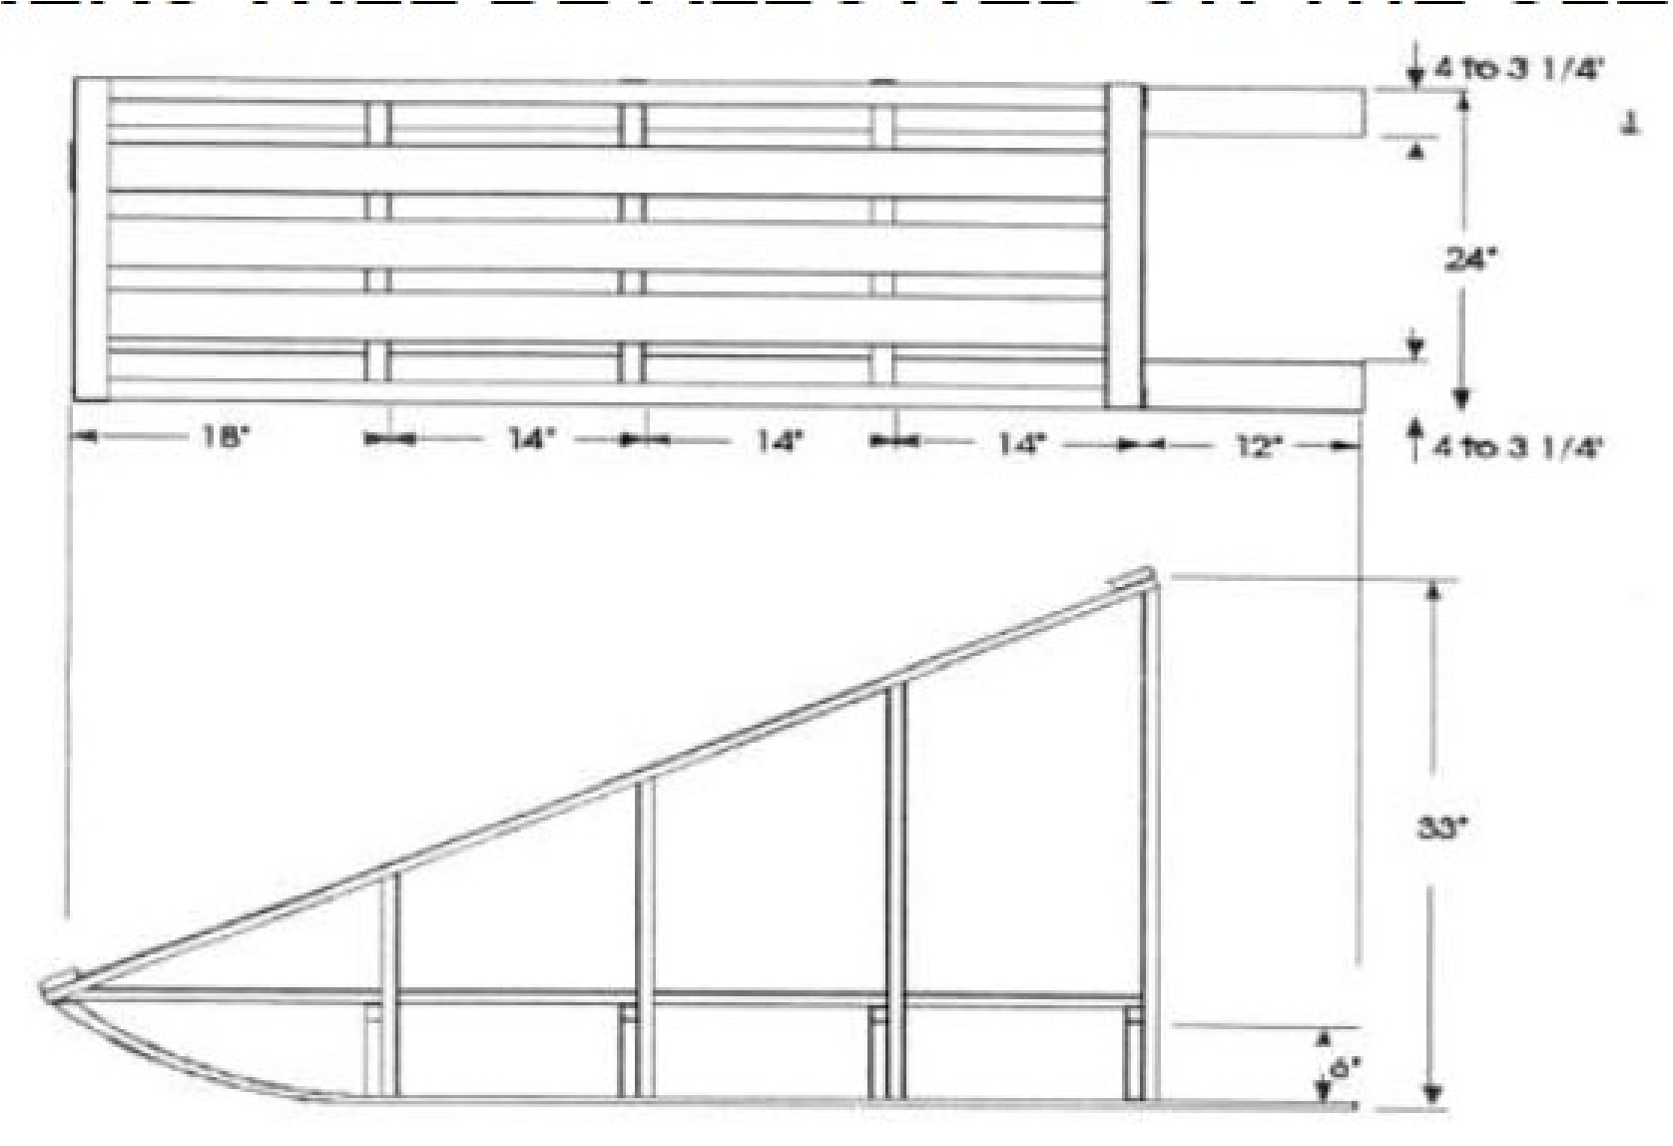

For more information contact the Yucca Council Service Center at 915-772-2292 or visit
www.yuccabsa.org
Bill of Materials

2 pieces 4 in. x ½ in. x 6 ft. Runner
6 pieces 1 in. x 1 in. x 18 in. Cross Supports
4 pieces ½ in. x 4 in. x 5 ft. Floor Cover
8 pieces 1 in. x 2 in. x 6 in. Upright Support
2 pieces 1 in. x 2 in. x 40 in. Rear Upright
2 pieces 1 in. x 2 in. x 38 in. 2nd Rear Upright
2 pieces 1 in. x 2 in. x 26 in. 2nd Front Upright
2 pieces 1 in. x 2 in. x 12 in. Front Upright
2 pieces ½ in. x 2 in. x 6 ft. Hand Rail
1 piece ½ in. x 2 in. x 30 in. Front Curve Guard
1 piece 2 in. x 2 in. x 18 in. Tow Bar

Sled Width: Approximately 24 inches
Sled Length: Approximately 72 inches
Sled Height: Approximately 33 inches

VOLUNTEERS HAVE GRACIOUSLY OFFERED TO OVERSEE EACH EVENT. THEY HAVE BEEN BRIEFED ON THEIR DUTIES AND RESPONSIBILITIES. PLEASE FOLLOW THE SCOUT OATH AND LAW. PLEASE BE RESPECTFUL TO THE VOLUNTEERS

For more information contact the Yucca Council Service Center at 915-772-2292 or visit www.yuccabsa.org

