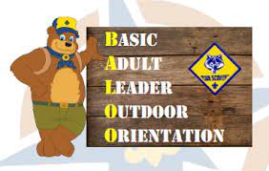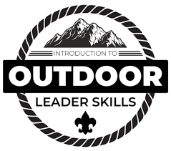
Date: April 29th (Sat) 9 am – 30th (Sun), 2023 11am
Location: Leasburg Dam State Park – Group camping site
Cost: $25 for either course
Registration dateline: April 21st, 2023

You may register online at yuccabsa.org or at the Yucca Council office by phone 915-772-2292 or in person.

“Every scout deserves a trained leader”
For additional questions please contact:
Baloo training - Delbert Humberson at delhumberson@gmail.com or 915-345-9637
IOLS training – Alejandra del Plain at alejandra@delplain.com or 575-202-7466
