Welcome to the University of Scouting 2026
On behalf of Circle Ten Council and the 2026 University of Scouting team, I welcome you to this year’s ultimate Scouting training event at First United Methodist Church Richardson, Texas. Learn new things, discover new ideas. Let’s WinTogether!
This is the largest single training event for adults and select youth leaders in Circle Ten Council! You’ll have the opportunity to meet and share ideas with other like-minded friends of scouting. This document has all the information you need to plan your day - to be prepared. Should you still have any questions or ideas on how we can improve for next year, please feel free to contact me by sending an email to 1213.rob@gmail.com.
We have significantly increased our course offerings for this year. In fact, 30% of the courses we are offering are new to 2026! Isn’t that reason enough to join us to learn and share your best Scouting ideas? And why not bring a friend as well.
We encourage you to use your time between classes for networking with old friends, to make new friends and to enjoy lunch. Our Midway this year is planned to be our biggest and best ever. And we have added a Program area to highlight scouting opportunities: Philmont, NYLT, Sea Base and much more will provide you with exposure to new tools and ideas for improving your Scouting unit.
Of course, we could not do this without the exceptional dedication and support of many volunteers. From instructors to the administrative staff, I thank you for your efforts to make this a spectacular event. I also thank those who came before me and put together a great program. Their efforts coupled with ideas from other University of Scouting programs across Scouting America make for a great training opportunity!
Be sure to read through the following information to help ensure you have the best experience possible.
As a Thank You to First United Methodist Church Ricardson for hosting us, please bring a canned food item to deposit in their food bin near the registration desk.
On behalf of the youth in Circle Ten – a sincere THANK YOU for joining us! By your registration you have indicated your dedication to the principle that every Scout deserves a trained leader.

Rob Hayes, Chancellor
University of Scouting 2026
Circle Ten Council | Boy Scouts of America
Special University of Scouting Guest Speaker
Sean McGinnis
Start the day off right and hear what Sean McGinnis, Executive Vice President Membership Engagement Scouting America has to share about membership and Winning Together!
Be sure to arrive early as registration opens at 7AM..
Early is on time!
Your Personal Schedule
Please use the table below to denote which classes to register for. You may use this to assist you before you register online. Be sure to review classes in ALL COLLEGES! We have moved several classes from different colleges to the College of General Studies, added Sea Scouts and Exploring, Leadership Specific training and much more. Although lunch is not required we do offer two opportunities to have lunch and you will need to schedule which lunch period you prefer.
Over 30% of our class offerings are new this year!
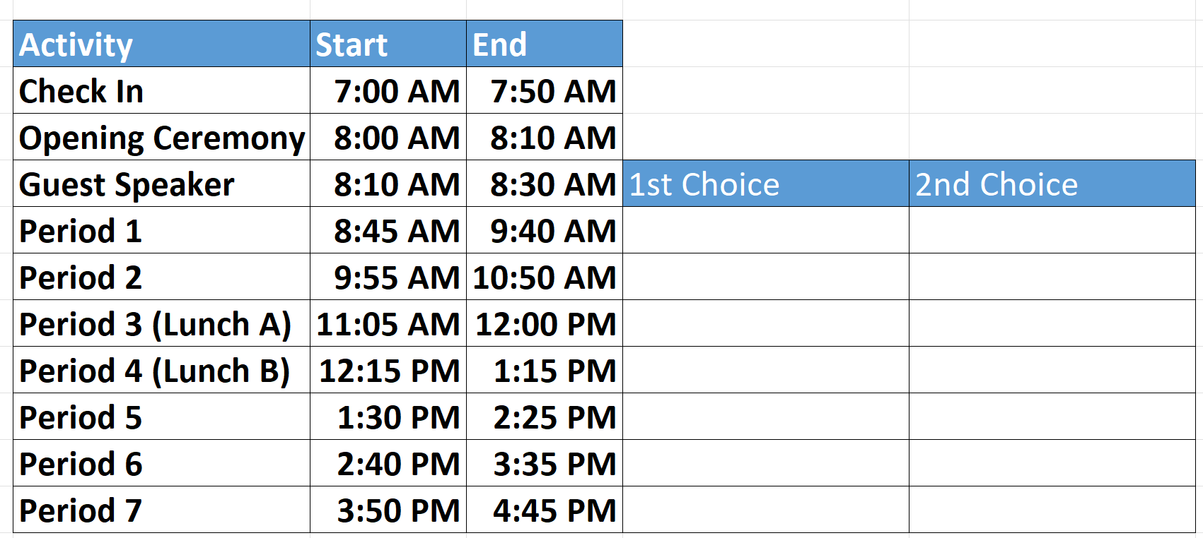

Registering For the University of Scouting
New this Year - Schedule an hour, Periods 1-5, to browse Midway and Program areas.
Class sizes are limited; please register early to ensure you can attend the courses you desire.
Although we do our best to accommodate all registrations, due to instructor availability, class limitations, and circumstances beyond our control, we may find it necessary to reschedule or cancel classes, at the last minute. If that happens you will be able to switch classes.
Walk-in registration will be available on the day of the event. Walk-ins will receive course assignments based on availability of classroom space, instructors, and time.
Registration is open to Adult Scouters and Youth who are ages 13 and above and achieved the Rank of First Class or higher.

New this Year - Commissioner Position Training
University of Scouting 2026 will introduce all-new Position-Specific Training classes specifically for commissioners.
Available Training
● Unit Commissioner
● District Commissioner / Assistant District Commissioner
● Roundtable Commissioner
● Revamping Roundtable
You Will Need Your Scouting America Member ID to Register
Your Scouting America Member ID can be found in the following ways:
- On your printed membership card
- In my.scouting.org Below your name on the first screen after login.
What Happens in Bad Weather?
Weather in North Texas is unpredictable. In the unlikely event of a hazardous weather concern, you will be notified that University of Scouting has been postponed.
Accessibility/ADA Accommodations
First United Methodist Church Richardson offers comprehensive ADA accommodations, including handicap parking, wheelchair seating in the Sanctuary and Worship & Arts Center.
Lunch and Snacks
There will be two snack shacks which will be open to purchase a snack from 7:30 AM until 3:00 PM. Lunch is a separate fee, NOT included in the registration fee. Lunch must be ordered at the time you register for a separate fee of $12.00. Please see our registration page for details of a limited menu. Vegetarian option available. If you desire, you may bring your own lunch/snacks. Microwaves are available in the cafeteria area. Lunch will not be available for walk-ins.

Attire
The University of Scouting encourages all participants to wear the complete Field Uniform of Scouting America. Due to physical activity and/or possible messiness, some classes may suggest you remove your scout shirt and wear your activity shirt. All clothing should be scout appropriate.
What else do I need to bring?
- A pen and paper
- Water bottle
- Snacks, as needed
- If you are not ordering lunch through the registration, bring lunch
Parking
Participants - Please use parking lots A, C, D and E (see map below). Parking lot B will be reserved for University of Scouting staff so that they can load and unload supplies for the event. Follow the signs to the Main Entrance on the south side of the building and proceed to the Welcome Desk area. See Check in below for additional information.

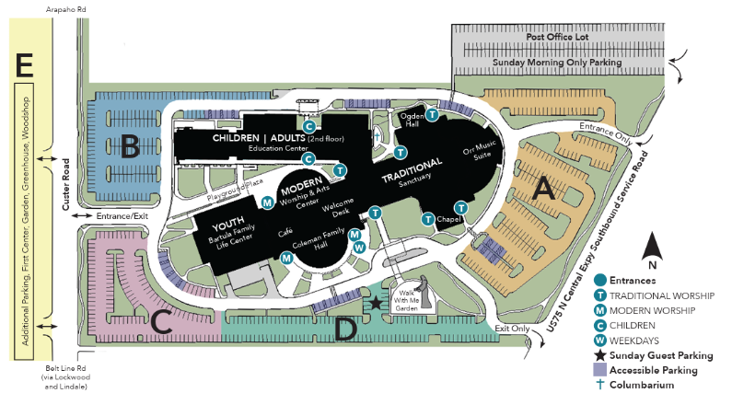

Check-in
All participants and staff must check in with the Administrations Team at the Registration Desk located in the Coleman Hall to the left of the main entrance. Check in will open at 7:00 a.m. As you might imagine, with over 500 expected participants, lines can
become quite long. Please don’t wait until the last minute to check-in and register. You MUST check in at the registration desk regardless whether you have pre-registered or not. Rooms will change up to the day of the event,
Please use parking lots A, C, D and E, go through the doors on the south side of the building marked “Main entrance” and proceed to check in area, Registration Desk, in Coleman Hall.
We will be issuing wristbands for all participants. The Registration Desk in Coleman Hall will have staff on hand throughout the day to assist you with any questions or schedule changes.

Class Attendance
Each class will take attendance using QR code and google forms with unique codes for each class. Instructions will be provided on the day of the event.
University Midway
Circle Ten Council recognizes there are several companies in North Texas who work together with Scouting America. We have invited a number of these companies to attend and will provide an opportunity for you to visit, learn about their mission, and have an opportunity to learn about special product promotions. Community-based service organizations will be on hand so you may learn how you or your scouts may partner with them to serve the needs of the communities. Our Midway does feature prizes and drawings. Make sure you learn the rules and participate.
New this Year - University of Scouting Program Area
Are you looking for new ideas to "zhuzh up" your scouting program? Or, have you heard about Scouting's “high adventure” camps but would like to know more? Check out our newly created Program area will be focused on promoting the wide range of programs in Scouting, offered within and outside of Circle Ten Council. Stop by the Program Area and find more ways for your Scouting unit to Win Together!
Guests and Children?
Guests are not allowed. All who attend the University of Scouting must register. There is no accommodation for babysitting, daycare or other means of looking after children. As a courtesy to other attendees and to prevent any disruptions, children are not permitted to attend the event even if accompanied by a parent or guardian.
The only exception to this rule is those youth (13 years or older and Rank of First Class or above) who have registered as participants.
2026 University of Scouting Faculty
Name | Position | Email Address | Phone #
Rob Hayes | Chancellor | 1213.rob@gmail.com | (214) 263.5060
Bram Franklin | Vice Chancellor | bramfranklin@gmail.com | (214) 609-9089
Dr Larry Featherston | Dean Cub Scouting | larryfeatherston@gmail.com | (214) 336.3071
Doug Dellow | Dean Scouting BSA | doug.dellow@gmail.com | (940) 231-5947
Rick Diamond | Dean Venturing | Rickdiamond1000@icloud.com | (469) 644-0168
Amy Weems | Dean General Studies | Ad.weems@gmail.com | (817) 891-0736
Robert Phillips | Dean Sea Scouts & Exploring | phillips.rm403@gmail.com | (214) 405-4995
David Grossman | Dean Leader Specific Training | dmgrossman@sbcglobal.net | (214) 418-8691
Michele Crawford | Midway Exhibitor Director | crawford-clan@sbcglobal.net | (214) 793-2933
David Cauble | Program Exhibitor Director | caubletxsg@gmail.com, | (469) 441-6070
Sean McGaughey | Marketing Director | seanmcgaughey840@gmail.com | (817) 798-2853
Shannon Goldman | Administration Director | goldmanjax@yahoo.com | (904) 993-2666
Kristine Schwope | Q.M. Food | kschwope@hotmail.com | (214) 734-2281
Robert O'Neal | Q.M. Equipment & Facilities | robert@78fence.com | (214) 769-6175
C10 - Daniel Murphy | Blackpug (C-10) | daniel.murphy@scouting.org | (214) 509-2103
C-10 Kyle Hair | Blackpug (C-10) | hairkyahoo@gmail.com | (214) 529-4067
Parker Rae | Technology (C-10) | Parker.Rea@scouting.org | (214) 902-6763
Trey Otte | Advisor | trey@otte.us | 214.402.4718
Jimmy Greenwood | Advisor | jimmy@greenwoodjr.com | 214-212-2627
CC Hardin | Advisor | cjhardin@att.net | 469-667-4137

Welcome to University of Scouting 2026!
Rob Hayes
Volunteer Chancellor
University of Scouting 2026

