New this Year - Leader Position Training Tracks

Online Leader Position training not your thing? Do you prefer face to face leader training? We have got you covered with your leader specific training trek::
- Cubmaster and Assistant Cubmaster
- Cub Scout Den Leader
- Pack Committee
- Scoutmaster and Assistant Scoutmaster
- Troop Committee

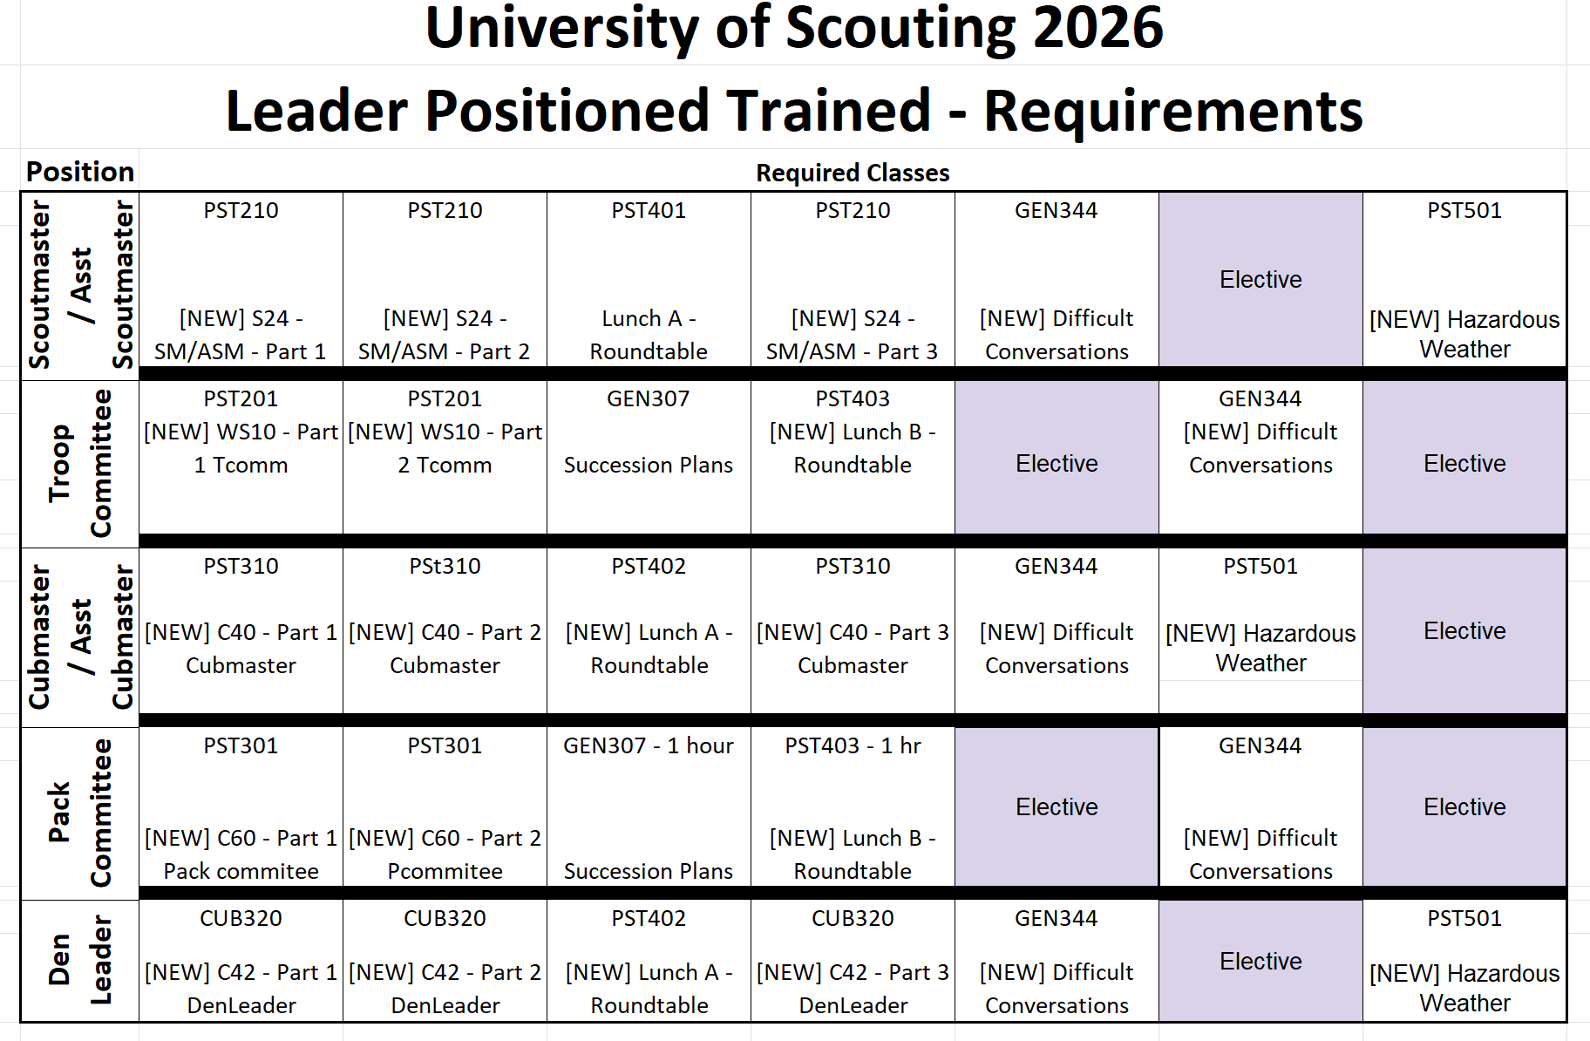

New for University of Scouting: Position-Specific Training Tracks

Get Trained. Build Confidence. Lead Better.
This year, University of Scouting introduces an all-new Position-Specific Training Track designed to provide a complete learning experience for leaders in a single day. Rather than selecting individual classes, participants can enroll in a curriculum specifically tailored to their Scouting position.
Available Training Tracks
● Troop Committee
● Pack Committee
● Scoutmaster / Assistant Scoutmaster
● Cubmaster / Assistant Cubmaster
● Den Leader / Assistant Den Leader

Each track includes the required position-specific training and Hazardous Weather Training (where applicable), ensuring participants complete the foundational training expected for their role.
But we don’t stop with the basics. Our expanded curriculum goes beyond required training to help leaders develop the practical skills they need to succeed. Topics include:

● Handling difficult conversations
● Succession planning
● Building strong leadership teams
● Sharing best practices from experienced Scouters
● Other practical leadership skills specific to your position

During lunch, participants will take part in a dedicated Position Roundtable, featuring experienced Scouting leaders who will answer questions, share ideas, and discuss real-world challenges in an informal, interactive setting.

Already completed some or all of the required training? No problem! You are still encouraged to participate. Simply provide proof of completion, and you’ll receive credit for those courses, freeing up time to attend additional elective classes offered throughout the University’s many Scouting colleges.

Recognition
Participants who complete a Position-Specific Training Track will receive a special commemorative University of Scouting Position-Trained Council Shoulder Patch, recognizing their commitment to delivering the best possible program for Scouts.
New this Year - Position-Specific Training Track & Patch
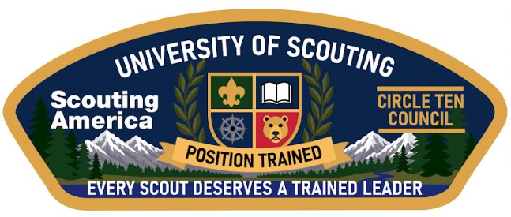
Whether you’re brand new to your position or an experienced leader looking to sharpen your skills, the University of Scouting Position-Specific Training Tracks offer the knowledge, confidence, and practical tools to help you succeed.

