Camp James Ray
Family Weekend
Program Guide
2026


Welcome to Camp!
To the families and leaders of our young Scouts,
We’re mighty glad to welcome y’all out for a weekend under the wide Texas sky—a chance to leave the hustle of town behind and gather together in the true spirit of Scouting.
Out here among the tall trees and winding trails, you’ll find more than just a place to rest your boots. You’ll find time to reconnect—with your Scout, with your family, with the outdoors, and with the simple joy of being together. Whether you’re roasting marshmallows over a crackling campfire, exploring the woods side by side, or watching the stars come out one by one across the night sky, this weekend offers memories that’ll stick with you for years to come.
We believe there’s something special about time spent out in the open country. Nature has a way of working its own kind of magic, and time around the campfire tends to bring folks a little closer together. Our hardworking camp staff will be nearby the whole weekend, ready to lend a hand and make sure your stay is smooth, safe, and full of good times.
Adventures on the Frontier
While you’re here at camp, you and your Scout will have plenty of chances to take part in activities the whole family can enjoy. From hikes through the woods to crafts, games, and shared meals, every part of the weekend is meant to build confidence, friendship, and a spirit of adventure.
We encourage you to lean into the camp experience: set the screens aside, listen to the breeze in the trees, and take in the sights and sounds of the outdoors. The memories you make here—laughing together, learning new things, and sharing a campfire—are the kind that last a lifetime.
May your weekend be filled with laughter, discovery, and the warm glow of the campfire beneath the big western sky.
Yours in Scouting,
The Camp Staff

Contents
ARRIVAL AT CAMP 3
PROGRAM AREAS 5
ADVANCEMENT AT CAMP JAMES RAY 6
CUB FAMILY WEEKEND DAILY SCHEDULE 7
SELECTED INFORMATION FROM THE LEADER’S GUIDE 8
Important Notes Regarding Camp Departure During Program Times 8
What about the weather or other emergencies? 8
Lost and Found 8
Campsite Set-up/Inspection Guidelines 9
Check Out Procedures 10
Camp James Ray Map 11
GOLDEN GOOSE CHALLENGE 12

ARRIVAL AT CAMP

When you arrive, you will be guided to your campsite. Please drop your gear and return your car to the main parking lot.

Cars are not allowed in campsites. If you have an exceptional need, you will need to speak with the camp director at headquarters.

Once your gear is dropped, an adult will check-in at headquarters. Turn in any outstanding required adult forms and receive your packet, then you will stop at the health lodge to turn in your health forms. When you are finished, continue on to the pool to complete your swim check if you have not done this before camp.

The rest of your group can go directly to the pool for swim checks while you handle the paperwork. All participants, adults and youth, must provide a completed swim check or complete one upon arrival. Participants who do not complete a swim test will be marked a NON-SWIMMER.

Make sure you check out the trading post before you head to flags before dinner.

If you would like assistance, please stop by headquarters and we will do our best to assist!

PROGRAM AREAS

Sanford Aquatics Center & Lake Texoma Waterfront

Scouts have the opportunity to practice swimming skills, ride two amazing water slides and soak up the rays, with sunscreen on of course, in our 128,000-gallon pool.

The pool is designed with zones appropriate for all scouts and adults who would like some time to cool off and enjoy some time in the pool.

The waterfront will not be open for Cub Family Weekend.

Field Sports- a Scout is physically fit…

From soccer skills to gaga ball and your favorite outdoor games, your time in field sports is a great way to burn off some energy and get some exercise!

Outdoor Skills- be prepared for outdoor adventures

Practice your outdoor skills and be prepared for greater outdoor adventures

Creation Station- get in touch with your creative side

Art supplies and ideas abound at the creation station. Make something amazing!

Some ideas include:
- Build a woodworking project
- Practice your leatherworking
- Paint a portrait

Nature – get close and personal to our outdoor environment and the creatures who live there

Scouts will get to travel around our own little neck of the woods and learn about native plants and animals, having safe, informative interactions with animals at the same time.

Share your story-

Take time to share with our community and supporters about your favorite camp activities by writing notes, drawing pictures, or maybe recording a short video about camp.

Don’t forget to take a fun picture at our photo booth to share!
Target and Range Sports-

Scouts will practice their skills in BB guns, archery, and use wrist rockets. Scouts have the opportunity to earn achievements through age-appropriate skills development and proven efficiency.

Classes start on the hour with a safety briefing.

Scout Skills & Team Building

Sharpen your scout skills and introduce your family to new ones. Engage in team building activities and create some family memories.

ADVANCEMENT AT CAMP JAMES RAY

Your Scouts will have an opportunity (weather permitting) to complete the following electives while at camp:

- Swimming
- Archery
- BB Guns
- Slingshot (time and personnel permitting)

Depending on your group discussions and activities you participate in, you may be able to complete additional Adventures while at camp.

If you find yourself in need of additional program supplies or resources while you are at camp, please reach out to a staff member. If we are able to accommodate your request, we are happy to help!

SPEAKING OF ADVANCEMENT….

Don’t miss your opportunity to earn your very own Golden Goose Award!

Sign up to help out in a program area, take a dip in the pool, and earn your very own leader advancement. See the appendix for more information.

CUB FAMILY WEEKEND DAILY SCHEDULE

 | Friday | Saturday | Sunday
7:30 a.m. |  |  | Check Out begins
7:50 a.m. |  | Flags, Breakfast follows at 8:00 | Flags, Grab & Go Breakfast
9:00 a.m. |  | Open Areas | Pack up and depart
10:00 a.m. |  | Open Areas | Check Out Ends
11:00 a.m. |  | Open Areas
12:00 p.m. |  | Flags, Lunch follows at 12:15
1:00 p.m. | Arrival, Check-In, Set Up Campsite, Health and Swim Checks | Shoes Up
2:00 p.m. | Arrival, Check-In, Set Up Campsite, Health and Swim Checks | Open Areas
3:00 p.m. | Arrival, Check-In, Set Up Campsite, Health and Swim Checks | Open Areas
4:00 p.m. | Arrival, Check-In, Set Up Campsite, Health and Swim Checks | Open Areas
5:00 p.m. | Arrival, Check-In, Set Up Campsite, Health and Swim Checks | Shoes Up
6:05 p.m. | Flags, Dinner follows at 6:15
7:30 p.m. | Leader’s Meeting | Pool Party
8:00 p.m. | Opening Campfire
9:00 p.m. | Back to Campsite | Back to Campsite
10:30 p.m. | Lights out | Lights out

Special Events
Time | Activity | Location
2:30-3:30 | Tie Dye | Handicraft
3:30-5:00 | Leatherworking | Handicraft
2:00-5:00 | Woodworking | Activity Center

More activities may be available and will be announced via Remind and at leaders meeting on Friday evening!

SELECTED INFORMATION FROM THE LEADER’S GUIDE

Important Notes Regarding Camp Departure During Program Times

The safety of our campers and staff is our priority, as well as the enjoyment of the program areas. If any Unit or individual chooses to leave camp before scheduled check-out time, please communicate with staff to have the gate opened.

There will be no driving in camp during program hours except as necessary by camp staff or in case of an emergency.

Please “be prepared” and plan accordingly.

The front gate is now closed each night from 11:00 p.m. - 6:00 a.m. If anyone must leave camp and return between these times, they will have to speak with the camp director prior to departure to get the gate code for reentry.

What about the weather or other emergencies?
Camper and staff safety are the priority of Camp James Ray. Emergency Action Plans are in place to address emergencies such as inclement weather, fires, lost campers, and more. This policy will be shared with all parents of campers, all leaders, and all staff at camp.

In the event weather becomes severe or other emergencies arise, camp staff will instruct you on further action according to the Emergency Action Plan. Campers and leaders are required to follow the instruction of the camp director, Program director, Camp Rangers, or other designee.

If at any time you feel unsafe, please feel free to take shelter in the dining hall. It will remain unlocked during camp.

Lost and Found
Lost and found items should be taken to Headquarters. All items left longer than 7 days after departure will be donated or disposed of.

Campsite Set-up/Inspection Guidelines

Tents- Inspect for damage, is it properly pitched: Are the tents secured against possible damage from wind and weather? Is there any damage to the tent or lines to report?
Campsite neat and clean, no trash on ground: Is the campsite, including the area beyond the tents and the trails leading to the campsite, free of litter?
Natural surroundings left intact: Leave the campsite as it is. Moving rocks to line the pathway is unnecessary and usually leads to soil erosion.
Fire Guard Chart: Review the fire guard chart posted at the latrine. Is the chart filled out in its entirety? Is the chart posted so that all can see who is in charge for the day? Have the person in charge for the day signed or initial the chart to signify that they have checked the campsite.
Clotheslines properly strung: Are all clotheslines strung high enough that anyone can walk under them?
Latrine clean and free of personal gear: Check the latrine. Is there toilet paper? Are there any personal items left in the shower, dressing, or sink areas (Soap at the sink is fine)? Is the floor swept or hosed off? If more than one unit shares the latrine, the evaluation is shared to all units.
Latrine hose properly stored: Is the hose coiled and not strewn across the floor (not posing a tripping hazard)?
The focus of the inspection is to ensure that the campsite offers a safe and healthy environment for the campers.
If any damage is discovered or a concern arises, tell your group guide or report it to the camp director.
Bagged trash should be left at the roadside entrance to your campsite or placed in the dumpster. Dumpsters are located at the rear of the dining hall or at the entrance to ranger workshop across from headquarters.

EXTRA FUN AT CAMP JAMES RAY

Religious Emblem Award- details in your packet, patches available for purchase at the trading post

Pool Party- Saturday Evening (Complete with the Duck Race!)

Campfires Friday evening

Golden Goose Challenge for adults

Activities available outside the Activity Center, plenty of seating and a great place to relax

Thank-you notes to staff- Want to recognize a staff member and say thank you? Note cards are available in HQ

Thank you postcards for our Friends of Scouting Donors- send a note to our generous donors to let them know how much fun you are having at camp! Postcards are available in the leader’s lounge, along with markers and pencils. (bonus- its in the air-conditioning)

Camp Communication

Camp James Ray is utilizing the Remind app to share important information with our campers and allow inter-camper communication. Download the app before you arrive at camp! When you arrive, we will have a QR code to share with your adults that will allow you to join your session’s group.

Your group will be closed at the end of your session.

Camp Photos


Share photos of your camp fun! Simply scan this QR code to drop them in the Camp James Ray Dropbox. QR codes are available outside the Photo Booth and on various bulletin boards around camp.

Check Out Procedures
- Available Times: 7:00 a.m.- 10:00 a.m. at Headquarters

- Packing up your Vehicle

The yellow gate will open at 6:00 a.m. for you to bring your vehicle to camp. Please be mindful to try to stagger your times of vehicles at your campsite to avoid traffic jams.

- Don’t Forget to Retrieve

- Ducks in HQ
- Medical Forms from Health Lodge
- Any Lost & Found items in the Activity Center

- Bring With You

  - Completed Surveys
  - Any outstanding Golden Goose Award applications
  - Information about any issues with your tent or campsite

- Checking Out

Check out ONLY when you are ready to leave camp property. If your whole unit is not leaving at the same time, each individual will need to check out as they leave.’

Description | STAFF MEMBER | UNIT LEADER
Campsite neat and clean, no trash on ground: Is the campsite, including the area beyond the tents and the trails leading to the campsite, free of litter?
Natural surroundings left intact: Have natural features been left as they were when you entered camp? Moving rocks to line the pathway is unnecessary and usually leads to soil erosion.
Clotheslines and gateways removed: Are all clotheslines and manmade camp improvements removed?
Latrine clean, free of personal gear and hose properly stored: Shower, dressing and sink area free of personal items? Stalls swept and toilet lids down?

Camp James Ray Map
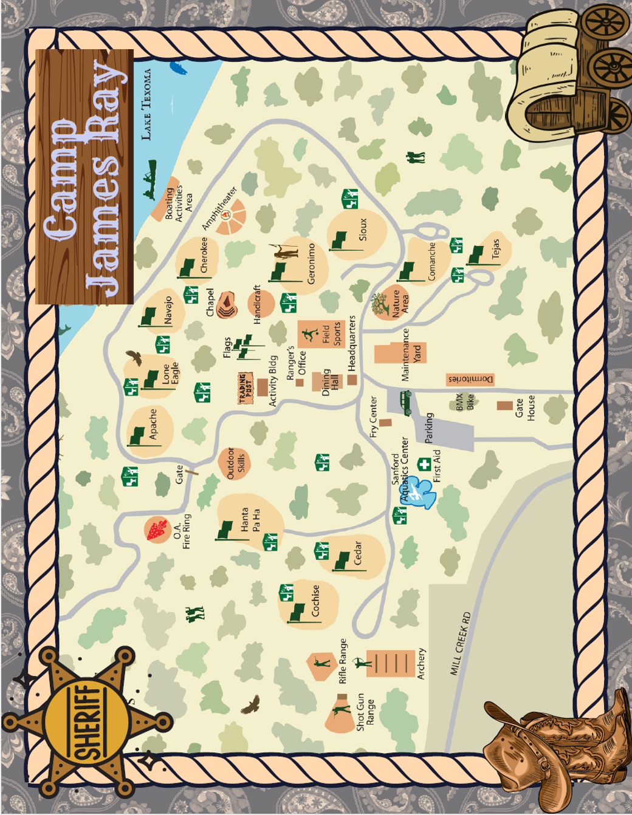

GOLDEN GOOSE CHALLENGE
All adults are welcome and encouraged to participate in the Golden Goose Challenge! Complete five of the tasks below to earn your 2026 goose, or complete eight of the tasks below to earn the coveted Golden Goose!

- Assist in the dining hall for set up or take down* (arrive 15 minutes before your scheduled meal service, plan to stay approx. 15 minutes after meal service is complete)
- Empty a trashcan
- Attempt the swim test
- Slide down both slides
- Attend a leader meeting
- Have 100% of your unit complete a thank you postcard
- Perform a song at campfire with other leaders*
- Help set up or take down at the shooting sports ranges*
- Take a nap
- Have a treat from the trading post
- Assist at the pool or waterfront as a lookout*
- Assist at the shooting sports range (rangemaster certified leaders a plus)*
- Help sort ducks on Wednesday morning

*Sign-ups are available in the leader’s lounge.

Official forms will be available upon check-in at camp!

