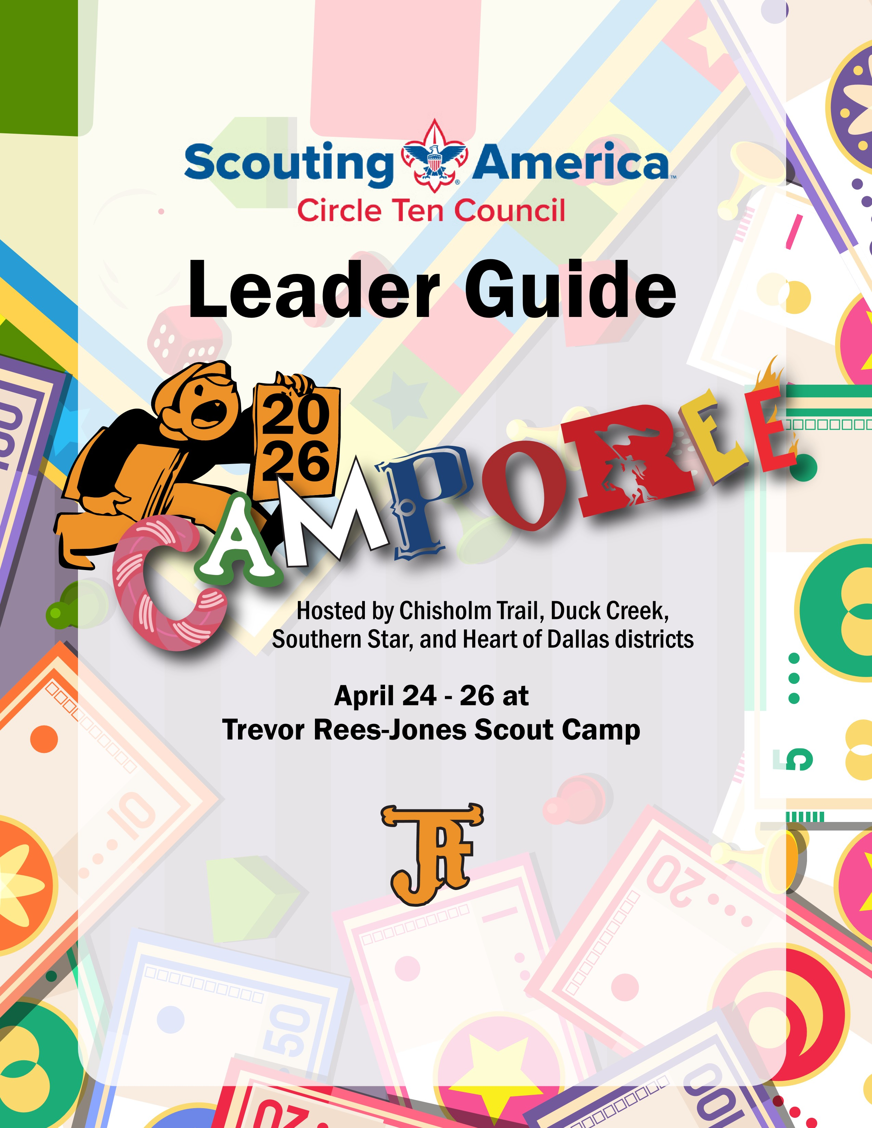

General Information
Registration
Units must register all adult and youth Scouts on the council website (only one registration per unit): Circle Ten Council - 2026 TRJ Camporee #2 (CT DC HD SS)

Registration closes April 21th at 11:00 PM.
For any questions, comments, or concerns about Camporee, email Nick Clark clarkncharge@msn.com
Fees
Scouts: $25
Scouters:$15
Staff: $15

Order of the Arrow Brotherhood: $25.00 (payable at the event - cash or check made out to Circle Ten Council or cash) Campsite
Once a troop is registered, a campsite will be assigned on Friday night based on availability, the size of the troop, and the size of the campsite. Campsites will be pre-assigned.
Meals
Each troop is responsible for providing meals for their Scouts. (staff will meet together and share food made by the kitchen staff)
First Aid
Minor injuries, such as cuts, scrapes, scratches, bruises, and minor burns, may be treated with proper first aid by the unit.
If the injury is more serious or suspected to be more serious, every Scout and Scouter may make use of the Camporee First Aid Station. If necessary, send for help. If a Camporee staff member with a radio can be found quickly, ask the staff member to radio for help.

Check-in and Registration
Forms required for arrival
Unit Roster (downloaded from myscouting.org) Medical Forms (Part A&B) are required for all participants and must be turned in by the unit at check in. Forms for each participant must be fully complete including signatures and copy of the insurance card hps://filestore.scoung.org/filestore/HealthSafety/pdf/680-001_AB.pdf
Check in Process
Once arriving at the parking lot, a Scoutmaster or a Troop Representative should come in the Headquarters building with the following items:
1. Circle Ten Council Arrival Checklist
2. Proof of Advanced Registration. (Print out your registration form, with the number of Scouts and number of Scouters present)
3. Medical Form A & B for each participant
4. Notify registration of the number of patrols competing in the Saturday events
Vehicles and Campsite Setup
On Friday night, vehicles will be allowed at the campsite to make the campsite setup easier. If a troop has a trailer, the trailer may stay at the campsite through the duration of Camporee. However after Friday night, NO VEHICLES ARE PERMITTED IN CAMPSITES, unless you have a handicap pass (See Handicap Procedure below).

Driving around camp is strictly prohibited except for handicapped Scouts and Scouters, Camporee service crew, and Camp Rangers. The speed limit must be obeyed for the safety of all persons on camp.
Handicap Procedure: If a Scout or Scouter is handicapped and must use a vehicle during Camporee, they MUST bring and present a VALID handicap-parking tag to receive a Camporee approved handicap parking pass. All handicap passes will be distributed at the CAMP HEADQUARTERS.

Events
Camporee features a program consisting of patrol events in the morning and afternoon. Please divide your troop into patrols of 6 to 10 scouts with 8 being the target number per patrol. The use of putting together a “Super Patrol” is discouraged to keep it a friendly competition for all. Instead, think about your older Scouts mentoring/bonding with your new scouts.

Troop Patrol Competition
EVENT | DESCRIPTION
Flash Point: Fire Rescue  (Small Fire Building) | Patrols will be timed on building a small fire.
Skill Check  (Knot and Relay) | Challenges focused on knots required for Trail to First Class
Jenga  (Campsite Inspection) | Make cool gadgets and, demonstrate patrol and troop spirit and swag
Organ Trail  (Orienteering) | Use your compass to find the points.
Hungry Hungry Hippos  (Pancake Toss) | Make a Pancake and start the toss
Pass Go  (Chariot Race) | Build your chariot and race other patrols. (materials provided at event)
Statego  (Shooting Sports) | Archery, Rifle, Shotgun ranges will be open for scouts
Yeti Spegiti  (Tug-of-War) | Troop event
Shoots and Ladders  (Climbing Wall) | Climbing Wall
Sea of Thieves  (Human Ship maneuvers) | Battle against the other teams in life size boats made by people
Patrol Flags | Patrol Flags For judging
History Board | Brief History Boards on the troop
Awards
Awards will be presented at the campfire on Saturday night. There will be many categories to win, including best patrols from the morning events, winners of the contests, campsite inspections, and more.
Note: Patrols will want to keep their 10 Essential items with them during the competitions as this will be scored at various stations. (check your scout book)
Troops are asked to have skit or song prepared for the campfire. All material will need to be preapproved and can be submitted at the SPL and SM meetings.
Schedule
NOTE: Final schedule will be provided at check in. Some locations may change. We will announce any changes during Camporee. The Admin team will be based in the Dining Hall on Saturday.
Day | Time | Activity | Location
Friday | 6:30 – 9:30 PM | Registration and Check-In | Headquarters
 | 10:00 – 10:25 PM | SPL/ SM Meeting (Q & A) | Dining Hall
 | Immediately after SM/SPL Meeting | Key Staff meeting | Dining Hall
 | 11:00 PM | Lights Out/Quiet Time | Everywhere
Saturday | 7:00 – 8. 00 AM | Breakfast | Campsites
 | 8:30 – 8:45 AM | Flag Ceremony/Announcements | Flagpoles by Dining Hall
 | 9:00 – 12:00 PM | Morning Events - Patrols are dismissed from flags to compete in the morning round robin events. Schedules and instructions will be provided to the patrols. | See map
 | 11:00 AM - 1:00 PM | Brotherhood sign up for eligible members of the Order of the Arrow (prepay or bring cash/check $25) | Dining Hall
 | 12:00 – 1:15 PM | Lunch | Campsites
 | 1:30 - 4:00 PM | Afternoon Events  Competitions resume. Follow patrol schedule provided at morning flags.
 | 1:30 - 1:50 PM | Scoutmaster Meeting about Order of the Arrow callout - logistics and locations will be provided for the call out. | Dining Hall
 | 3:00 – 5:00 PM | Order of the Arrow Brotherhood Walk | Flagpoles by Dining Hall
 | 4:45 – 5:00 PM | Flag Ceremony/Announcements | Flagpoles by Dining Hall
 | 5:00 - 5:15 PM | Scoutmaster / SPL Meeting | Dining Hall
 | 5:00 – 6:30 PM | Dinner | Campsites
 | 7:30 – 8:30 PM | Campfire Skits/ Awards | OA Field
 | 8:30 – 9:00 PM | Order of the Arrow Call-Out Ceremony | Leaving from Campfire
 | 11:00 PM | Lights Out/Quiet Time | Everywhere
Sunday | 7:30 – 8:30 AM | Breakfast | Campsites
 | 8:45 – 9:00 AM | Flag Ceremony/ Announcements | Flag Poles
 | 9:15 – 9:45 AM | Scouts Own Service | Chapel
 | 9:15 – 11:30 AM | Campsite Inspections/ Troop Checkout | Campsites, Headquarters

Friday
Check-in and Registration (6:30 – 9:30 PM)
Troops will arrive, verify registration, get campsite assignments (please have all paperwork ready and all paid in full)
SPL, Scoutmaster Meeting (10:00-10:25)
Senior Patrol Leaders and Scoutmasters will gather at the Dining Hall with Adult and Youth Staff lead for a brief review of Camporee events.
Lights Out/Quiet Time (11:00 PM)
All Scouts and Scouters are to be in their tents, lights out, and are to refrain from loud noises that would disturb others.
Saturday
Opening Flag Ceremony (8:30 AM)
For this flag ceremony only, field uniforms (Class A) are not required. Patrols should be ready to depart from flags to begin the competitions. Scouts should wear activity uniforms (Class B) or fully embrace the “Board Gamest” theme. Bring patrol flags!
Morning Competitions Begins (9:00 AM – 12:00 PM)
Patrols will compete at each activity. Instructions and schedules will be provided at morning flags.
Lunch (12:00pm-1:15pm)
All troops provide their own lunch.
Order of the Arrow Brotherhood Check-In (11:00 AM – 1:00 PM)
Register for Brotherhood at the dining hall. Brotherhood fees are $25 cash or check made out to Circle Ten Council. Must be current on Mikanakawa Lodge dues to participate (annual dues can be paid at miki.org).
OA Callout Meeting for Scoutmasters (1:30-1:50 PM)
A Scoutmaster or an adult troop representative from each troop participating in the Order of the Arrow Callout should attend this meeting for instructions and locations for the evening callouts after campfire.
Afternoon Events (1:30 PM – 4:00 PM)
Afternoon events and competitions resume. Follow schedules provided at morning flags.
Order of the Arrow Brotherhood Walk and Ceremony (3:00 PM – 5:00 PM)
Brotherhood candidates will meet in front of the dining hall 15 minutes prior to the 3:30 walk to seal their membership in the Order of the Arrow. This walk is for those who are candidates or are already brotherhood honor.
Flag Ceremony (4:45 PM – 5:00 PM)
“Day is done, gone the sun…” All Camporee attendees, wearing field uniforms (Class A), will gather at the Flag Poles.

SPL, Scoutmaster Meeng (5:00 PM)
Senior Patrol Leaders and Scoutmasters will gather at the Dining Hall with Adult and Youth Staff lead for a brief review of the day’s competitions, and a look ahead to remaining activities, including the evening’s campfire, OA ceremonies, and check-out procedures.
Units must inform and gain approval for the skits or songs their unit will perform at the Campfire.
Dinner (5:00 PM – 6:30 PM)
All troops are to provide their own dinner.
Campfire and Awards (7:30 PM – 8:30 PM)
Camporee participants will gather for an evening of awards, skits, songs and other entertainment. At the Campfire winning patrols and troops will be awarded for their teamwork.
Order of the Arrow Call-out Ceremony (8:30 – 9:00 PM)
At the conclusion of the Camporee campfire, troops participating in the Order of the Arrow Call-Out will be led from the Campfire area to a ceremonial fire by Arrowmen.
Sunday
Flag Ceremony (8:45 AM – 9:00 AM)

Scouts, Scouters, and staff will gather at the Flag Poles. A Field uniform is required.

Scouts Own Service (9:15 AM – 9:45 AM)

The OA staff members will lead the Scouts Service

Inspections and Check-out (9:15 AM – 11:30 AM)
Camporee Staff will inspect each campsite, expecting it to be in better shape than it was before Camporee. Once the campsite passes a check-out inspection, the unit’s leader will be given the Camporee patches and any other checkout materials.

Camp Rules
1. OBEY:
a. Scout Oath
b. Scout Law
c. Outdoor Code
d. All warning signs, including any and all off-limits markings
e. Buddy system at all times
2. DRESS:
a. Flag ceremonies (except Saturday morning’s flag-raising), campfire, and OA ceremonies – BSA Field Uniform (Class A shirts and Scout or Scout-approved pants or shorts.)
b. Competition events and other non-ceremonial day activities – Scout or troop t-shirts and Scout or Scout-approved pants or shorts
3. NO FIREARMS
4. NO ALCOHOL, NO ILLEGAL DRUGS.
5. Safeguarding youth training and Guide to Safe Scouting must be respected and followed at all times.
6. Electronic Device usage is according to each troop policy.
7. Lights out by 11:00 pm.
8. VEHICLES and TRAILERS:
a. Upon arrival at camp Friday, all vehicles will be parked in the camp’s main parking lot according to the instructions of the parking crew.
b. Temporary passes will be issued to vehicles towing trailers so that the trailers may be parked in, or near, the troop’s campsite.
c. Handicapped Scouts, Scouters, or Staff may receive a Camp Handicapped Tag following the procedures on page 3.
d. Only one (1) vehicle pass will be issued per troop.
e. Scouts must walk around camp throughout the duration of Camporee.
9. CONSEQUENCES:
a. If a Scout disrupts Camporee by failing to follow one or more of the above Camp Rules, he or she may be instructed to call a parent/guardian to request to be taken home from camp as soon as possible. If a parent/guardian is unable to come to camp to take the Scout home, the Scout’s Scoutmaster will be responsible for removing the Scout from camp. DO YOUR BEST to have good, clean fun while displaying scouting spirit.

Order of the Arrow Ceremonies
Call Out
A Scoutmaster or adult troop representative needs to send the Callout information meeting at 1:30 pm to receive instructions and locations.
Please bring a list of elected candidates who will be called out that evening with you to the 1:30 pm meeting.

Brotherhood
Ordeal Members who completed their Ordeal more than 6 months ago are eligible to seal their membership in the Order of the Arrow by becoming a Brotherhood Member.
Please encourage Scout and Scouter who are eligible to complete their membership by:
• Coming to the Dining Hall between 11:00 am and 1:00 pm on Saturday to:
• Verifying eligibility
• Confirming Mikanakawa Lodge dues are paid for 2026 or pay (2026 dues are $25)
• Filling out a Brotherhood registration card and pay their $25.00 fee (cash or check) if not prepaid for the OA Brotherhood sash
• Receiving instructions on their Letter of Rededication to service in the OA and the Brotherhood Walk requirements
You will also need to meet in front of the dining hall at 3:00 PM sharp, where the Brotherhood Walk will commence and will be followed by the Brotherhood Ceremony. The Brotherhood Ceremony is one of the most meaningful experiences available to members of Scouting America. Those participating in it should be prepared to do their best to live a life of cheerful service to others.

