Buffalo Trail Council


PUSHCART DERBY 2026
DATE: November 7, 2026
LEADER’S GUIDE

Location: Midland College
3600 N Garfield St.
Midland, Texas 79705

Practice Runs: 11:15am-12:00pm
Registration: 12:00-12:45pm
Tailgate Lunch by Unit: 11:00am-1:00pm
Council Races: 1:00-2:00pm
Adult Race & Awards: 2:00-2:30pm
Cleanup & Depart: 2:30-3:00pm

Registration Deadline is Thursday, November 5th by 5:00pm.
$40 per car/team entry for full car or $5 per Scout if no car and
would like to get on list to be on a team, First come first serve.
8 person teams but can run with less. One Car per team, no Sharing cars.
3 Divisions: Lions & Tigers; Wolves & Bears; Webelos & AOL.
Coed teams are ok as well for family packs! New Packs build car(s) soon!

Units need to have the Boy Scout Medical Form Parts A & B for each participant.

http://www.scouting.org/scoutsource/HealthandSafety/ahmr.aspx

Registration Link

https://scoutingevent.com/567-push

Team Divisions:
3 Divisions Lion & Tiger, Wolf & Bear, Webelos & AOL
Teams for all divisions will consist of 8 members with each team member only being allowed to be a part of 1 team. Can run with 4 to 6 but will have to have a pair or two pair do multiple legs of race.
If a pack does not have enough Scouts to field a team or teams, a provisional team will be formed with Scouts from another pack

Each Unit must have at least 1 cart to participate. If a Unit has more than one team per division, they must have 2 carts.
All Divisions are required to have an adult pit crew of 4-5 adults for each race at start line and 3 change points on track and turnaround.

Safety:
Every Racer is Required to wear the following:
- Helmet (bicycle, motorcycle or skate) – each racer must have their own helmet equipped with a strap.
- Pants/Jeans – No shorts!
- Closed toe shoes – No sandals or shoes with an open back!

Optional but Highly Recommended:
- Gloves – Full gloves including the fingers.
- Knee and elbow pads
- Long sleeve shirt
- Eye protection – optional.
- Operation during event:
- Only use your feet and the rope/steering mechanism attached to the axle to steer the cart.
- Clear the course before removing safety gear (seat belt, helmet, gloves, etc.)

Patches and Awards:
  - Patches: All registered Scout Participants will receive patches while supplies last.
  - Awards: 1st place in each division in the council race and the Council overall champion will receive!

Pushcart Construction Rules
- All carts must pass a safety inspection prior to racing. If the cart does not pass, the members of the team will be notified of the reason the cart failed and will have the opportunity to fix the issue and pass inspection prior to race time.
- Pushcarts are to be built by team members with adult supervision (overseeing the work for safety) where required due to the age of the team members. Please follow the Guide to Safe Scouting guidelines.
- Wheels must have a total outside diameter of no less than 8 inches and no greater than 12 inches.
- Wheels must be made of plastic or solid rubber only. No inflatable tires will be allowed.
- The carts wheelbase will be measured from axle to axle and must be no less than 30 inches and no greater than 48 inches.
- Nails will not be permitted for axles. Axles must be screws, bolts or shafts and will be inspected for safety prior to the race. It is recommended to use a shaft attached to the wooden axle with U bolts and then secure the wheels to the shaft with cotter pins. (Refer to included diagram).
- All carts must have steering blocks on the top side of the front axle board to limit the angle of turn.
- The total length of the cart is not to exceed 84 inches including the secured push bar.
- The total width of the cart must be no less than 20 inches and no greater than 40 inches.
- All carts must have at least 1‐1/2 inches of clearance.
- Cart bodies must be constructed of wood. Metal fasteners are permitted.
- Due to short distance and low speed seatbelt Is optional and not required.
- All carts must have a seat with a secure back for the driver to sit in while driving the cart.

- All carts must include a secured push bar no greater than 60” in length.
- All carts must be powered manually; no motors or other devices for power will be permitted.
- All carts must have 4 wheels, 2 in the front and 2 in the back.
- All carts must have front wheel steering with drivers able to steer the cart using their feet on the front axle, rope or other steering mechanism can be used and attached to the front axle to hold on to or help steer.
- It is recommended that holes been drilled into the main frame near the front so that you can move the front axle back to fit smaller drivers. (Refer to included diagram).
- optional footrests with Velcro straps or other device to slide feet into can be installed on the front axle to ensure that scouts do not put their feet down while the cart is in motion. Not Required!
- Personalization such as: seat pads/covers, painting, decals and reflectors are allowed if they meet safety standards.
- Cardboard number plates, covers, and panels are allowed if they are secured safely.
- After the safety inspection there can be no alterations made to the cart.

Events:
Relay Race – Rules & Logistics
- The track will be a 100‐yard straight and will consist of two to four lanes with 2-4 carts racing simultaneously.
- Each team will race at least 2 times (Double elimination format). The winners of each division will be determined by this method. Races are not timed.
- Teams shall pre‐determine drivers and pushers for each segment of the race.
- The Pit Crew will stage the carts at the starting line. When the racing officials determine that all carts are properly set, and each member is wearing appropriate safety gear the race can start.
- 2 team members will begin the race at the starting line with one-member pushing and one‐member riding/driving. They will drive for a predetermined distance to the 1st 5‐yard changeover box. While car in the box the 2 new team members switch places with the rider/driver and pusher to continue racing towards the 2nd changeover zone. At the 2nd changeover zone 2 more team members will switch places with the rider/driver and the pusher. At the 3rd and final changeover zone where the last 2 team members will switch places with the rider/driver and pusher then go past the line at one end of track and the driver gets out so team can turn the car and the rider/driver Switch places and return to 3 changing stations where the opposite team members get to Ride/Drive or push this leg of race. The First team to the finish line wins.
- A race judges will watch all exchanges occurring and any outside of the changeover zone will not be permitted. Rider/Driver should not exit the car until his team switching confirms in the box and completely stopped.
- To ensure that each racer has an opportunity to both push and drive it is a requirement!
- If a cart strays from its assigned lane and interferes with another cart it will need to return to its
lane or may be disqualified from that one race.
- If a driver exits a cart before it stops the car may be disqualified from that one race.
- Practice! Practice! Practice!

Relay Race – Division Specifics
All Divisions– Racers will drive 25 yards or ¼ of the track between changeover zones and must have one Adult Coach near the course to coach and direct their team. The coach is not allowed to touch the cart or move lane markers once the race begins. A disqualification may be imposed if they touch a cart or lane marker.

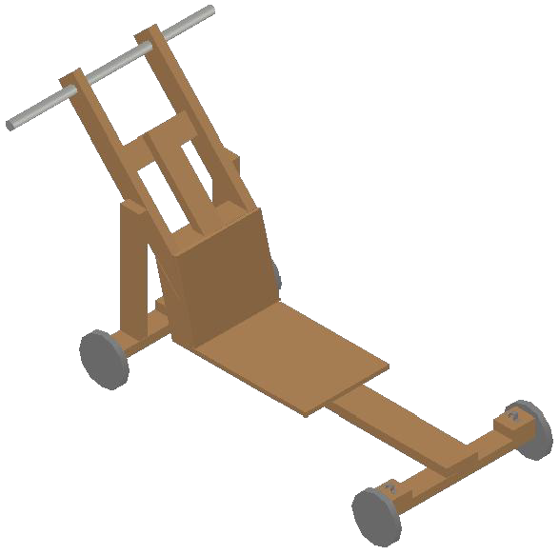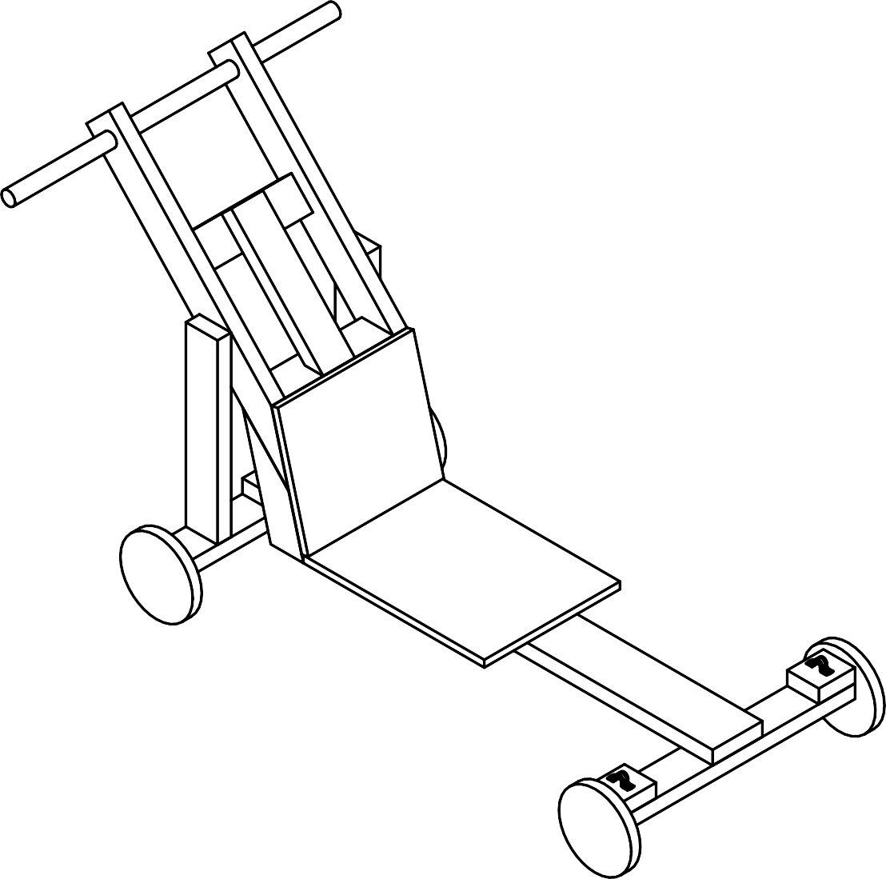
1
10
8
19
18
3
11
6
5
2
4
7

NOTES TO DRAWING
- WOOD PUSH BAR 1 1/2” DIAMETER (RECOMMENDED)
- WHEELS NOT TO BE LARGER THAN 12” DIAMETER
- 3/8" OR 1/2" PLYWOOD SEAT 15” WIDTH X 20” LONG (RECOMMENDED)
- STEERING BRIDLE, 1/4" NYLON ROPE
- STEERING MACHINE BOLT
- DRILL HOLES ON THE AXLES TO ADJUST CAR TO USER PROPORTIONS
- 2 X 4 SAFETY WOOD BLOCKS TO LIMIT STEERING ANGLE
- SEAT POSTS SUPPORT
- 2 X 4 WOOD CAR FRAME
- 2 X 4 HANDLE SUPPORT
- 2 X 4 X 28” WOOD AXLES
- CARRIAGE BOLT
- LAG SCREW (SEE ALTERNATE AND RECOMMENDED OPTION)
- MACHINE BOLT
- FLAT WASHER
- NUT
- SECOND NUT TIGHTENED AGAINST FIRST TO LOCK
- 3/8" OR 1/2" PLYWOOD SEAT 15” WIDTH X 13” HIGH (RECOMMENDED)
9
- 2 X 4 HANDLE POSTS VERTICAL SUPPORT

PERSPECTIVE VIEW

PUSHCART SUGGESTED PLANS

FEEL FREE TO MODIFY FOR YOUR DESIGN, BUT MAINTAIN THE SAFETY REQUIREMENTS
10
19

18
8

13"
1

APPROX. 36"

2

4812" CENTER TO CENTER
52" OVERALL

SIDE VIEW

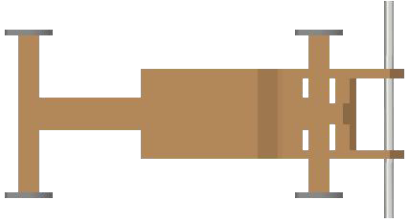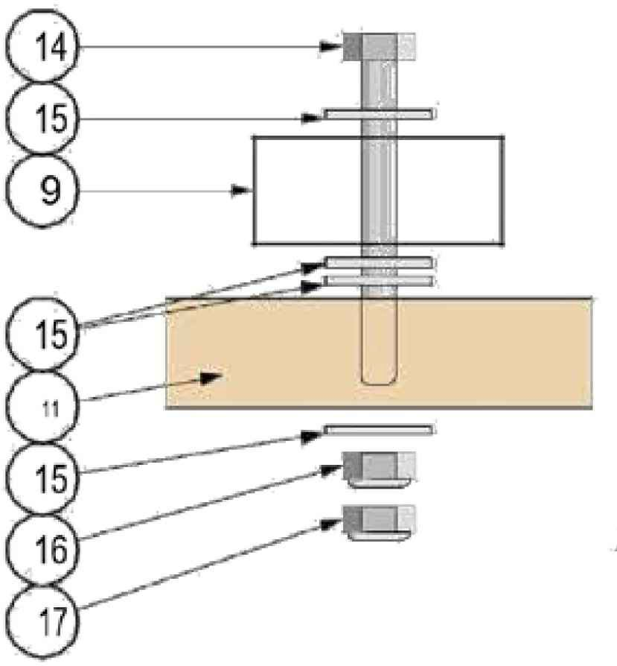
11
5
6
9
10
1
20"
7
4
15"
12" MAX.
9
3
8
2
TOP VIEW

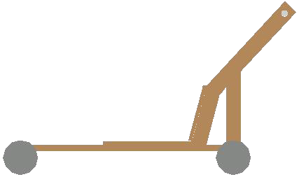



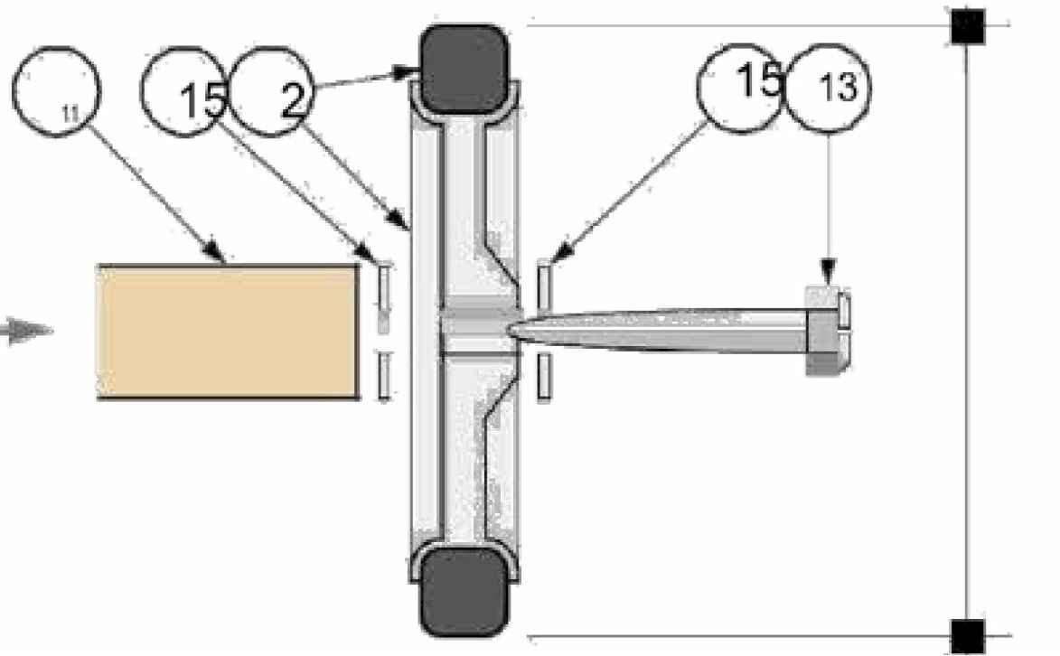
NOTES TO DRAWING
- WOOD PUSH BAR 1 1/2” DIAMETER (RECOMMENDED)
- WHEELS NOT TO BE LARGER THAN 12” DIAMETER
- 3/8" OR 1/2" PLYWOOD SEAT 15” WIDTH X 20” LONG (RECOMMENDED)
- STEERING BRIDLE, 1/4" NYLON ROPE
- STEERING MACHINE BOLT
- DRILL HOLES ON THE AXLES TO ADJUST CAR TO USER PROPORTIONS
- 2 X 4 SAFETY WOOD BLOCKS TO LIMIT STEERING ANGLE
- SEAT POSTS SUPPORT
- 2 X 4 WOOD CAR FRAME
- 2 X 4 HANDLE SUPPORT
- 2 X 4 X 28” WOOD AXLES
- CARRIAGE BOLT
- LAG SCREW (SEE ALTERNATE AND RECOMMENDED OPTION)
- MACHINE BOLT
- FLAT WASHER
- NUT
- SECOND NUT TIGHTENED AGAINST FIRST TO LOCK
- 3/8" OR 1/2" PLYWOOD SEAT 15” WIDTH X 13” HIGH (RECOMMENDED)
- 2 X 4 HANDLE POSTS VERTICAL SUPPORT
10

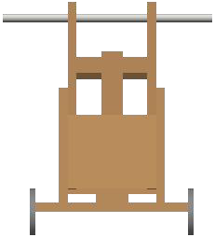


FRONT VIEW
1
10
8
19
18
3
11
2
28"

RECOMMENDED AXLE DESIGN
Using Lag bolts as axles is not recommended due to the number of races and teams the unit may use the car for during the event. A solid axle is recommended to ensure your racers spend more time on the track and less time in the pit (because that would truly be the pits). Below is one example of how to build an axle for your carts. This is not the only way or necessarily the best way.

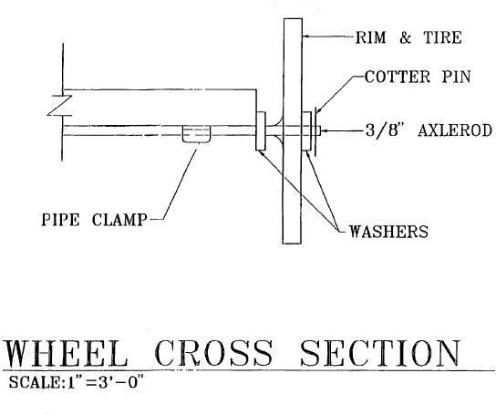

FOOTREST
To reduce the risk of drivers taking their feet off the steering bar to catch themselves should they lose their balance; a footrest is one minor modification that is also required.
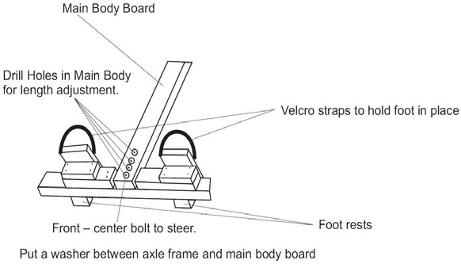

PUSHCART DERBY 2026 TEAM FORM (For Unit Use only)
It is the responsibility of each unit to read and understand the rules and regulations within the Leaders Packet.
Cost Per Team/Car: $40 includes 8 patches and chance for awards.
Pack #

Circle applicable Divisions:
Lions & Tigers (Div. I)
Wolves & Bears (Div. II)
Webelos & AOL (Div. III)

Team Name: Division #: ____ # of Youth(4-8): ____
Team Name: Division #: ____ # of Youth(4-8): ____
Team Name: Division #: ____ # of Youth(4-8): ____
Team Name: Division #: ____ # of Youth(4-8): ____
Team Name: Division #: ____ # of Youth(4-8): ____
Team Name: Division #: ____ # of Youth(4-8): ____
Team Name: Division #: ____ # of Youth(4-8): ____
Team Name: Division #: _________ # of Youth(4-8): ____

All units must provide at least two adult volunteers for the day’s event
1) 2)
Cell #: Cell#
3) 4)
Cell #: Cell#__________________

