ARMADILLO DISTRICT
Capitol Area Council, Texas

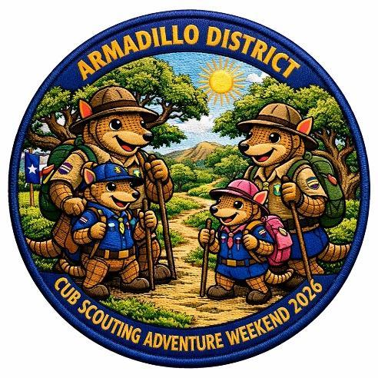

CUB SCOUTING ADVENTURE WEEKEND

GUIDE 2026
October 23-25, 2026
Smilin’ V Scout Ranch
250 County Road 286 Spur, Liberty Hill, TX 78642

REGISTER ONLINE AT
https://scoutingevent.com/564-116623

Scouting Adventure Chair: Brian Shipman (210)413-7353, me@brianshipman.com
Staff Lead: Enrigue Trejo (512) 415-2823, atxtroop33@gmail.com
Administration Lead: Sean McCain (512) 587 9070, sean.armadillodistrict@gmail.com
Health Officer: Nichol Howard (515)637-1552, nhoward1986@outlook.com
Order of the Arrow Chapter Advisor: Justin Smith, (801) 419-6462, justin@troop685.com

Capitol Area Council, Armadillo District, Cub Scouting Adventure Weekend 2026 (CSAW26)

This Guide has the information and directions to prepare you for a successful weekend at CSAW.

When: Friday, October 23 to Sunday, October 25

Where: Smilin’ V Scout Ranch, 250 County Road 286 Spur, Liberty Hill, TX 78642

Directions to 250 County Road 286 Spur, Liberty Hill, TX 78642
Take US-183 N to Highway 29 West  Turn left onto Highway 29 West; go 2.4 miles  Slight left onto FM1869/RR1869; go 6.6 miles  Turn left onto CR 285; go 1.0 mile  Turn right onto CR 286; go 0.7 miles  Slight right onto CR 286 Spur; go 0.3 miles  Take the 2nd right to enter Smilin’ V Scout Ranch parking area | 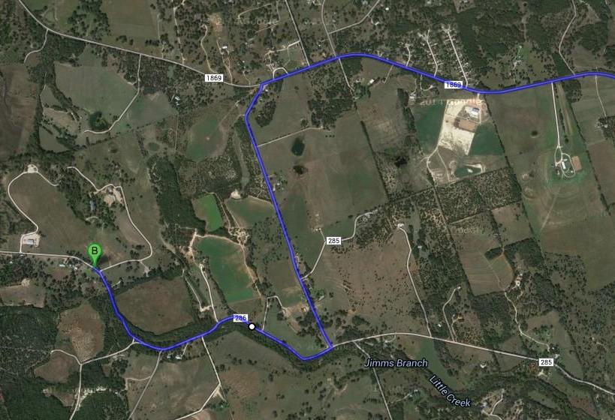

What: CSAW is a two-night Cub Scout camping event that is staffed by older youth and Scouters. This event is about giving our youngest Scouts a great weekend with Scouting basics: camping, hiking, advancement and the outdoors . . . rain or shine. There will be Range and Target Activities with BB guns, archery, and slingshots along with Adventures for each Cub Scout rank. Participation can be camping one or two nights; or day-only for both Cub and Staff registrants.

Cub Scout Activities (Lead by Staff made up of Troops and Crews)
Examples of Cub Scout Adventures and activities being presented by Staff:
- Lion--On Your Mark Adventure with Red Light Green Light Relay, Obstacle Course, and Lion Box Car Derby - all Staff units (Troops & Crews) are asked to bring a Lion Box Car with Scout appropriate decoration that can include Unit information, be no longer than 30 inches and no wider than 18 inches, include shoulder straps so a Lion can comfortably carry it -

- Tiger--Tigers Tag Adventure with Blob Tag, Pass the Ball, Being a Good Sport
- Wolf--Paws of Skill Adventure with Kickball and its rules, understanding the Scout Oath and Law
- Bear--Bear Habitat Adventure that includes preparing for a 1-mile walk with the six essentials, map reading, learning the path, Leave No Trace, and going on the 1-mile walk.
- Webelos--Webelos Walkabout Adventure that includes preparing for a 2-mile walk outside, planning the walk, checking the weather, SAFE Checklist, First Aid, Leave No Trace, going on the 2-mile walk and discussing the results of the walk.
- Arrow of Light (AOL)--Outdoor Adventurer with Scout Basic Essentials, gear for an overnight campout and how to carry it, SAFE Checklist, campsite location and setup, food and kitchen safety, discussing the results of the campout
  - Activity--Map Reading and Planning the Walk activity station on the 1 and 2 miles walks at Trailhead
  - Activity--Six Essential, SAFE Checklist activity station on the 1 and 2 miles walks at 1/10th mile in
  - Activity--Leave No Trace activity station on the 1 and 2 miles walks at 2/10ths mile in
  - Activity--Packing for a Campout activity station on the 1 and 2 miles walks at 3/10ths mile in
  - Activity--First Aid activity station on the 1 and 2 miles walks at 4/10ths mile in
- Range and Target Activity rangemasters want all Cubs to get to shoot at target in BBs, Archery and Wrist Rocket.
  - Activity--Hammer, nails and wood activity station at the Target and Range Activities Area
  - Activity--Challenge and Teambuiding activity station at the Target and Range Activities Area
  - Activity--Target Practice with hula hoops and a frisbee activity station at the Target and Range Activities Area
- DRAWING activities, with paper and markers at the Large Pavillion. Materials for the adventures will be provided.

Food, Water & Utilities
- Each unit is responsible for providing food and drinks for their Scouts and adults over the weekend. Packs should be Be Prepared to host a member or two of the Admin Team for each of the meals. The Admin member is there to talk about Scouting and ensure a two-way communication channel with your Pack.
- Potable water is available at Smilin' V Scout Ranch. Water spigots are located at Pavilion #1, Pavilion #4, Administration Building, Stable, and Large Pavilion kitchen. We encourage units to bring adequate water containers – or carry-in H2O for their purposes. Plan on at least one gallon of water per person per day. Each person should carry a water bottle throughout the day. Please make sure that everyone stays hydrated.
- Water will be transported to the ranges and activity stations by service staff.
- No electricity is available at the campsites. No gas generators allowed. Coordinate with Admin Building on electricity needs.
- Cell phone service is available, but reception is better in some spots than others.
- There will be a Dutch oven cooking contest for Staff units on Saturday evening. Bring your favorite recipe! The Staff camping area does not have fire rings so Be Prepared to use raised charcoal tables or other camp fire rings. There are two prizes – one for Savory and one for Sweet. (cancelled if fire-ban)

Parking
- Plan to park in the parking lot
- Do NOT drive off the gravel roads
- One vehicle with or without trailer will be allowed near the campsites, plan accordingly
- Arrive, park, and carry gear across the bridge to Pack campsite near a pavilion. You may want to bring small wagons to carry gear. Feel free to reach out to Staff volunteers for help.
- Packs will camp in designated campsites around Pavilions #1, #2, #3, #4

Check-in
- Check‐in is Friday evening starting at 5:00 pm or Saturday morning starting at 7:30 am.
- You will need:
  - Final unit roster
  - Copy of BSA medical forms Parts A&B for all participants
  - Order of the Arrow Callout list, if applicable
  - Payment for any additional attendees
  - Copy of current Securing Youth Training (SYT) certificates for all registered adults
  - Late arrivals/early departures must check-in/out at the Administration Building. After dark, staff escort is required between parking and campsites.

Uniforms
Packs and Staff units are encouraged to wear your distinctive unit T-shirts (“Class B”) during all activities for comfort and to save field uniforms (“Class A”) for Flag raising, campfire and Sunday’s Scouts Own Service.

Bathrooms
There are twelve (12) permanent restrooms available for adults, visitors, male Scouts, and female Scouts. Port‐a‐potties will supplement these facilities.

Eligibility and Definitions
All youth and Scouters registered with Scouting America are eligible to attend the Cub Scouting Adventure Weekend. We follow Cub Family Camping practices in accordance to SYT guidelines. Guests are welcome to attend the Saturday night campfire, but must leave once the campfire has ended. Any others not registered with Scouting America must be accompanied at all times by a registered Scouting America leader.

Per Scouting America requirements, all adults (18 and older) attending an OVERNIGHT event / activity must be currently registered in a position in Scouting America and have a current, valid Safeguarding Youth Training (SYT) certificate, and completed Part A & B of the medical forms.

Cub Scout EXCEPTION: Cub Scout’s parents or legal guardians taking part in an overnight Cub Scout program with their own child or legal ward are not required to register as leaders in Scouting America. All adults must review the “How to Protect your Children from Child Abuse: A Parent’s Guide” that can be found in the front of each Cub Scout handbook. In addition, the parent or legal guardian must be accompanied by a registered Scouting America leader any time they are with youth members other than their own child/ward. All other overnight adults must be currently registered in an adult fee required position.

Registration
Early bird pricing of $10 for the first 300 registrations. Staff (Troops, Crews, and Scouters not with Packs) price is $10 until registration closes October 25, 2026. Registration fee is per attendee.

For your information:
Early Bird registration $10 -- First 300 registrations
Regular registration $15 – After the first 300 registrations.

Staff Opportunities
As Staff, the Troops and Crews have an opportunity to:
Introduce your Troop and Crew to attending Cub Packs: help them learn hiking and camping right! Cub Scouts get a good experience – rain or shine -- hiking and camping with rank advancement and target shooting fun.
- Service Hours for all Scouts supporting Cub Scouts.
- Camp for one or two nights; or Saturday-only.
- Compete in the Dutch Oven Cooking Challenge
- Connect with your District Cub Scout Packs and Dens. Clever idea: offer to Grubmaster a Pack of your choice! Impress Cub parents watching Scouts cook, serve & clean.
- NOT a recruiting event – It’s service to Cubs. All participating units and adults will be recognized and promoted in-accordance-to Scouting America guidelines throughout the weekend.
- NOT Troop or Crew camping, its Troop and Crew units providing staff to a Cub Scout event and camping in the staff area – more information on methods and etiquette in October Leader’s Guide Part 2 Update.
- IS a Troop Promotion, Advertising & Service event – each staff adult instructor (18+ years old) and Troop unit get a yard sign with a QR code to your home page.

Staff units will camp far-away and across the road (east) from the Cub Scout camping area pavilions in a well-marked Staff camping area. District Staff, individual-registrants, and range staff will camp together.

Other Items
Campfires are allowed only in campfire rings and if there is no burn ban. Gas stove cooking is always allowed.

Units must consolidate equipment into one vehicle or vehicle with trailer that can go to the campsite and park.

Staff unit sites are sited by 1st arrivals - 1st placed: North —> South direction.

Summary of CSAW staff roles & positions:
- Event Lead – Brian Shipman, Pack 685
- Staff Lead – Enrique Trejo, Troop 33
- Range Lead – Bill McGuire, Crew 3
- Administrative staff – Sean McCain, Troop 9
- Service (2) w/truck OPEN
- Program guides leading Packs on the Adventure Hike – Staff volunteers
- Instructors in Cub rank advancement at activity locations on the Cub Adventure Hike -- Staff volunteers.
- Staff volunteers can support in the BB and Archery ranges as range masters, advancement-instructors and safeties.

General Schedule
- Friday, October 23rd – Sunset 6:53 PM – dark at 7:21 PM
  - 5 PM - Check in starts
  - Set-up camp, settle in for fellowship at your campsite or the Large Pavillion
  - 8:30 PM Staff Meeting with Unit Leads (youth and adult) at the Large Pavillion
  - 9PM - Pack lights out
  - 10PM - Staff lights out

- Saturday, October 24th – Twilight 7:09 AM -- sunrise 7:41 AM
  - 8 AM - Breakfast at campsites
  - 8:45 AM Opening Ceremony at the flagpoles, come with your units Flag
  - 9 AM to Noon - Target and Range Activities and Adventures - Scheduled to be provided in October
  - Noon to 1PM - Lunch at campsites
  - 1 PM to 4 PM - Target and Range Activities and Adventures - Scheduled to be provided in October
  - 4 PM to 5:30 PM - Present Campfire skits, songs and stories to Admin team for approval at the Large Pavillion
  - 5:30 PM to 6:45PM - Dinner and cleanup at campsites
- Saturday evening – sunset 6:51 PM – dark 7:14 PM
  - 6:45 PM “Campfire” at Large Pavillion
  - 8:00 PM Pack specific activities like S’mores and group activities like night kickball with glow in the dark ball, astronomy and night hike
  - 9PM - Pack lights out
  - 10PM - Staff lights out
- Sunday, October 25th – Twilight 7:23 AM Sunrise 7:44 AM
  - 8 AM - Breakfast at campsites
  - 8:30AM - Scout’s Own Service at Large Pavillion
  - Camp clean up - Units must walk their camping area with the Admin Team and get approval
  - Check out - Pick up medical forms A and B or binder from the Health Officer

Important: All participants must register for the Armadillo Scouting Adventure Weekend.
- If you are an individual who is not with an attending unit, you should register as an individual. If a Troop or Pack registers you, you should NOT register as an individual.
- All payment adjustments after ONLINE registration closes (October 16th) may be made at check-in with event staff. Additional Scouts and leaders may be added at check-in.
- Registration, payment, and refunds will be according to Capitol Area Council policy.
- All registrants will receive an Armadillo District Cub Scouting Adventure Weekend 2026 patch.

Security, Safety and Administration
- Make sure all Rosters and Medical forms are filled out prior to arriving at camp. Rosters must include SYT dates to prove validity
- All youth and adults are issued a wrist band indicating that they have checked in.
- Unit youth who are trained Den Chiefs; please wear your Den Chief cords.
- If any person is identified as not properly checked in (no wristband), then they should be escorted to the Admin Staff to get properly signed in.
- For security, no youth camper should leave camp without the unit leader first bringing the camper to admin and meeting the person signing the camper out in the presence of an admin staffer.
- At least two registered adult leaders who are 21 years of age or older are required to attend with each unit, and to be present during the entire Scouting Adventure Weekend. Units bringing female youth must bring at least one registered adult female who is 21 years of age or older. All leaders must have a current Safeguarding Youth Training (SYT) certification.
- Individual units are responsible for keeping track of their members at all times.
- Past problem: Staff unit parents leave camp (& town) after youth drop-off without back-up: emergency or adult contacts on the medical form should be available to pick up their Scout within a few hours after being notified of the Scout becoming sick or of other medical issues.

