Lost in the Woods

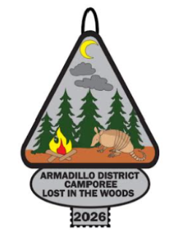
Armadillo District Camporee 2026
Leader’s Guide
March 6-8, 2026
Camp Green Dickson
Gonzales, Texas

Questions?
Camporee Chairs:

Sean McCain 512-587-9070
ScoutmasterT9Austin@gmail.com

Maya Gamble 512-922-3936
maya.scout.troop@gmail.com

Camporee Theme – Lost in the Woods

In a dense national forest, a patrol of Scouts on an overnight navigation exercise found themselves disoriented as dusk approached. The map they were using had water damage, rendering crucial landmarks illegible, and their compass had been accidentally damaged earlier in the day. Panic briefly set in as the sun dipped below the horizon, but they quickly remembered their core training. Instead of wandering aimlessly, they halted their movement, employed the “STOP” method—Stop, Think, Observe, and Plan. They observed their surroundings, identified a nearby stream, and planned their next steps, realizing that following the water downhill would eventually lead to a known trail or road, increasing their chances of rescue.

Utilizing their acquired survival skills, the Scouts focused on immediate needs: shelter and warmth. They worked efficiently as a team, using a shared survival knife to gather deadwood and pine boughs. Within an hour, they had constructed a lean-to shelter reinforced with debris insulation to protect them from the cold night air. Next, they practiced their fire craft; using a ferro rod from their emergency kit, they ignited a small, controlled fire. This provided essential warmth, a morale boost, and a safe way to purify water from the stream using a metal container they carried. Their training superseded their fear, allowing them to establish a secure, if temporary, camp.

As dawn broke, the fire was maintained, providing a clear smoke signal visible above the tree line. They organized their limited rations, making them last longer, and used a signal mirror to flash light toward the open sky intermittently. Their proactive use of signaling devices and resourceful approach to self-reliance paid off. A search-and-rescue team spotted their smoke signal mid-morning. The Scouts emerged from the woods tired but safe, proving that the discipline, preparedness, and practical skills learned through the Scouting program are invaluable tools for facing unexpected challenges in the wilderness.

General Information

Our Armadillo District Camporee will be held March 6th through 8th at Camp Green Dickson. Camporee is an outstanding opportunity for Troops, Venturing Crews, Sea Scout Ships and Explorer Posts to showcase Excellence in Teamwork, Scout Skills, and Spirit. Camporee is also a fantastic opportunity for fellowship and camaraderie with Scouts from other units in the District.

If certain individuals, patrols, or entire units elect not to camp, please make sure to follow the proper check-in and out procedures. Make sure proper two-deep leadership is present in any decisions made.

Awards will be given for each event, top patrol for overall skill, top patrol for overall spirit, top unit, best campsite, best gateway, and possibly a few others. Campsite inspections will be judged in the traditional Jamboree camping style. This includes orderly tents and kitchen area, cleanliness of the site, signage, proper storage of tools, etc.

Registration Information

Early Bird Registration: January 12, 2026, through January 22, 2026 ($10 per participant)
Regular Registration: January 21, 2026, through February 20, 2026 ($15 per participant)
Adult Staff (As advised): January 12, 2026, through February 27, 2026 ($15 per participant)
Saturday Only: January 12, 2026, through February 27, 2026 ($15 per participant)
Late Registration: February 21, 2026, through February 27, 2026 ($20 per participant)

All registrants will receive a Camporee Patch.

All units/participants should be registered online before February 27, 2026, to allow Camporee staff the opportunity to accommodate each unit/participant. There will be no on-site registration, no exceptions.

It is best that you register as a Unit. Payment may be made online, by check to the Frank Fickett Scout Training and Service Center, or by check at event check-in. If you are an individual not with a Unit (such as a staff member), you will select the link to register as an individual and pay the fee. If your unit registers you, you do not need to register as an individual. If you have trouble paying online, contact the Camporee Chair. Those requiring registration assistance should contact the Camporee Chair.

Following registration and payment, refunds will be considered only according to standard Council policy.

Eligibility

All adults must have a physical copy of their valid SYT certification. All youth participants should be registered with/according to their unit. Anyone who is not registered with Scouts BSA is not allowed to attend daytime activities or overnight camping. However, guests are welcome for the Saturday night campfire, but should leave once the campfire has been completed, and are to be checked in/out upon arrival/departure.

Event Overview

We need unit participation in sponsoring/manning an event station, so please look over our events section and sign up for a hosting leadership role. You will be responsible for staffing and supplying these stations. Please let the Camporee Chair know which event your unit is choosing to host by emailing your choice to ScoutmasterT9Austin@gmail.com. Please contact the Camporee Chair with two or three options (ranked in interest) in case another unit has already secured event stations.

There will be an Opening Ceremony on Saturday morning. Patrol competitions will begin afterwards. Each patrol should complete at least 8 of the 10 events. Saturday evening, we will have a campfire, skits, awards, and an Order of the Arrow call-out (dependent on Units and nominated individuals attending). The Armadillo Chapter will also have a Brotherhood Ceremony for eligible members. Please sign up in advance at ScoutmasterT9@gmail.com. Sunday morning, we will have a Scout’s own service, clean up, and check out (Camporee staff must check and approve your campsite clean-up for you to be checked out and have medical forms/SYT returned).

Patrol Competitions
Each unit is encouraged to participate in all of the events. Scouts are encouraged to wear surviving the wilderness themed uniforms or Class B shirts during all activities for comfort and to save Class A’s for Campfire and Sunday’s Scouts Own Service.

Skits at Campfire
Each unit should create an original skit based on the surviving the wilderness theme. Higher scores will be awarded for originality and consistency with the Camporee theme. All unit skits will be scored by a panel of independent Scouters. Please prepare skits and have them approved by the District Executive or District Chair to participate.

Order of the Arrow Call Out at the Evening Campfire and Brotherhood Ceremony
Following skits will be the Order of the Arrow call-out ceremony. If you wish to have your unit members announced at Camporee, please make sure to have your list of candidates for the call-out and Brotherhood Ceremony to the District Order of the Arrow Chapter Advisor, Chris Connell, ChrisConnell.Scouting@bioexsystems.com.This call-out and Brotherhood ceremony is dependent on potential candidates from respective Troops, Crews, Ships, and Posts attending Camporee.

Travel Instructions
Camp Green Dickson:

- Take US-183 S to Gonzales, TX (70 miles from Austin).
- Turn left onto FM 532 East in Gonzales, go 8.5 miles.
- Turn right onto FM 795; go 3.2 miles.
- Bear left to continue on Co Rd 354; go 2.2 miles.
- Entrance gate on the left.

If using Google Maps for directions, input “Camp Green Dickson” for the destination.

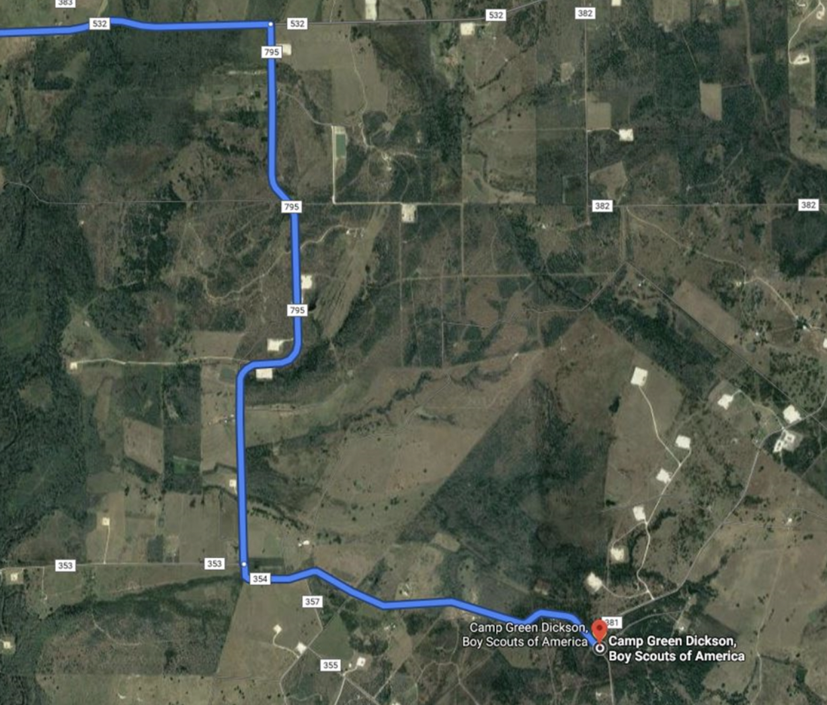
Unit Arrival & Camping Arrangements
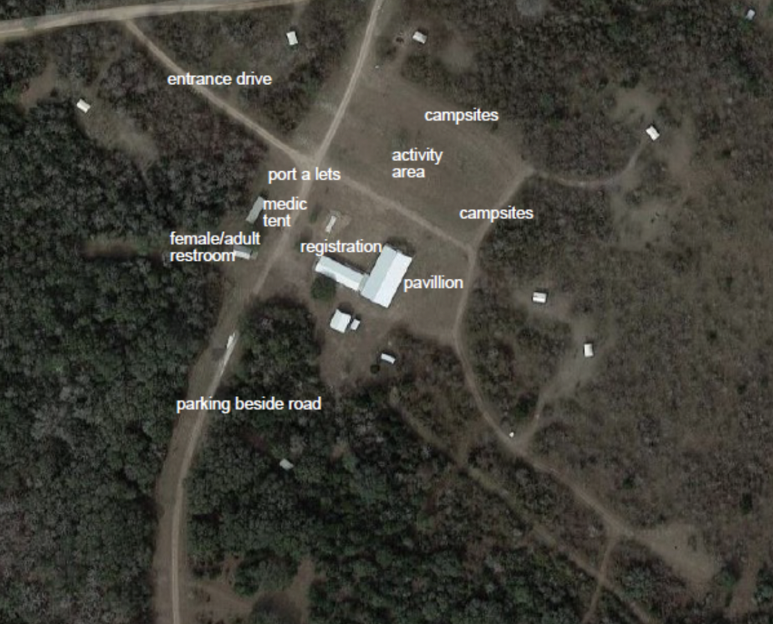

Parking
Parking attendants will be available to direct traffic onto the campgrounds on Friday night and Saturday morning. To facilitate the large number of vehicles arriving at the event, we ask that Units consolidate equipment into as few vehicles and trailers as possible. Vehicles/trailers carrying unit equipment will be directed to the campsite. All other vehicles will be directed to the parking lot. We ask that scouts and adults carry their personal equipment from the parking lot to their designated campsite. We will have large maps and signage to guide you.

Upon Arrival
When your entire unit has arrived in the campsite vicinity, please send a single person to check in at the Camp Green Dickson entrance. Checking in outside of the scheduled time will be allowed on Saturday only at the designated registration point. Anyone who has been checked in to the campsite, that it leaving must check out at the registration point prior to leaving.

Check in Schedule:
March 6, 2026 - 6:30 PM through 9:30 PM
March 7, 2026 – 6:30 AM through 9:30 AM

You will need:

- Two updated attendance lists (one copy will remain with event staff).
- Copy of Scouts BSA medical forms Parts A & B for all participants.
- Order of the Arrow Call-out List and Brotherhood Ceremony candidates, if applicable.
- Check for registration fees, if applicable.
- Copy of SYT Certificates for all adults staying to camp overnight.

Participant Arrival Outside of Allotted Check-In Schedule
Participants must report to the Registration Office to be given directions to campsites and to collect fees, if they have not already paid. Please note that individual units are responsible for keeping track of which members are present at all times.

Campsite Assignment
Units will be camping within their designated boundaries, the size of which is set by the number of attendees that the unit registers. Campsite boundaries will be designated by stakes and marking tape plus signs with unit numbers. You will be assigned a campsite and given a map to locate it. Some units will share campsites. In those cases, please be considerate in leaving space if you are the first to arrive.

Gear Drop Off for Competitions
If your unit has equipment needed for competitions, you may leave it in the staging area close to the Pavilion to avoid the need to take it to your campsite.

Camp Rules
This is a Scouting event! As such, proper scout-like behavior is expected of all Scouts and all Scouters at all times. Individual units are responsible for monitoring their Scouts and adults. We are guests at Camp Green Dickson and have an obligation to leave it better than we found it!
Among the important ‘Do’s’:
- Have Fun!
- Obey the Scout Law!
- Leaders: Keep track of your scouts; Scouts: Let your leaders know where you are.
- Keep a clean camp. All camps will be periodically inspected, and camps must be completely kitchen-clean before departure on Sunday.
Among the list of ‘Don’ts’:
- No smoking – Adults or Scouts.
- No alcohol – Adults or Scouts.
- No damaging of property – including the Camp, other patrols, other Units, etc.
- No trash left for others to clean up.
- No personal firearms.
- No wandering into the back woods or other campsites not in use.

Schedule - Subject to Change

Friday, March 6
6:00-‐9:30 PM | Arrival; Setup Camp; Final unit roster/payment – Registration Office
10:00 PM | Cracker Barrel (bring your own food) – SMs / SPLs and Staff Chaplain Aid Meeting – at Pavilion
11:00 PM | Lights out

Saturday, March 7
8:30 AM | Event Coordinator Meeting; Hand out Event Maps; Pass out & explain score sheets -‐Pavilion
9:00 AM | Flag and Opening Ceremony at Flagpole.  Bring your unit’s flag.
9:30-‐11:45 PM | Patrol Competitions
11:45 -‐1:30 PM | Lunch at your campsite
1:30-‐2:45 PM | Patrol Competitions continue
3:00-‐4:30 PM | Service Project
4:30-‐7:00 PM | Skit Auditions reviewed at Pavilion  Tally awards points at Registration  Free time and Dinner  Pack up if not camping for the night
7:00 PM | Skits, Awards, Campfire and OA Call-out
11:00 PM | Lights out

Sunday, March 8
8:30 AM | Flag Ceremony
8:45 AM | Scouts Own Service
9:45 AM | Pack up/Clean Camp/Depart

The 2026 Camporee Theme is “Lost In The Woods"

Unit Competitions

All participants should carry water and snacks to get through the morning. Competitors will be attending various stations and performing physical as well as mental challenges, so “Be Prepared.” At some events, the Event Coordinators will have materials that you may need to complete the event. Remember that scout skills are the basis for all events.

Event coordinators (Units) will have the basic materials needed at each event. However, each patrol should at least have the following basic gear:
Patrol Flag
Scout Handbook (for reference, will be helpful)
Weather-appropriate clothing
Sturdy walking/hiking shoes Snacks/drinking water
Sun protection, if needed
Paper/pen/pencil
Bandana or scarf

Scoring
At each event, the patrol will be scored on a) skill (shortest time, success, etc.), and b) Scout Spirit. The scale is 0-10 for each item, with an 11 reserved for exceptional performance. The skills for almost every event are found in the requirements for Tenderfoot, 2nd Class, and 1st Class. Practice makes perfect.

In order to qualify for the Spirit Award or the Top Patrol Award (skill), a patrol must complete at least 8 of the 10 events. If a patrol completes more than 8 events, the best 8 scores will be used. Patrols can attempt an event one time.

Events
Each attending unit will manage one of the planned activities. The list of events follows. Please contact the Camporee Coordinator as soon as possible with your “Top 3” preferred activities. SPLs Roane Heining, Troop 9, and Emily, Troop 99 will work with your SPL or Crew leader to help coordinate the activities.

Camporee Activities 2026

- Survival Quiz Show
Skills Questions
Equipment: Scout Book (brought by participants and used for reference), list of questions with allowable answers
Objective: Ask skills questions, including topics like treating water, building shelter, knot demonstration, finding one’s way, first aid, and food preparation, based on skills included in the Scout Book.
Scoring: One point for correct answers

- Find Your Way Home
Orienteering Course
Equipment: Compass, 3 sets of instructions that include distance and degrees on the compass, objects in a field, multiple sets of instructions that lead to 3 objects in the field (ensure no Patrols have the same instructions). May include a 20-foot marking at home base for Patrols to measure pace prior to starting the course.
Objective: Patrols use the compass and instructions to locate 3 objects in the field and report back with the description of the objects located and the order in which the objects were located
Objective: Timed event scored as 15 points less than 7 minutes, 10 points less than 14 minutes, 5 points less than 20 minutes, 15 points for each object, and properly located.

- Keep it Cool
Water Race
Equipment: 8 Large Sponges, a 5-gallon bucket of water, a 1-gallon bucket
Objective: Use the 8 large sponges to move one gallon of water from the 5-gallon bucket to the 1-gallon bucket 20 yards away. Neither bucket can be moved by the Patrol.
Scoring: Fasted time to fill the 1-gallon bucket wins

- Nailed It
Team Nail Driving
Equipment: Each team will need a piece of wood, a hammer, a cord, a stencil, and nails
Objective: Using a stencil of a campfire, tent, tree, or bear, create an image of the stencil using wood, nails, and a hammer.
Rules: Can only use provided materials.
Scoring: The best version of the image wins.

- Fire and Water
Fire Building Challenge
Equipment: Tinder, kindling, fuelwood, matches, string, a metal bucket, and water
Objective: Patrols build a fire that floats on the water and must burn for at least 60 continuous seconds.
Scoring: Timed event from the start. Shortest time to burn fire for at least 60 continuous seconds wins

- Walk it Off
First Aid Challenge
Equipment: 4 triangle bandages, two 4” elastic bandage rolls, two splinting sticks or SAM splint, a water bottle with water inside, 7 index cards with one scenario written on each, and a hat or bag.
- Scenario A: A Scout trips over sharp rocks while hiking down a trail. They receive a cut on their left forearm that severs an artery. They also sustained a simple fracture of their lower right leg.
- Scenario B: The Senior Patrol Leader is kayaking over some rapids when the kayak crashes into a tree hanging over the river. The SPL receives a simple fracture of the right forearm and a gash on their right shoulder, causing arterial bleeding.
- Scenario C: While on a hike, a Scout patrol finds an electrical repairman lying at the bottom of a transformer pole. They are not breathing and have burns on both hands.
- Scenario D: While swimming in a country pond, one Scout jumps from a rock ledge and does not come back up to the surface. The other Scouts notice they are gone, jump in, and pull them out. They are not breathing and have a gash on their forehead that is bleeding profusely.
- Scenario E: A Scout is mountain biking when a dog bites them on the right ankle. The Scout swerves to get away and falls heavily on the road. They lacerate a large area of their left elbow, into which dirt and sand are ground into the elbow. Their left wrist is swollen and painful.
- Scenario F: A woman is pinned under a fallen tree branch at the edge of the lake. When she is released, it is found that she has a cut over her right eye and is spurting blood. Her right ankle is very painful and swelling rapidly.
- Scenario G: On an extremely hot day, several Scouts are sitting at the picnic table before starting lunch. One of the Scouts falls to the ground. Their face is hot, dry, and flushed, and their pulse is exceptionally rapid. Their left ear is torn and bleeding profusely.
Instructions: Write out one scenario on each card and place them into a hat or sack for blind drawing by a patrol. After drawing a card, patrols are allowed two minutes of deliberation before demonstrating a course of action that includes securing the scene, calling for help, and providing first aid for the emergency scenario drawn. The patrol with the highest scoring demonstration wins.
Scoring: Patrols can be scored by points (earn points for each correct step of response in the scenario, i.e., triage/assess, call for help, render first aid, etc.), time (complete task within a set amount of time, 15-30 sec penalty for improper first aid application), or a combination of time and points.

- Don’t Drop Them
Stretcher Race
Equipment: Two 6’ spars, blanket, lashing rope, wooden cross supports
Instructions: Make available the equipment and allow the patrol to look it over. Explain that the challenge is to move two youth from a starting point to an end point 20 yards away by using a stretcher. The method of stretcher construction is left to the patrol. The youth being transported cannot touch the ground, be dragged, or fall off.
Scoring: Timed event from “Go” to build the stretcher and move two youth across the end point.

- Home Sweet Home
Build a Shelter
Equipment: Tarp, limbs, branches, natural materials
Objective: Have the Patrols use the equipment to build a shelter
Scoring: Best shelter to cover two youth wins

- Signal For Help
Patrol Flag
Equipment: 1.5’ x 1.5’ fabric, fabric markers, Patrols can bring a prepared armadillo stencil
Objective: Make a patrol flag that shows an armadillo in the woods.
Scoring: Best design wins

- Can I Eat It?
Safe to Eat or Use
Equipment: Printouts of similar items that could be food, plants, water, heat, etc.
Objective: Assess if safe to eat, use, or touch. Explain what could be done to make the item safe without being unsafe. It would still be unsafe to defang a venomous snake, but boiling or treating river water could be safe.
Scoring: 1 point for correct identification of safe/not safe. Bonus 2 points if able to accurately state how the object could be made safe.

- Don’t Drown
Team Building
Equipment: Several planks or similar objects
Objective: Using fewer planks than patrol members, come up with a way to cross a “river” of 20 feet without getting wet. Only the Patrol Leader can talk after the initial planning assessment. Touching the water requires the whole team to start over.
Scoring: Timed event with bonus points for working as a team. Consideration given to team size.

- Guided Survival
Pitch a Tent in the Dark
Equipment: One small tent
Objective: Setting up a tent blindfolded, individually or as a team, for the fastest time

- Don’t Eat It Shelter
Log Cabin Building
Equipment: Mini marshmallows and pretzel sticks
Objective: Use the marshmallows and pretzel sticks to build a log cabin no bigger than 8” x 8” and two stories tall.
Scoring: Based on teamwork used to assess, design, and build the best log cabin

- Knot It!
Equipment: 15 lengths of 5’ cord
Objective: Tie a knot that is impossible to untie. At 2:30 PM, Patrols report back to the activity and are randomly assigned a knot to untie.
Scoring: Timed event. Two sets of times. Maker – Time it takes another team to untie the knot, longer the better. Destroyer – The time it takes to untie the knot, faster the better.

- FIRE!!!
Make a fire starter
Equipment: Cardboard egg carton, lent or similar material, paraffin or candle wax
Objective: Just have fun making a fire starter from an egg carton, lent and wax.
Instruction: Place lentils into the cups of the egg carton, melt wax, pout into the egg carton cups

- It’s On!
Tug-of-war
Equipment: Long, thick rope
Objective: Challenge another patrol to a best of 3 rounds of tug-of-war

- Hunt for Dinner
Archery
Equipment: Archery range and archery equipment, instructor, and Range Safety Officer
Objective: Safely enjoy archery

Lost in the Woods Campfire and Awards Ceremony
Each patrol should be prepared to perform a song, skit, or cheer on Saturday evening. All planned songs, skits, or cheers should be Lost In The Woods themed, so pull out those old favorites and rewrite them to match the theme. All skits must be submitted for approval by the District Executive or District Chair before campfire!

All Day All the Time
Proudly display your Lost in the Woods costumes. All Scouts and leaders are encouraged to wear wilderness survival-inspired outfits and accessories. No weapons allowed.

Gateway Competition
There will be a Unit award for Spirit Gateways. Your gate doesn’t have to be big, but it should be festive and represent your take on the Lost in the Woods!

Awards
Each unit-‐sponsored event will score its own activity and report results to Camporee staff. They will provide a skill score and a spirit score.
Traditional Camporee Awards will also be provided for the best Gateway and the best unit campsite.

Campsite Inspection Sheet

Unit & Patrol Sites
- Evidence of Scouts camping as Patrols (tents together, etc.) ________
- Dining fly is properly pitched ________
- Tents properly pitched ________
- Evidence of campsite improvements/gadgets ________
- Proper display of United States and Unit flags ________
- Tents have uniform and neat appearance ________
Health & Safety
- All tools & equipment safely stored ________
- If ax(es) present, ax yard properly marked and safe ________
- Liquid fuels properly stored ________
- Firewood neatly stacked in safe place ________
- Tent lines flagged for safety ________
- First Aid kit marked and in plain view of all ________
- Campsite clean and free of litter ________
Camp Kitchens
- Fire, if any, are in fire rings ________
- Unit use “Bearmuda Triangle Method” ________
- Kitchen clean and orderly ________
- Duty roster posted ________
- Menu posted ________
- Food properly and safely stored ________
- Dishwashing station set up properly ________
Total Score (maximum 100 points)
Total _______

Emergency Action Plan

Location: Camp Green Dickson
3360 County Road 381
Gonzales, TX 79629

Emergency:
Medical, Fire, Sheriff: Call 911

The physical address of the camp is noted above.

Notify camp headquarters immediately after calling 911.

Important Phone Numbers

Camporee Chair: Sean McCain 512-587-9070
First Aid at Camp: To be determined.
District Chair: David Stroud 512-413-1769
Activities Chair/NCAP Short-term: Stephen Harris
512-499-4351
District Executive: Amara Davis 210-788-5439

Emergency Shelter:
In case of dangerous weather, the pavilion will be used as an emergency shelter. If you cannot get to that building, the following standard safety procedures should be followed:

Lightning
- Adults, keep your car keys with you at all times.
- When lightning and thunder are less than 30 sec apart, seek shelter in an enclosed vehicle or building.
- Do not seek shelter under a lone tree.

Tornado
All campers will seek shelter in a ravine or other low area. Lie flat with hands/arms shielding head and face.

Camper Security

Make sure all forms are filled out before arriving at camp, please. Think of those waiting to be checked in after you. A Scout is courteous.

All fields on the unit registration form for each camper must be filled out and turned into the admin. Standard AO-804

No youth camper can leave camp without the unit leader first bringing the camper to admin and meeting the person signing the camper out in the presence of an admin staffer. Standard AO-804

Wrist Bands will be used throughout the event. Any person who is not wearing an arm band should report to an adult camporee staff member right away. Standard AO-804

Any unauthorized person in camp who may pose a possible threat should be reported to 911, and camporee staff should be notified right away. Standard AO-804

Per BSA requirements, at least two registered adult leaders who are 21 years of age or older are required to attend with each unit and to be present during the entire Camporee. Units bringing female youth must bring at least one registered adult female who is 21 years of age or older. All leaders must have a current Youth Protection Training/Safeguarding Youth certification.

Important Reminders

The following are some important reminders for Camporee (in no particular order):

Work gloves | Bring work gloves for the service project that we will work on with the camp ranger.
Fires | Any fires at the individual campsites must be off the ground so as to not burn / scorch the grass. Check current burn bans in effect before having any fire.
Trash | All respective unit trash should be packed out by the unit when they depart.
Unit gear | Large, bulky and heavy unit gear should be consolidated into one vehicle or trailer that will be allowed to pull up next to the campsites. The walk from the main parking area to the camping sites is not far.
Event gear | Make sure to read the event that your unit is hosting and bring all applicable items and gear to host the event. Camporee staff will provide scorecards. Contact Stephen Harris if you have any questions concerning items that you might need for your event.
Water | Camp Green Dickson has reported some issues with their well. Please plan to bring water for your unit.
Toilets | Portable toilets will be provided at Camporee.
Cracker Barrel | Please bring your own snack, food, and drink to the Friday night Cracker Barrel that we will have at the Pavilion.
Bandana / Blindfold | As some of the events require individuals to be blindfolded, please bring a bandana or blindfold for the Camporee events.
SYT Certificates | All adults should bring a copy of their SYT/ certificates upon unit check-in. Don’t forget to bring a copy.

