Eastern Service Area Middle Tennessee Council

Introduction to Outdoor Leader Skills (IOLS)

The Eastern Service Area will be hosting an Introduction to Outdoor Leadership Skills course on November 4-5, 2022. Located at Charles E. Parish Reservation (Camp Tubb). IOLS training is required for all Scoutmasters and Assistant Scoutmasters. But…. that doesn’t mean we can’t have some fun while we do it!!!
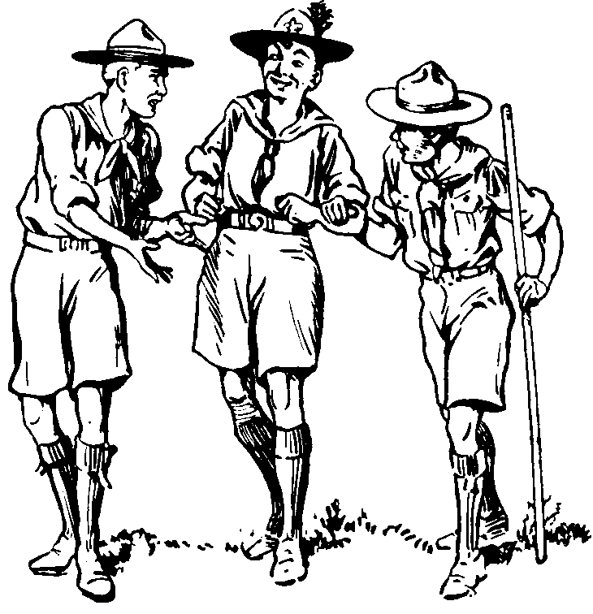
Charles E. Parish Reservation
400 Tubb Lane
Walling, TN 38587

November 4-5th, 2022
Course begins at 5:00 pm on Friday the 4th and will be completed by 4 pm on Saturday November 5th.
(approximately 23hrs must include overnight requirement)

We will have a conference call
for your convenience on Thursday,
October 27th at 7pm to better prepare you for these courses.

The Introduction to Outdoor Leader Skills course will teach participants the skills and knowledge necessary to take a youth from Tenderfoot to First Class. It will also provide an in-depth look into the patrol method by giving participants hands-on experience. This class is mandatory for all Scoutmasters and Assistant Scoutmasters, and is a prerequisite for troop leaders who wish to go to Wood Badge. Webelos leaders are also encouraged to come and participate. For those who wish, Introduction to Outdoor Leader Skills will also satisfy the requirements for Outdoor Leader Skills for Webelos Leaders.

To be eligible for the course please have your online Leader Specific training, YPT and your BSA Health form parts A and B completed.

Registration for the course is $25. Deadline is Thursday October 21, 2022, at 11:55 p.m.
Late registration will be $30 until Friday October 28th at 11:55pm. NO WALK ONS

Friday Night please bring your own sack dinner. Cracker Barrel will be provided after the evening campfire. Breakfast and lunch is included on Saturday. Be sure to bring a mask, camp chair, and personal water bottle.

To register, go to mtcbsa.org – Training or any Eastern Service Area district page – IOLS.
For more information, please contact: Linda Case: (615) 672-4031 or caselj@bellsouth.net

Camp Tubb at Parish Scout Reservation
