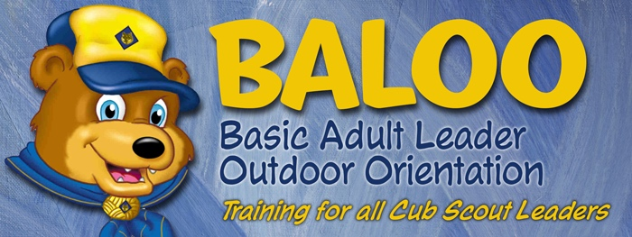
Cogioba
2022 BALOO

When: March 19, 2022

CHECK-IN: SATURDAY, MARCH 19 – 9AM
CHECK-OUT: SATURDAY, MARCH 19 - 6PM
LOCATION: CONTACT:
Scout Hub 514 Jeff Walter, District Training Chair
1751 Madison St. (931) 980-7889
Clarksville, TN 37043 Email: jeffreywalter13@gmail.com

REGISTRATION LINK: www.mtcbsa.org/Districts/Cogioba/Calender
Please select the date of the event and registration will be attached.
COST: $10 per adult

What is BALOO?
BALOO stands for Basic Adult Leader Outdoor Orientation. It's the introductory training Cub Scout leaders should complete before taking Cub Scouts on an overnight camping trip. The BSA requires that you have at least one BALOO-trained adult on every Cub Scout den or pack overnight outdoor event. That includes pack camping and Webelos den overnighters.
A BALOO-trained leaders should be at any overnighter regardless of whether it is a pack, district, or council event.
Having at least one BALOO-trained adult will make your Cub Scouts’ camping experience awesome as it can be.

