2026 MTC VOA

Klondike Leaders Guide
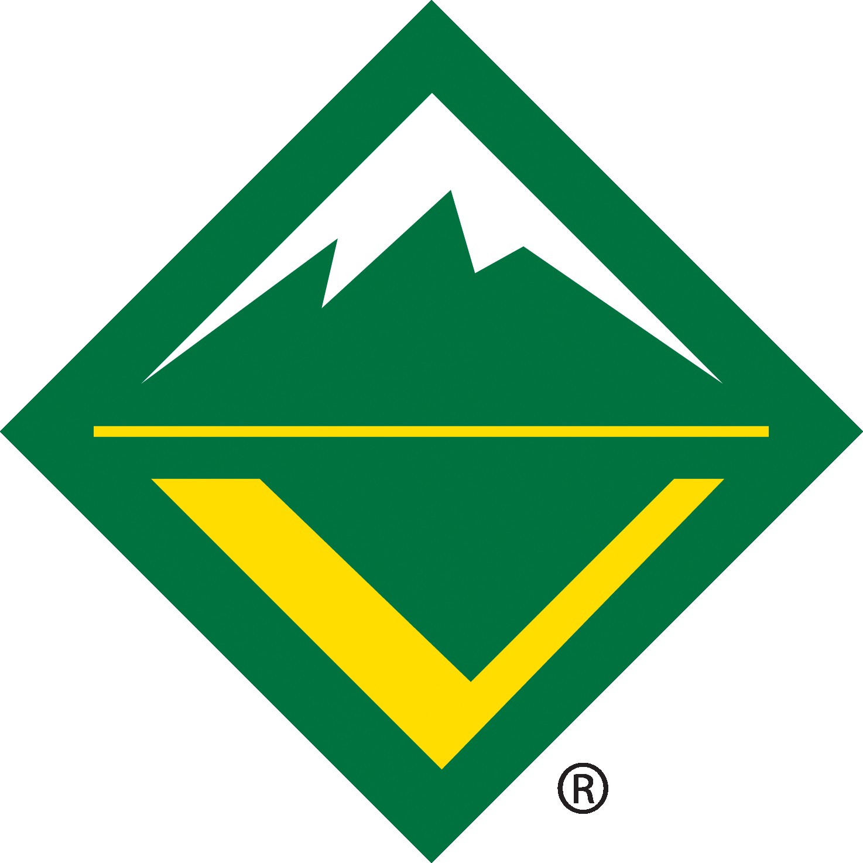

Table of Contents
Table of Contents 1
Overview 1
Registration 1
Sled Teams 1
The Klondike Derby 2
Towns (events) 2
Derby Map 4
Sleds 4
Special Event Gear 5
Clothing 5
Camping 6
Meals and Refreshments 6
Events Contests 6
Trading Post 6
Event Schedule 6
Appendix 7

Overview
The 2026 MTC VOA Klondike Derby is upon us, and this year’s theme is All In! This event will take place March 13th-15th, 2026, at Camp Craig on the Boxwell Reservation. This leader's guide will outline all of the important information, such as sled rules, an outline of all the events, and more. All of the information will be in this guide, there is no part B.

Registration
Registration may be accomplished online through BlackPug. The last day to register online is at 11:59 pm on Sunday, March 8th, 2026. The registration fee is $50. Staff members (stations and key staff) coming for the weekend may register as “Staff - Weekend” for $40. Staff members hosting stations coming for the day only on Saturday may register as ‘Staff - Sat. Only” for $10 (only lunch provided for those registering at this level). If you are planning to attend only for the day, please email MTCVenturing560@gmail.com for more information. A 5 day out virtual meeting will be held on Monday, March 9th, 2026, at 7:00 pm. An email will be sent the morning of the meeting to each unit leader registered with the link to the meeting.

Sled Teams
Crews, Ships, and Troops may register as many 4-6 person sled teams as they wish. Provisional sled teams are allowed. For more information about provisionals, please email MTCVenturing560@gmail.com. Each sled team will be responsible for their sled and gear. Teams may not share equipment on the course, as all teams will be running the course concurrently and will not be readily available to one another.
One Scout on the team shall be designated as their Team Leader, and one should be designated as the Musher (driver). The Crew Leader directs and manages their sled team while the Musher pushes the sled. All commands while moving the sled should come from the Musher. This position should be rotated so as not to burn anybody out. Sleds are encouraged to be decorated to match the theme. All sled teams are encouraged to have a team name, team flag, and team yell. Please be inventive and imaginative!
PLEASE NOTE: the events are designed for sled teams of 4 or more members. All gear on the sled is expected to support the number of members on your sled team. You are encouraged to have at least 5 Scouts per sled, partially because it can be tough to pull a sled with only 4 Scouts, and also, if you have an injured Scout, this will leave you with only 3 to pull the sled. Teams smaller than four are not allowed, and anyone younger than 14 is not permitted at this event.

The Klondike Derby
The Klondike Derby is made up of several obstacles along a trail. As each Sled Crew reaches the obstacle entrances, they will be greeted by the mayors (station staff). A cheerful and spirited reply will be expected. (Note: Some sled teams have been known to bribe the mayor. Some mayors may be bribable, while others may have higher integrity.) The mayor will explain the event or activity to take place within their town and any special rules or requirements of the obstacle. Some obstacles may be timed events, and others may be judged on the degree of completion. All obstacles are judged on teamwork. Each mayor will award sleds with points. Scoring will be by station, plus an overall award for best overall performance, spirit, and participation. No person except the sled team may be with the sled team between events. This includes adult leaders (Advisors, Skippers, Scoutmasters), siblings, & parents. Adults on site should be prepared to volunteer during the derby to assist alongside Town Mayors.

Towns (events)
PLEASE NOTE: The following contains information about what activities are at each station. To improve the event experience for the youth, it is asked that unit leaders not share information about the stations with the sled team, but rather what kinds of things to be prepared for. An example would be to simply say to “Expect mind games, scout skills, and tests of physical fitness.

- Geocaching - Camp Light
An orienteering course will be set up with 13 points. Each point will have a card, going up in value as they go. Each card will have instructions to the next card written on it. Cards may not be immediately visible, requiring some searching around the point. Score based on completion.

- Minesweeper - Duck Head
Members of the sled will arrive at Duck Head to find trash barrels arranged on the ground in a 6x6 grid. Under each trash barrel is a card. Members have to go one at a time, picking one barrel to flip the card that is under it, but replacing the barrel over the card. Members cannot receive any further help, direction, or instruction from their sled team once they are at the grid, ready to make their pick. There will be 6 jokers in the grid acting as mines. Each card flipped adds one point, not counting the same card twice. Mines take away 6 points each.

- Escape game - Craig Chapel
Members of the sled will arrive at the Craig Chapel and have to participate in an escape game. Score based on time.

- Chill out - HAB
A break station that will have the trading post set up and multiple decks of cards for entertainment. Town mayor has the option to run card games. This specific station may be altered to include a set activity.

- Retrieve the card - Field (?)
Each member of a Sled has to go through an obstacle course to retrieve a card and go back. The number of cards they retrieve in 5 minutes determines how many points they get, but they must stay in a specific order, meaning every member of the sled must participate an equal number of times.

- Emergency Fire - Fire Trail Entrance
Teams get a few cards from a deck, a few matches, and flint and steel, and whatever other resources they find to start a fire and burn a string suspended above their fire bin. Scored based on time.

- Ace Shot - NRA Rifle Range
Each sled member has a certain number of rifle shots to shoot at playing cards, and points are scored by accuracy. One person per team gets a chance to shoot an ace at a longer distance for bonus points.

- Sled Pull - High Adventure Field
There will be at least two mayors of this town, varying drastically in physical size. The sled will have to call heads or tails on a coin toss. If the sled wins the toss, they choose which advisor they have to pull 100 yards across the field. If the sled loses the toss, the mayors decide between themselves which of them will be pulled.

Derby Map
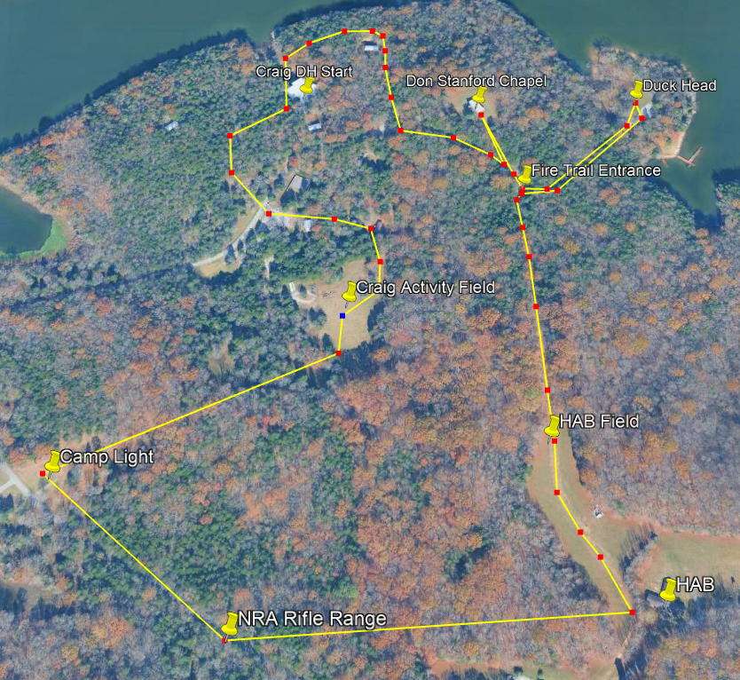
PLEASE NOTE: Map is not exact, it is a reference. The trails going to, between, and from Camp Light and the NRA Rifle Range are subject to change drastically due to varying upkeep. Updated map will be given to sled teams upon arrival.

Sleds
The Klondike sled is important, as it must be strong enough to carry all the team's gear or an adult and be durable enough to handle the rough Boxwell backcountry terrain. There are a variety of websites on the internet with sled plans. Choose whichever one you like, or go with a design of your own, just make sure it will pass sled inspection on Saturday morning. Below are the guidelines for a sled -
- Sleds should be made out of wood or PVC.
- Sleds should measure between 5’ (60”) and 7’ (84”) in length.
- Sleds should measure between 18" and 26" in width.
- Sleds should be at least 36" in height.
- Sleds must have a tow rope securely attached to the front of the sled.
- Sleds must have a brake rope securely attached to the rear of the sled.
- It is encouraged to use hardwoods for the sled runners or a set of skis.
- Sleds must be assembled using screws or lashings. Metal "L" brackets and metal supports are prohibited.
- Using nails for assembly is prohibited.
- No sharp objects protruding from the sled, i.e., screws, sticks. Staves are an exception.
- All sled and team gear may be lashed to the sleds. Bungee cords are prohibited.
- Either your unit number, team name, or team flag must be visible on the sled at all times. Sleds are highly encouraged to be decorated, painted, or stained.
- Wheels, rollers, tracks, levers, motors, or any other feats of engineering designed to provide a mechanical advantage are prohibited.
- Resources for Sleds are provided in the Appendix.
- Note: the rules above apply to the resources in the appendix. The resources are only for ideas/references.

All sleds and gear will be inspected. Corrections must be made before the derby starts Saturday morning. All sleds must meet these standards and include the special event gear. This is a scored event, and a missing sled, missing event gear, or a sled that does not meet the guidelines will lose points until all deficiencies are corrected.

Special Event Gear
Each team must have all of these items on their sled. The team may use anything on the sled to complete any given task. If there is a change to any obstacle task or material needed for the sled, the Crew Advisor, Ship Skipper, or Troop Scoutmaster will receive a call from the activity chair advising of the change. Below is a list of required materials that must be carried on the sled -
- A first aid kit
- An orienteering compass
- Flint and steel

Clothing
Be comfortably cool. Wear clothing in layers. Layers can be removed and carried on the sled. They can be put back on if the sun goes down or it begins to get cooler on the trail. Since Scouts will be racing around the course, it is likely they will build up a sweat. Therefore, cotton clothes should NOT be worn close to the body.
WE CANNOT STRESS CLOTHING ENOUGH!!!! THE CONDITIONS AT KLONDIKE ARE VARIABLE AND ALMOST ALWAYS COLD, WET, WETTER, OR SOAKED DOWN DEEP TO MY BONES WET! STAYING WARM IS ESSENTIAL TO SAFETY AND TO COMPLETING THE COURSE! WHILE FIRST AID IS A SKILL WE NEED TO COMPETE – WE DON'T WANT TO USE IT IN A REAL-LIFE SCENARIO AT KLONDIKE!

Camping
Base Camp for the 2026 Klondike will be at Camp Craig. Upon arrival, please drop off your sled and gear at the Dining Hall or at your campsite, then park at the Craig parking lot. Weekend long parking at the Dining Hall, the HAB, or the top of the hill at Craig are reserved for staff. Each unit will be assigned a campsite upon arrival. If you wish to have a fire at your campsite, fire barrels and fire extinguishers will be available at the Dining Hall. Advisors, Skippers, and Scoutmasters are responsible for two-deep leadership and co-ed camping. Crews, Ships, and Troops are asked to help by making the best use of the camping space so all scouts can be accommodated.

Meals and Refreshments
All meals will be provided, but please plan on providing your own food if you have special dietary needs. Cracker barrels are also in the plans. Within registration, please let us know any dietary restrictions we should be aware of. Feel free to bring your own snacks on the trail!

Events Contests
This year, we will be having one contest, a Dutch oven cooking contest. The dish should be ready to be presented to the judges at dinner on Saturday night. The winner will be announced on Sunday morning with the rest of the awards.

Trading Post
There will be a trading post at Klondike! There will be small refreshments, such as sodas, chips, and candy, as well as merchandise for the event. The trading post will most likely accept cash only. The Trading Post will be in the Dining Hall over the weekend, relocating to the HAB during the sled derby itself.

Event Schedule
Friday, March 13th, 2026 -
- 5-7 PM - Check in @ Craig Dining Hall
- 7-8 PM - Opening Campfire @ Campfire Area
- 8:15-8:45 PM - Leadership meeting w/Crew Leaders and Adult Leaders @ Craig Dining Hall
- 11 PM - Lights out @ Campsites
Saturday, March 14th, 2026 -
- 7-7:30 AM - Last-minute check-in @ Craig Dining Hall
- 7:30-8 AM - Flag @ Flagpole
- 8-9 AM - Breakfast @ Craig Dining Hall
- 9:30-9:45 AM - Safety Check @ Under the Veranda
- 10 AM - Start Klondike! @ Craig Dining Hall
- 12-1 PM - Lunch, pause all activities. Go to the nearest station for lunch.
- 1-4 PM - Stations.
- 4-5:45 PM - Open Activities @ Craig Dining Hall
- 6 PM - Flags @ Flagpole
- 6:30-7:30 PM - Dinner @ Craig Dining Hall
- 8 PM - Announcing Winners @ Craig Dining Hall
- 11 PM - Lights out @ Campsites
Sunday, March 15th, 2026 -
- 7:30-8 AM - Flag @ Craig Flagpole
- 8-8:30 AM - Scout’s Own Service @ Craig Dining Hall
- 8:30-9:30 AM - Breakfast
- 10 AM - Council VOA Meeting and Elections @ Craig Dining Hall
- 12 PM - Camp closed.

Appendix
Remember to surf the Internet safely! These links have been pursued, yet we cannot guarantee that they will not change and that the links from the pages are safe. Use adult guidance and good judgment when searching!

Sled Plan Build Links -
https://scoutingevent.com/Download/062125565/OR/Klondike_Derby_Plans_for_Sleds.pdf
https://scoutdocs.ca/Klondike/Klondike_sled_plans.php
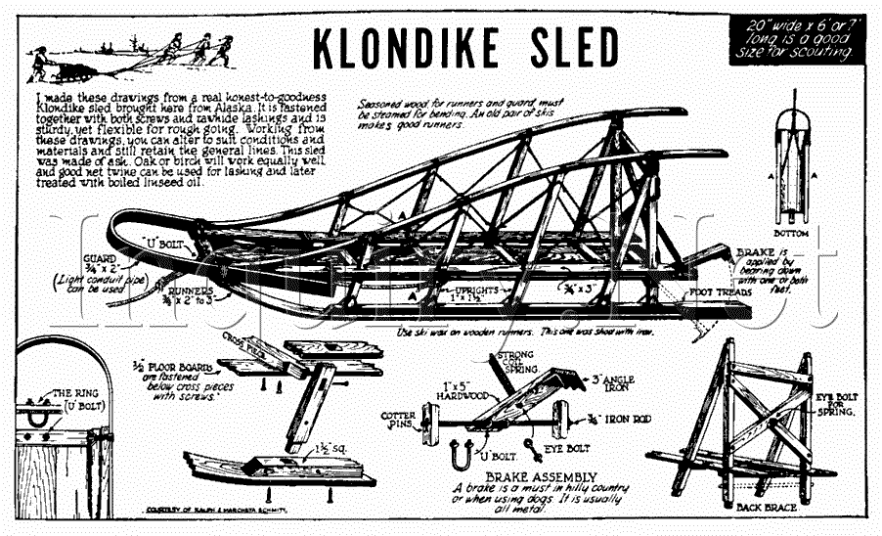
https://skcscouts.org/wp-content/uploads/2019/12/2020-Klondike-Sled.pdf

