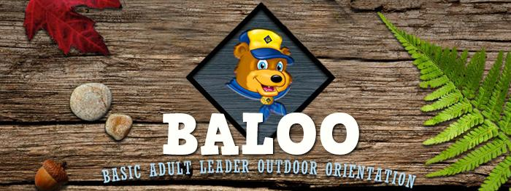**BASIC ADULT LEADER OUTDOOR ORIENTATION**

**Boxwell Camp Craig**

**September 26-28, 2025**

**$40.00 including meals**

**Sandra Green 615-856-7777 eph5@att.net**

**Who should take this training?**

Cub Scout Leaders including Cubmasters, Assistant Cubmasters, and Den Leaders.

**Why BALOO?**

This session follows the full BALOO syllabus, giving participants a unique, hands-on experience with knot tying, camp cooking, and other essential Cub Scout camping skills. You’ll gain the knowledge and tools needed to plan and conduct safe and successful overnight camping experiences for your Pack. Throughout the course, you’ll work as a team alongside fellow Scouters from across the council, building both skills and connections.

A BALOO-trained adult is required to be onsite for any overnight camping trip (Pack, District, or Council). It’s highly recommended to have more than one leader in your Pack complete BALOO training to ensure coverage if the primary trained leader is unavailable.

**What to Bring:**

* BSA Medical Form A and B
* BALOO online training certificate (My.scouting.org>>BALOO Prerequisite Training v2)
* Camp chair
* Personal camping equipment (a suggested gear list will be emailed to those who register).
* Field Uniform and Activity Uniform (Class A and B), plus clothing appropriate for the weather.

**Note:** Please eat supper before you arrive Friday evening. Additionally, reach out with any dietary restrictions so that we may accommodate you.