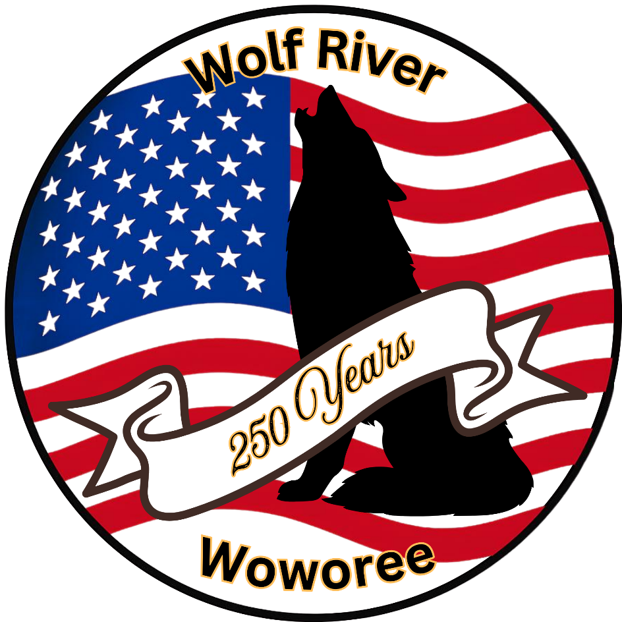
Wolf River Woworee 2026

Friday-Sunday, September 25th-27th, 2026 Camp Currier, Eudora MS

Hosted by
Wolf River District

Welcome to Woworee 2026

Welcome all Arrow of Light, Scouts, Scouters and Arrow of Light Parents to our upcoming Woworee.
What is a Woworee? A Webelos Outdoor Weekend (WOW) enables Arrow of Lights an opportunity to earn elective adventure pins. Camporee is a weekend of competition between scouting units to show off their skills and learn some new skills, often signing off on merit badge and rank requirements.

Woworee is a combination of both the Webelos Outdoor Weekend and a Scouting America Camporee. Scouting America Scouts, Arrow of Light Cub Scouts will gather for outdoor activities and competitions. Scouting America units will work together using the EDGE methodology of teaching to teach the Arrow of Light Scouts, scout skills needed when they become scouts and elective Adventure Pins. Scouts will be scored on teamwork, leadership, and outdoor skills. Individual Arrow of Light Scouts will be scored on behavior during the events, willingness to work as a team or help another AoL scout and overall willingness to do their best while earning new adventure pins. The Cub parents have an opportunity to see how other units run their program in the Scouting program which can be helpful in choosing a cross over unit and/or bringing new ideas to an already decided upon unit. Our Scouts will have opportunity to work on rank requirements, some merit badge requirements and show off their unit. There is now an opportunity for some boys and girls to get part of their Aviation Merit Badge by taking a drone class by Bluff City Overwatch’s Mickey Keaton. The event fosters camaraderie and friendship among different Scout troops and our Arrow of Light cubs.

For the first time we will be including our district neighbors to join in the activities as the loss of the Webelos due to June 2024 ruling that Webelos may not participate in any activities with the Scouting America Scout Troops.

Brandon Prevette
Wolf River District Executive
(901) 327-4193 x203
brandon.prevette@scouting.org
Keri W Neece
Wolf River Woworee Director
901-786-3337
kerineece@gmail.com

Registration Fee 25.00 per individual
All youth and adult fees are to be paid before closing date of September 15 to insure a tee shirt and patch for your scouts and parents. Patches will be passed post event in your individual units.

Staff members should sign up separately (see section below), they may travel and camp with their units.

2026 Super Scouting Camporee

General Information

- Camp Currier is located at 9700 West Commerce Street, Hernando, MS 38632
- There is limited Cell service in camp.
- Each troop will be assigned to a campsite location.
- Scouts can feel free to wear their troop’s Activity Uniform while in camp.
- All accidents and emergencies are to be reported by Unit Leaders to Camporee Director and or Camporee Doctor. All injuries are to be reported and presented to the Camp Medical staff by the Unit Leaders, Scouters present, or youth leaders. If an injured scout cannot be moved, the Camp Medical staff and Camp Ranger will arrange transportation.
- No Scout is to leave camp without reporting to their Scoutmaster and or responsible adult for the Arrow of Light Scouts.
- All meals will be prepared by patrols and should be well-balanced.
- The Camporee Committee Chairperson has final say on all scoring issues.
- Awards will be given out at the Saturday campfire.
- Scouts must follow the buddy system while moving around camp.
- Siblings may not join the family at this campout due to June 2024 Rules for camping with Troops.

Campsite Guideline

- No Open Fires (including charcoal) on ground in campsites. At this time, we believe that fires in designated fire pits will be allowed, but this may change at the discretion of the Camp Ranger. If so, we will let you know.
- Keep areas around the water supply clear. Water is a shared resource in camp.
- Tents or shelters should be arranged to best advantage and erected correctly.
- Patrol menus and duty rosters are to be always posted.
- Meals are prepared, eaten and cleaned up in allotted time.

Medical Forms
● All participants and guests should have the Annual Health and Medical Record (Parts A & B) filled out and brought to camp.
● The Medical Officer for the event will ask that copies of the medical form in the event of an emergency but all medical forms should be kept in the camp but accessible to specified individuals in case of emergency.

2025 Super Scouting Camporee Schedule of Activities

Friday

4:00 PM – 7:00 PM Camp Set Up – go directly to your assigned camp
7:00 PM – 8:30 PM Cracker Barrel All Scouts and Leaders should attend
Cracker Barrel will include
A) short Q & A about the next day’s events.
B) any changes to the schedule
C) distribution of tee shirts
D) check-in for your contribution to Cracker Barrel with State Food.

Saturday

7:00 AM Reveille
8:00 AM Opening Ceremonies
8:30 AM - 9:15 AM Session One
9:30 AM – 10:15 AM Session Two
10:30 AM – 11:15 AM Session Three
11:30 AM- 12:15 PM Session Four
12:30 PM – 1:15 PM Lunch in your campsite

1:30 PM – 2:15 PM Session Five
2:30 PM – 3:15 PM Session Six
3:30 PM – 4:15 PM Session Seven
4:30 PM – 5:15 PM Session Eight

5:15 PM – 6:30 PM Dinner in your campsite
6:45 PM – 7:00 PM Evening Colors
7:15 PM - Campfire and Awards

Sunday

11:00 AM All campers off site, final site inspection

What to do!

Troops
- Register your unit with Black Pug.
- Pick a state to represent Scouting America- this will also be represented in your donation to cracker barrel on Friday night. Extra points for you to have your campsite or at least the area used for your class with state representation.
- Pick an Arrow of Light Adventure in part of whole to teach during your sessions.
- Report both state and Arrow of Light Adventure to kerineece@gmail.com.

Arrow of Light Adventurers

- Register with Black Pug.

As Arrow of Light Campers, you will be camping with all the other Arrow of Light Campers. Your pack number will be, for the weekend, Pack 558. You will share your experiences in your home packs with the other campers in a fellowship to lay the foundation for Chickasaw Council Familyhood. We are all scouts and believe in a program that will help us all through our lives.

Your Cub Masters for the weekend are Victor Foster and Casey Travis. Both people are experienced Cubmasters and if you have questions for help within your home units feel free to ask them. Meals will be provided by the Camp for Arrow of Light campers only. Troops will be cooking in their own camps so for today please feel free to feel special.

Arrow of Light scouts will be judged not by their teaching abilities or campsite activities like the troops, but by the individual scouts. We will be looking for scouts that show the words of the Scout Law through their actions. Individual scouts will be noted in the classes and as we walk around from site to site

Event and Event Overall Awards

Troop Level

Ribbon Level Event Awards Campsite Inspection 1st, 2nd and 3rd dust pans Troop of Excellence 1st, 2nd and 3rd place flag ribbons

Plaques showing the skill or Adventure Loop will be given to each unit based on the guidelines that your fulfilled the expectation of the Arrow of Lights and their Adult escorts. Go the extra mile!!!!!!!!!!!!!!!!

Arrow of Light Level Awards

Arrow of Light scouts will be judged not by their teaching abilities or campsite activities like the troops, but by the individual scouts. We will be looking for scouts that show the words of the Scout Law through their actions. Individual scouts will be noted in the classes and as we walk around from site to site.

