**2025 Distinguished Citizens Award Dinner**

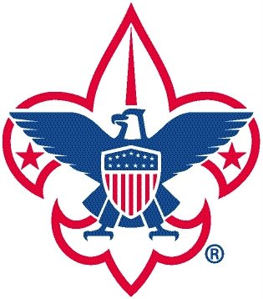 ***The Chickasaw Council***

***Honoring Karl Schledwitz***

*October 30, 2025*

Name(s)

Organization

Address

City State Zip

Telephone Email Address

Name as you would like it listed in the program:

***Please reserve the following (All tables seat 8)***

|  |  |  |
| --- | --- | --- |
| **🞎** | **Title Sponsor:**  $50,000 | Includes four Tables, special seating, Dinner Sponsorship, prominent program recognition, video recognition and formal recognition during dinner. |
| **🞎** | **Eagle Sponsor:**  $25,000 | Includes two Tables, special seating, formal recognition during the dinner, Reception Sponsorship, and recognition in the program. |
| **🞎** | **Life Sponsor:**  $10,000 | Includes one Table, special seating, formal recognition during dinner, Awards sponsorship, and recognition in the program. |
| **🞎** | **Star Sponsor:**  $5,000 | Includes one Table, formal recognition during dinner and full-page recognition in the program. |
| **🞎** | **First Class Sponsor:**  $3,500 | Includes 4 seats, formal recognition during dinner and ½ page recognition in the program. |
| **🞎** | **Tenderfoot Sponsor:**  $2,500 | Includes 2 seats, formal recognition during dinner and ¼ page recognition in the program. |

***Please RSVP by October 10th***

**Reserve ______ seats**

**Total $ _________________**

Distinguished Citizens Award Dinner

Chickasaw Council, BSA

171 South Hollywood Street

Memphis, TN 38112-4802

**RSVP & Payments may be sent to**:

**You may also RSVP online:** [**www.chickasaw.org/DCAD**](http://www.chickasaw.org/DCAD)

**SCAN TO RSVP**

**ONLINE**

*Questions: Contact Casey Norwood at Casey.Norwood@Scouting.org or (901) 327-4193.*

*Please make check payable to the Chickasaw Council. For tax purposes, this benefit is valued at $75 per person. Tax statements will be issued to all contributors by January 31, 2026.*