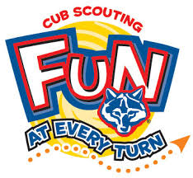

**February 2 and February 9, 2018**

**Cub Scout Pack 123 will be conducting our annual**

**“SCOUTING FOR FOOD DRIVE”**

**to benefit the local “Pantry of Your Choice” food pantry.**

**We would appreciate your grateful contribution in helping us feed the hungry!**

**Please place your donations of non-perishable food items**

**In the bag provided & leave on the FRONT PORCH**

**NEXT SATURDAY MORNING, February 9, BEFORE 9:00 AM.**

**Scouts will begin pick up at 9:00 AM that morning, so please have your bag ready!**

**For questions or problems, please contact Cub Scout Pack Member XXXXXXX.**

**If interested in joining the Cub Scouts, contact XXXXX, Pack 123, Phone XXXXX**

**Thank You Again For Your Invaluable Support!**



**February 2 and February 9, 2018**

**Cub Scout Pack 123 will be conducting our annual**

**“SCOUTING FOR FOOD DRIVE”**

**to benefit the local “Pantry of Your Choice” food pantry.**

**We would appreciate your grateful contribution in helping us feed the hungry!**

**Please place your donations of non-perishable food items**

**In the bag provided & leave on the FRONT PORCH**

**NEXT SATURDAY MORNING, February 9 BEFORE 9:00 AM..**

**Scouts will begin pick up at 9:00 AM that morning, so please have your bag ready!**

**For questions or problems, please contact Cub Scout Pack Member XXXXXXX.**

**If interested in joining the Cub Scouts, contact XXXXX, Pack 123, Phone XXXXX**

**Thank You Again For Your Invaluable Support!**