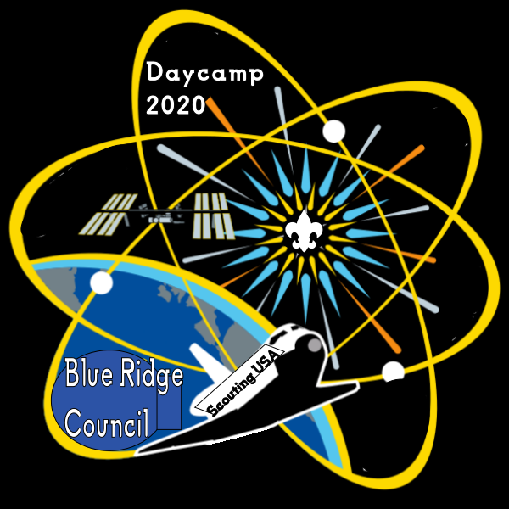
Six & Twenty District
Cub Scout Day Camp 2021
Camp Providence
1642 Providence Church Road
Anderson, SC
July 12-16, 2021

Photo and Medical Alert Release Forms

First Name: ____________________________ Last Name: ________________________________

Contact: ______________________________________ Phone #: ___________________________

Photo Release

I hereby assign and grant to the Boy Scouts of America the right and permission to use and publish photographs/video recordings/electronic representations and/or sound recordings made during my child’s Cub Scout Day Camp. I also hereby release the Boy Scouts of America from any and all liability from such use and publication.

I hereby authorize the reproduction, sale, copyright, exhibit, broadcast, electronic storage and/or distribution of said photographs/video recordings/electronic representations and/or recordings without limitation at the discretion of the Boy Scouts of America, and I specifically waive any right to any compensation I have for any of the foregoing.

__________________________________ ___________________________________ ________________
Parent or Guardian printed name Parent or Guardian Signature Date

Alert Bracelet Release

Due to HIPA regulations, if you would like your child to wear a red wrist band indicating a medical condition or allergy to allow easy identification in case of an emergency, please complete this form.

I give the Six and Twenty District Cub Scout Day Camp permission to provide my child a red wrist band daily for the

following medical condition/allergy ___________________________________________________________________.

__________________________________ ___________________________________ __________________
Parent or Guardian printed name Parent or Guardian Signature Date

Participant Name: ________________________________________________________________

Name of medication: ______________________________ Dosage to be given: ________________

Dosage instructions: ________________________________________________________________

________________________________________________________________________________

Medical purpose: __________________________________________________________________

________________________________________________________________________________
Dates at camp medication will be taken. Check the ones that apply and fill in the time

_____ Monday Time: __________
_____ Tuesday Time: __________
_____ Wednesday Time: __________
_____ Thursday Time: __________
_____ Friday Time: __________

__________________________________ ___________________________________ __________________
Parent or Guardian printed name Parent or Guardian Signature Date

Participant Name: ________________________________________________________________

Name of medication: ______________________________.Dosage to be given: ________________

Dosage instructions: ________________________________________________________________

________________________________________________________________________________

Medical purpose: __________________________________________________________________

________________________________________________________________________________

Dates at camp medication will be taken. Check the ones that apply and fill in the time

_____ Monday Time: __________
_____ Tuesday Time: __________
_____ Wednesday Time: __________
_____ Thursday Time: __________
_____ Friday Time: __________

__________________________________ ___________________________________ __________________
Parent or Guardian printed name Parent or Guardian Signature Date

