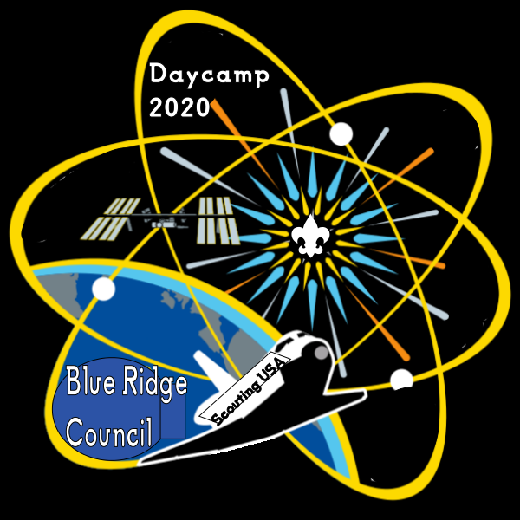
Six & Twenty District
Cub Scout Day Camp 2021
Camp Providence
1642 Providence Church Road
Anderson, SC
July 12-16, 2021

Permission Release Form

First Name: ____________________________ Last Name: ________________________________

Contact: _____________________________ Emergency Phone #: __________________________

I, _________________________________________________, as the parent and/or Guardian of

___________________________________________________ do hereby authorize the Six & Twenty District Cub Scout Day Camp staff to release my son/daughter named above into the care of the individuals I declare below at the closure of camp days.

The following individuals are authorized to pick up my son/daughter:

_____________________________________________Relationship to Scout: _________________

_____________________________________________Relationship to Scout: _________________

_____________________________________________Relationship to Scout: _________________

_____________________________________________Relationship to Scout: _________________

I further understand that by granting this permission, I relieve the Day Camp staff from any responsibility or liability for releasing my son/daughter as I have directed.

Signature: ________________________________________ Date: __________________________

A new permission form must be submitted if anyone other than the above named individuals will be picking up your son/daughter.

