For Additional Information

If you would like additional information about this mountain- top training experience, you may register through the council website: OR
Contact

Mills Grant,
Course Director
mgrant@newlifeturf.com

Erik Uselton,
Council Program Director erik.uselton@scouting.org

OR
Simply drop this off at the Blue Ridge Council office in
Greenville and you will be contacted.

Name: District: Registered Position: Unit: Phone: Home

Office

Course Schedule
Fall 2021
September 24-26
& October 15-17

Note:

All participants are required to attend all day during all sessions, including the sessions that fall on Fridays or on Monday holidays.

Course Uniform:
For the course, Scouters will need a complete field uniform for the program in which they are registered. This should include shirt, pants, or shorts with the appropriate socks and belt. Information on other clothing and equipment needs will be provided to each registered participant prior to the course.

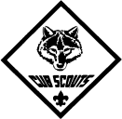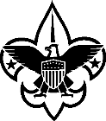

For the 21st Century

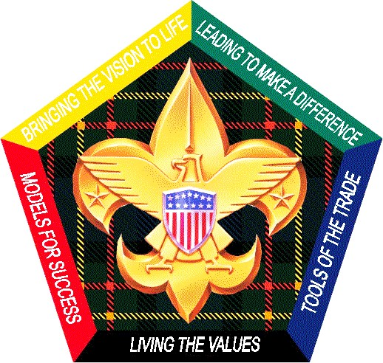

for All Adult Leaders in
Scouting

Presented by the Blue Ridge Council

Rev1-190112

What Takes Place?

Participants in Wood Badge for the 21st Century attend a six-day course. The fall course this year is offered as two sessions of three days each.
Course attendees begin their Wood Badge experience as Cub Scouts, then bridge into Boy Scouting and form into a patrol for the balance of the course. Selected staff members are designated as troop guides to work with the patrol during the course and during the patrol’s interim patrol meetings held between the two weekend sessions. To cap the whole Scouting progression, several key staff members serve in the role of a Venturing crew, working side-by-side with the troop during their outdoor experience.
The whole course models first-hand what a Scout experiences during a month as a Scout. During this training, participants are given the opportunity to assume leadership roles to plan and carry out an extended outdoor experience.
Within this framework, participants take part in numerous presentations, discussions, and activities that explore and advance a wide range of leadership philosophies and tools. A key area of exploration is the process of team development. By recognizing the stages through which leadership teams pass, participants will learn to apply appropriate leadership strategies that enable teams to reach their highest level of performance.

Wood Badge:

A Two-Step Process…

Practical Experience
Wood Badge for the 21st Century is a two- step process, beginning with the outdoor experience, consisting of living the Scout program. Those participating are exposed to leadership and Scoutcraft skills as they apply to both adults and youth. Through living in a Scouting atmosphere for an extended period of time, Scouters develop a deeper understanding of the Scouting program that can have a profound influence on the lives of youth in our communities.

To demonstrate an understanding of the leadership skills taught at the course, each participant writes a contract outlining how he or she will apply the lessons learned through their role in Scouting after the course. This contract is called a ticket.

Application Phase
The outdoor experience is followed by a period of up to eighteen months during which the Scouter applies the skills learned during the practical experience in his or her Scouting position – at the unit, district, or council level. Through this period, each Scouter is assigned a counselor who acts as a resource, evaluator, and Scouting mentor to assist the participant in putting into action those points discussed during the course. This is demonstrated by the process known as working your ticket.
Once the ticket is completed to the mutual satisfaction of the participant and the counselor, the Wood Badge Award is presented.
Who May Attend
Wood Badge?
Wood Badge is designed to meet the advanced leadership needs of all Scouters, particularly Cub Leaders, Scoutmasters and Assistants, Venturing Crew Advisors, and other unit, district, and council Scouters.

How do I qualify?
To qualify, you must
- Be a registered member of the Boy Scouts of America.
- Have not previously attended a Wood Badge for the 21st Century course.
- Have completed the basic training courses for your Scouting position – this includes New Leader Essentials and Leader Specific Training for unit level leaders and Commissioner Basic Training for Commissioners. (Previous versions of leader training courses are acceptable.)
- Have completed the outdoor skills program if there is one appropriate for your Scouting position. Introduction to Outdoor Leadership Skills is required for Scoutmasters and Assistant Scoutmasters.
- Be capable of functioning safely in an outdoor environment.
- Have successfully completed a BSA Health Form (Parts A, B, C) prior to the start of the course.

