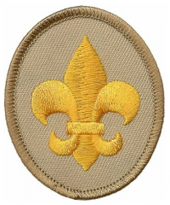
Pathfinder Program
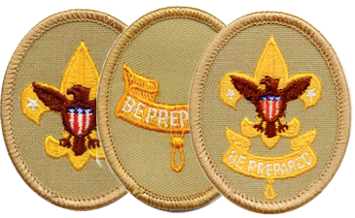
The Pathfinder Program is a two and a half day program which is designed for Scouts who have just joined a troop and/or have just crossed over from Cub Scouts. The program is designed for participants to complete many requirements for Scout, Tenderfoot and Second Class Ranks. Scouts will also complete several requirements for the First Class Rank. This is a transitional program to help your Scouts understand the patrol method, learn basic Scouting skills, have new experiences and have fun.
Program Goals
- To provide a well-organized program based lead by qualified instructors.
- To maintain an adequate ratio of instructors to Scouts.
- To instill in the Scouts a respect for the Scouting Methods and Ideals found in the Scout Oath, Law and the Outdoor Code.
- To provide an exciting and memorable summer camp experience.
Before Sending Scouts to the Pathfinder Program:
- Ask an older Scout in your troop to show the new Scouts how to read and use the Scout Handbook.
- If your troop has more than four boys participating in Pathfinder, please provide an adult leader to assist the Patrol Guide (Staff Member) throughout the week. This is an excellent opportunity for the new leader in your troop to learn about Scouting. Troops may rotate their leader through the week as needed.
- Host a shakedown prior to summer camp to make sure that the Scouts have all the equipment they need for the week. Below is a list of the items the Scouts need specifically for the Pathfinder program:

Required Items | Items Needed Daily | Optional Items
-Rain Gear  -Water Bottle  -Day Bag  -Pens  -Good Hiking Shoes/Boots | -Water Bottle  -Pen  -Pathfinder Passport  (Given out on Monday) | -Compass  -Pocket Knife  -Camera

A Day in Pathfinder
The Pathfinder Program begins at 9:00am on Monday morning with an opening ceremony. During this ceremony, Scouts will be grouped into patrols and meet their Patrol Guide who is an experienced Scout that will work with your Scouts as their instructor and mentor for the week. Scouts maybe instructed by different Patrol Guides throughout the day. We will attempt to place Scouts of the same troop in the same patrol. The Scouts will be finally present their Pathfinder Passport which they need to have with them at all times.
Below is a sample day for Scouts in the Pathfinder Program:
9:00-9:15-Opening Ceremony-The ceremony will take place in the Pathfinder Shelter behind the First Aid Lodge.
9:15-12:00-Patrol Time-Specific time at a site to work with the Patrol Guide on rank requirements.
12:00-2:00-Lunch and Free Time
2:00-5:00-Patrol Time-More time to work with Patrol Guide to work on rank requirements.
In addition, a day will be scheduled for the troop to take a five mile hike. The hike will probably take place on Wednesday morning. Scouts will have the option to go on the hike. If they do not go, they will stay at camp and work on additional requirements. Scouts going on the hike will leave at around 9:30. Please send at least one leader from your troop on the hike with the Scouts. Refer to the sample schedule on the next page for an idea of the general layout of the week.

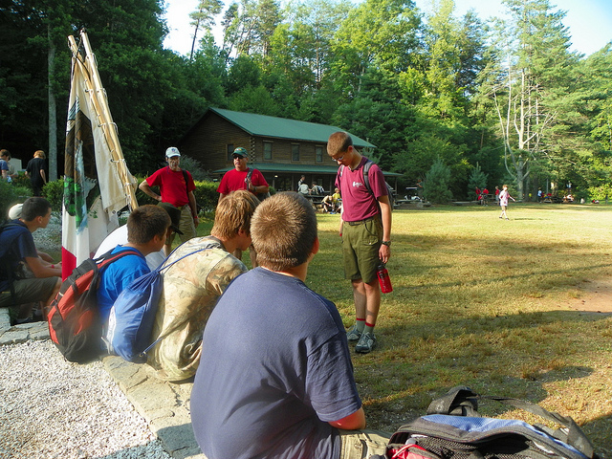

Additional Information
Pathfinder Graduation
Scouts who participate in the Pathfinder program will be recognized during the Wednesday evening campfire. Pathfinder participants will receive a certificate and a special Pathfinder patch.
Advancement
Along with the Patrol Guide signing off in the Scout’s Pathfinder Passport, each Scoutmaster will receive an advancement sheet with the requirements their Scout completed during the program.
Schedule Flexibility
Each Patrol Guide is given the flexibility to structure the week to maximize their patrol’s learning and enjoyment of camp. Therefore the times listed in the sample schedule section, provide a good outline, but not a definitive schedule. Other activities guides may include to their schedule may include:
- Touring the camp and explaining the activities at the different program areas. This builds enthusiasm in new Scouts by showing them activities they can look forward to when they return to camp the next year.
- Participate in various evening activities as a patrol to sample program areas such as rifle shooting, archery, free swim, etc.
- Inter-Patrol Competitions provide opportunities for the Scouts to get to know one another and have fun doing it. Some games the Scouts may play includes: Night Watchman, Steal the Bacon, Kickball, etc.
Getting the Most from Pathfinder
In order for your Scouts to truly take advantage of the Pathfinder Program, there must be a leader committed to working with the Scouts throughout the program. For example, leaders should ask to see the Scout’s passports each night and test them on what they have learned. If you, as a leader, are satisfied with the Scout’s knowledge, then sign off the requirement in their Scout Handbook. Though there will be informational meetings and announcements, we encourage you to seek out the Pathfinder Director if you have any questions or concerns.

