Leader’s Guide and Registration

Camporee Leader’s Guide and Registration

September 22th –24, 2017

Table of Contents

Chairman’s Letter 2

General Information 3

Registration Information 4

Map and Directions 5

Registration Form 6

Dear Scout Leaders,

Greetings and welcome to “Shoot out at COI (Camp Old Indian).”

On September 22 – 24, 2017, the Southbounder District will hold its Camporee, “Shoot out at COI.” The event will be held at Camp Old Indian. This will be a great weekend of fun and exciting activities and games. Most if not all the activities and games will test each Scouts knowledge and skills and how they can work together as a Patrol. It can’t be missed. Saturday night will feature a campfire style celebration where we will award those top Patrols. . (Don’t forget your flags.)

We will also have a Troop Gateway Competition. So start planning your Gateways now.

I want to encourage you to come Friday evening, set up, and join us for our Cracker Barrel (Scoutmaster and SPL), which will outline the weekends activities. Saturday morning, we will start with “Shoot out at COI” opening ceremony. Activities and Games for our Boy Scouts will fill the day! We will close the evening with a Campfire, hosted by our OA Chapter with Award Presentations for our Patrol Medalist during the program. Sunday morning, we will provide a worship service that we ask all units to attend.

This is a BIG event. Be prepared and sign your group up early. It helps us to be better prepared. We would like to receive your registration form and fees mailed to Blue Ridge Council Service Center by September 1, 2017. There is a financial benefit for early registration and site selection for your scouts. Please refer to page 4-6 for registration details.

Remember to attend the Cracker Barrel meeting Friday night. Our “Shoot out at COI” staff will be introduced, and additional information will be shared with you at that time along with any questions that you might have. Your Camporee Staff/Committee has been working hard for the last six months so that we can have a successful event. After the orientation meeting, there will be time to discuss information with your unit before taps.

For this Camporee, it is my desire to provide life long memories for all who attend. I want to thank all of you for the incredible work you do in Scouting. Let’s work together to make “Shoot out at COI” not just a catch phrase but a reality.

If you have any questions, please contact Jay Best at 864.346.1564 or e-mail at jbest4t3scouts@hotmail.com.

YiS,

Jay E Best Jr
Southbounder District Chair

GENERAL INFORMATION

WHEN: Friday, September 22nd through Sunday, September 24th 2017

WHERE- Camp Old Indian

CAMPSITES: Campsite locations will be assigned as the registration is received. Vehicles will not be allowed in campsites, only Unit Trailer. Please help the staff monitor the conditions of the Camporee facilities so things are left better than when you found them. Outdoor Ethics (Leave No Trace). We will observe CO-ED unit camping regulations as outlined in the Guide For Safe Scouting. (Exploring – Venturing)

PARKING/ FIRST AID: There will be plenty of parking available. Participants will be asked to park all vehicles in Camp’s parking lot. Your trailer may remain in the campsite. You will need a vehicle to place your trailer in your campsite, but it must leave after the tailor is located within your campsite. First aid will be available at a First Aid/ Medical station. Each unit should also make their own first aid provisions. We will have a medical person on site, but any major injury - will need your unit to transport your scout, or scouter, to the local medical facilities, unless an ambulance is needed or required. Leaders should collect all medications and dispense at the proper times.

UTILITIES: Water will be available on site. All Scouts should carry a canteen or water bottle with them during the events. All trash is to be carried to the camp’s trash container. Bring your own trash bags and leave the campsite clean.

COOKING: Cook with gas, liquid fuel, or grills. No grills or other cooking facilities are available on site. As long as there is no “RED FLAG” no fire ban, Fires are allowed in the fire pit in each campsite and they must be manned. No Ground Fires except in the camp sites fire rings. No in-ground pits are to be dug! They are to be attended at all times. Bring your own wood. No flames in tents! * Guide to Safe Scouting (fire buckets)

UNIFORMS: Full Field Dress (Class “A”) uniforms are required at the Saturday morning Opening Ceremony, Saturday campfire, and at the Sunday morning Worship Service. Otherwise, Activity (Class “B” - a Scouting tee shirt) uniforms are recommended the rest of the time. This is a Scouting function; make sure your Scouts are dressed as such.

Activities/Games: All Games are based on the Patrol Method. The Games will test the Scout’s knowledge and skills. There will be awards for 1st, 2nd, & 3rd place finishing Patrols.

Patrol Method: Patrol Size should be a maximum of 8 Scouts, if a Troop is unable to have an 8 Scout Patrol, please note this on your registration form.

Campfire Program- If your Unit is expected to participate in the Campfire Program on Saturday night, please use the Campfire Program Planner to plan your Song or Skit and note on your registration form on what song or skit you plan to do.

REGISTRATION INFORMATION

The Camporee Staff is in the process of having everything in place for your unit to have an outstanding weekend, so please make every effort to fill in the Registration Form completely.

This fee includes unit registration items, insurance, participation in events, use of utilities, and one official District Camporee Patch per Participate.

Cost to Register:
- Initial deposit Boy Scouts/Adult Leaders: $5.00 each
- Remainder of the fee is based on final payment date/time
- No registration after September 1 2017.

(Note – There is a $2.00 registration fee every time an online registration is made or an addition to a units registration is made – it is non refundable.)

When to Register:
- initial $5.00 deposit per person to register
- First day to register ……………………….………………...– June 5, 2017
- First registered – 1st choice in campsite placement

(Total registration fee includes the initial deposit fee)
- Registration June 5, 2017 through July 30, 2017..……...– Total $9.00 per person
- Registration from August 1, 2017 to August 23, 2017.…– Total $10.00 per person
- Registration from August 24, 2017 to Sept. 1, 2017...….– Total $15.00 per person
- Registration Closed as of September 2, 2017

Your unit will receive:
- Camporee registration packet with complete schedule, event and campsite maps, campsite and gateway inspection forms.
- Full Schedule for each day’s Activities and Games.
- Camporee Activity/Game Play List in detail.

On Site Check-in:
- Schedules and maps at check-in.
- Campsite Assignments.

Mail Unit Registration forms and fees to:
Blue Ridge Council Service Center
Attn: Lori Maguire/2017 SB Camporee
1 Park Plaza
Greenville, SC 29607

Directions to Camp Old Indian

From US 25 (Greenville, SC/Asheville, NC) Exit US 25 at COI sign (15 miles north of Traveler Rest, SC) onto Old 25. Right at COI sign (watershed) on Callahan Mountain Rd. Camp at top of hill on left.

From I-26 West on SC 11. (If traveling from Columbia, SC, exit Northwest on 176 which runs into 11 at Campobello, SC.) Continue on SC 11 until you see the sign for SC 101. Turn right onto State 912. Turn right onto Callahan Mountain Rd. Camp will be on right at bottom of hill.

From 101 (Greer, SC) Take 101 until it stops at SC 11. Crossover 11 onto State 912. Turn right onto Callahan Mountain Rd. Camp will be on right at bottom of hill.

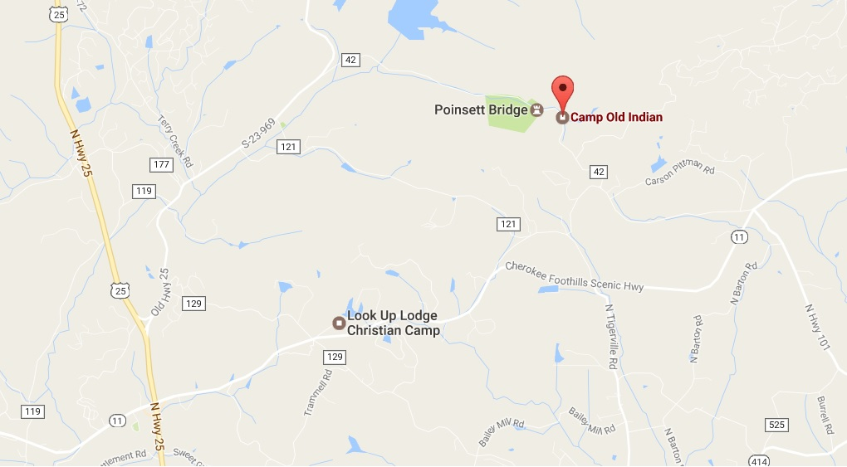

(Note – There is a $2.00 registration fee every time an online registration is made or an addition to a units registration is made – it is non refundable.)

Unit Registration Form

September 22nd -24th, 2017

Unit Type & # _____________ Leader Contact______________________
Leader Cell Phone___________________
Leader Email ____________________________

Registration:

Total # of Scouts/Scouters Registered Camping _____X Initial Fee $ 5.00 = ___________
PLUS (Additional Fees)
Registration Before 7/30/2017 _____X Fee $ 4.00 = ____________
Registration after 8/01/2017
Before 8/23/2017 _____X Fee $ 5.00 = ____________
\ Registration after 8/24/2017
By 9/1/2017 _____X Fee $ 10.00 = ____________

Total # of Scouts Camping _____

Total # of Adults Camping _____X Initial Fee $ 4.00 = ___________

Total Fees paid: $___________

Troop Patrol Information: (Maximum of 8 Scouts per Patrol)
# of Patrols _____
# of Scouts per Patrol _____
Patrol Name 1 __________________ Skit/Song ; __________________
Patrol Name 2 __________________ Skit/Song ; __________________
Patrol Name 3 __________________ Skit/Song ; __________________
Patrol Name 4 __________________ Skit/Song ; __________________

Medical Information
List of any special medical needs required by members of your Troop:

Final Registration Due- September 1, 2017
Make checks payable: Blue Ridge Council, BSA
For Questions please contact Jay Best: 864.346.1564

