Blue Ridge Council
Presents

Cub Family Weekend

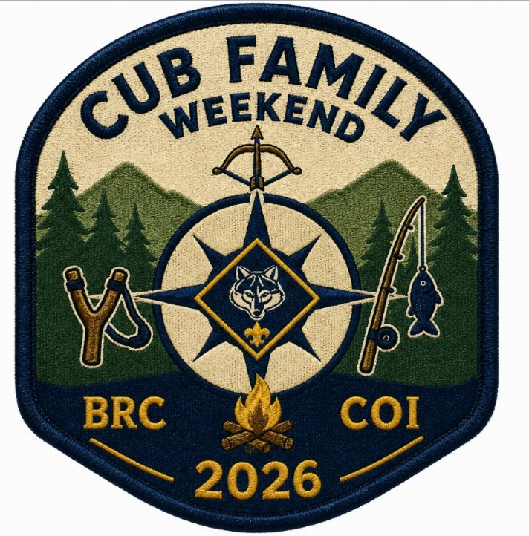

Camp Old Indian
601 Callahan Mountain Rd. Travelers Rest, SC

October 16-18

Welcome
The Blue Ridge Council welcomes you and your Cub Scouts at Camp Old Indian for Cub Scout Family Weekends this October.
We hope that your experience during this Cub Family Weekend will be filled with excitement and fellowship, and you can build great memories for yourself, your Scouts and family.
As you read this guide, you will find all the information you need to make the weekend a success. Should you have any additional questions or concerns not addressed in this document, please contact: Nichole Niemeyer at nicholeniemeyer.com, Kathron Fehrer at southerngentleman56@msn.com, or Jake Gotimer at Jacob.gotimer@scouting.org or 518-763-9599.

Check-In

Check-in is from 5:00 – 7:30 PM on Friday evening, or 7:15 – 8:30 AM on Saturday mornings. We will have over 200 attendees this weekend. There will be parking assistance for Friday check-in, but not Saturday morning. To speed up check-in, we encourage each Pack to arrive at the same time and gather in camp’s parking lot. One vehicle only per unit will be allowed to drive gear to the campsites. Once all gear is transported that vehicle should remain in the main parking lot until it is time to pack out on Sunday.

NO ONSITE REGISTRATIONS WILL BE ACCEPTED

Refund Policy
The Blue Ridge Council has a no refund policy, with the following exceptions:
- Illness of the scout prevented attendance.
- Illness or death in the scout’s immediate family prevents their attendance.

All refund requests must be submitted to Jacob.gotimer@scouting.org for consideration.

Accommodation

You do not need tents at Camp Old Indian! Campsites have 4 and 8 person Adirondack shelters with cots and mattresses. Each unit will be assigned a campsite or multiple campsites. Adirondacks may need to be divided by male/female Cubs and Adults depending on the size of your Pack. There are a few different styles of Adirondacks in camp. Families may share Adirondacks that have dividers between sleeping areas.

Each site has a firepit and bathhouse with showers and individual toilet stalls.

There is plenty of firewood in camp, you do not need to bring any with you.

You are welcome to bring a tent, but not all sites may have a comfortable location for it.

Campsite assignments will be given at check-in. We are full for the weekend, so campsite changes cannot be made.

Trading Post

Our camp trading post is stocked with adult t-shirts, camp souvenirs, snacks, drinks and more. Stop in and see us Saturday. The trading post is equipped to take all forms of payment.

What to Bring
- Scouting America Annual Health & Medical Record Part A & B-for EVERY PERSON attending including adults and parents.
- Personal sleeping items – sleeping bag, pillow, bedroll, air pad
- Personal hygiene items – soap, towel, toothbrush, toothpaste, brush, comb, etc.
- Personal Medication
- Change of clothes
- Rain Gear
- Extra Shoes
- Bug Spray
- Flashlight and Lantern
- Camp Chair
- Cell Phone
- Water Bottle
- Closed Toe Shoes (to be worn at all times)
- Money for Trading Post
- 100 ft. extension cord if you need one for a CPAP
- Wagon to help get gear to the campsite.

Emergency Procedures
Written procedures are established for fires, lost scouts, and severe storms or other emergencies. Our staff will monitor the weather and will do everything possible to continue the program. The event coordinator or staff advisor should be notified immediately of all emergencies that occur while at camp.

Transportation
Cub Scout Camping Events at Camp Old Indian are family camping events. Each family is responsible for the safe transportation of its members to and from camp and to make sure that all vehicles meet national insurance standards. Please remember that transporting scouts or adults in the bed of an open pick-up truck or trailer – whether covered or uncovered – is against the policy of Scouting America.

Only 1 vehicle per unit will be are allowed beyond the parking lot to transport gear and then be parked at the main parking lot. It is a long walk up hills to many campsites. A wagon can help in transporting gear.

Tips for Campers
The following are some tips that will help you while participating in a Cub Scout Family Camping Program.
- Be courteous to your other campers – do not cut through other campsites.
- Practice setting up and taking down your tent before coming to camp if you are bringing one.
- Bring only what you need to spend the weekend. You may need to hike-in and hike-out your gear. Some families find it easier to bring a small wagon to help transport gear to your campsite.
- Follow your schedule to ensure all groups can do each activity.
- Camp wildlife likes your snacks. Please do not feed them or leave food in your sleeping quarters. By doing so you are sending an open invitation for wildlife to come visit you.

Meals

Meals will be served on Saturday and Breakfast Sunday morning in the dining hall if you pre-purchased the meal plan. If you did not purchase the meal plan, there will be a grab and go breakfast available in the back of the dining hall Sunday morning. Each site has a firepit that can be used for cooking. Units may also bring camping propane stoves for cooking. Some units have brought their propane grills and cooked in the parking lot tailgate style.

Check Out Procedures
We ask that all participants leave camp no later than 11:00 am Sunday. This will enable our staff to complete the necessary clean-up and sanitation of the camp.
Please practice Leave No Trace by cleaning your campsite before departing. After breaking down your campsite please carry any trash to our dumpster located behind the dining hall, flip the blue trash cans upside down, and sweep out the bath houses. When departing camp, please stop by the camp office and sign out.

Annual Health and Medical Record
BSA Annual Health and Medical Record (most recent printing) are required for all attendees (including cub scout, parent, sibling, and leaders) at Cub Scout Camping Events of Blue Ridge Council. Only Parts A & B are required for events lasting less than 72 hours. Medical forms must be turned in at registration and will be returned at check-out on Sunday morning.

Medication
Medications may be kept with the parent/guardian of the scout and dispensed as prescribed.

Tentative Schedule

Friday
5:00 – 7:30 – Check-in @ Office
7:00 – 8:30 – S’mores @ Scoutcraft
5:00 – 10:00 – Set up and hangout @ Campsites
10:00 pm Lights Out

Saturday
7:15 – 8:30 – Late Check-ins @ Office
7:15 – 8:30 – Breakfast
8:45 – 9:00 – Opening Flag ceremony, parent meeting, youth range safety talk
Morning rotations
9:15 – 10:00
10:15 – 11:00
11:15 – 12:00
12:15 – 1:30 – Lunch
Afternoon rotations
1:45 – 2:30
2:45 – 3:30
3:45 – 4:30
5:00 – 6:15 – Dinner
7:30 – 8:30 – Campfire Program @ Amphitheater

Sunday
8:00 – 8:30 – Sunday Morning Chapel @ Dining Hall
8:45 – 9:30 – Grab and Go Breakfast pickup @ Dining Hall
9:30 – 11:00 – Pack and clean up campsites
No later than 11:00 am – Check Out @ Office
Office will be open 7:30 – 11:00

Camp Rules and Regulations
We are all, first and foremost, members of Scouting America. The basic rules governing Camp Old Indian are the Scout Oath and Scout Law. We also ask that you follow the Outdoor Code. Rules are for your Scout’s safety, the protection of equipment and the preservation of fairness to everyone.
- No personal vehicles are permitted in camp – all cars must be parked in designated parking areas.
- No pyrotechnics of any kind are permitted on camp property.
- No alcoholic beverages or other unlawful drugs or substances are allowed in camp.
- Closed-toed shoes must be worn at all times in camp.
- No transporting passengers in the back of pick-up trucks is allowed.
- Sheath knives are not allowed in camp. Bring approved folding pocketknives only.
- Personal firearms or archery equipment are not allowed on camp property.
- Leaving Camp – anyone leaving camp must first check out at the camp office.
- Wildlife – Camp Old Indian is blessed with a wide variety of wild creatures. Under no circumstances should anyone touch or disturb snakes or other animals.
- Respect of Privacy – Adult leaders must respect the privacy of youth members in situations such as changing into a swimming suit or taking showers. Adults must also protect their own privacy in similar situations.
- Groups camping as a unit MUST HAVE TWO-DEEP LEADERSHIP
- Separate Accommodations – Scouts are not permitted to sleep in an Adirondack or tent of an adult other than a parent or guardian.
- Campfires – are permitted only in designated fire pits in each campsite with the approval of the camp office or camp ranger prior to burning. Campfires are NOT to be left unattended at any time.
- All Scouts are responsible for the cleanliness of their campsite and for assisting in keeping the camp clean for others to enjoy.
- Running after dark is not permitted.

