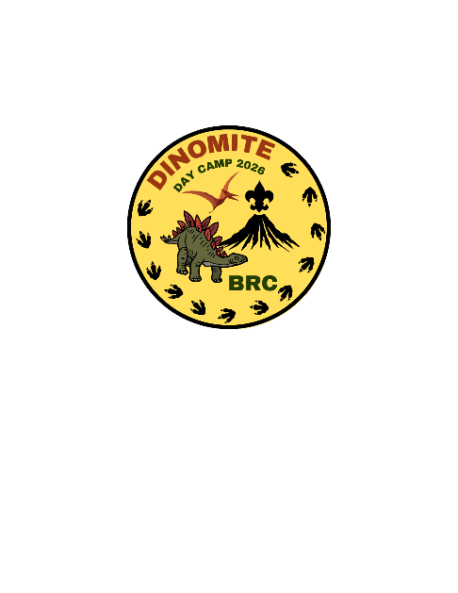
Three Rivers District Anderson Area
Cub Scout Day Camp

Consent and Acknowledgement of Day Camp Parent Guide

I have received, read, and understand the Sadlers Creek Three Rivers District Cubs Scout 500 2023 Leader’s Guide. My Scout(s) and I agree to follow the rules and regulations outlined in the guide and will accept discipline according to the policy stated in the guide without exception.

We understand that we must provide lunch for each of our Scouts every day except Friday and that the Day Camp will not have provisions to provide food for forgotten lunches.

____________________________________________ ________________________________
Parent or Guardian Signature Date

____________________________________________ ________________________________
Scout Signature Date

____________________________________________ ________________________________
Scout Signature Date

____________________________________________ ________________________________
Scout Signature Date

