UNIVERSITY OF SCOUTING

Blue Ridge Council
Scouting America

January 10, 2026
8:00 A.M. – 4:30 P.M.

Easley First Baptist Church
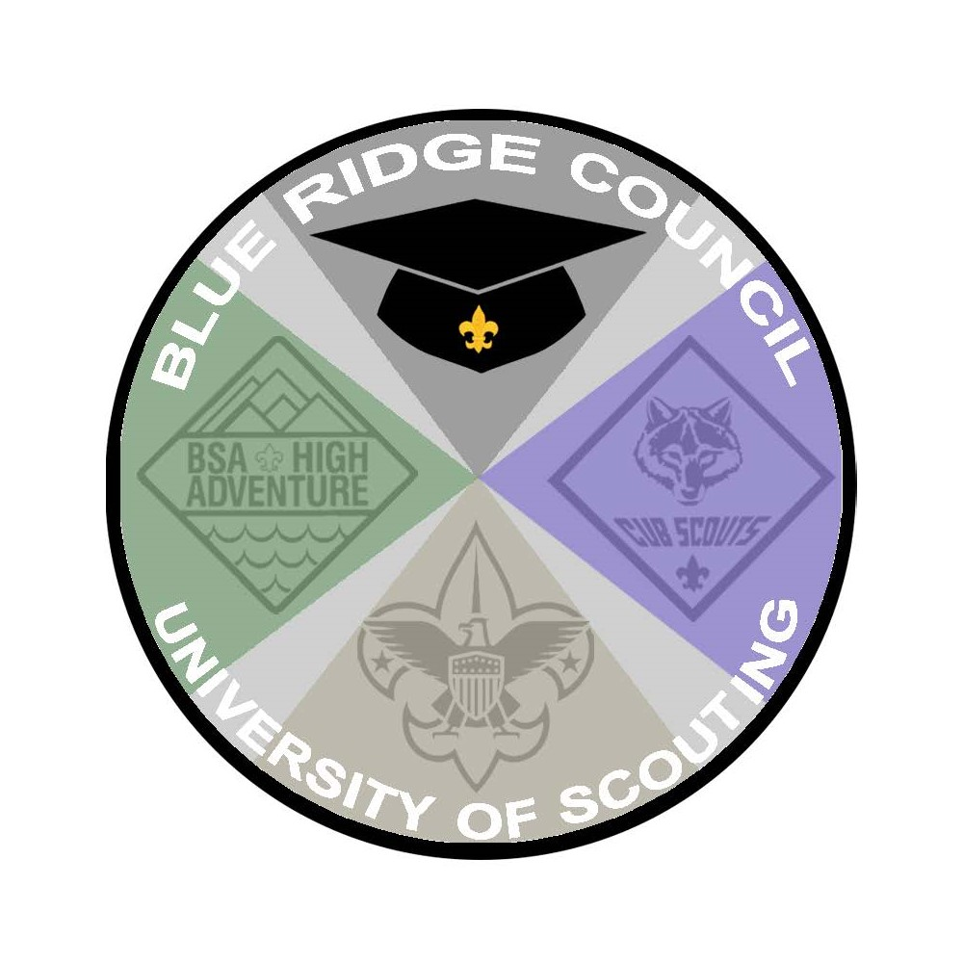

TABLE OF CONTENTS

GENERAL INFORMATION………….………………………………………….4

THE DEGREE PROCESS…………………………...………..……….…..…..8

LOCATION………………………….……………………………….….…..…...11

COLLEGE OF CUB SCOUTING …………………….……………….....…....12

COLLEGE OF SCOUTING BSA…………...……………...….……….……...16

COLLEGE OF ADVENTURE SCOUTING….……….…...………..……...….18

COLLEGE OF ELECTIVES…………….………..…………….….......….……21

COLLEGE OF Advancement and Program ………………..……......24

REGISTRATION INFORMATION………….……………….…….……….……26

WEAR YOUR CLASS A / FIELD UNIFORM

Back for 2026

UNIVERSITY OF SCOUTING

GENERAL INFORMATION

Purpose of the University of Scouting – The “University of Scouting” is a supplemental training opportunity for all adult Scout leaders. It is the only time during the year where you can find, all in one place, the widest variety of training opportunities in all program areas (Cub Scouts, Scouting BSA, Adventure Scouting, Advancement and Program Operations, and Elective Courses). Whether you are new to the program or a veteran of many years, the University provides interesting courses aligned to build stronger leaders and stronger programs.

- The College of Cub Scouting provides a wide variety of courses from working with Cub Scout aged youth to pack administration to planning for an outdoor program, all focused on meeting Scouting goals while having fun as a pack or den.
- The College of Scouts BSA provides an exciting variety of troop, patrol and outdoor planning supplemental courses to help manage the challenges of a great troop experience.
- The College of Adventure Scouting is an interesting combination of courses for those who wish to learn more about Scouting’s “senior” programs (Venturing, Sea Scouting, and Exploring) and resources and information on a variety of adventure and high adventure activities. This college will also supported by classes with the Order of the Arrow.
- The College of Elective Programs offers many “general studies courses” that cut across all the programs. Just about everything from diversity and special needs to using technology can be found in the Elective Programs.
- The College of Advancement and Program focuses on Advancement Policies and practices, Merit Badges, Risk Identification and Mitigation, Unit, District and Council Operations, and Advanced Training Opportunities.

All these opportunities are available at the University for learning how to better serve our young people and better work with our fellow leaders!

Online Registration – Online registration is available after December 1st, 2025 at https://scoutingevent.com/551-UofScouting26 Participant and will close at midnight Sunday, January 4th, 2026. Mail-in (paper) registrations will not be accepted.

- Registration – Regular Fee $12 *(Registration Fee DOES NOT include lunch)*
- LUNCH OPTION - **Optional Fee** - $15 for A Buffet Style Plate from Tropical Grille
- Extra Center Event Patches will be available for $5 each

Pre-Registration is important – The anticipated large attendance requires advance scheduling. To ensure the best possibility of attending your desired courses, early registration is essential. Classes do sell out. Additional details on registration are provided on pages 17-18.

Included with Registration – The per person registration fee includes attendance at six University of Scouting courses, a patch, Keynote Speakers, certificate of attendance and/or other forms of recognition as appropriate, liability insurance recovery, and administrative costs.

Opening and Lunchtime Assemblies – In the morning and during lunch, assemblies will be for all participants to participate and enjoy. We urge everyone to join for the assemblies and interact with the UoS Staff and Keynote Speakers.

Certifications and Credit for BSA Classes – Certifications and credit for standalone and official BSA training courses will be handled by the instructors of those courses.

Event Cancellation/Refund Policy – If for any reason the University is cancelled, a decision to cancel the University of Scouting will be made prior to 8:00pm Friday, January 9, 2026. This information will be available on the BRC web site (http://www.blueridgecouncil.org) and email communication will be sent out to all attendees and instructors of the event.

Basic Schedule – A personal schedule specific to each participant will be made available prior to the event for pre-registered attendees.

- 8:00 am – 8:45 am - Morning Assembly
- 9:00 am – 9:50 am – UoS Course Session #1
- 10:00 am – 10:50 am – UoS Course Session #2
- 11:00 am – 11:50 am – UoS Course Session #3
- 12:00 noon – 12:45 pm: Lunch
- 1:00 pm – 1:50 pm – UoS Course Session #4
- 2:00 pm – 2:50 pm – UoS Course Session #5
- 3:00 pm – 3:50 pm – UoS Course Session #6
- 4:00 – End of Event: Graduation and Closing

UNIVERSITY OF SCOUTING

COURSE LEVELS

100-level courses are fundamental courses addressing the nature of the Youth Scout and the Unit Programs. These courses provide information useful to all Scout leaders regardless of experience.

200-level courses address more specialized topics providing guidance and context for Unit Leaders and Committee Members and expound further on topics initially addressed in 100-level courses.

300-level courses concern management of the Unit Programs to meet BSA objectives, and the evolution of Scouting principles.

400-level courses focus on quality trained leadership and program evaluation to provide the best possible Scout Program experience.

The levels are not intended to literally correspond to a registrant’s year of attendance in the University, but rather to provide general guidance as to likely interest based on a Scouter’s current position and level of experience. For all Scouters new to the University of Scouting, we strongly recommend you consider taking the 100 Level courses in your first year. These courses will give you an excellent working knowledge of not only the Scouting program but also working with Scout-age boys and girls.

UNIVERSITY OF SCOUTING

The Degree Process
General Guidelines

- The Blue Ridge Council (BRC) University of Scouting is designed on the principles of the four stages of Advancement.
  - A Scout Learns
  - The Scout is Tested
  - The Scout is Reviewed
  - The Scout is Rewarded

- To receive course credit toward a Degree, one must be a registered Scout (Youth) or Scouter (Adult) with current Youth Protection Training. Any Scout or Scouter who attends the BRC University of Scouting is strongly encouraged to pursue a Degree.

- There are five Degrees to be earned in three Scouting Majors at the Blue Ridge Council University of Scouting. Associates, Bachelors, Masters, Doctorate, and Continuing Education Degrees can be earned in Cub Scouting, Scouts BSA, and Adventure Scouting Majors.

- Generally, each class period of coursework earns one credit toward your desired Degree (unless otherwise noted). Credits are earned based on the number of credits for the course. A one class period course earns one credit. A two class period course may earn one or two credits, and a three class period course may earn two or three credits. Some classes (such as some BSA course curriculums) do not earn any credits toward the degree process.

- Select any Scouting Major to earn a Degree. Coursework may not be credited towards more than one Degree (of any Scouting Major) at the same time, however Degrees in different Scouting Majors may be pursued at the same time. Courses you take accumulate from year to year as you work toward different Degrees. Whether you are working with College of Cub Scouting, College of Scouts BSA, or College of Adventure Scouting, you may continue to accumulate credits, even when your registration moves into one of the other Scouting programs. Note, no degrees are conferred for the College of Advancement and Program or College of Elective Programs.

- You may take courses from any Scouting Major at any level and from the list of Advancement and Program Operations and Elective courses. To attain a Degree in one of the Scouting Majors, however, all requirements for that Degree must be met.

- Course levels (Level 100, Level 200, etc.) are intended to represent the complexity of the course. Generally, we recommend that students take Level 100 courses before Level 200 courses and Level 300 courses before Level 400 courses, etc. because courses are logically more sophisticated, progressive and/or specialized as the level increases. However, we leave it to each Scouter to determine what courses to take at any level.

- The College Dean is the approving authority for conferring degrees. Please contact the Dean if there are any questions on degree requirements.

Associate Degree: To earn an Associate Degree in a Scouting Major, do the following:
- Complete three course credits at any course level in the Scouting Major for which the Degree is sought (College of Cub Scouting, College of Scouts BSA, or College of Adventure Scouting).

Bachelor Degree: To earn a Bachelor Degree in a Scouting Major, do all the following:
- Complete six course credits at any course level.

- At least four of these course credits must be in the Scouting Major for which the Degree is sought (College of Cub Scouting, College of Scouts BSA, or College of Adventure Scouting). The remaining two course credits may be from any College (including the Advancement and Program or Elective Programs Colleges).

Masters Degree: To earn a Masters degree in a Scouting Major, do all the following:
- Hold a Bachelor Degree in that same Scouting Major (College of Cub Scouting, College of Scouts BSA, or College of Adventure Scouting).
- Complete six additional course credits (for a total of 12 credits) at any course level.
- All six of these additional course credits must be different from those completed for the Bachelor Degree.
- At least three of these additional course credits must be in the same Scouting Major as the Bachelor degree.
- The remaining three additional course credits may be from any College (including the Advancement and Program or Elective Programs Colleges).

Doctorate Degree: To earn a Doctorate degree in a Scouting Major, do all of the following:
- Hold a Masters degree in that same Scouting Major (College of Cub Scouting, College of Scouts BSA, or College of Adventure Scouting).
- Complete six additional course credits (for a total of 18 credits) at any course level.
- All six of these additional course credits must be different from those completed for the Bachelor and Masters degrees.
- At least three of these additional course credits must be in the same Scouting Major as the Masters degree. The remaining three course credits may be from any College (including the Advancement and Program Operations or Elective Programs Colleges).
- Upon completion of the above course work, serve in a teaching role in the Scouting Major at the discretion of the Dean of that College –OR- Complete three goals approved by the Dean of the respective College.
NOTE: It is the responsibility of a Doctoral candidate to contact their Dean personally immediately following the completion of the course work and no later than October 15th, 2025 to be added into the teaching plans for the next University of Scouting. No exceptions.

Continuing Education Degree: To earn a Continuing Education degree from the BRC University of Scouting, do all of the following:
- Hold a Doctorate degree in any Scouting Major (College of Cub Scouting, College of Scouts BSA, or College of Adventure Scouting).
- Complete six additional course credits (for a total of 24 credits) at any course level.
- All six of these additional course credits must be different from those completed for the Doctorate degree.
- All additional course credits may be in any College (including the Advancement and Program or Elective Programs Colleges).
- Upon completion of the above course work, serve in a teaching role in the University at the discretion of the Dean of the respective College. NOTE: It is the responsibility of a Doctoral candidate to contact their Dean personally immediately following the completion of the course work and no later than December 30th, 2025 to be added into the teaching plans for the next University of Scouting. No exceptions.

Deans:
- Provost: Russell Buchanan – russelldbuchanan@gmail.com
- College of Cub Scouting: Katy Davidson
- College of Scouts BSA: Adam Boggs
- College of Adventure Scouting: John Cederman
- College of Advancement and Program Operations: Dee Kivett
- College of Elective Programs: Position is Open and will be filled after 2026 event

HAVE EACH LEADER IN YOUR UNIT ATTEND SEPARATE COURSES! SHARE INFORMATION!

COLLEGE OF CUB SCOUTING

WELCOME

Welcome to the College of Cub Scouting! Before you read the Cub Scouting course listings, we’d like to explain a little bit about the nature and perspective of College of Cub Scouting courses. Cubs are FUN! And as such, fun should be a part of your unit planning. The College of Cub Scouting classes are designed with the Pack and Den Leader in mind. All classes are taught from the perspective of one’s who have “been there, done that” and will incorporate your feedback into the class discussion. Everyone starts somewhere and Scouting, is built on the volunteer experience.

The College of Cub Scouting focuses on four aspects:

- Effective meetings for the Cub Den and Pack Leader

- FUN activities for Cub Scouts and Scouters

- Planning for now and the future

- Recruiting and retention; techniques that work and how to sustain a good program

In addition to Council-wide events such as University of Scouting, Districts offer monthly Cub Scout Leader Roundtables as well as a myriad of more specific, targeted training sessions, including BALOO, Outdoor Webelos Leader Training, and Leader-Specific Training. You the Cub Scout leader should take advantage of all of these training options – they offer you immediate help, answers to questions, ideas, additional capabilities, and a broadening perspective.

So again, welcome! Please read over the course descriptions, select those classes of most value and interest to you, and we look forward to seeing you at the University!
Sincerely,
Katy Davidson
Katy Davidson
Dean - College of Cub Scouts
COLLEGE OF SCOUTS BSA

WELCOME

Welcome to the College of Scouts BSA! Before you read the Scouts BSA course listings, we’d like to explain a little bit about the nature and perspective of College of Scouts BSA courses. Does Boy Scouts intimidate you? Are there leaders that you know that are very proficient and seem to have it all together?

Did you know, they started right where you are!!!

The College of Scouts BSA focuses on four aspects:
- The BSA Troop is the heart of the program. Strong Troops build and retain strong leaders. The College shows you how to build a strong Troop.

- Personal growth is as important to the adults as it is to the youth in the program. The College strives to stretch the leader’s knowledge and skills.

- Are you a match for that 14 year old? The College provides the Leader with strategies to not only reach the youth in the program, but to build that lasting positive impression necessary for a complex and sometimes scary adventure called life.

- Scouting Skills – The College helps improve the Leader’s skills both in knowledge and proficiency. You will be amazed at how many skills you will use outside of the Scouting environment.

In addition to Council-wide events such as the University of Scouting, Districts offer monthly Scout Leader Roundtables as well as a myriad of more specific, targeted training sessions, including Outdoor Leadership Skills Training, Leader-Specific Training, and Wood Badge. You, the Scout leader should take advantage of all of these training options – they offer you immediate help, answers to questions, ideas, additional capabilities, and a broadening perspective.

So again, welcome! Please read over the course descriptions, select those classes of most value and interest to you, and we look forward to seeing you at the University!
Sincerely,
Adam Boggs
Adam Boggs
Dean - College of Scouts BSA

COLLEGE OF ADVENTURE SCOUTING

Welcome to the College of Adventure Scouting!

Before you read the Adventure Scouting course listings, I’d like to explain a little more about the nature and perspective of College of Adventure Scouting.

The College of Adventure Scouting focuses on four aspects:
1. Venturing Program is a co-ed program that was founded in 1998. It’s members consists of former Boy and Girl Scouts as well as other interested youth between the ages 14-20 years old.
2. Order of the Arrow was founded in 1915 and is Scouting’s National Honor Society. Beginning in February of 2019, Venturing and Sea Scouting youth will be eligible for membership in the OA.
3. High Adventure is a crucial piece to help keep our youth engaged. Whether it is learning about what is offered on the National level in terms of high adventure bases or on the local level, it is a vital for leaders to take advantage of these opportunities.
4. Shooting Sports provides Scouts occasions to learn about not only safety practices when using firearms, but proper training on how to use the firearms.

So again, welcome! Please read over the course descriptions, select those classes of most value and interest to you. Please contact me if you have any questions or concerns, and we look forward to seeing you at Scouting University!

Sincerely,
John Cederman
John Cederman
Dean-College of Adventure Scouting

COLLEGE OF ADVANCEMENT AND PROGRAM

WELCOME

Welcome to the College of Advancement and Program! Before you read the Advancement and Program course listings, we’d like to explain a little bit about the nature and perspective of College of Advancement and Program courses. The College recognizes that well run programs know and follow the rules. The Guide to Safe Scouting and Guide to Advancement are just two of the most important guides to keeping a program safe and healthy. The College will deliver what you need to know and do to excel in today’s world.

The College of Advancement and Program focuses on four aspects:
- Scout Units are held accountable for meeting all current standards. The College offers classes to both educate and equip Units to successfully operate a high performing program.

- Advancement is more than one of the 8 Methods of Scouting. The College delivers tips and techniques to use Advancement as a performance tool.

- Risk Management is key to a heathy program. The College offers topics that explore the relationship a Unit has with the Charter Organization and others who pose risk to the program.

- Behaviors. The College explores both youth and adult behaviors that are key to sustaining a safe and effective program.

In addition to Council-wide events such as the University of Scouting, Districts offer monthly Scout Leader Roundtables as well as a myriad of more specific, targeted training sessions. You the Scout leader should take advantage of all of these training options – they offer you immediate help, answers to questions, ideas, additional capabilities, and a broadening perspective.

So again, welcome! Please read over the course descriptions, select those classes of most value and interest to you, and we look forward to seeing you at the University!

Sincerely,
Dee Kivett
Dee Kivett
Dean - College of Advancement and Program

COLLEGE OF ELECTIVES

WELCOME

Welcome to the College of Electives! Before you read the Electives course listings, we’d like to explain a little bit about the nature and perspective of College of Electives courses. The College is designed to cover a broad range of topics that are applicable to either of the Programs, Cub Scouting, Scouting BSA or Venturing.

The College of Adventure Scouting focuses on four aspects:
- The Scout Oath Scout cites three main points, Duty to God and Country, Duty to Others, and Duty to Self. The College of Elective Programs seeks to grow strong leaders in all three areas.

- The 8 Methods of Scouting are key to building a strong program. The College of Electives offers creative ways to use the eight methods effectively.

- Keeping the Outing in Scouting is a fundamental method employed in all Scouting programs. The College strengthens the Leader’s skills in using the Outdoors effectively in the Program.

- A Game with a Purpose! The College of Electives brings life to the game of Scouting. Share ideas with experienced practitioners and bring your experience to the table as well.

In addition to Council-wide events such as the University of Scouting, Districts offer monthly Scout Leader Roundtables as well as a myriad of more specific, targeted training sessions. You the Scout leader should take advantage of all of these training options – they offer you immediate help, answers to questions, ideas, additional capabilities, and a broadening perspective.

So again, welcome! Please read over the course descriptions, select those classes of most value and interest to you, and we look forward to seeing you at the University!

Sincerely,
Russell Buchanan
Russell Buchanan
Provost

REGISTRATION INFORMATION

1. Registration for the 2026 BRC University of Scouting can only be done in one way, online through the Council website https://scoutingevent.com/551-UofScouting25 Participant registration price is $12. Instructors should not register as attendees of the classes they teach, as doing so takes an available seat away from a prospective attendee.

2. All courses offered by the University of Scouting are suitable for all Scouters unless the course description specifically defines the target audience. College of Adventure Scouting courses are also opened to Venturing age youth except for the adult leader training courses (VAPST and VCST). Read the entire catalog carefully.

3. Each College offers numerous courses. Read the descriptions carefully to evaluate course content in light of your needs and desires.

4. Before going online to register, be sure you understand the degree requirements for the College you choose as your primary. If you choose to earn a degree, the University requires you to identify your primary College.

5. Participants may attend courses offered by any College; however, each College requires completion of a specific number of courses in that College to earn a degree. Courses are kept small to facilitate learning and student participation. If early participant registrations warrant, additional popular courses may be scheduled.

6. Note that the length of some courses spans more than one period.

7. Some courses do not qualify for a degree in any College (Standalone). A training card will be awarded for BSA training courses. University Standalone courses may be awarded a certificate of completion. Standalone courses will accommodate all who register; you do not need to choose backup courses.

8. When registering online, select all your classes first. Then starting with the first period, register your classes in order by periods. Classes may be changed up to the end of the registration period.

9. Online registration is validated prior to the preparation of your course schedule – if issues surface the UOS Registrar may contact you. You may contact the UOS Registrar at laura.lucsky@gmail.com.

10. Instructors and Staff taking courses should also register for the classes they want to take. Instructors should NEVER register for the classes they are teaching whether or not they are also taking additional classes.

11. The University reserves the right to cancel courses or make appropriate changes in order to accommodate the largest number of Scouters.

