Application Form NYLT
Online registration:
https://www.scoutingevent.com/551- 2017NYLT
What is the process?
- Submit online application
- Pay $100 deposit
- Reservations accepted in the order received.
- A unit is limited to two (2) reservations until April 4th. The council will place any on-hold reservations if space is available.
- After April 4th, Troops can submit up to 8 Scouts for the course.
- Each Scout will receive a confirmation and additional course information shortly after the application is received.
- Deposits are not refundable, but a unit can transfer the reservation to another Scout.
- Properly-dated medical form and fee balance for each Scout needs to be at the Scout Service Center or emailed to nylt.brc@gmail.com, 30 days before the course.
- By some rare chance, if the course is not full 30 days in advance, we will continue to accept applications until 2 weeks prior to the course. Applications submitted within 30 days of the course should be accompanied by full payment and a current medical form.
- A Scout Master recommendation is required before final acceptance to the course. Please have the Scout Master email John Cederman at nylt.brc@gmail.com with the recommendation.
- A Code of Conduct will be signed by the participant before being accepted to the course.
- Council Approval is required for all participants before being accepted into the course.

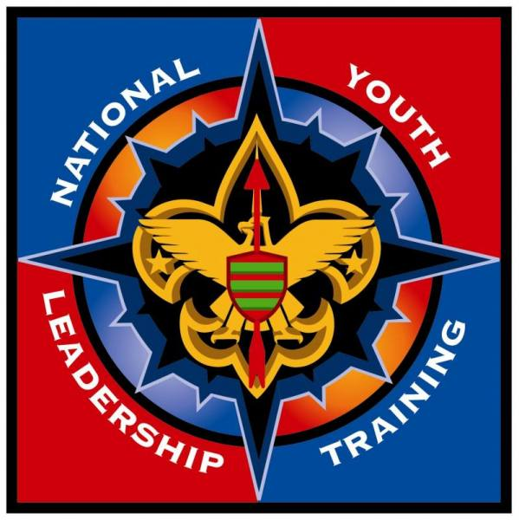

National Youth Leadership Training
Blue Ridge Council
Week: June 4-9, 2017
Camp Old Indian
Travelers Rest, SC

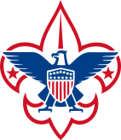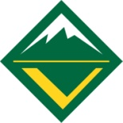
What is National Youth Leadership Training?
It is a week long experience conducted by Blue Ridge Council to provide each Scout with a meaningful Scouting experience that will enhance his/her role and responsibilities as a leader.
NYLT integrates the best of modern leadership theory with the traditional strengths of the Scouting Experience. Through activities, presentations, challenges, discussions, and audiovisual support, NYLT participants engage in a unified approach to leadership that gives the skills and confidence to lead well.

What are the course objectives?
- Give participants the confidence and knowledge to conduct the Boy Scout Troop, Varsity Scout Team, or Venturing Crew Program.
- Provide participants with a clear understanding of team and personal development, and how those elements relate to being a leader.
- Guide the participants through the stages of team development.
- Create an environment of Scouting fellowship and fun guided by the Scout Oath and Law
- Give participants the opportunity to share ideas and experiences with Scouts from other troops, teams, and crews.
- Have fun and experiences Scouting at its best.
What is the course content?
Youth at NYLT are learning and using the same skill se and language that adults learn and use at Wood Badge.
Through activities, events, games, and adventures. NYLT participants will work and play together as they put into action the best Scouting has to offer. They practice and experience leadership skills firsthand.
Each Scout returns to his/her unit with a toolbox of leadership skills and increased understanding of his/her role as someone who can shape the direction of the unit. The Scoutmaster, Team Couch, or Venturing Adult Advisor is the enabler who creates a positive environment for youth leadership.

What are the participant requirements?
Boy Scout and Varsity Scouts
- 13 years of age by the start of the course
- Participated in Introduction to Leadership Skills for Troops (ILST)
- At least First Class Rank
- Scoutmaster or Team Coach Recommendation
- Council Approval
Venturing Crew Members:
- 14-20 years of age by the start of the course
- Participated in Introduction to Leadership Skills for Crews (ILSC)
- Advisor Recommendation
- Council Approval
When and Where?
The course begins at noon. Check-in is between June 4th, 11-Noon. Closing ceremony will be held Friday June 9th at 4 PM.

The course will be held at Blue Ridge Council's Camp Old Indian

NYLT is a co-ed course open to both male and female participants.

What is the cost?
The cost for the training is $240.

The training includes food, training materials, and use of patrol camping equipment.

Who to contact?
Traci Bridwell
864-233-8363
Traci.Bridwell@scouting.org

Course Director
Kay Borkowski
nylt.brc@gmail.com

