2017 Camp Old Indian Trading Post Pre-Order
ORDER NOW and SAVE!
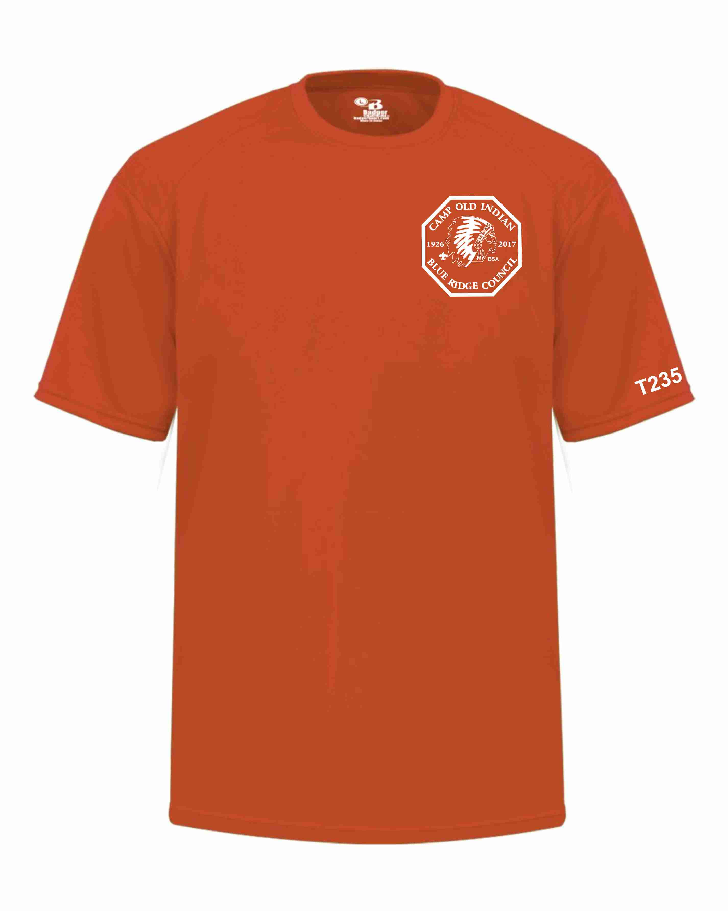
Order your 2017 design Camp Old Indian T-shirt now and have your Troop’s number on sleeve. Minimum of 8 shirts required for screening.

Pre-Orders only
Troop No. will be printed on sleeve
Troops can only select one color for the unit.
All shirts are moisture wicking YS – AXL - $18.00
2XL – 3XL - $22.00
Color Choices for the Troop Shirts only choose one color per troop order. Must order 8 or more t-shirts.
Orange
Neon Yellow
Blue
T-shirt | moisture wicking  t-shirts
YS- AXL | $18.00
2XL – 3XL | $22.00
Grey
Green
Tan
Black
Purple
Red
Burgundy

ORDER by May 5th !
Order will be available for pick-up the Sunday of your arrival at summer camp. Troops can only select one color for the entire order

Blue Ridge Council
1 Park Plaza
Greenville SC 29607
Fax: 864-233-2424
Or email to traci.bridwell@scouting.org

