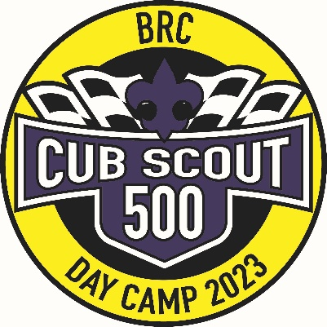
Sadlers Creek Three Rivers District Cub Scout
Day Camp
Sadlers Creek State Park Pavilion, Anderson, SC

Photo and Medical Release Forms

Scout’s First Name: ________________________ Last Name: ______________________________

Contact: ______________________________________ Phone #: ___________________________

Photo Release

I hereby assign and grant to the Boy Scouts of America the right and permission to use and publish photographs/video recordings/electronic representations and/or sound recordings made during my child’s Cub Scout Day Camp. I also hereby release the Boy Scouts of America from any and all liability from such use and publication.

I hereby authorize the reproduction, sale, copyright, exhibit, broadcast, electronic storage and/or distribution of said photographs/video recordings/electronic representations and/or recordings without limitation at the discretion of the Boy Scouts of America, and I specifically waive any right to any compensation I have for any of the foregoing.

__________________________________ ___________________________________ ________________
Parent or Guardian printed name Parent or Guardian Signature Date

Alert Bracelet Release

If you would like your child to wear a red wrist band indicating a medical condition or allergy to allow easy identification in case of an emergency, please complete this form.

I give the BRC Three Rivers District Cub Scout Day Camp permission to provide my child a red wrist band daily for the

following medical condition/allergy ___________________________________________________________________.

__________________________________ ___________________________________ __________________
Parent or Guardian printed name Parent or Guardian Signature Date

