Leader/Parent Guide
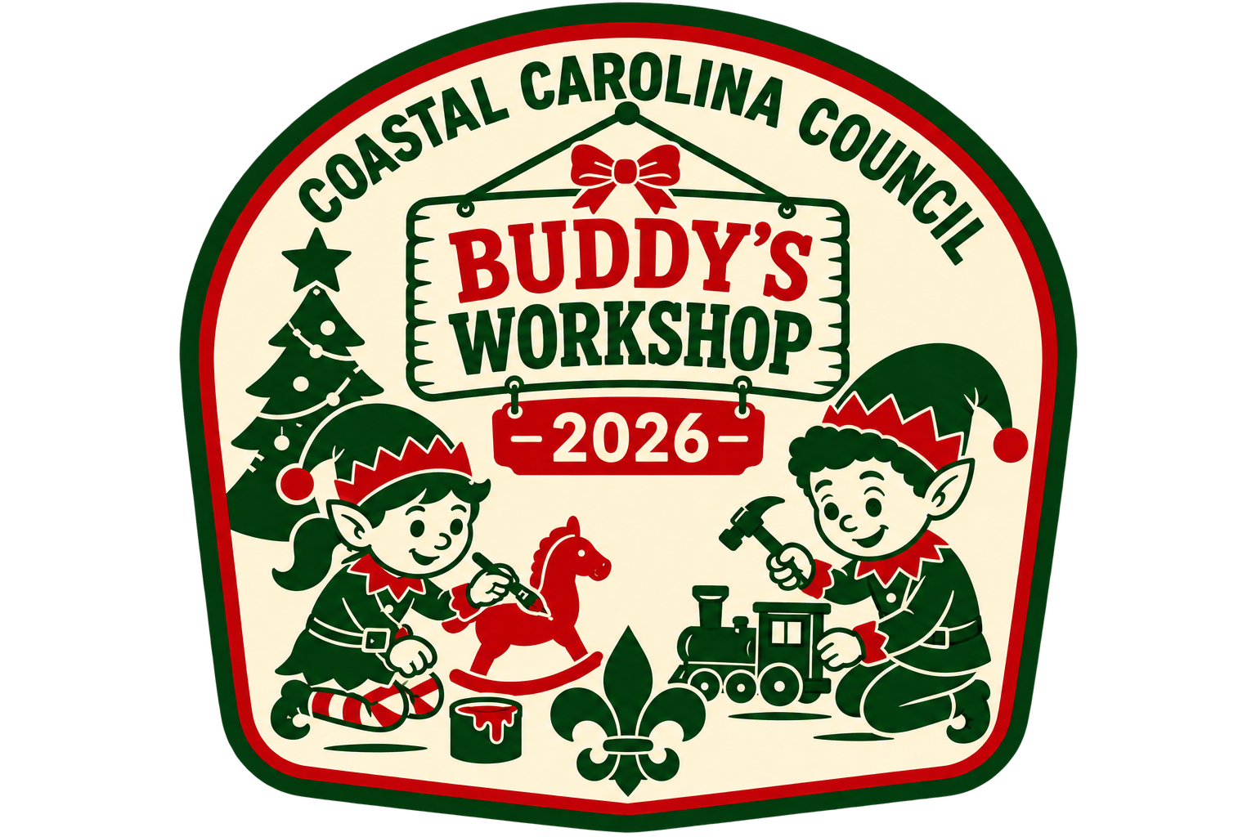
Program Overview
The Buddy the Elf Holiday Workshop is a cheerful Cub Scout activity built around creativity, cheerful sportsmanship, and fun inspired by the Holiday Spirit. Scouts will participate in games, crafts, and refreshments that celebrate kindness, imagination, helpfulness, and holiday cheer while remaining age-appropriate for all Cub Scouts and siblings.
All activities will be run by Troop aged scouts with adult oversight.
Anticipated group: All Cub Scouts, siblings, and friends are welcomed to join in on the Holiday fun with an adult partner(s). All activities are geared towards Cub Scout aged youth.
Anticipated length: The program will run for about 4 hours. We will run two groups, the first group beginning at 8:30 a.m. to 12:30 p.m. and the second group will begin at 2:00 p.m. to 6:00 p.m.
Cost: The cost is $25 for all participants. We ask that any person (adults, siblings, friends) who wishes to participate register and pay for the event. Only those participants who are given an activity passport will be allowed to participate due to not having extra resources on hand.
The $25 covers the cost of the program materials, refreshments, and a commemorative PATCH!
Registration: Please register through the Council’s Black Pug website. For any assistance please contact:
Monica Campbell
843-763-0305
Monica.Campbell@scouting.org
Location: All activities will be held at the Coastal Carolina Council office located at: 5935 Rivers Ave Ste 200, North Charleston, SC 29406. Enter through the first door on the right-hand side of the building (door is labeled). If you need access to an elevator, one is available, just let us know when you are arriving and we will guide you to the right location.
Schedule
Time | Activity | Notes
AM Group 8:15-8:30  PM Group 1:45-2:00 | Check In | Participants will receive their name tags and activity passports.
AM Group 8:35-8:45  PM Group 2:05-2:15 | Opening | Welcome and general housekeeping notes.
AM Group 8:50-12:15  PM Group 2:20-5:45 | Open Activities | All activities are open to participants to participate. Work at your own pace and try to complete your passport.
AM Group 12:20-12:30  PM Group 5:50-6:00 | Closing | Bring the event to a close and thank all for coming.

Activities:
When the participants check-in, they will be given a name tag and an activity passport to map out their way through Buddy’s workshop. At each workstation one of Buddy’s elves will punch their passport and lead the participant(s) through the workstation activity.
The activities range from writing letters to Santa, arts and crafts, culinary masterpieces, elf games, photo opportunities, and some relaxation with some refreshments while watching one of Whoville’s favorite characters, The Grinch!
In addition to having some fun and getting a head start on our holiday cheer, we will also be hosting a non-perishable food drive. We ask that each person visits our Helping Hands station and makes a donation. All the food collected will be handed over to a local food bank who will make sure these items get to the ones who truly need them. Remember a Scout is KIND and HELPFUL!
Make sure after you visit all 15 workstations and get your passport punched you go find the head elf to get a surprise!
