LOWCOUNTRY MUSTER
with the Swamp Fox!

📅 September 18–20, 2026
📍 Sgt. Jasper Park – Hardeeville, SC

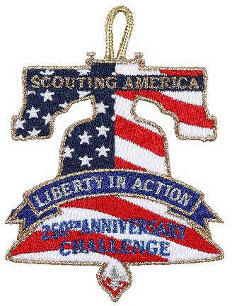

🪶 Calling all Lowcountry Patriots! Brigadier General Francis Marion, the “Swamp Fox” himself is having a muster September 18th through the 20th. He invites all to celebrate 250 years of the spirit of our country. Join him in earning the Liberty in Action Challenge.

Snapshot of the Liberty in Action Patch
The 250th Anniversary of the U.S.A. patch is a temporary patch that can be earned:
- By all Youth, Scouts, Explorers, Family Members, and Adults
- From March 2026- February 2027
- Patches should be available for purchase at the beginning of April 2026 in Scout stores.
- Please take photos and use #America250Partner when posting on social media. Don’t forget to tag Scouting America!

Before Arrival
- Medical forms collected
- Roster confirmed
- Meals planned
- Campfire skit prepared
- Cooking dish assigned
BULLETED CHECKLIST
- ✅ Maintain two-deep leadership at all times
✅ Comply with all Scouting America policies
✅ Keep track of all youth participants
✅ Encourage Scout spirit
What to expect
As a Scout attending the Lowcountry Muster, you can expect an exciting and active weekend filled with outdoor adventure, teamwork, and learning. From the moment you arrive on Friday, you’ll check in, participate in an opening ceremony, and complete the required safety briefing before enjoying some free time to settle in camp. Throughout Saturday, you’ll rotate with your unit through hands-on activities like BB shooting, archery, cooking demonstrations, games, service projects, and a history presentation. You’ll need to be prepared to stay outdoors, bring proper gear, and work together with your unit while following all safety and leadership guidelines, including two-deep leadership. There will be opportunities to improve your shooting and archery skills while also contributing to your unit’s cooking challenge and campsite responsibilities. In the evening, you’ll enjoy a campfire where units perform songs or skits, with extra recognition for sharing local Lowcountry history. Overall, this weekend will challenge you to grow in skills, teamwork, and appreciation for the spirit of our country while having fun in a true Scouting environment.
