HIGHLAND GAMES LEADER GUIDE

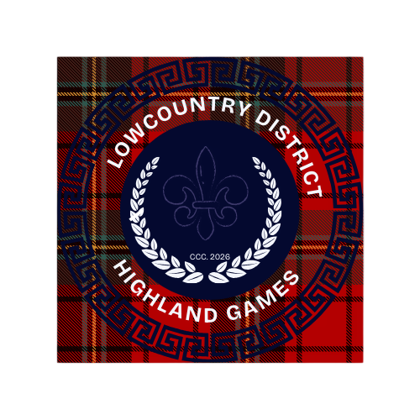
2026 Highland Games
Hosted by the Lowcountry District
Coastal Carolina Council Scouts of America
Camp Chairman
Renae Hardage
renaesscoutlife@gmail.com
843-263-1952
Lowcountry District welcomes Scouts to come and experience the many different games offered at the Camporall.
Events will be offered to Scouts BSA, Webelos, Cub Scouts, Explorers, Venture Crew, and Ships.

Highland Games Logistics
- Dates: April 24-26, 2026
- Location: Lake Warren 1079 Lake Warren Rd Hampton, SC 29924
- Registration: Registration will occur through the council online in Black Pug. Registration is open until April 10, 2026. Please register as early as possible. We will be organizing Scouts from Troops and Packs together to form our Clans.
- Fee: The fee per Scout is $20.00 for regular registration (March 16th-31st), and $27.00 for late registration (April 1st-10th). The fee per leader/parent is $5.00. The fees cover the cost of patches, awards, cracker barrel, program supplies, and cleaning supplies.
- Check-In: Check-in starts at 5:00pm at Lake Warren. At check-in, units will need to submit a completed roster and any outstanding fees.
- Parking: Units will need to enter the park through the front gate. Camp will be behind the Ranger Station.
- Medical Services: According to BSA policy, all Scouts and leaders should complete an Annual Health and Medical Record form (parts A&B only) for all Scouting activities. It is the responsibility of the unit to obtain and maintain copies of these forms for members of their unit. Medical forms will not be turned in to the camp staff at check-in.
- Uniform and Dress Code: The official BSA Field Uniform (Class A Uniform) is required for traveling to and from the campout, flag raising and lowering, and Sunday’s worship service.
- Check-Out: We ask that all troops participate in a trash sweep of the grounds prior to checking out. Check-out can occur after the flag-raising ceremony on Sunday morning. When ready for check-out, inform a staff member for site inspection. Units will be released after the successful completion of their final site inspection.
- Fires: Troops will need to ensure that fires are kept in established campfire rings to keep campfires off the ground at all times. Please also provide your own firewood. These policies help us follow Leave No Trace & the Outdoor Code:
As an American, I will do my best to- Be Clean in my outdoor manners, Be careful with fire, be considerate in the outdoors, and be conservation-minded.
- Sanitation: Toilet facilities will be available. Opportunities to clean the bathrooms will be scheduled for both Saturday and Sunday mornings. Units will be asked to sign up for bathroom duty at the SPL/PL meeting, Friday night.
- Safety: Normal safety precautions should be taken at these events: no throwing of rocks or other objects, no sheath knives or machetes, no liquid fuel, no open flames in tents, no unattended fires, etc. All accidental injuries should be referred to the medical officer immediately.
- Conduct: The Scout Law and Scout Oath are the codes of conduct at Camporall.
- First Aid: Trained medical personnel will be available at the camp to treat any injuries or moderate illnesses.
- Meals: Units are responsible for their own meals. The meals your unit should be prepared to make are: two dinners (Friday if your unit chooses & Saturday) and two breakfasts (Saturday & Sunday). The park will provide lunch to Scouts participating in the fishing event.
*We highly recommend that meals be simple, easy to prepare, and clean up.

General Rules and Guidelines
- All Scouts, leaders, and visitors must adhere to the Boy Scout Oath and Law, the Outdoor Code, and the BSA Guide to Safe Scouting for the duration of the Campout.
- Scouts are not permitted to leave the boundaries of the campground.
- The buddy system shall be used at all times during the Camporall.
- Unit leaders are responsible for their Scouts and visitors at all times.

Location: Lake Warren
Date: April 24-26, 2026
Itinerary:
Friday,April 24, 2026
5:00 pm – 8:00 pm Check-In
9:00 pm – 10:00 pm Leaders Meeting & Cracker Barrel (Scoutmaster/Cubmaster, SPLs/Den Leader)
11:00 pm Taps / Lights Out
Saturday: April 25, 2026:
6:45 am Reveille 7:00 am – 8:00 am Breakfast
8:10 am – 8:30 am Flagpole Assembly 8:35 am- 9:30 am Clan Gathering
9:30 am – 12:45 pm Fishing and Free Time
12:45 pm – 1:30 pm Lunch
1:35 pm – 6:00 pm Highland Games
6:05 pm – 7:30 pm Dinner
7:35 pm – 9:00 pm Campfire, Awards, Skits 9:30 pm- 10:00 pm Cracker Barrel
11:00 pm Taps / Lights Out
Sunday, April 26, 2026:
7:00 am Reveille
7:30 am – 8:30 am Breakfast
8:40 am – 9:30 am Worship Service
9:30 am – 11:00am Grounds Sweep & Check Out
**** Staff cannot leave until cleanup checks after all participants leave. ****Please be respectful to all units. Unload and return your vehicle to the parking area before setting up your tent and site.
Please familiarize yourselves and your Scout with each of the games and events,
All of which we want to make sure that safety is first. Scouts will be throwing and
carrying heavy objects throughout the day. We encourage Scouts to bring work
gloves to wear during some of the events.

Individual  Events:  The Caber Toss  Stone Put  Haggis Hurl  Farmers Carry  Tossing the Wellie  Team Events:  Tug-O-War  RB Consumption  Kilt Run | Skits:  Each Clan should plan a skit for campfire.  Troops and Packs will be combined to make Clans. | Flag creation competition:  The flag competition requires each  clan to create a five-foot pole with  a customized flag matching your  Clan theme. What has worked in  the past for units was to give the  flag to a single member of the  clan. The flag  should measure no more than 3  feet by 2 feet.
Scouts and adults should bring fishing poles if they have them.

Anyone over the age of 16 will need to purchase a fishing license.

* Although Camporall is organized as a fun event to help promote unity within the District, there are still some opportunities to complete some requirements for Merit Badges and rank advancement. Please notify Renae if you have a Scout who would like/need to work on the Communications Merit Badge. They can do Scout’s Own, Campfire, or Flag Ceremonies.
* Any Scout who completed or is working on Bugling is welcome to perform Reveille in the mornings.
* Please reach out if there is any other way we can help Scouts achieve Scouting goals.

