May 2023 Skyuka Trading Post, online sales items
Short Sleeve T Long Sleeve T Crewneck Sweatshirt Ballcap (SKYUKA is printed on back in an arch)
Gilden Dry-Blend Gilden Heavy Cotton Gilden Heavy Blend
50/50 Cotton/Poly 100% Cotton 50/50 Cotton/Poly
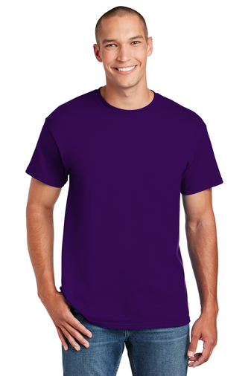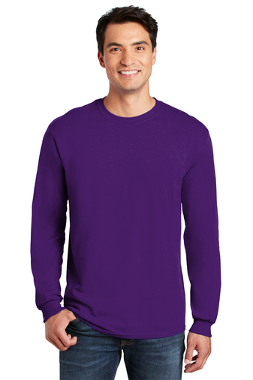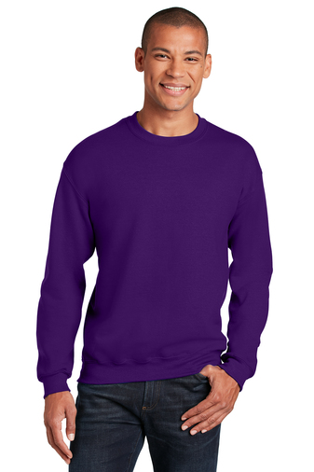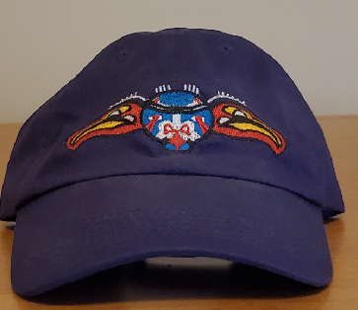
Adult S-XL: $14 Adult S-XL: $18 Adult S-XL: $25 $15
Adult 2XL: $ 16 Adult 2XL: $20 Adult 2XL: $27
Adult 3XL: $ 17 Adult 3XL: $21 Adult 3XL: $28
Adult 4XL: $18 Adult 4XL: $22 Adult 4XL: $29

Shirt Artwork (tipi = back center, Indian on Shirt Sizing
the Mountain is left front chest)
