Webelos Woods 2025
Event Guide
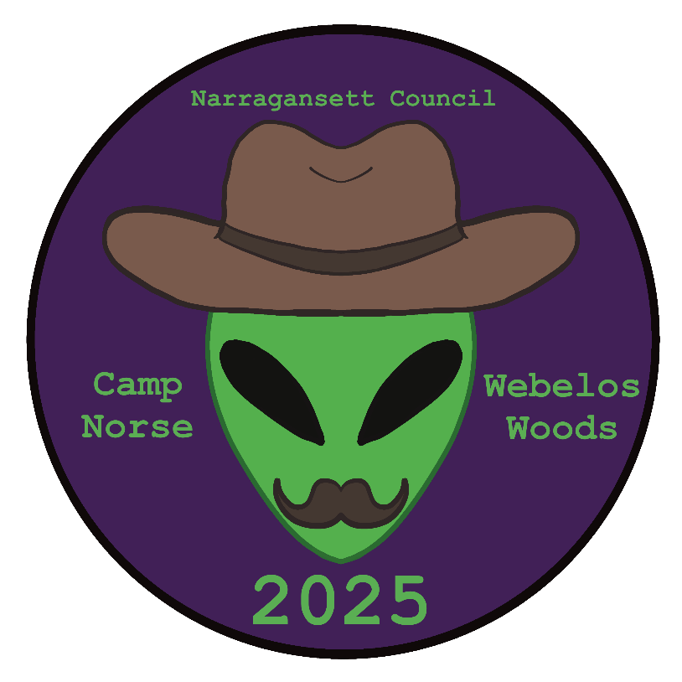

Narragansett Council BSA
Camp Norse
112 Parting Ways Road
Kingston, MA

September 19-21, 2025

Table of Contents

Introduction Error! Bookmark not defined.
Why should I attend Webelos Woods? 3
Where/when will the event be held? 3
How to Register 4
Event Check-in 5
For Scout BSA Troops 6
Additional questions? 6
Webelos Woods Schedule 7
What to Bring 8
Camp Norse Map 9

Howdy Webelos, AOLs, and Scouts BSA Troops!

Welcome partners and space explorers! Get ready for an exciting adventure at Webelos Woods, where cowboys and aliens come together for a weekend of fun!

Put on your cowboy hats or space helmets and head to Camp Norse for scouting challenges, exciting games, scout skill showcases and more! Your skills will be judged on time, quality or completion for points to compete with other troops.

You’ll get to make new friends, work as a team, and enjoy the great outdoors under the stars with your fellow scouts, just like real space cowboys!

This wild weekend will happen from September 19th to 21st 2025, and we can’t wait to see you there. This is a special once-a-year event you don’t want to miss!

Why should I attend Webelos Woods?
For Webelos/AOL scouts and their parents, this once-a-year event is a great way to:
- Discover the fun and adventure that’s soon to come when they become Scouts.
- Get an introduction to the working of a Scout BSA troop and the scout-led patrol method.
- Participate in numerous entertaining and useful Scouting skills, as Scouts teach the thrill of camping in the great outdoors, reinforce Scouting values and instill a strong desire to become a Scout.

For Scouts, it’s a fantastic opportunity to show off your skills, your unit, and get the Webelos/AOL inspired and excited about their Scouting future!
And what’s better than doing that all with Cowboy and Aliens as the backdrop? Every attendee, young and old, is welcome to join us in costume as their favorite character – prizes will be awarded for the best costumes!

Where/when will the event be held?
Camp Norse
112 Parting Ways Rd
Kingston, Massachusetts

Friday evening September 19th through Sunday morning, September 21, 2025

How to Register (Deadline: 9/15/25)
- Sponsors: Webelos/AOL dens are encouraged to reach out to a sponsoring troop to spend the weekend with, or troops can reach out to one or more Webelos/AOL dens and offer to be their sponsor. If you are unable to arrange a unit to match up with, let us know so we can assist you.
- Meals: Sponsoring Troop will be responsible for meals of attendees. There may be a cost for food that is NOT included in registration payment (see below)
- Sign up online at the Narragansett Council BSA web site http://www.narragansettbsa.org.
- Payment is required at the time of registration. (No payment option will be available during the weekend of the event.) Fees include a patch, campsite and unit flag participation ribbon.
Cub Scout (Council Cost) (includes 1 parent): $20
Cub Scout (Out of Council Cost) (includes 1 parent): $25
Scouts BSA (Council Cost): $20
Scouts BSA (Out of Council): $25
*Note: Attendees may be responsible for contributing a separate fee to the sponsoring Troop for food expenses.

- Campsites: Select preferred site at the time of registration. Host will follow up with units to confirm.

Event Check-in

- Troops with their Webelos/AOL Scout + parent guests may arrive at Camp Norse beginning on Friday evening at 5:30PM.
- Please send a representative to the Camp Norse Admin/Welcome Center (overlooking the main parking lot where Trading Post is) to check-in when you arrive.
- Provide a roster of ALL Scouts, Scouters, and parents camping/ attending the event.
- Provide BSA Health Forms for ALL Scouts, Scouters, and parents camping/ attending
- No vehicles are allowed in camp sites except to tow a unit trailer to the site. The tow vehicle must be removed immediately after unpacking.
- Webelos/AOL leaders & parents must wait for their sponsoring Troop to arrive before going to their designated campsite.
- Webelos/AOL units wishing to arrive on Saturday morning may check-in at the Camp Norse Dining Hall beginning at 7:15AM.
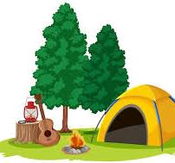

For Scout BSA Troops
- Food: Sponsoring troops should invite their Webelos/AOL guests to help plan and prepare meals at their campsite.
- Activities: Troops are encouraged to run an activity or skills station of their choice and are responsible for event supplies. Please provide preferred station at registration, some options are below:
    - First aid
    - Cooking Methods
    - Fire Building
    - Escape room at the Fort
    - Orienteering/Map & Compass
    - Pioneering/Shelter Building

- Friday Night Cracker-Barrel: Senior patrol leaders and Scoutmasters should attend. Please bring a snack to share to the dining hall. (See schedule for exact time) Last minute announcements and schedules will be available at the gathering. The event is important to keep Scouting units up to date on weekend news.
- Saturday Night Campfire: If your unit would like to present a skit or song, please let the staff know by Saturday afternoon of the event.
- Proper Scouting attire, appropriate behavior, and two-deep leadership are required at all times.
- Scout camping rules apply.
- Rubbish: Please pack out all your trash. Dumpsters WILL NOT be available at the camp. Remember to leave no trace.

Additional questions?
- Adult Leader: Raschel Escola at NarragansettWebelosWoods2025@gmail.com
- Adult Leader: Michael Smith msmithdj@verizon.net

Webelos Woods Schedule
2025

Friday, September 19th Events/Activities
5:30 pm – 8:00 pm Unit check-in (at Admin Building) and campsite setup 8:30 pm Cracker Barrel - Scoutmasters/SPL meeting in Dining Hall. 10:00 pm Lights and fires out. Quiet in the campsites.

Saturday, September 20th Events/Activities
6:30 am REVEILLE: Rise and Shine 7:00 am Prepare Your Own Breakfast in Camp Site 7:15 am – 8:30 am Continue Unit check-in /Registration at Dining Hall 8:30 am Opening Flag Ceremony (Class A Uniform) 8:45 am Stations Open
11:45 am Stations closed for lunch 12:00 pm Prepare Lunch in Camp Sites
1:00pm Trading Post OPEN until 4pm 1:30 pm Stations Open
4:00pm Trading Post CLOSED
4:30 pm Stations Close 4:45 pm Closing Flag Ceremony (Class A Uniform, all Invited)
5:00 pm All-faith Service at Dinning Hall (Class A Uniform) 5:30 pm Prepare Your Own Dinner in Camp Site
8:00 pm CAMPFIRE PROGRAM at Amphitheater 10:00 pm Lights Out ALL QUIET in camp

Sunday, September 21st Events/Activities 7:00 am REVEILLE: Rise & Shine 7:30 am Breakfast in Camp Site / Pack-up camp. By 10:30 am Break camp. Remove all trash from site. Leave No Trace!

What to Bring
Food (Provided by the Host/Sponsor Troop)
Tent and tarp (Webelos/AOL scouts may share a tent with their parent/guardian)
Warm sleeping bag & Sleeping pad
Sweatshirt
Pillow
2 pair pants
2 shirts
2 pairs of socks
2 pairs of underwear
Scout Uniform (Class A) (required for all Scouts & Leaders for flag ceremonies)
Scout T-Shirt (Class B)
Shorts
Boots & Sneakers
Warm jacket
Folding chair
Mess kit, Knife, fork, spoon & cup
Water bottle
Soap, Wash cloth, Towel, Toothpaste & brush
Compass
Paper, Pencil & Handbook
A Day Pack
Flashlight
Unit Flag
Money for Trading Post

Optional
Camera
Props for skit

Pack for the weather. Bring cold weather or wet weather gear as appropriate. It might get cold at night!

Camp Norse Map
