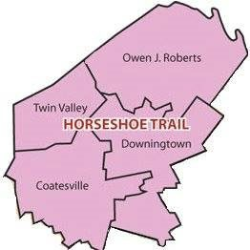
Horseshoe District
Open Pinewood Derby Race
April 9, 2022 from xx to xx
Location: XXX

Parents, Have you always wanted a chance to build and race a pinewood derby car outside the normal Cub race and test your unique designs with only limited rules to hinder your design concepts, this is it.

Prizes for faster car and most novel design

Entry fee: a $20.00 donation is requested, but not required.
No preregistration is required
All cars MUST be Checked in by X:XX AM on race day.
The following rules are to ensure that the cars do not damage the racetrack.
- All cars must pass the following inspection on to qualify for the race
- Width shall not exceed 2‐3/4 inches.
- Length shall not exceed 7 inches.
- Must utilize the block of wood from the official kit.
- No sharp edges that may damage the track.
- Weight shall not exceed 6 ounces. The Official Scale will not be questioned!
- No lubricating oil may be used. Axles may be lubricated with powdered graphite or silicone.
- The car must be free‐wheeling, with no motors/engines.
- No loose materials of any kind are allowed in the car.

