
Trader Patch - $5.00 each
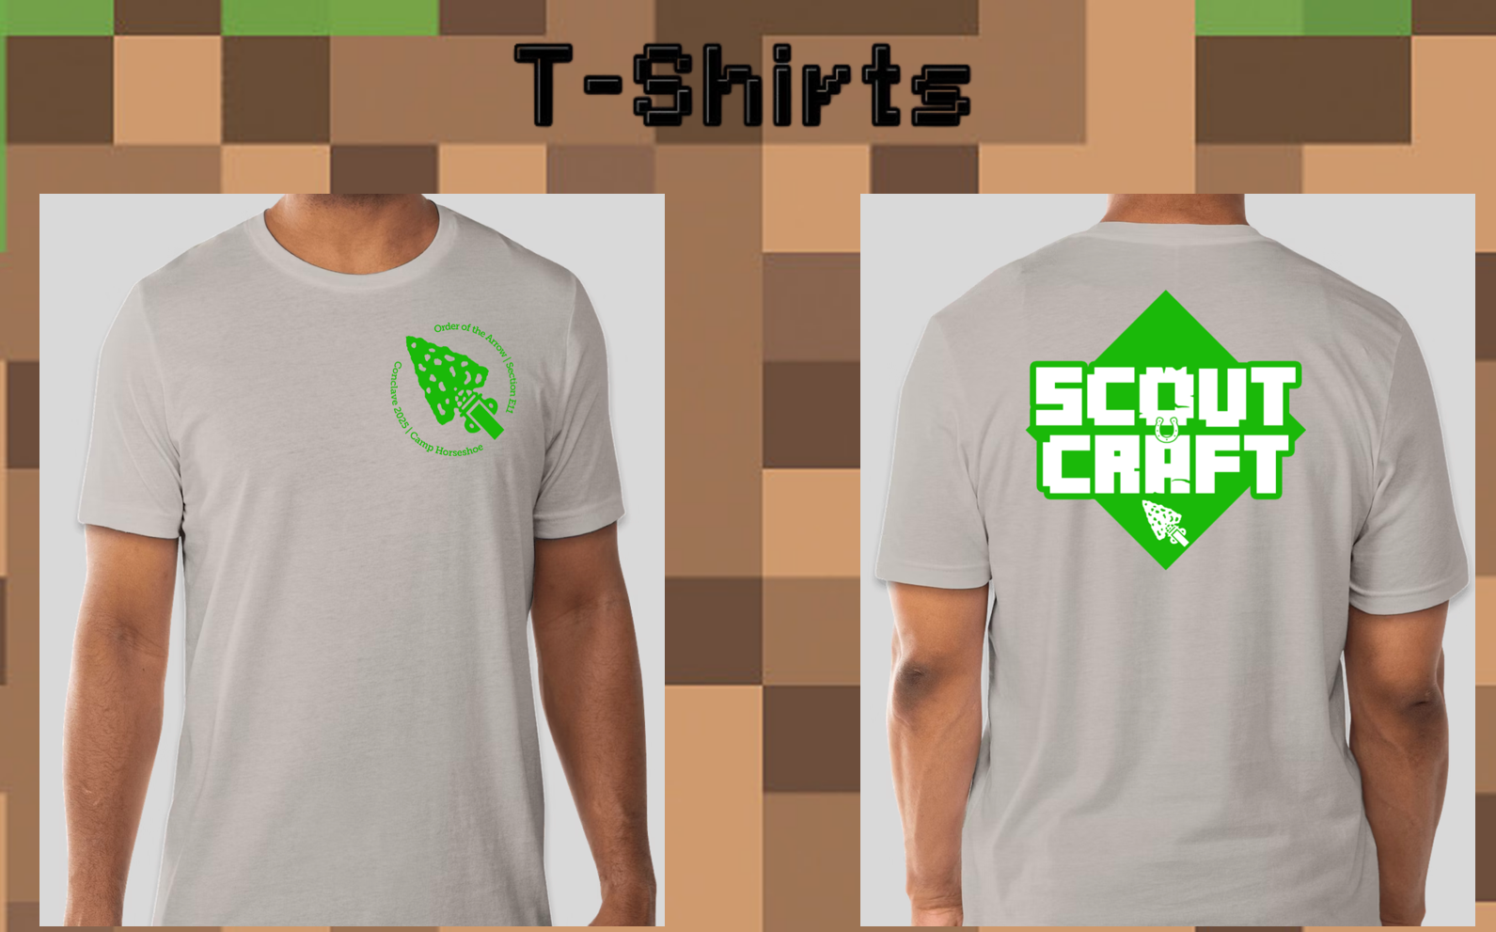Delegate T-Shirt - $20.00 Each
Delegate Hoodie - $40.00 Each

