Chester County Council Cub Camporee (C5)
Ware Goes Medieval
“HEAR YE, HEAR YE, all Lords & Ladies. The Grand Old Duke and Duchess of Ware cordially request your presence to be their guest at the C5 Royal Games and Banquet held at Castle Ware in the year of our Lord 2024 on May the 4th.”
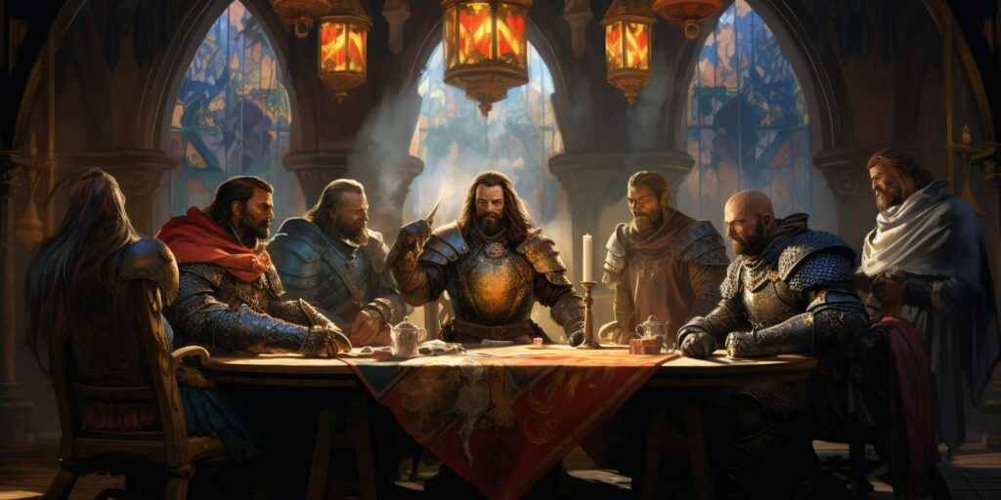

Come join us as Camp Ware will be transported back into the Middle Ages where there will be lots of fun and activities for all ages. Bring your court and pack your tents for an overnight camp experience or sign up just for Saturday.
This year Chester County Council and Order of the Arrow Octoraro Lodge #22 will host the C5 Cub Scout overnight event at Camp Ware from Saturday, May 4th to Sunday, May 5th. You guessed correctly, it will be a medieval theme based on the high courts, castles and jesters. The weekend will provide a sneak peek to this year’s Cub Scout Resident Camp which will have a medieval program as well.
Program Activities will range from several medieval themed games, jousting, branding, Dutch Oven cooking, and archery, just to name a few. While participating in the games, collect gold coins to increase your realms wealth courtesy of the Duke and Dutchess. The Trading Post will be open and stocked with all its usual sundries of Horseshoe Reservation goodies as well as snacks and drinks.
In the evening, we will be hosting a Royal Banquet to quench the hunger from the day’s activities. The repast is provided by Octoraro Lodge’s very own world class kitchen staff for the entire weekend.
Register your intent at:https://scoutingevent.com/539-c5
Sign up as a Pack and stay in one the Camp Ware’s sites or as a family and camp in the field. Site assignments for Packs will be first come first serve. You will need to provide your own tents. Octoraro Lodge members can sign up to help staff for the weekend at the same registration link.
The Duke and Dutchess of Camp Ware are enthusiastically waiting for your RVSP.
Chester County Council Ware Goes Medieval Schedule
Saturday 9:30am Camping Arrivals and Check In Begins
10:30am Day Arrivals and Check In Begins
11:00am Flag Raising/ Opening
11:15am - 4:00pm Quests/ Trading Post open
12:30pm – 1:30pm Lunch
5:00pm Trading Post Closed
5:45pm Retreat (Class A uniforms)
6:00pm - 7:00pm Royal Banquet (Buffet Style)
7:00pm Trading Post open
8:00pm Trading Post closed
8:30pm Campfire
10:00pm Taps
Sunday 7:00am Reveille
8:00am Breakfast
9:00am Scout’s Own Service
9:30am Camp Cleanup
11:00am Close Camp
Tournament Quests: Jousting, Robin Hood’s Archery Contest, Slingshot the Goblins, THE VIKINGS ARE COMING!!! regalia, The King’s Cake (Dutch Oven cooking Demo, various carnival games just to name a few. Plus Scout Skills: Fire building, Knots & Lashings, Orienteering, First Aid skill stations.
Other activities at Castle Ware can include a quest through the trails to enjoy nature waking up from its long Winter’s nap. Don’t forget your fishing rod and binoculars for fishing and birding along the scenic Octoraro.
All of these activities will lead up to a camp-wide Royal Banquet with all the fixins’. Then as the sun sets over Horseshoe Scout Reservation for a Campfire.

