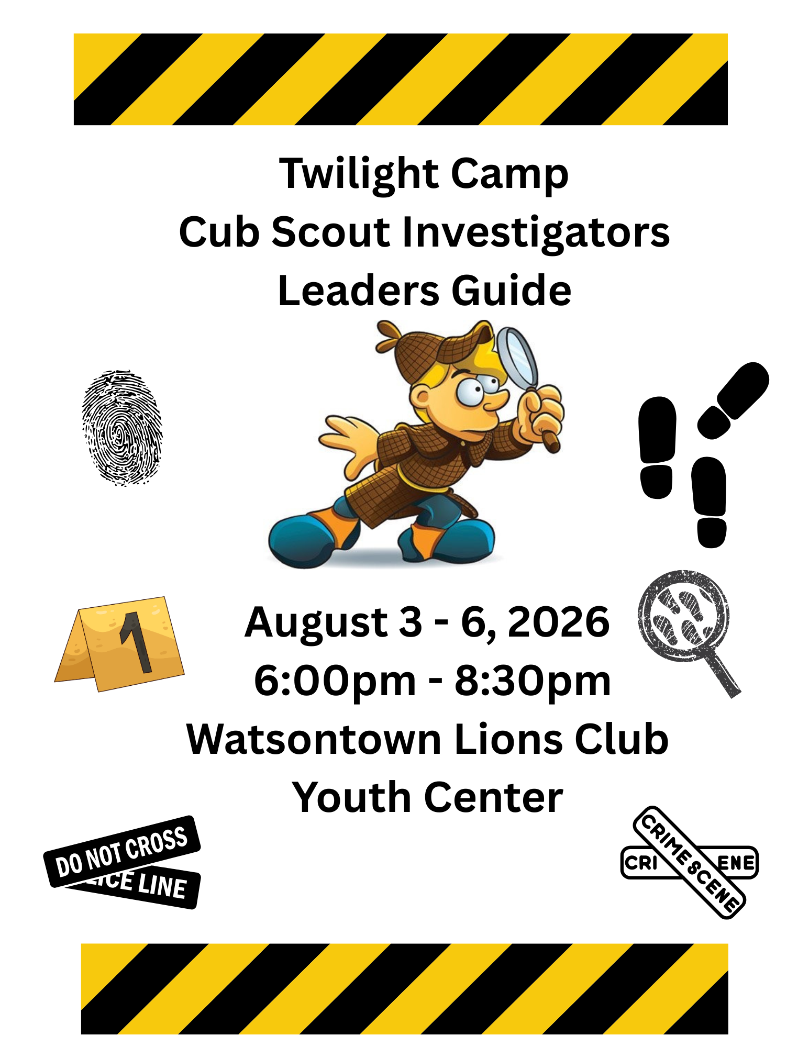

This leader guide is published by the Scouting America, Susquehanna Council #533
815 Northway Road, Williamsport, PA 17701
(570) 326-5121
www.susquehannascouting.org
Council President Kate Hastings
Council Commissioner Kay Trick
Scout Executive Dennis Dugan
Camping Committee Chairman Mike Stender
Staff Advisor Reuben Stugart
Twilight Camp Director Denise Stevenson / Carlonnie Hoover
Twilight Camp Program Director Denise Stevenson/Carlonnie Hoover

Scouting America, Susquehanna Council is a proud partner agency of the United Way

Guide to the Leader Guide:

Camp Theme – CSI: Cub Scout Investigators 4
Letter from the Staff Advisors: 4
Watsontown Lions Club Youth Center 5
Important Dates 5
REGISTRATION - PRE-Camp 5
Youth Eligibility 5
Camp Registration Fees - Youth 5
Camp Registration Fees- Adults 6
Cancellations and Refunds 6
Staffing & Camp “Walkers” 6
All Staff MUST register and pay the staff fees for Twilight Camp (see Camp Registration Fees-Adults below). 6
Station Leads and Station Assistants 6
Youth Station Assistants 7
Daily Staff Responsibilities 7
Camp Guides or “Walkers” 7
Daily Responsibilities 7
Health Forms and Other Forms 8
Health and Medical Records 8
Medical – “Check in Process” 8
Unit Rosters - Scout & Adult 8
Check-in/Check-out Procedures 9
Visitors 9
Leaving Camp Early 9
Adults 9
Scouts 9
National Scouting America Policies 10
Illegal, Immoral or Unacceptable Acts 10
Narcotics & Dangerous Drugs 10
Alcohol 10
Action Taken on Above Violations 10
Tobacco Use 10
Camp Policies & Procedures 10
CUB SCOUT DICIPLINE Outline 13
Suggested Items 13
Do Not Bring 14
Pack Pre-Camp Checklist 14
The Four must have forms 14
TWILIGHT CAMP CAMPERSHIP APPLICATION 21

Camp Theme – CSI: Cub Scout Investigators

Twilight Camp is 4 days of exciting program designed to test the limits of your child’s imagination and give them the opportunity to expand their understanding of Crime Scene Investigation. During those 4 days of fun, your Cub Scout will participate in activities that encourage them to investigate all possibilities, ask questions, learn procedures and most importantly have FUN!!!!!
*These activities will continue rain or shine. In the event of severe weather, alternate activities will be offered!

Twilight Camp is operated by nationally trained local Scouters interested in providing a fun, exciting outdoor program for Lions, Tigers, Wolves, Bears, Webelos and Arrow of Light Scouts.



Letter from the Staff Advisors:

Welcome to the 2026 Susquehanna Council Twilight Camp! The Susquehanna Council and our Twilight Camp staff are very excited to have you, and your Cub Scouts join us this summer. We have a very exciting program this summer with tons of fun and activities planned! We hope to make this camp enjoyable for everyone.

This year’s theme will focus on 4 days full of exciting activities with each day focusing on a different crime that the cub scouts will need to investigate and help solve. We hope you and your cub scouts are as excited as we are to have fun and learn about CSI.

Please take the time to review the information provided to you in this guide to better serve you and your Scouts. Be sure to take advantage of what this leader guide has to offer, as it will assist you in planning a successful Twilight camp experience for your Cub Scout pack.

Watsontown Lions Club Youth Center

4261 White Deer Pike, New Columbia, Pa 17856

Important Dates

July 19: REGISTRATION Closes

REGISTRATION - PRE-Camp
As you prepare your pack for Twilight Camp this summer, here are a few points to keep in mind while going through the registration process.
- Always keep a copy of all receipts and forms related to camp for your pack’s records.
- Keep all your camp-related receipts and forms together and have them with you any time you go to the Scout Service Center to make arrangements and payments for camp.
- Always take all your camp-related receipts and forms to camp when your pack attends.
- If whoever handles all the pre-camp registration will not be going to camp with the pack, then make sure that the leader who will be going to Twilight Camp has all the necessary copies of receipts and forms. Make sure that they understand what the receipts and forms mean and are prepared to complete the registration process at the day camp office.

Twilight STEM Camp Location Daily Program Length
Monday-Thursday Watsontown Lions Club 6:00 p.m. – 8:30 p.m.
August 3 - 6

Twilight Camp is limited to 75 Scouts. Available spaces will be filled on a first-come, first-serve basis.

Youth Eligibility
Twilight camp is open to all youth ages 5-11.

All Scouts attending who are Lion or Tiger Scouts must be accompanied by an adult partner.

Camp Registration Fees - Youth
Regular Fee $75 per registered Cub Scout / $75 for Non-registered Youth

Camp fees for Twilight camp include patch, camp program and materials, evening snacks, and water. Scouts should eat their evening meal before they arrive.

Complete payment of all camp fees is required when submitting Scout Roster Forms. Camp registration fees are transferable between Scouts, less the $30 cancellation fee (Example: Dave pays for camp but then cancels. Dave’s fee can be used for Gary, but Gary must make his own separate payment of $30 to cover the difference of Dave’s non-refundable cancellation fee).

Your pack is welcome to bring along a Den Chief to help during your stay at camp. Den Chiefs are considered Scouts and not adult leaders; therefore, you will need to list them on the Scout Roster Form, labeled as a Den Chief (written next to their name).

Youth who join Scouting in the Spring and Summer are still eligible to attend Twilight Camp! Unit leaders should coordinate their registration and paperwork prior to registration for Twilight Camp.

Camp Registration Fees- Adults
Adult/Staff with Patch- $10

Adult leaders attending Twilight Camp are required to register. All adults must be registered members of the pack and/or be the parent or legal guardian of an attending Scout. Adults in direct contact with and having supervisory capacity over Scouts are required by the Commonwealth of Pennsylvania to comply with Act 15 regarding clearances, as well as up-to-date Safeguarding Youth Training.

All individual adults staying at camp must be listed on the Adult Roster Form (page 12) showing when they will be at camp. (Example: Ron will be attending with the Pack 7 on Tuesday and then Chad will take his place Wednesday through Thursday).

Cancellations and Refunds
There is no refund for missed days. Each session requires a $30 non-refundable cancellation fee (this includes all Scouts and campership recipients) Twilight camp registration fees are transferable between Scouts, less the $30 cancellation fee (Example: Dave pays for camp but then cancels. Dave’s fee can be used for Gary, but Gary must make his own separate payment of $30 to cover the difference of Dave’s non-refundable cancellation fee). Only refund requests submitted by the Scout’s parent or legal guardian will be considered.

“Homesickness” is not considered to be a refundable medical reason.
Refunds will not be issued at Twilight camp through the camp director. Please submit any refund requests in writing with the following information: Youth name, pack # (if a registered scout), dates Youth attended twilight camp and the reason for the cancellation. All refund requests must be submitted in writing to the Scout Service Center by August 31, 2026.

Staffing & Camp “Walkers”

We are looking for both youth and adult leaders to help during Twilight Camp. If you have an energetic personality and want to help cub scouts solve these crimes that have been reported in Susquehanna Council, please email Reuben.Stugart@sccouting.org. We have opportunities for volunteering at different stations ranging from games to a crime lab, to the evidence station, to the print station, along with opportunities to walk around with the groups and experience all the fun activities. See the exact descriptions below.

All Staff MUST register and pay the staff fees for Twilight Camp (see Camp Registration Fees-Adults below).

Station Leads and Station Assistants

Registered adult Scouters that help by providing guidance and two-deep leadership. Station leads will be responsible for setting up and tearing down your station each day and making sure that program is implemented properly. They are responsible for taking attendance at each station, following the schedule, and staying on task. Station assistants will help with setting up and tear down of your station and assist the station lead, as necessary.

All Station Leads and Assistants must have current Safeguarding Youth Training.

Youth Station Assistants

Scouts will help with set up and tear down each day, help prepare the activities for each incoming group, and help entertain the cub scouts during their time at that station. Cub Scouts love seeing and interacting with older youth and it gets them excited to join Scouts BSA or a Venture Crew one day.

Daily Staff Responsibilities
1. Arrive at Twilight camp by 5:30 p.m.
2. Pick-up your Station Packet (updated daily), which includes the following:
• A list of all the groups by rank and name
• A registration packet which includes copies of the day camp emergency plan.
• An attendance sheet – Please take attendance as each group comes to your station.
• A map of Twilight Camp
• A copy of the daily program schedule
• A copy of instructions for emergency procedures
3. Obtain all necessary supplies and set up your station. Be ready for scouts by 6:15 each day.
4. Take attendance as each group comes to your station, stay on schedule, lead the scouts in your designated activity, make sure all injuries and illnesses are reported immediately to the Camp Health Officer by the “walker” designated to that group, follow the plan in case of an emergency, be positive and create a fun and memorable time for scouts.
5. Clean up your station and dispose of any trash. Leave the area better than we found it.
6. Return Station Packet and station supplies to the Twilight Camp Director.

Camp Guides or “Walkers”
Registered adult Scouters that help by providing guidance and two-deep leadership for a group of Scouts attending Twilight Camp. Walkers are responsible for taking attendance, keeping the group on schedule, and providing leadership within the group.

All Walkers must have current Safeguarding Youth Training.

Daily Responsibilities
1. Arrive at day camp by 5:45 p.m.
2. Pick-up your Group Leader Packet (updated daily), which includes the following:
• A roster listing all Scouts and adults in your group (names, ages, ranks, etc.)
• A list of all the other groups by rank and name
• A registration packet which includes copies of the day camp emergency plan.
• An attendance sheet - You must turn in one copy to the camp director by 6:15 p.m.
• A map of Twilight Camp
• A copy of the daily program schedule
• A copy of instructions for emergency procedures
3. Always stay with your group and provide leadership to the group by taking attendance, staying on schedule, helping with all activities, reviewing advancements, reporting all injuries and illnesses immediately to the Camp Health Officers, following the plan in case of an emergency, being positive and creating a fun and memorable time for the Scouts.
4. Stay with your group until all your Scouts have been picked up to return home
5. Return Group Leader Packet to the Twilight Camp Director

We ask that EACH unit attending camp help by providing 1 or 2 leaders to be staff, whether it be a station lead, a station assistant, or “Walkers”.

Health Forms and Other Forms

Health and Medical Records

Every youth and adult who will be attending Twilight camp this summer must submit a Scouting America Health Form Parts A & B. The form must be filled out completely and signed by the Scout’s parent or legal guardian. The parent or legal guardian must annually update Health Forms. This is to ensure that if any medical changes have occurred that the youth will receive safe and proper treatment in the event of an emergency. Make sure you include all necessary medical information that our staff would need to know in case of an emergency.

Susquehanna Council is no longer required to keep these health forms on file and therefore will be returning them once the camp has concluded. It is still always a good idea to make copies, just in case the originals are lost or damaged.

Medical – “Check in Process”
A medical check-in is required as part of your pack’s check-in procedure. All health forms will be turned in to the Camp Health Officer who will review them with you. The medical recheck is provided to protect against the spread of illness, to verify the use and proper administration of prescription drugs and to evaluate any changes in medical conditions.

All prescription drugs should be clearly labeled with the Scout’s name and pack number and turned in to the Camp Health Officer for safe storage and proper administration.

Unit Rosters - Scout & Adult
The Scout & Adult Roster Forms (Found in the attachments section at the end of this document) must be filled out in their entirety and submitted to the check-in staff at your Twilight camp. The rosters contain important information regarding the number of youth and adults in your pack as well as emergency contact information. Scouts must be listed by rank as they may be grouped at twilight camp by rank and not by pack. If your pack is using different leaders throughout the course of the week, make sure that the rotation schedule is clearly indicated on the Adult Roster Form when turned in. Scouts must have two-deep adult leadership at all times.

You should have at least three copies of your completed roster before you arrive at camp.
- Camp Leader - You will have one copy to keep with your records
- Scout Service Center – You or a unit leader will send in rosters

- At Twilight Camp Check-In - You will turn in one copy along with all your pack’s medical forms and prescription medications

Check-in/Check-out Procedures

Each youth must be signed in each day during the check-in process by a parent or guardian.

Each youth member must be signed out each day by a parent or guardian.

The check-in/check-out staff must physically see who is signing in and out each youth each day to ensure that all youth are accounted for and are sent home with the appropriate adult.

Visitors

Visitors are welcome throughout the week at camp. Please inform anyone from your pack who is planning to visit Twilight camp that they must first report to the camp office where they will sign the logbook; giving their name, the name of the Scout they’re visiting and/or the purpose of their visit. At that time, they will be issued a colored wristband that they must wear the entire time they are at camp. Once their visit has concluded, they must stop by the day camp office and sign-out and surrender their colored wristband.

Please advise all parents to leave all family pets at home. No pets of any type are permitted on Twilight camp property.

Leaving Camp Early

Adults
Any adult member of your pack who must leave Twilight camp early must sign-out at the camp office. A logbook will always be available for this purpose.

Scouts
Youth members of your pack may not leave Twilight camp without the permission of a parent or legal guardian and a pack leader. The Scout wishing to leave must be accompanied to the camp director by a leader to make sure that the Scout is leaving with the right person. The Scout must also sign out in the logbook at the day camp office.

Parents taking their Scout home before the end of a session must sign their Scout out.


National Scouting America Policies
Scouting America has firm policies regarding situations which could occur in camp. Any Camp Staff member, adult leader, Scout or visitor unwilling to abide by these policies is unacceptable in camp. These are not negotiable.

Illegal, Immoral or Unacceptable Acts
As a character-building organization caring for other people’s children in camp, any illegal or immoral activity has no place in Scouting America.

Narcotics & Dangerous Drugs
Possession, use or being under the influence of narcotics or dangerous drugs (including marijuana) will not be tolerated on the properties of Scouting America or properties on which Scouting events are being held.

This does not involve the proper use of prescribed medications by a patient under the care of a licensed physician.

Alcohol
Possession, consumption or being under the influence of alcohol (including beer) will not be tolerated on the properties of Scouting America or the properties on which Scouting events are being held.

Action Taken on Above Violations
When an individual is suspected of having committed an act of an unacceptable nature, the following steps will be taken:
- The Day Camp Director is to be notified immediately. If the matter is of a serious nature, the Council Scout Executive will be immediately notified.
- All inquiries will be undertaken in a careful and confidential manner by the Day Camp Director or Scout Executive. Scouting America supports all local laws, ordinances, and codes of government bodies in whose territory we operate our facilities.

Tobacco Use
The Susquehanna Council observes the Smoke Free Policy of Scouting America which prohibits smoking in all facilities of the Council and of Scouting of America.

Therefore, tobacco use is not permitted in any building, storage shed, program area or other facilities for general use of Scouts, leaders and visitors. An adult who must use tobacco is asked to use discretion and not smoke around Scouts and other youth in camp as well as not in any enclosed facility which includes tents. A designated smoking area will be announced.

Camp Policies & Procedures

The camp administration has implemented procedures to address the possible intrusion of unauthorized persons onto the twilight camp property. All camp staff will be trained in the use of these procedures and steps to take in such instances.

Twilight Camp Program Director - Will daily inspect the Twilight camp property and monitor its security while Twilight camp is in session and will report any irregularities to the Camp Director and Staff Advisor.

Twilight Camp Director - Will monitor the sign-in/out log and will report any irregularities to the Staff Advisor.

Staff Advisor - Will investigate all reports as appropriate, will notify law enforcement agencies as required and will promptly notify the Scout Executive.

Telephone
Please advise parents of the following procedures should they need to contact someone at Twilight camp as quickly as possible in the event of a family emergency.

- For Twilight camp call District Executive Reuben Stugart first at 570-932-1819 if no one answers but the voicemail, please leave your name and telephone number where you can be reached, the person’s name you’re trying to contact, their pack number and indicate clearly that it is an urgent matter or family emergency. Your call will be returned as quickly as possible.

- If the matter is pressing or time sensitive and Reuben Stugart did not answer and you have already left a message on the voicemail as described above, then call the Scout Service Center at (570) 326-5121. If no one answers there but the voicemail, please leave the same message with the same information that you just left for the District Executive. Your call will be returned as quickly as possible.
- If you were unable to reach the District Executive or anyone at the Scout Service Center and left messages at both places, then call Scout Executive Dennis Dugan at 518-258-7257.

Statement of Camp Policies & Procedures
- Twilight camp will be operated on the chartered unit basis (packs under their own leadership) which is recognized as the ideal method for Scout Camping.
- The Twilight Camp program will be organized on a rank basis and administered on the principle that it is a day camp being operated and maintained for the benefit of all units and the youth members of the Susquehanna Council.
- Pack leaders will deal directly with the Scouts. The services of the Twilight Camp Staff are counseling, coaching and of a supervisory nature. The purpose of Twilight Camp is to provide experiences for the packs that will make them better able to conduct their own program.
- The program of Twilight Camp will be based upon the needs and desires of the packs to the greatest possible extent that camp resources will permit.
- Pack leaders should see to it that all new campers are properly oriented and assisted to get the most out of the camp facilities and to assure the Scouts of a positive experience.
- There shall be a minimum of two adult leaders always present with each pack. The pack leader or anyone serving as a pack leader must be at least 21 years of age and a registered member of Scouting America. The second adult may be a registered Scouter 18 years of age or older, or a registered parent or guardian of a participating youth member. Registration must be paid registration with a unit, district, or the Council. Beyond the minimum of two registered leaders, any third or fourth leader would not need to be registered as long as they are the parents or guardians of a participating pack member.
- The buddy system is used at all times. The adult leader is responsible for carrying out this regulation. Whenever a Scout leaves his group for any reason, he must be accompanied by his buddy. This applies also to the necessary trip to the restroom.
- Hazing, initiation, or any type of physical or emotional abuse to any person at twilight camp will not be tolerated at any time. Immediate action will be taken to correct these occurrences should it be necessary.
- Any emergency at camp will be managed quickly and effectively. All campers are asked to go immediately to the designated meeting area upon hearing the appropriate signal. Pack leaders should take roll call of their Scouts and await further instructions from the Twilight Camp Director or the Twilight Camp Program Director. These steps should be followed regardless of the type of emergency.
- Any Scout or Scouter who arrives later or leaves earlier than check-in and check-out must sign-in and out with the camp director. Record your name, date and time of day in the logbook that will be available at all times with the camp director. Please cooperate in the interest of maintaining accurate camp counts. The adult leadership is responsible for providing written notice to the twilight camp director if a camper leaves. If a youth participant is leaving prior to the end of the scheduled session, sign-out must occur.
- Firearms, fireworks or weapons of any type are not permitted at Twilight camp. Punk and incense sticks are also not permitted.
- Any damage or destruction of property by any camper or leader will have the cost of repair or replacement billed to their respective unit.

Knives, Axes & Saws
Pocket knives, machetes, and sheath knives will not be brought to camp.
No trees are to be cut on twilight camp property.

Chemical Fuels
The Susquehanna Council does not permit the use of liquid fuel stoves and lanterns during Twilight camp. Exceptions may be granted by the Scout Executive for appropriate training programs. Propane may be used under adult supervision, and all cylinders or bulk storage tanks must be removed from the property.

Transportation of Scouts
The following guidelines are based on the National Council Policy on the Transportation of Scouts.
- All drivers must possess a valid driver’s license.
- All drivers must be 18 years old or older.
- The vehicle must have a valid inspection certificate.
- Traffic regulations must be obeyed.
- Minimum liability insurance of $50,000 - $100,000 - $50,000.
- Passengers may not ride on tailgates or in truck beds.
- One passenger per seatbelt only.

Pets in Camp
Scouts and leaders are not permitted to bring any type of pets to Twilight camp. Campers are not permitted to remove from their natural habitat any mammal, bird, reptile or amphibian except at the direction of an authorized Twilight Camp Official.

Valuables
Twilight camp is not responsible for lost or stolen money or personal possessions. It is suggested that items like cell phones, radios, CD & MP3 players, handheld video games and DVD players should not be brought to Twilight camp. Lost and found items can be turned in or sought for from the camp director. All items should have the Scout’s name on them or be inscribed with an ID.

CUB SCOUT DICIPLINE Outline
Cub Scouts are expected to always respect each other and others while at Twilight Camp. If a Scout’s behavior jeopardizes the safety of themselves or others, or doesn’t portray the proper Scouting values, they should be asked to stop.
Walkers are responsible for maintaining order within the Den. Any and all disciplinary actions will be judged on a case-by-case basis by the Camp Director in consultation with the Council Staff Advisor. When issues arise, the following guidelines will be followed:
1st offense: Warning by Den Walker or Staff Member
2nd offense: The Scout will spend one rotation with the Camp Director and will miss that scheduled activity. The activity will NOT be made up. The incident is documented and notification will be given to the parent/guardian at the end of the day.
3rd offense: Immediate notification of parent/guardian. Incident is documented, and youth may be sent home
and not permitted to return to camp.
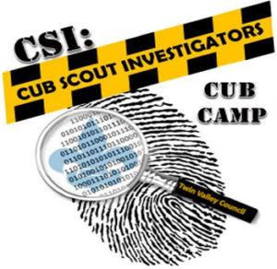
Physical discipline is NOT allowed at Twilight Camp (even with your own scout) Scouts are not to be insulted, degraded, or demoralized through verbal discipline.

Suggested Items
Adult
Sneakers/comfortable shoes*
Backpack
Insect repellent (No Aerosol Sprays)
Sunscreen (No Sprays)
Sunglasses (Optional)
Raincoat /poncho
PA Background Checks/ YPT
Please set the example by only wearing clothing that is appropriate for Scouting and camping.

Scout
Water Bottle
Sneakers/comfortable shoes*
Backpack
Insect repellent (No Aerosol Sprays)
Sunscreen (No Sprays)
Sunglasses (Optional)
Raincoat /poncho

*** HEALTH FORMS PART A&B *** Certification

Do Not Bring
• Alcoholic beverages
• Pets
• Non- Scout-like literature
• Bicycles, skateboards or rollerblades
• Water guns/super soakers
• Spray paint
• Dice

• Non-prescription drugs
• Firearms & ammunition
• Bows & arrows
• Pocket knives
• Machete/sheath knives
• Punk sticks
• Firecrackers/fireworks

Cell phones, music devices, and handheld video games and DVD players are strongly discouraged at camp. They will not be allowed in any program area.

* Shoes should be broken in before camp. No sandals or open-toed shoes are allowed. Closed toe shoes must be worn throughout Twilight camp for each Scout’s safety.

• Twilight camp is not responsible for lost or stolen money or personal possessions

Pack Pre-Camp Checklist
- Arrange for two adult leaders in camp at all times while pack is attending camp
- Suggested ratio: 2 leaders for every 8 Scouts
- Arrange for adequate transportation of Scouts and adults to camp and home again
- Pay camp registration fees. Regular Fee deadline: July 19, 2026
- Collect completed Scouting America Medical Forms Parts A & B from all Scouts and adults going to camp
- Make a second set of copies.
- Collect any completed and signed Scout Release Forms
- Complete Scout & Adult Roster Forms and have three separate copies made
- Have copies of all camp related receipts and forms organized for arrival at camp

The Four must have forms
This final section being provided to you contains a complete set of all camp-related forms. They will be single sided so that you will no longer have to worry about disassembling the main body of the leader guide and risk losing the information that was on the back of the forms. You can now take any form safely and easily out of this packet and make all the copies that you need.
Scout Roster Form
Adult Roster Form
Campership Application Form
Scouting America Health Form: also available at https://filestore.scouting.org/filestore/HealthSafety/pdf/680-001_AB.pdf

 | Scout’s Name (Please Print Clearly) | Age | Grade  (As of Fall) | Rank | Emergency Telephone
1
2
3
4
5
6
7
8
9
10
11
12
13
14
15
Scout Roster

Pack # ____________________
Camp Leader ______________________________ Telephone (______) ___________________ Email ___________________________________
List all Scouts by Rank and grade for the 2026 – 2027 school year. All adults attending camp list on the “Adult Roster.”

 | Adult’s Name (Please Print Clearly) | Registered Position | Volunteering as a Walker | Date of SY Training | Mon | Tue | Wed | Thur.
1
2
3
4
5
6
7
8
9
10
11
12
13
14
15
Adult Roster
Camp Leader __________________________ Telephone (______) ____________ Email ____________________
List all adult leaders and check the days that they will be present in camp - Scouts must have two-deep adult leadership at all times.

Pack#
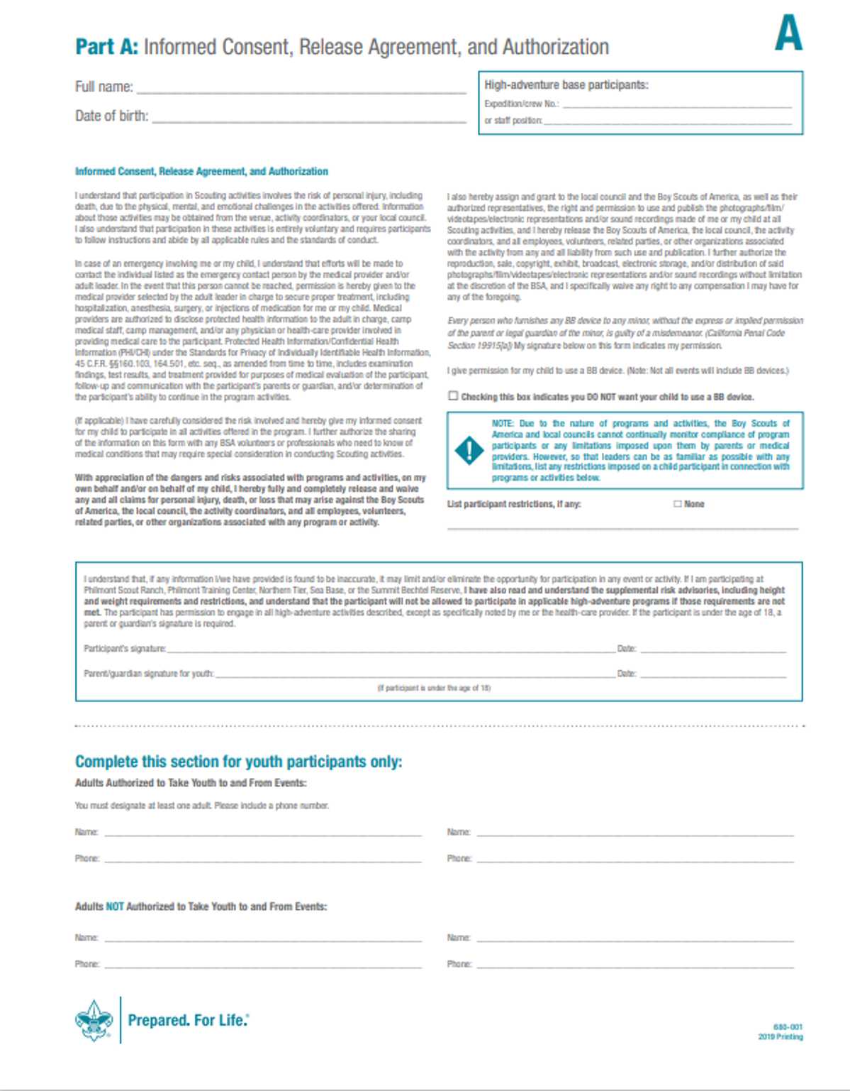

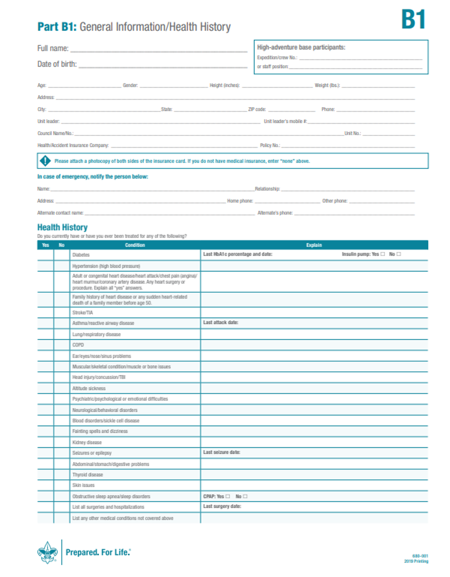
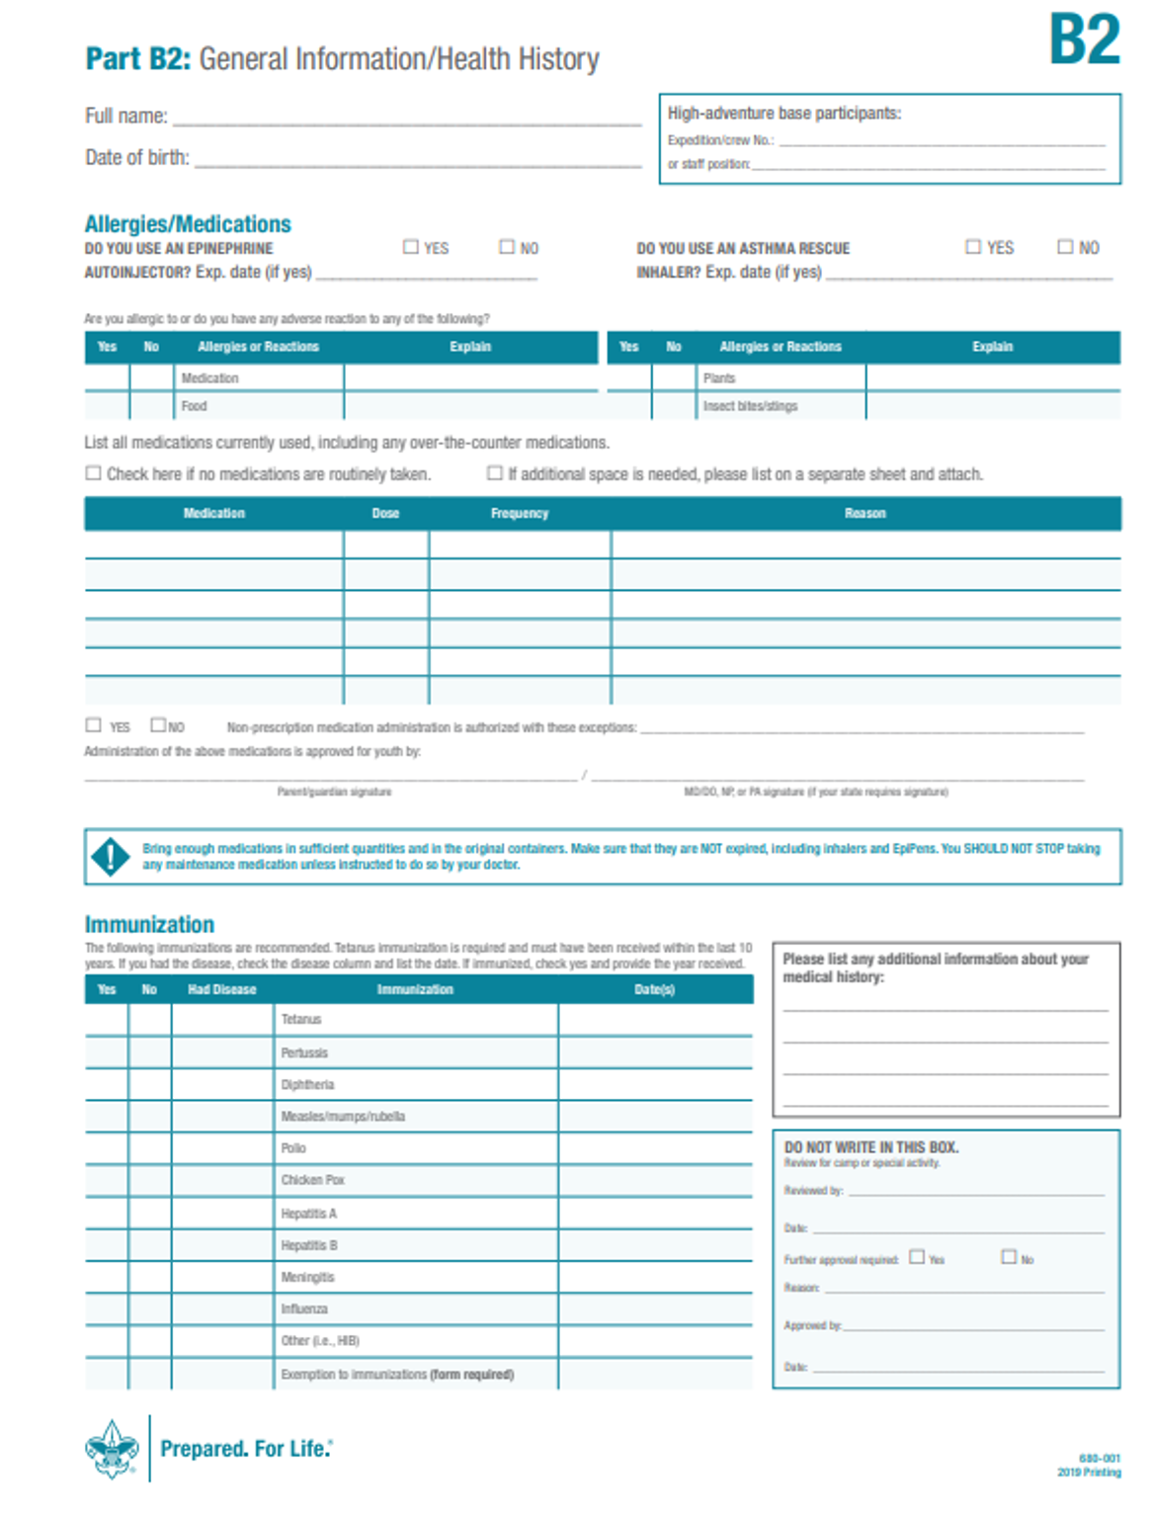


SUSQUEHANNA COUNCIL
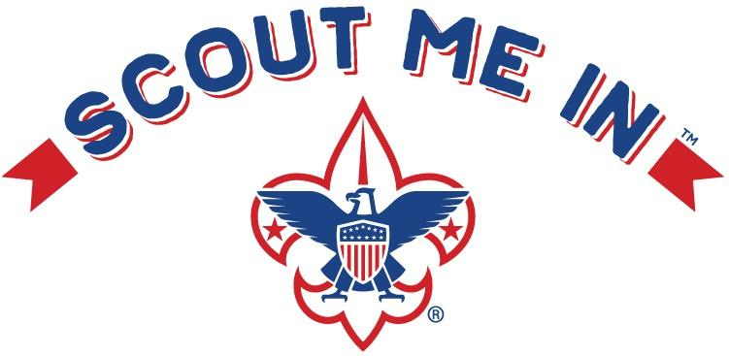
815 Northway Road
Williamsport, PA 17701
(570) 326-5121

TWILIGHT CAMP CAMPERSHIP APPLICATION
Limited funds are available for Camperships for Scouts who could not otherwise afford to attend Camp Karoondinha. The Camperships are subject to the following conditions:

- The Scout should pay as much as possible.

- The unit or chartered organization should pay as much as possible.

- The unit should provide money-earning opportunities for Scouts.

- Unit Committees should apply only for the balance needed after the above sources are exhausted.

- Scouts should be assigned some tasks to perform commensurate with the campership, so they have the feeling of earning their own way.

The maximum for a campership is ½ (50%) of the camp fee.

Deadline for application is July 12, 2026.

Scoutmasters/Cubmasters will be notified if a campership has been approved and if so, the amount. Campership funds will be distributed to scouts through the online registration/ payment system.

2026 Camp Fees

Cub Scout Twilight Camp $75.00

Please turn applications in to Reuben Sturgart at reuben.stugart@scouting.org or to the Susquehanna Council Service Center.

Camperships are based on Financial Need

(Both Pages of the Application are REQUIRED; Unit Leader signature is REQUIRED)

Any campership applications received without these required parts will not be considered.
Applicants may submit documentation of extenuating circumstances

APPLICATION FOR CAMPERSHIP – RESIDENT CAMP

(Deadline For Application – July 12, 2026)
Applicant
Name Age Rank Address City State Zip
Troop/Pack #  Scouts BSA Week  Cub Scout Week
 Webelos/AOL Session
The applicant regularly participates in:
Unit Meetings | Yes | No
Activities | Yes | No
Has the applicant received a campership before? | Yes | No
Has the applicant receive a summer camp campership this year? | Yes | No

Parent / Family Information
Names Number of children in family Number of children attending scout camp
Father’s occupation  Mother’s occupation Household yearly income: |  | Currently employed: Yes Currently employed: Yes |  | NO
Under $15,000 | $15,001-$28,000 |  | $28,001-$39,999
$40,000-$49,999 | $50,000-$74,999 |  | $75,000+
Does the campership applicant receive free or reduced lunch at school? Yes No

Thrifty
A Scout works to pay their way and to help others. He/she saves for the future. They protect and conserve natural resources. The carefully use time and property.
The unit participates in the:
Council Popcorn Sales Yes No
Friends of Scouting Yes No

The applicant has participated in the:
Council Popcorn Sales Yes No
Unit Fundraising Yes No

Other camp fundraising projects conducted by the unit:
Project Date Amount earned by Scout Project Date Amount earned by Scout

Requested Campership Amount
Please complete the following lines. Start with the total camp fee (found on page 1) and then deduct the amount each party is able to pay towards that camp fee. The remaining amount is listed below the line as your “Campership Request.”

Camp Fee (from page 1) |  | $ 75
Amount family is able to pay | (minus) | $
Amount Unit is able to pay | (minus) | $
Amount Scout received from popcorn | (minus) | $
Amount Scout will earn from  other fundraisers to go towards camp | (minus) | $

Campership Request $
(Camp fee minus the amounts listed above. Note that the request is not to exceed ½ (50%) of camp fee)

Unit Committee
We, the Unit Committee, feel this Scout should have an opportunity to go to a summer program. Because:

Signed Position

Council Office Use
Received on

Application: Approved Not Approved Amount $

Signed:
Campership Committee Chairman / Advisor

Date:

