**CACOOSING DISTRICT**

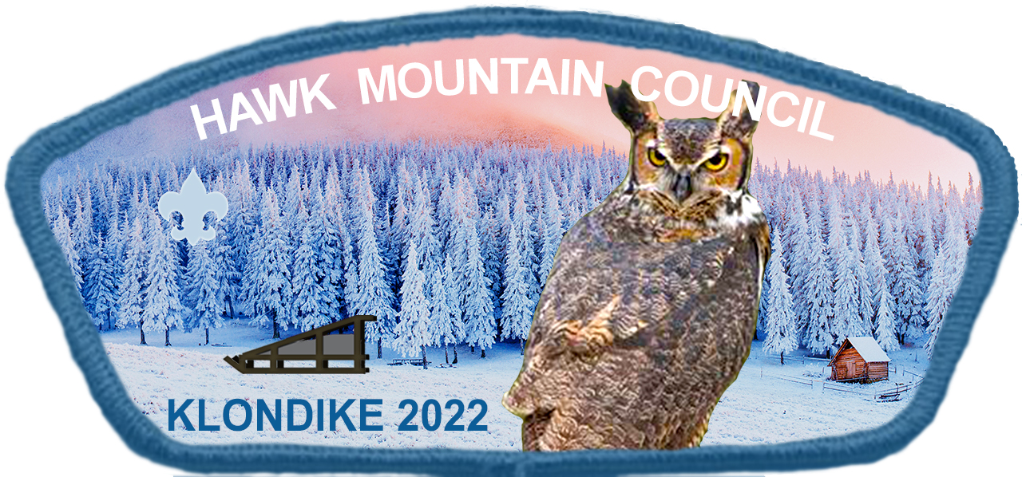

**SCOUTS, BSA**

**ACTIVITY PROGRAM**

### January 15, 2022

**Hawk Mountain**

**Scout Reservation**

**2022 KLONDIKE DERBY**

**Participants**

Scoutmaster and Senior Patrol Leader:

The excitement and enthusiasm for 2022 Klondike Derby is growing! Guidelines and details for this year's Klondike derby is included in this packet. Please ask questions prior to the event if they arise during your preparation for the derby. The following items listed will help to understand the expectations of the derby.

**PARTICIPATING SCOUTS**

* Patrols should remain the same at each station throughout the day
* Patrols that fail to complete the trail must sign out at the Klondike HQ
* Patrols are expected to follow the trail that is outlined on the map and follow all the instructions given to the Patrol leaders when signing in for the derby.
* Patrols are expected conduct themselves based on the values of the scouting program: this includes patrol name, on-trail movement, and station times.
* The Official Scout uniform is **not** expected at this event

**UNIT LEADERS**

* During the derby unit leaders should respect the format of the derby by allowing patrols to participate in each station event without interference.
* For emergency reasons, we require that a minimum of two adult leaders per Troop (one of whom must be over 21 years of age) remain on the Reservation property during the Derby.
* Derby Recognition awards, patches, and score sheets will all be done immediately following the derby.
* Patrols that fail to comply to the guidelines of the derby could suffer loss of points during the derby

**KLONDIKE JUDGES**

* Stations should be challenging and incorporate the use of the patrol method
* Stations should be setup to be consistent for all patrols which includes scoring, expectations, time, and provided directions
* Stations will only include content that is used in the station description packet and will only be evaluated based on the reference(s) cited in the station description packet
* A station score sheet should be used to support managing the station consistently throughout the day and to provide reflection materials back to the troop leadership after the derby is completed.

**2022 KLONDIKE DERBY**

**EVENT INFORMATION**

**DATE:** Saturday, January 15, 2022. **THE EVENT WILL BE HELD RAIN, SNOW OR SHINE.**

**NO ALTERNATE DATE**. Cancellation, if necessary, will be broadcast by WRFY (102.5 FM) and WEEU (850 AM) by 7:00 AM on Saturday.

**TIME:** 8:00 AM to 4:00 PM (Patrols finishing after 4 PM may or may not be considered for placing)

**PLACE:** Hawk Mountain Scout Reservation

**REGISTRATION:**

All Units must submit their online **registration** to the Hawk Mountain, _____________ by Tuesday, January 11, 2022. Scouts are $5.00 and Adults who are not station judges are $5.00. Extra activity patches can be ordered/purchased for $2.00 each. On the day of the event, a Unit Leader or SPL must check-in at the Miller Dining Hall with a **completed Derby Roster** listing all Scouts and adults in Camp. Vehicles use for the day must follow camp policy.

ANY REGISTRATION RECEIVED AFTER THE DEADLINE WILL BE ASSESSED AN ADDITIONAL **$1.00** PER SCOUT LATE FEE. TROOPS REGISTERED ON TIME AND HAVE ADDITIONAL SCOUT(S) TO PARTICIAPTE ARE NOT SUBJECT TO LATE FEE(S).

**STARTING TIME:**

All Patrol Leaders must arrive at camp with their Patrol and sled between 8:00 AM –

8:45 AM and report to the Cub Scout (Miller) Dinning Hall for their initial inspection.

Stations will last approximately 20-30 minutes with the exception of cooking (lunch) which will be one hour. The recognition and awards portion will occur following the Klondike Derby.

**KLONDIKE PATROLS:**

No less than 4 or more than 8 Scouts per patrol. One Scout is to be the driver of the sled (the driver steer & brake the sled). All other remaining Scouts pull the sled with the tow ropes. The driver must give direction on how to pass obstacles such as logs, rocks, and ditches. All patrols must be comprised of Scouts from the same troop unless cleared by the Klondike committee.

**NO MORE THAN 8 BOYS MAY BE WITH THE SLED AND PARTICIPATE AT THE KLONDIKE DERBY STATIONS**. Patrols who attempt to enter the derby with more than 8 scouts will have their score excluded from the derby competition. This also includes rotating scouts between stations. We encourage your troop to mix older Scouts with younger Scouts. This is a great training tool for your older Scouts to “lead” the younger Scouts.

**2022 KLONDIKE DERBY**

**REQUIRED EQUIPMENT**

**PERSONAL EQUIPMENT:**

* Mess Kit
* Eating Utensils
* Rain clothing
* Folding pocket knife on each person (no fixed blade knife)
* Cold weather clothing, gloves and cap, extra socks in coat pocket (If it is a warm day, above 45 degrees, a long underwear/thermal layer need not be worn but must be brought along. - Be Prepared!)
* Weather – proof shoes or boots.

**SCOUTS MUST HAVE:**

Inspection stations will also include the following: Scouts having stocking caps or hats that are able to cover the ears, gloves or mittens, and weatherproof shoes or boots covering/providing ankle support. Hoods do not qualify as proper head gear but are recommended as additional protection. **Athletic shoes will not be permitted on the trail. Anyone not properly dressed will not be permitted on the trail!**  Judge’s decision at the initial sled inspection is final!

**PATROL EQUIPMENT:**

* Sled made to meet required specifications noted herein
* Patrol Flag
* Patrol cooking gear
* Hobo stove with matches, tinder, kindling and fire wood for lunchtime meal
* Patrol first aid kit (include three pair of rubber gloves and three safety goggles)
* Sled repair kit
* Water jug(s) to hold two gallons of water
* Watch
* Solid-Made wheels with one axil
* Minimum of two compasses
* Rope
* One blanket (at least one full size for making an emergency stretcher)
* Paper and pencils, and a covered clipboard
* Coffee can or plastic container containing a roll of toilet paper.

**NOTE**: There will be an initial inspection of Scouts and Patrol gear at the Klondike HQ. C.S. Dinning Hall will also serve as the registration area prior starting on the trail and for final inspection along the trail. All equipment listed above is necessary for the Derby.

**IF ANY OF THE FOLLOWING ITEMS ARE USED OR DONE, POINTS DEDUCTIONS AND/OR DISQUALIFICATION WILL RESULT:**

**SCOUT HANDBOOKS OR OTHER HANDBOOKS, CELL PHONES, WALKIE TALKIES, IMPROPER NUMBER OR SIZE OF WHEELS USED ON THE BOTTOM OF THE SLED, OR MOVING STATION MATERIALS WITHOUT PERMISSION**

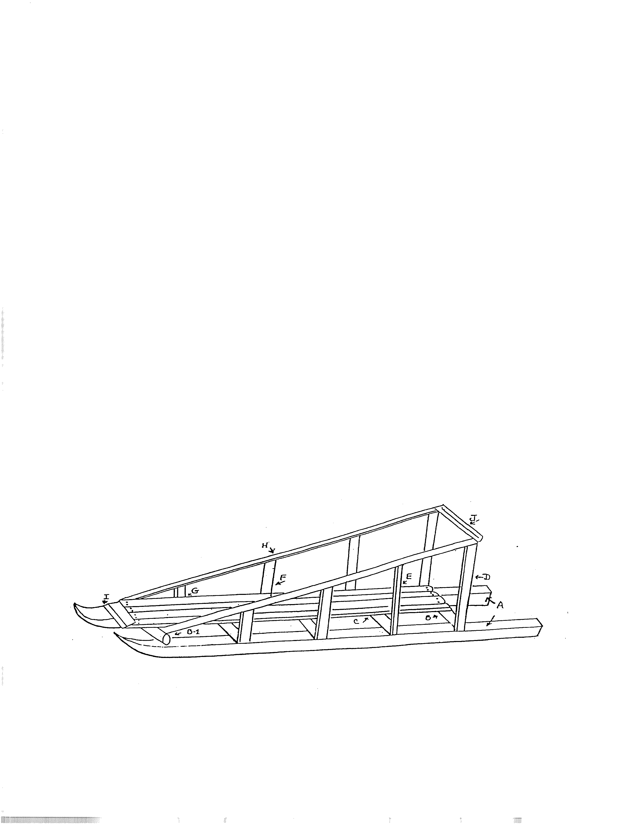**2022 KLONDIKE DERBY**

**SLEDS – FAIR COMPETITION**

*BILL OF MATERIALS*

A. 2 pieces 2"x6"x6'6" runners.

B. 4 pieces 2"x2"x18" cross supports.

B1. 1 piece 2"x2"x20" cross support.

C. 4 pieces 1/2"x4"x5' floor planks.

D. 2 pieces 1"x2"x40" rear uprights.

E. 2 pieces 1"x2"x31" second rear upright.

F. 2 pieces 1"x2"x22" second front upright.

G. 2 pieces 1"x2"x18" front uprights.

H. 2 pieces 1"x2"x6' hand rails.

I. 1 piece 1"x4"x16" tow bar.

J. 1 piece 1"x2"x20" handle bar.

**SLED SPECIFICATIONS**:

Sleds may be of your own design, or you may use the sample plan that is included in this booklet. All sleds must be built to the following specifications:

1. Capable of transporting one Scout and 50 pounds of gear.
2. Length 5 foot minimum; 6 ½ foot maximum.
3. Width – 18 inch minimum; 24 inch maximum.
4. Sleds must have a minimum of 4-inch ground clearance.
5. **One pair of solid-made wheels on a single axel with a wheel diameter not to exceed eight (8) inches may be mounted on the sled. Patrol should make decision to use wheels. No deer carts. Wheels not fitting allowed size or correct number will need to be removed prior to starting the derby.**
6. Sleds are to be made of wood. Metal hardware may be used.
7. Sleds should have two ropes of ¾ inch and 12 feet long; one for each side of the sled (no wash line or twine). A brake rope at the rear of the sled is essential.
8. A sled repair kit with 4 – 5 items is required for minor sled repairs that may be needed on the trail. Include hammer, screwdriver, pliers, wrench, nuts/bolts, nails, or screws and wire/duct tape to repair sled. Inspectors expect each sled to be repairable on the trail, plan your kit accordingly.
9. **If commercial skis are used as runners, they must be reinforced with 1” x 4” or heavier boards**.
10. Sleds should have wire or cloth on the sides to prevent the loss of patrol gear.
11. Side rails make lifting of the sled easier over ditches or logs.

**2022 KLONDIKE DERBY**

**COOKING**

**NOTE: LIQUID FUELS ARE NOT PERMITTED AT HAWK MOUNTAIN SCOUT RESERVATION. PROPANE AND BUTANE WILL NOT BE ALLOWED FOR THE COOKING STATION. CHARCOAL MAY BE USED AND IS RECOMMENDED. MATCHLIGHT CHARCOAL IS PREFERRED**.

**COOKING INSTRUCTIONS**

Only the Patrol members are permitted to prepare the meal; adults are not permitted to assist in any way. Each Patrol must prepare an extra serving for a judge and a portion of the score will depend on how much the Patrol impresses the judge with their meal. Patrols should have at least two extra freezer bags to take left over food with them at the conclusion of the station.

**MENU**:

1. Meat/Vegetable stew or chili –prepared and cooked on site. No canned or pre-made stew.

2. Hot beverage

3. Bread, and spread (jelly, peanut butter, butter, etc.)

4. Dessert

The type of meat for the stew and ingredients for the stew will be up to the Patrol. Pre-cooking the meat is allowed and is recommended. Canned vegetables are acceptable to add to a stew or chili.

**UTENSILS:**  Each Scout in the Patrol must bring his mess kit and utensils. The Patrol will need a large pot for the stew (a Patrol of 8 will need to prepare 9 servings), a Chef’s kit, and additional pots and pans as required. Also, two garbage bags for clean-up. Bring everything you will need. No borrowing!

**ADDITIONAL EQUIPMENT**: Each Patrol will need to bring a hobo stove of the type shown. The Patrols must also bring enough charcoal or dry wood to cook the meal.

Secure a five-gallon metal bucket. It may be round or square. Burn it out well to get rid of whatever

was in it, such as paint, detergent, tar, etc.

Cut holes near the bottom of the can. They should be at least 4 X 4 inches. Let at least a 3-inch wide

strip of metal between the holes as shown in the drawing.

The stove needs a lid on which to set your cooking utensils and allow smoke to escape. This can be made

from ½ inch mesh chicken wire, fastened on a heavy wire hoop. The hoop should be about an inch

larger in diameter than the top of the hobo stove.

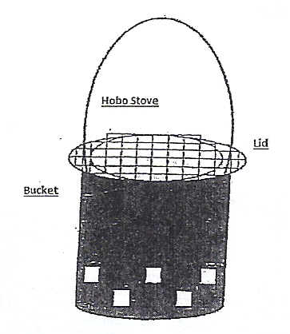

**2022 KLONDIKE DERBY**

**SKILL STATIONS**

**INSPECTION**

There will be two inspections conducted. The initial inspection will be the first scored patrol station prior to entering the trail. Patrols will be expected to demonstrate preparedness and fair competition. The closing inspection will be at 2nd inspection station. Patrols will be expected to demonstrate appropriate patrol and sled appearance.

**FIRST AID**

Scouts will need to be able to solve and treat an emergency situation that occurs in the woods/on the trail, on a seasonal troop outing, or a first aid situation that would be common in everyday living. Reference can be made to the current edition of the Boy Scout Handbook and/or First Aid Merit Badge Book.

**TRACKS - MAMMALS of PA**

Scouts should be familiar with the animal tracks of the mammals found on the charts produced by the PA Game Commission.

**YOUR FLAG & U.S. CONSTITUTION**

Scouts will need to be familiar with the proper presentation and protocols found in “Your Flag” publication through the B.S.A. and be familiar with the Preamble, Articles, and Amendments of the United States Constitution.

**KNOTS**

Scouts will need to know all of the required knots for rank advancement and be familiar with other knots found in the current edition of the Boy Scout Handbook. The Scouts will be required to know how each knot is used in the outdoors.

**SURPRISE STATION**

Scouts will be evaluated on leadership, teamwork participation, and completion of an unknown task within a set of parameters provided by the Judge at the station.

**COMPASS**

Scouts will be required to find compass degree readings and be able to use their individual pace. They should also know how to use a compass in conjunction with a map. Refer to the current edition of the Boy Scout Handbook.

**COOKING**

Scouts will be required to cook a lunch for themselves that will be evaluated based on proper menu, on-site preparation, leadership, patrol participation, quality of the meal, clean-up, and good etiquette. Please bring a Zip lock bag for the leftover stew.

**MAP SYMBOLS**

Scouts should be familiar with the identification of map symbols and how they are used in a reading a map. Refer to the current edition of the Boy Scout Handbook.

**TREES**

Scouts should be able to identify various tree species found at the Hawk Mountain Scout Reservation. Scouts should also reference the current edition of the Boy Scout Handbook for information on tree identification.

**WOODS TOOLS**

Scouts must demonstrate knowledge of wood tools parts, the safe use and handling, and the correct choice and effective use of various woods tools as shown in the Boy Scout Handbook.

**2022 KLONDIKE DERBY**

**TROOP ROSTER**

**Troop # _________**

Unit Leader @ Camp: __________________

Unit Leader Phone #: __________________

Campsite (if camping): _________________

**Patrol Name: _________________________**

Scouts:

_____________________________________

_____________________________________

_____________________________________

_____________________________________

_____________________________________

_____________________________________

_____________________________________

_____________________________________

**Patrol Name: _________________________**

Scouts:

________________________________________________________________________________________________________________________________________________________________________________________________________________________________________________________________________________________________________

**Adult Leaders at Camp for the Derby**

Name & Phone #:______________________

Name & Phone #:______________________

Name & Phone #:______________________

Name & Phone #:______________________

**Patrol Name: _________________________**

Scouts:

_____________________________________

_____________________________________

_____________________________________

_____________________________________

_____________________________________

_____________________________________

_____________________________________

_____________________________________

**Patrol Name: _________________________**

Scouts:

________________________________________________________________________________________________________________________________________________________________________________________________________________________________________________________________________________________________________