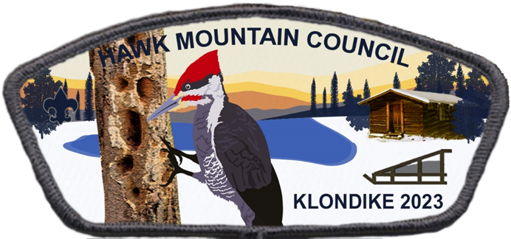

2023 Cacoosing District
Cub Scout Klondike

Leader Guide
Saturday, January 28, 2023
Breneman Park
2914 Reedy Rd., Reading, PA 19609
Registration begins at 8:30 AM, event begins promptly at 9:00 AM
Please note: This event will be held rain, snow, or shine. Cancellation only in the event of extreme conditions will be broadcast by WRFY (102.5 FM) and WEEU (830 AM) by 7:00 AM on Saturday.
No alternate date will be set.
If you have any program related questions or would like to volunteer, please contact:
Tim Trout, Program Chair: 484.868.7447 | tptrout3120a@gmail.com
If you have any administrative or registration questions, please contact:
Ryan Sagnip, Cacoosing District Executive: 570-234-4436 | ryan.sagnip@scouting.org

Dear Cubmaster & Pack Leaders,

Welcome to winter! This year’s Cub Scout Klondike will take place at Cacoosing Meadows Park in Sinking Spring. The experience will offer fun and excitement while also encouraging the Scouts to work together as a team! Event is for all Lions, Tigers, Wolves, Bears, Webelos, and Arrow of Light candidates.
It is recommended that a Sled Den be between 4-8 Scouts, if possible.
Station List: Scouts will travel stations as a Sled Den to learn and have fun! Stations include activities such as Fire Building, Winter Survival, First Aid, Flag History, Target Shooting, Games, and more!
Sleds (sleds are optional, but highly suggested to carry required items):
Sled can be a saucer, toboggan, self-built plastic sled (no sleds with metal rails permitted), or other similar object. Scouts should have some method to push/pull sled through the course, such as a rope. Scouts will need to have required items in a backpack or bag.
Required Items per Scout:
- First Aid Kit and Blanket (1 per Sled Den)
- Water bottle
- Warm winter clothes (hat, gloves/mittens, jacket)
- Weather appropriate boots
- Extra pair of socks (Be Prepared!)
Schedule:
8:30 AM – Registration/Sled Inspection
9:00 AM – 12:00 PM - Events
12:00-1:00 PM – Food & Fellowship
COST: Only $5 per person (with registration prior to Jan 26th) - $6 afterwards
All participants must be dressed appropriately for the weather – gloves, hats, and layers. Appropriate footwear is critical (sneakers are not appropriate for this event). We strongly suggest everyone bring along extra gloves & socks. Unit leaders are responsible for the safety of their Scouts and must enforce these rules.
Everyone registered will receive an event patch, hot dog & hot chocolate at the end of the event. To sign up, visit the Council website at www.HMC-BSA.org and navigate to the event page on the calendar. All registrations take place on the online registration system ‘Black Pug’. For accurate attendance tracking and to ensure we have enough supplies, please Do Your Best to sign up beforehand!
Don’t be afraid to ask questions prior to the event; having your Patrols prepared will help make this event fun for all!

